**After Compilation**:

When you want to find out the day. Enter your choice as 1

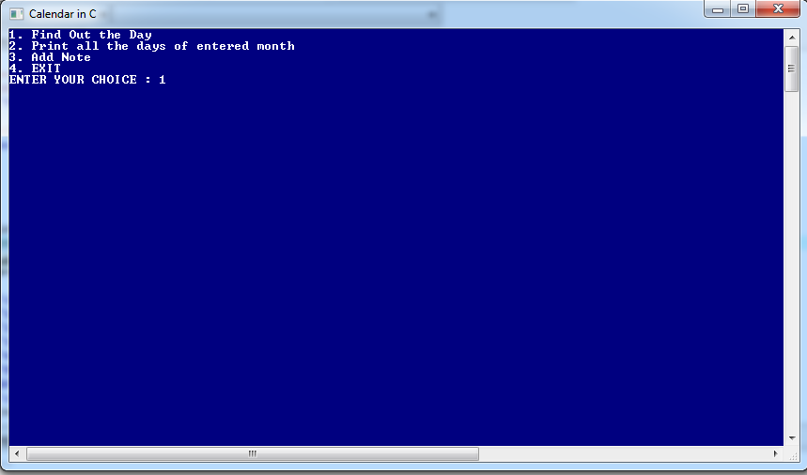

It displays the day of the entered date.

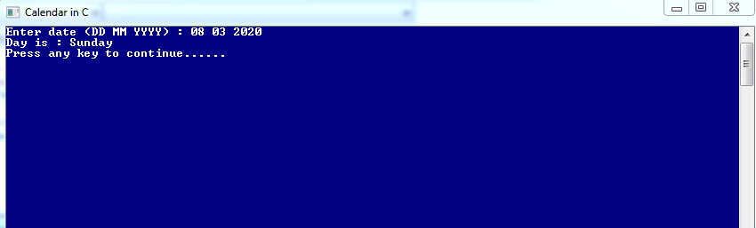

Press any key to continue. You will be redirected to the first screen.

If you want to see all days of a particular month.

Enter your choice as 2

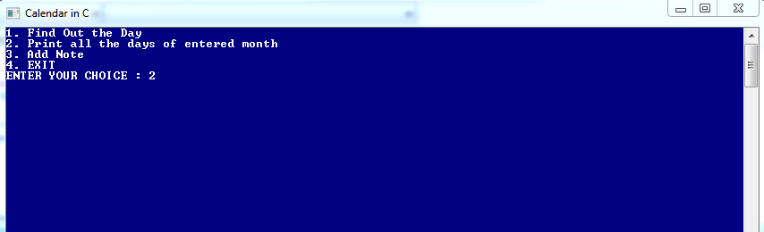

It displays the screen as below to enter the month to be displayed

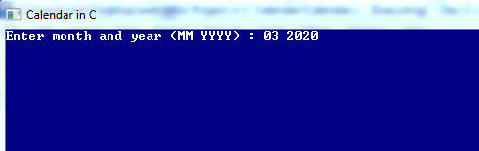

Output is as follows:

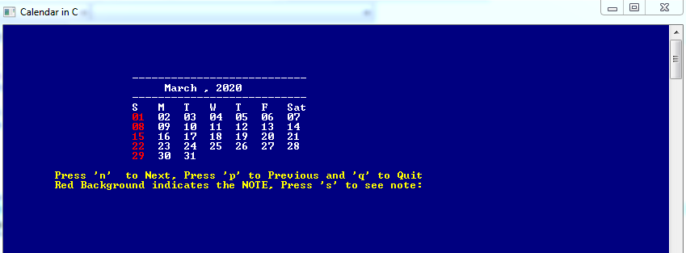

If you want to see next month press ‘n’

If you want to see previous month press ‘p’

If you want to see note press ‘s’

If you wanna redirect to first screen press ‘q’

When we press ‘n’. It displays next month as below.

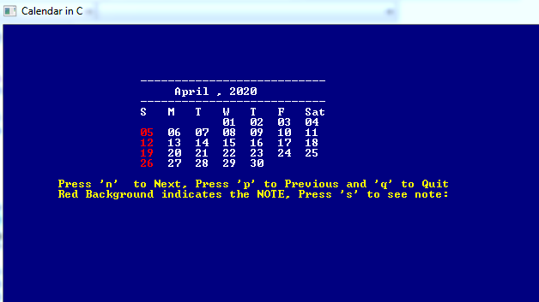

When we press ‘p’. It shows the previous month calendar ie March ,2020

When we press ‘s’. It displayed that the month has no note because we didn’t create a note. Press any key to redirect back.

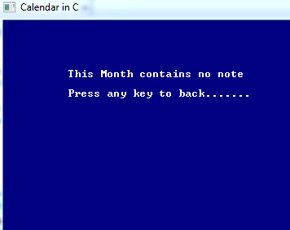

When we want to add notes to a particular date we can enter choice as 3

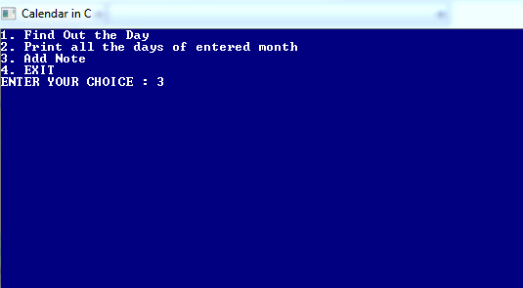

It displays the screen as below:

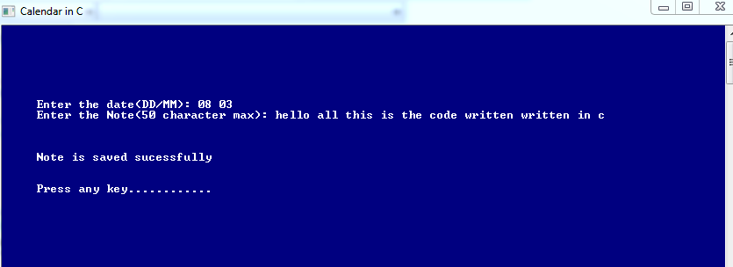

After adding the note to the particular date the note is successfully saved in “note.dat” file.

Press any key to continue:

After returning to the first screen check whether the note is saved or not.

Enter option 2

It displays the date to which note is saved in red color. It means a note is added to that date.

It is as below:

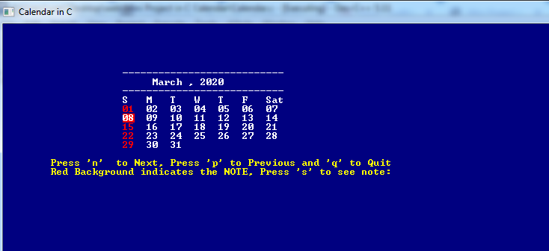

Press ‘s’ to see whether the note is saved or not.

It displays output as shown below:

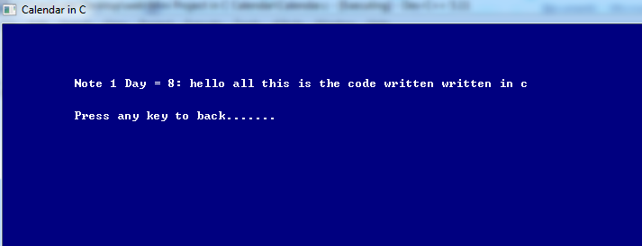

Press any key to return back

To exit from the program enter your choice as 4