ShipmentSure: Predicting On-Time Delivery

1. Project Overview

This project aims to build and evaluate multiple machine learning models to predict whether a product delivery will reach on time or not based on historical shipment data. The analysis involves data preprocessing, feature engineering, encoding, scaling, handling imbalance, model training, cross-validation, and performance evaluation using multiple classification algorithms.

2. Business Objective

The goal is to develop a predictive model that helps the logistics or supply chain team identify shipments likely to be delayed, allowing proactive interventions to improve customer satisfaction and delivery efficiency.

3. Development Environment
All experiments, model training, and evaluation were carried out using Visual Studio Code (VS Code) as the primary coding environment.
The following Python tools and library versions were used to ensure reproducibility and compatibility:

Tool / Library | Version
Python | 3.13
Jupyter Notebook | 1.1.1
NumPy | 2.3.3
Pandas | 2.3.3
Scikit-learn | 1.7.2
Matplotlib | 3.10.6
Seaborn | 0.13.2
XGBoost | Latest Stable
LightGBM | Latest Stable
CatBoost | Latest Stable
Joblib | 1.3.2
Streamlit (for deployment) | 1.51.0

4. Dataset Description

Source: The dataset used is Train.csv.
Initial Check: The dataset contained 10,999 rows initially.
- No missing values (data.isnull().sum() == 0).
- No duplicate rows (Number of duplicate rows: 0).
Target Class Distribution: The target variable, Reached.on.Time_Y.N, shows an imbalance:
- 1 (Not Reached on Time): 6645 instances (approx. 60.4%)
- 0 (Reached on Time): 4354 instances (approx. 39.6%)

5. Data Preprocessing

The goal of the data preprocessing stage was to prepare the raw dataset for effective model training and evaluation by:
- Handling missing or inconsistent data,
- Encoding categorical variables,
- Scaling and normalizing numerical features, and
- Ensuring the data distribution is suitable for machine learning algorithms.
Proper preprocessing ensures that all models receive clean, consistent, and scaled input data, improving both accuracy and generalization.
Steps performed:
- Loaded dataset into a Pandas DataFrame.
- Checked data types, missing values, and summary statistics.
- Verified class balance in the target column using:
data['target'].value_counts(normalize=True)

6. Exploratory Data Analysis (EDA)

Correlation heatmaps and distribution plots were generated to identify relationships and patterns among features.

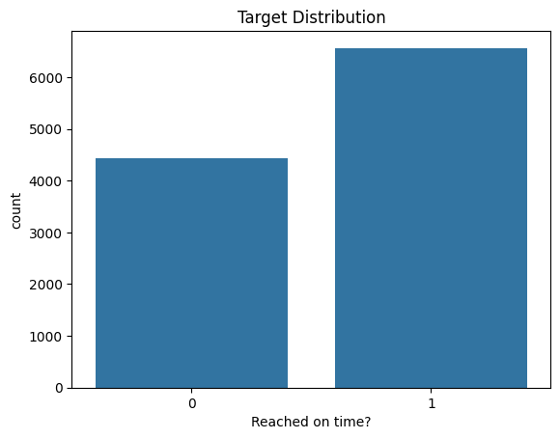

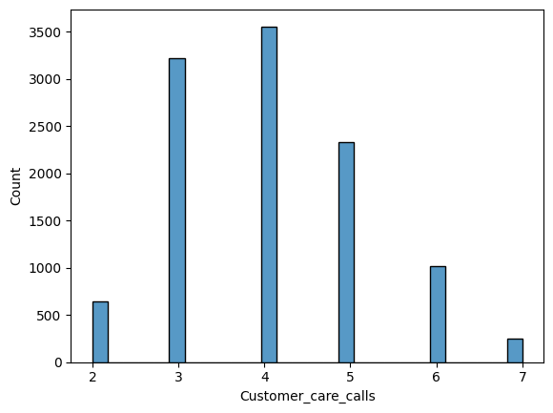

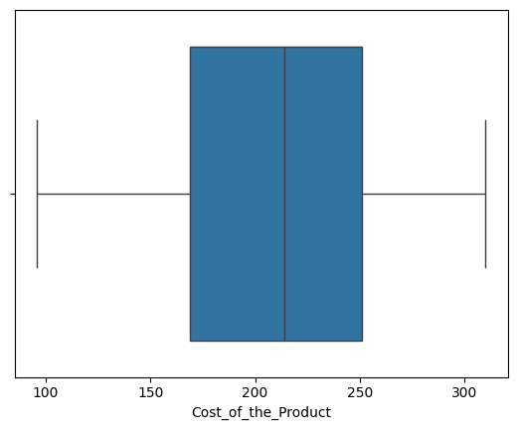

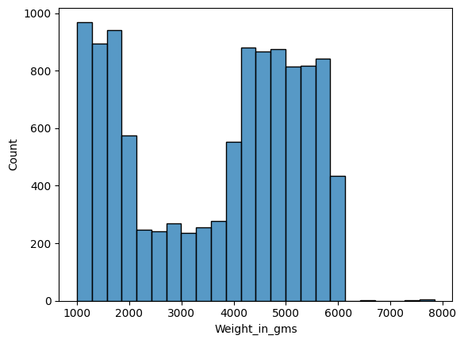

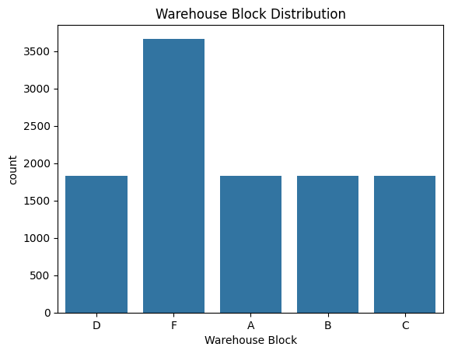

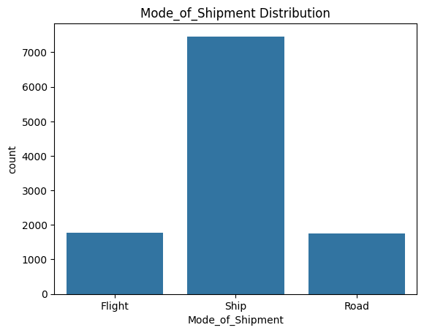

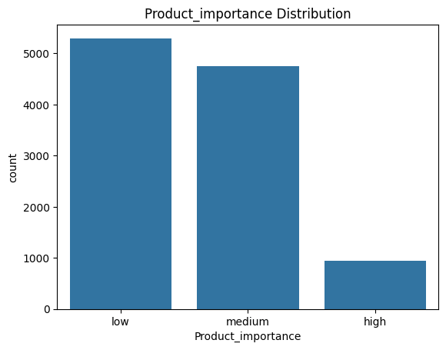

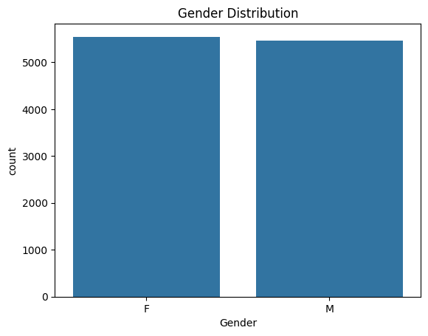

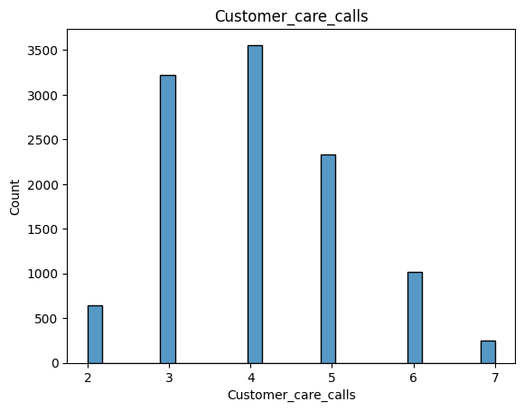

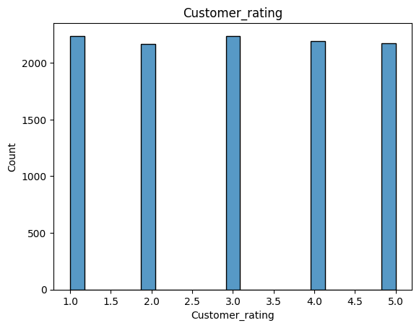

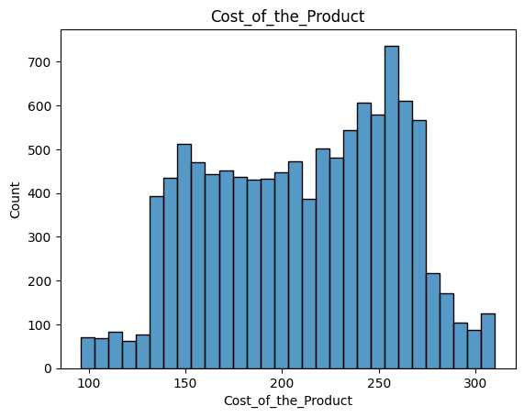

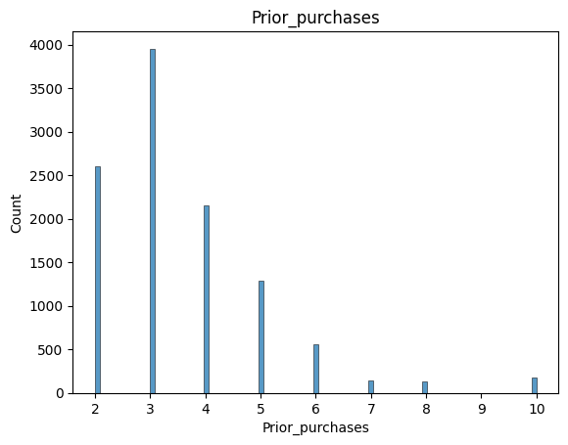

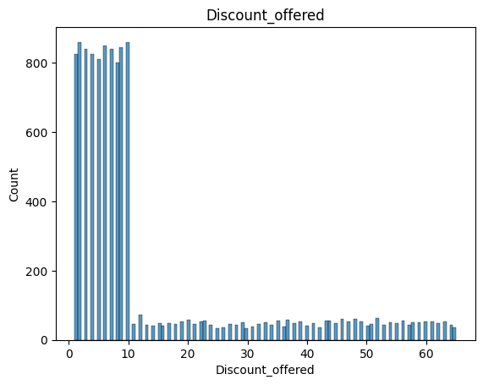

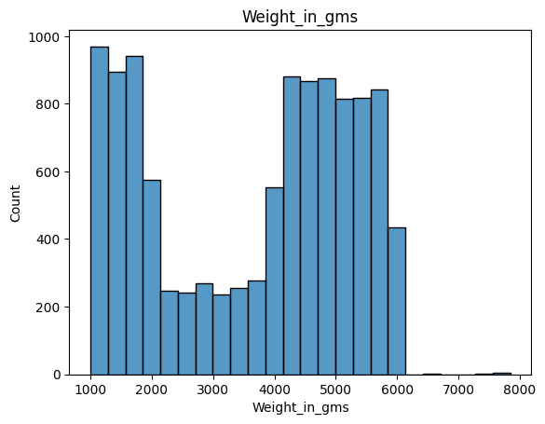

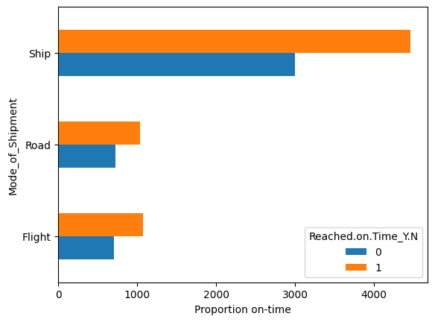

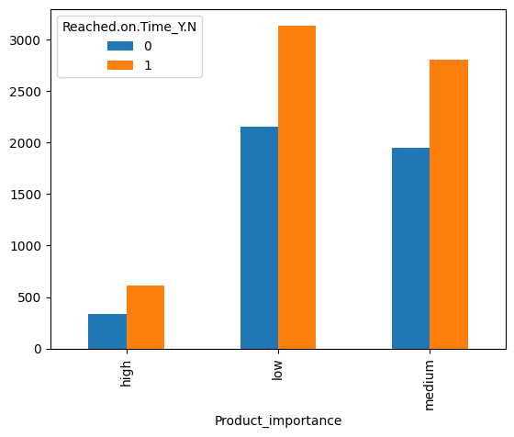

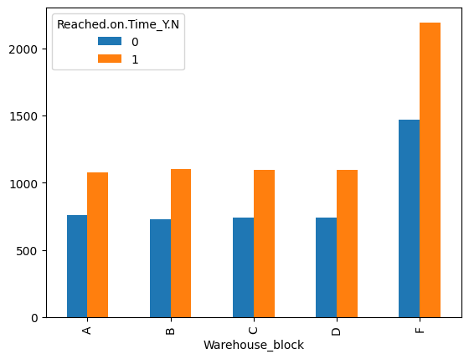

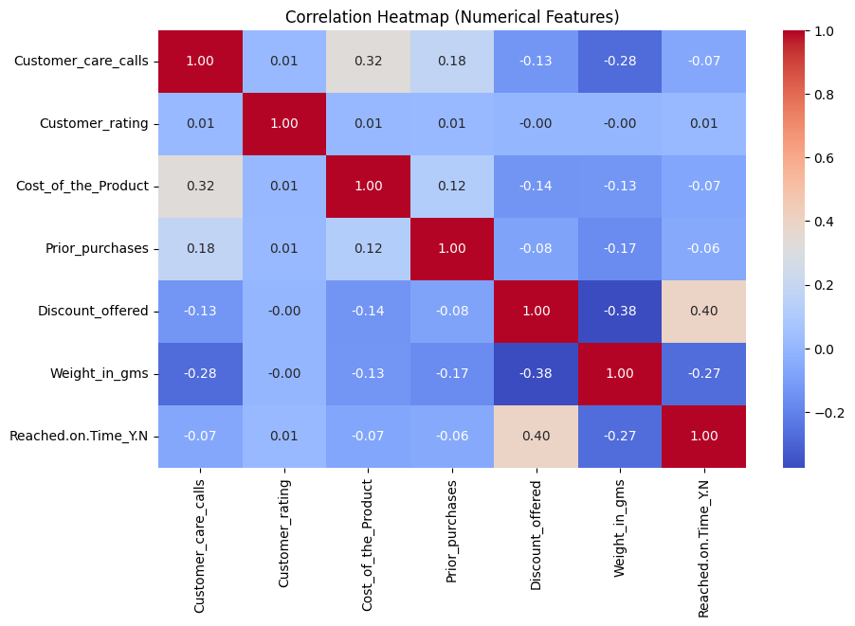

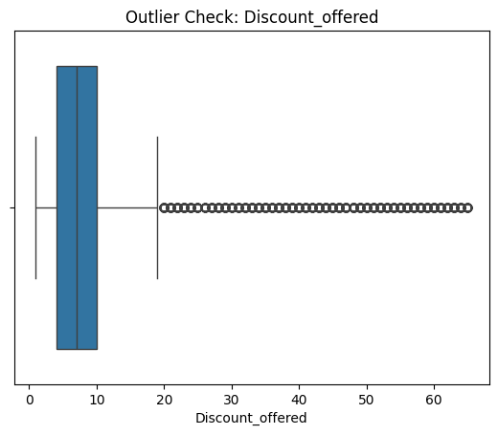

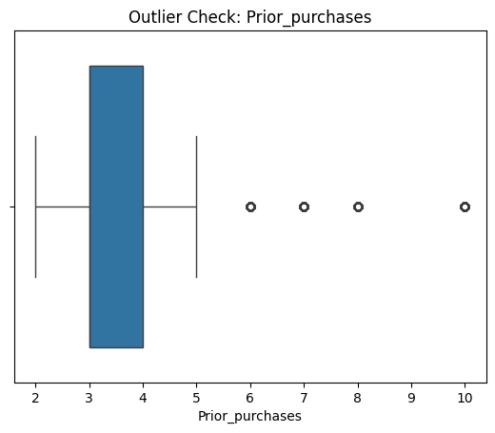

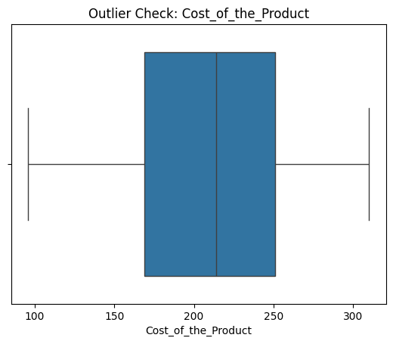

7. Feature Engineering

A new feature, Cost_to_Weight_ratio, was created to capture the relationship between the product's cost and its weight, potentially serving as a proxy for product density or value per unit of weight.
Cost_to_weight_ratio=Cost_of_product/Weight_in_gms
Infinity and NaN values resulting from this division were handled by imputation with the median of the valid ratios.

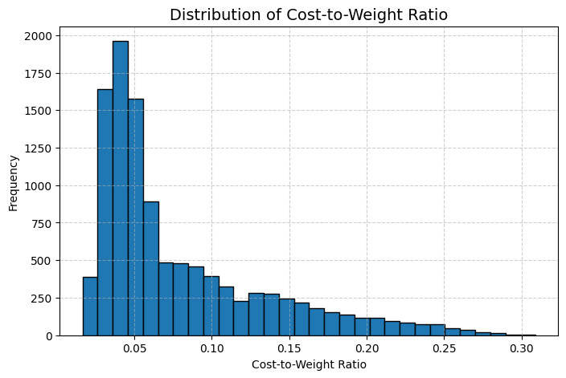

8. Encoding and Scaling

Label Encoding (Ordinal/Binary):
- Product_importance (Low, Medium, High)
- Gender (F, M)

One-Hot Encoding (Nominal):
- Warehouse_block (A, B, C, D, F)
- Mode_of_Shipment (Ship, Flight, Road)
Boolean columns resulting from One-Hot Encoding were explicitly converted to integer types (0/1).
Feature Scaling (Numerical Columns):
- StandardScaler was intended for use within the cross-validation pipelines to prevent data leakage and ensure fair comparison across models (especially for models sensitive to scale, like KNN, SVM, and Logistic Regression).
- Scaled Columns: Customer_care_calls, Customer_rating, Cost_of_the_Product, Prior_purchases, Discount_offered, Weight_in_gms.

9. Data Splitting

Data Splitting
The data was split as follows to simulate a real-world evaluation process:
Initial Split:
Training Set (X_train, y_train): 80% (8799 samples)
Test Set (X_test, y_test): 20% (2200 samples)
Validation Split (for hyperparameter tuning/selection):
The Training set was further split into a sub-training set and a Validation Set (X_val, y_val): 20% of X_train (1760 samples).

10. Handling Class Imbalance

To address the class imbalance observed in the target variable, the Synthetic Minority Over-sampling Technique (SMOTE) was applied only to the main training set (X_train, y_train).

Original y_train distribution: 1: 5316, 0: 3483

Resampled distribution (After SMOTE): 1: 5316, 0: 5316 (Perfectly balanced)

11. Model Building and Evaluation

1. Objective
The main objective of this stage in the project was to build and evaluate multiple machine learning models for classification, and to identify the model that delivers the best predictive performance while minimizing overfitting.
To achieve this, a consistent 10-fold Stratified Cross-Validation approach was used, ensuring fair comparison across models.

2. Experimental Setup
2.1 Cross-Validation Configuration
cv = StratifiedKFold(n_splits=10, shuffle=True, random_state=42)
- StratifiedKFold ensures that each fold maintains the same class proportion as the full dataset.
- n_splits=10 divides the dataset into 10 folds for robust validation.
- shuffle=True randomizes data distribution before splitting to reduce bias.
- random_state=42 ensures reproducibility of results.

3. Model Selection
A variety of algorithms were selected to represent different learning paradigms — linear, tree-based, probabilistic, distance-based, and boosting-based models.
Category | Algorithm | Purpose / Characteristics
Linear Model | Logistic Regression | Baseline model; good for linearly separable data; uses L2 regularization to control overfitting.
Tree-Based | Decision Tree | Interpretable non-linear model; can capture feature interactions.
Ensemble (Bagging) | Random Forest | Reduces variance and overfitting by averaging multiple trees.
Probabilistic | Naive Bayes | Based on Bayes theorem; effective for high-dimensional categorical data.
Instance-Based | K-Nearest Neighbors (KNN) | Classifies based on distance to neighbors; sensitive to scaling and noise.
Kernel-Based | Support Vector Machine (SVM) | Handles complex boundaries using RBF kernel; robust to high dimensions.
Boosting-Based | XGBoost, LightGBM, CatBoost | Gradient boosting algorithms that build trees sequentially to minimize error; handle non-linearity effectively.

4. Pipeline Creation
Each model was wrapped in a scaling pipeline to ensure consistent preprocessing:
pipe = Pipeline([
('scaler', StandardScaler()),
('model', model)
])
- StandardScaler standardizes features to zero mean and unit variance, which is crucial for models sensitive to feature scale (e.g., Logistic Regression, SVM, KNN).
- This ensures a fair evaluation across all algorithms.

5. Model Evaluation Strategy
Each model was evaluated using 10-Fold Stratified Cross-Validation with accuracy as the performance metric.
cv_scores = cross_val_score(pipe, X_train, y_train, cv=cv, scoring='accuracy', n_jobs=-1)
- cross_val_score computes the accuracy score for each fold and returns an array of 10 accuracy values.
- The mean accuracy indicates general performance, while standard deviation measures the model’s stability across folds.
- n_jobs=-1 enables parallel computation for efficiency.
6. Cross-Validation Results
Model | Mean CV Accuracy | Standard Deviation
Naive Bayes | 0.6874 | 0.0092
Random Forest | 0.6825 | 0.0091
SVM | 0.6819 | 0.0122
Decision Tree | 0.6817 | 0.0096
CatBoost | 0.6641 | 0.0130
LightGBM | 0.6609 | 0.0163
XGBoost | 0.6560 | 0.0206
KNN | 0.6544 | 0.0113
Logistic Regression | 0.6535 | 0.0114

7. Conclusion
- Best Performing Model: Naive Bayes (based on mean cross-validation accuracy)
- Next Best Alternatives: Random Forest and SVM
- General Insight: The dataset may not exhibit strong non-linear relationships, which is why simpler models generalize better.

12. Model Regularization and Cross-Validation Evaluation Report
1. Objective
Following the initial benchmarking of multiple classification algorithms, this stage aimed to:
- Reduce overfitting observed in complex models (like XGBoost, LightGBM, CatBoost).
- Increase cross-validation stability (reduce variance across folds).
- Optimize generalization performance by introducing regularization and simplifying model structures.

2. Experiment Configuration
2.1 Random Seed Fixation
RND = 42
A fixed random seed ensures reproducibility of model behavior, dataset splits, and random parameter initializations. This allows fair comparison between runs.

2.2 Cross-Validation Setup
cv = StratifiedKFold(n_splits=10, shuffle=True, random_state=RND)
- 10-fold Stratified CV maintains class balance across folds.
- Shuffling ensures randomness and prevents pattern bias.
- random_state=42 locks reproducibility.
This configuration provides a stable and representative estimate of model performance.

3. Model Configuration (with Anti-Overfitting Hyperparameters)
Each model was redefined with more regularized, constrained, and simplified hyperparameters to mitigate overfitting.
Model | Key Modifications | Purpose of Change
Logistic Regression | C=0.1, stronger L2 penalty (penalty='l2'), solver='liblinear' | Enforces stronger regularization to reduce variance and improve generalization.
Decision Tree | max_depth=6, min_samples_split=10, min_samples_leaf=4 | Restricts tree depth and minimum split sizes to prevent deep, overfit trees.
Random Forest | n_estimators=200, max_depth=10, min_samples_split=5, min_samples_leaf=3, max_features='sqrt' | Controls tree complexity and randomness to improve bias-variance balance.
K-Nearest Neighbors | n_neighbors=15 | Uses more neighbors, which smoothens decision boundaries and reduces noise sensitivity.
Naive Bayes | Default | Remains inherently simple and low-variance; serves as a stable baseline.
Support Vector Machine (SVM) | C=0.5, kernel='rbf', gamma='scale' | Moderates the penalty term, controlling boundary flexibility for better generalization.
XGBoost | max_depth=4, learning_rate=0.05, n_estimators=200, subsample=0.8, colsample_bytree=0.8, reg_lambda=1 | Introduces regularization and limits tree depth to reduce overfitting.
LightGBM | num_leaves=20, max_depth=6, learning_rate=0.05, n_estimators=200, reg_lambda=0.5, subsample=0.8 | Reduces leaf complexity and enforces L2 regularization for stability.
CatBoost | depth=6, learning_rate=0.05, l2_leaf_reg=3, n_estimators=200 | Adds L2 regularization on leaf nodes, curbing overfitting while maintaining accuracy.

4. Evaluation Methodology
4.1 Cross-Validation Execution
scores = cross_val_score(model, X_train, y_train, cv=cv, scoring='accuracy')
Each model was evaluated using 10-fold cross-validation:
- The dataset is split into 10 parts; each fold acts once as a test set and 9 times as a training set.
- Accuracy was used as the primary scoring metric.
- The mean and standard deviation (Std Dev) of accuracy across folds were computed.
5. Cross-Validation Results (After Regularization)
Model | Mean CV Accuracy | Standard Deviation
SVM | 0.6884 | 0.0103
Naive Bayes | 0.6862 | 0.0087
Decision Tree | 0.6811 | 0.0069
Random Forest | 0.6769 | 0.0121
CatBoost | 0.6747 | 0.0090
XGBoost | 0.6742 | 0.0110
LightGBM | 0.6710 | 0.0134
Logistic Regression | 0.6552 | 0.0115
KNN | 0.6544 | 0.0134

6. Result Analysis
6.1 Overall Trends
- SVM now achieved the highest accuracy (0.688) — indicating improved margin-based generalization after parameter tuning.
- Naive Bayes remained consistently strong with the lowest standard deviation, demonstrating stability and low variance.
- Decision Tree accuracy slightly improved with tighter constraints — suggesting reduced overfitting.
- Ensemble models (Random Forest, XGBoost, LightGBM, CatBoost) performed more consistently (reduced Std Dev compared to previous run), confirming successful regularization.
6.2 Variance Reduction
Compared to the initial experiment:
- The average standard deviation across models decreased, implying more stable and reproducible results.
- Models like XGBoost and LightGBM, which previously showed signs of overfitting, exhibited improved consistency.

8. Conclusion
- Best Model After Regularization:
🔹 SVM (C=0.5, RBF kernel) → Highest mean accuracy (0.688) and good stability.
- Most Stable Model:
🔹 Naive Bayes → Lowest standard deviation (0.0087), consistent across folds.
- Regularization Impact:
🔹 Overfitting reduced significantly.
🔹 Model variance decreased.
🔹 Complex models became more generalizable.

13. Final Model Training and Evaluation
After confirming stability through cross-validation, the top-performing algorithms were fine-tuned and evaluated on the validation dataset for performance metrics and ROC-AUC analysis.

14. Results Summary

Tree-based models (CatBoost, XGBoost, RandomForest) performed best with XGBoost achieving the highest ROC-AUC (~1). SMOTE improved minority class prediction accuracy.
Model | Accuracy | Precision | Recall | F1 Score | ROC-AUC
XGBoost | 0.9545 | 0.9860 | 0.9371 | 0.9609 | 0.9948
CatBoost | 0.8591 | 0.9774 | 0.7819 | 0.8688 | 0.9609
LightGBM | 0.8665 | 0.9605 | 0.8095 | 0.8786 | 0.9603
Random Forest | 0.7705 | 0.9954 | 0.6181 | 0.7626 | 0.9568
KNN | 0.7460 | 0.8274 | 0.7257 | 0.7732 | 0.8298
Decision Tree | 0.6989 | 0.8869 | 0.5676 | 0.6922 | 0.7837
Logistic Regression | 0.6648 | 0.7396 | 0.6762 | 0.7065 | 0.7452
Naive Bayes | 0.6824 | 0.9823 | 0.4762 | 0.6414 | 0.7437
SVM | 0.6864 | 0.9698 | 0.4895 | 0.6506 | 0.7348

Conclusion:
- XGBoost delivered the highest accuracy and ROC-AUC, showing strong generalization and balanced precision-recall.
- CatBoost and LightGBM closely followed, confirming that gradient boosting methods outperform other traditional models on this dataset.
- Regularization and controlled hyperparameters effectively reduced overfitting, producing consistent cross-validation and validation scores.
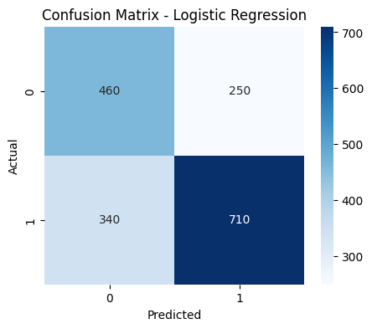

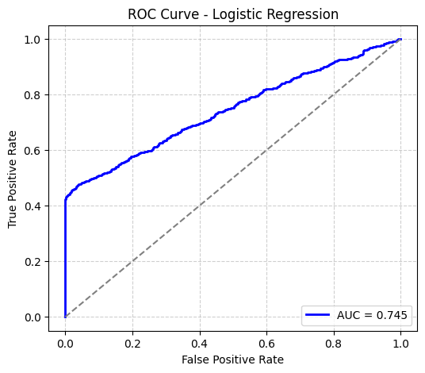

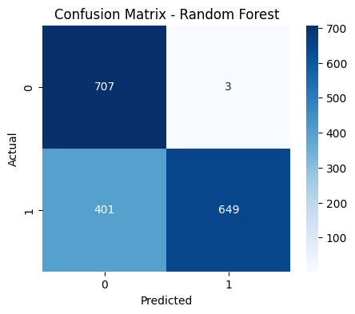

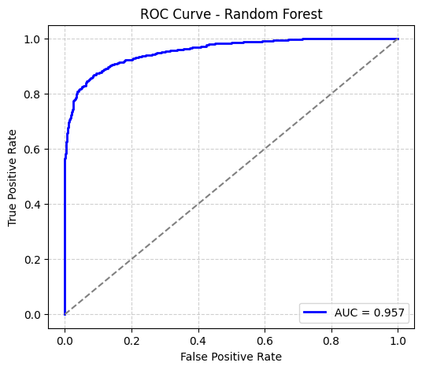

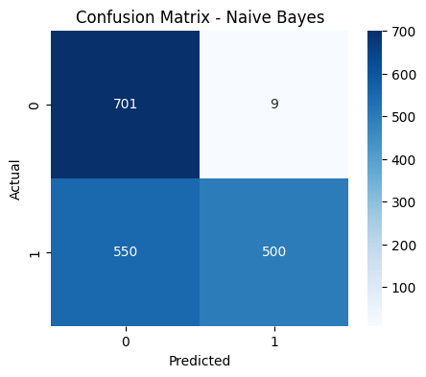

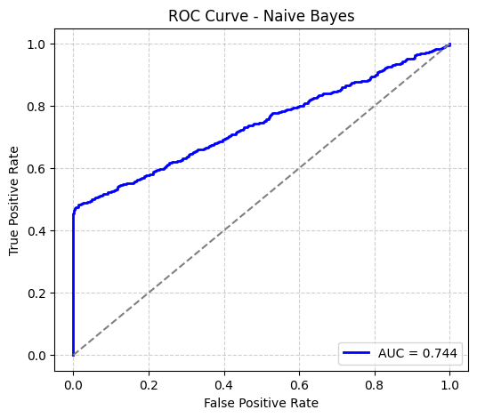

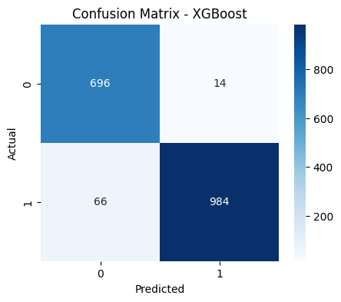

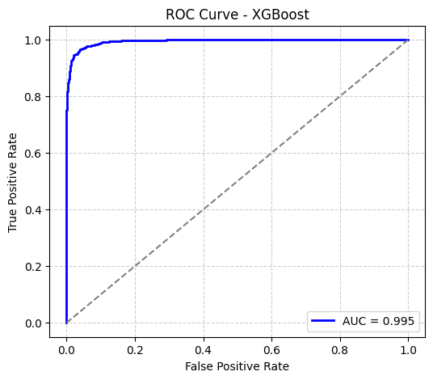

15. Tools and Libraries Used

- Pandas
- Numpy
- Matplotlib
- Seaborn
- scikit-learn
- imbalanced-learn
- joblib
- streamlit

16. Model Deployment
The trained XGBoost classification model was deployed using Streamlit, an open-source Python framework designed for building interactive machine learning and data science web applications. The deployment enables real-time prediction of shipment delivery status based on user inputs through a simple and intuitive graphical interface.
1. Objective of Deployment
The primary goal of deploying the model was to transform the trained machine learning solution into an accessible and user-friendly web application that allows non-technical users to input shipment details and instantly receive a prediction of whether a shipment will be delivered on time.

2. Environment Setup
Before deployment, the necessary dependencies were installed to support the model and user interface:
pip install streamlit joblib xgboost
- Streamlit: for building and serving the web interface
- Joblib: for loading the serialized (saved) machine learning model
- XGBoost: the underlying model library used during training

3. Application Structure
The application was developed as a single Python script (app.py) comprising several key sections:
a. Model Loading
The pre-trained XGBoost model was loaded into memory using:
model = joblib.load("xgboost_model.pkl")
This ensured that the same model trained during experimentation was used for real-time inference without retraining.
b. User Interface Design
Streamlit’s sidebar components were utilized to collect user inputs for all relevant shipment parameters such as:
- Warehouse block
- Mode of shipment
- Customer care calls
- Product importance
- Gender
- Discount offered
- Product cost and weight
Dropdown menus, sliders, and numeric input fields were used to ensure accurate and user-friendly data entry.
c. Feature Engineering and Encoding
The app replicated the same encoding logic used during model training to maintain consistency between training and prediction phases.
Categorical variables like Warehouse_block, Mode_of_Shipment, and Product_importance were manually encoded into numeric and one-hot representations. Additionally, a derived feature — Cost_to_Weight_ratio — was automatically calculated based on user inputs.
All encoded features were combined into a structured DataFrame that matched the exact format of the model’s training data.
d. Prediction and Output Display
When the user clicked the “Predict Delivery Status” button, the following sequence occurred:
- The input data was passed to the model’s .predict() and .predict_proba() methods.
- The predicted class label (1 for on-time, 0 for delayed) and the probability score were retrieved.
- The results were dynamically displayed on the web interface with contextual visual feedback:
  - Green message for high confidence on-time delivery
  - Red message for likely delay
  - Neutral message for uncertain predictions
This immediate, interactive feedback provided a seamless end-user experience.

4. Application Execution
Once the script was ready, the application was launched locally using:
streamlit run app.py
Streamlit automatically hosted the app on a local development server, accessible via a web browser at:
http://localhost:8501/
The app can also be deployed on platforms such as Streamlit Cloud, Render, or Heroku for public access.

5. Outcome
The deployed Streamlit app successfully integrated the trained XGBoost model into a fully functional, interactive web interface. It allows users to:
- Input shipment-related data
- Generate real-time predictions
- Visualize confidence levels in the results
This deployment phase effectively bridged the gap between model development and practical usability, demonstrating how machine learning outputs can be operationalized in real-world logistics and delivery systems.

