1. **View Photo Here and View Signature Here:**

For the View Photo here and view signature if we have link or upload button here to upload and then preview.

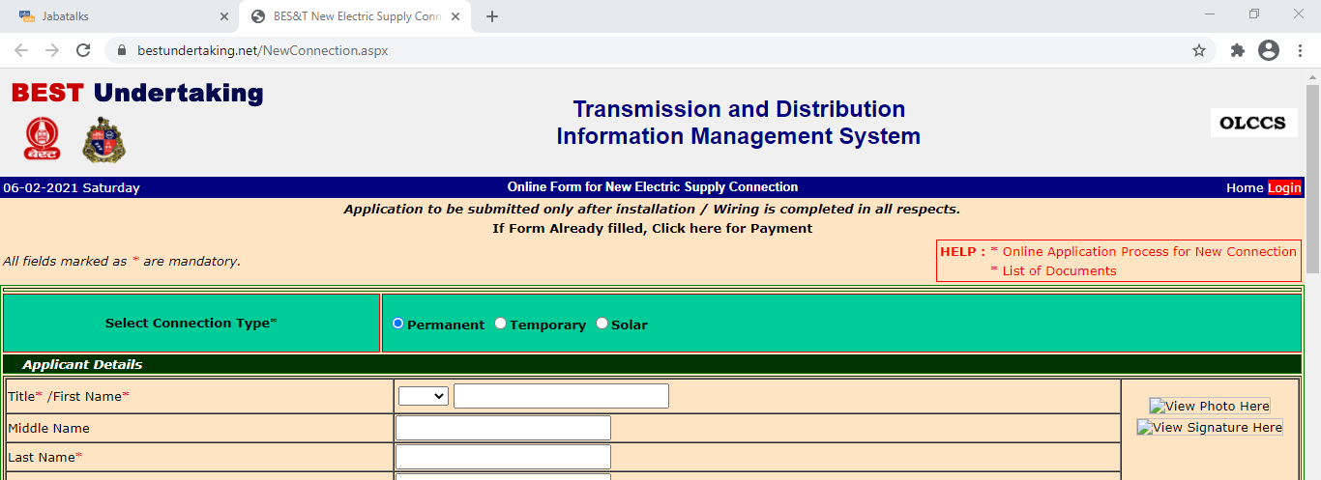

1. **PIN code, Select Area and select Road Name**

PIN code, Select Area and select Road Name is better with Text Box than a Drop Down.

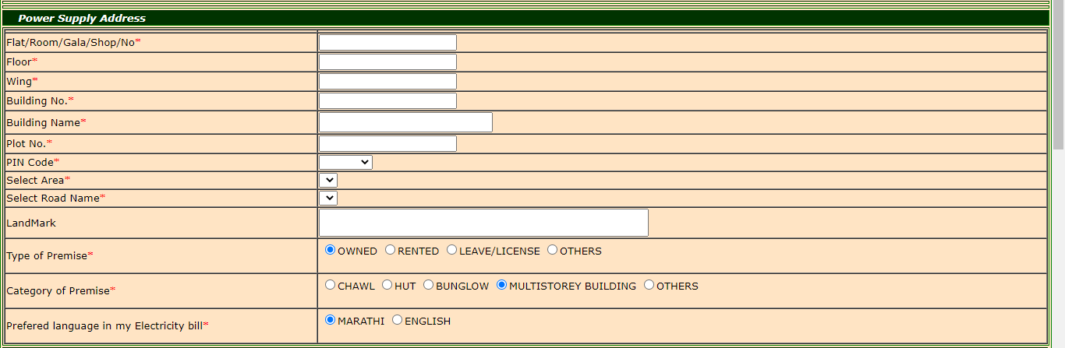

1. **Terms and conditions**

Terms and conditions would be better with a check box.

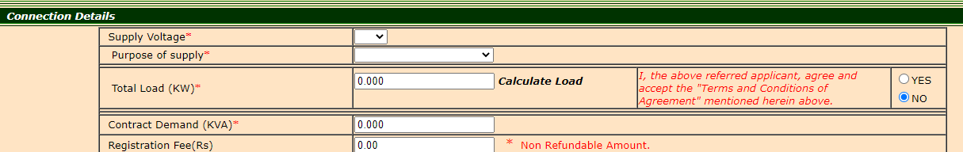

1. **OTP and accepting Conditions**

Accepting conditions here in this page and Click Submit and in the Next Page we can have the OTP Validation.

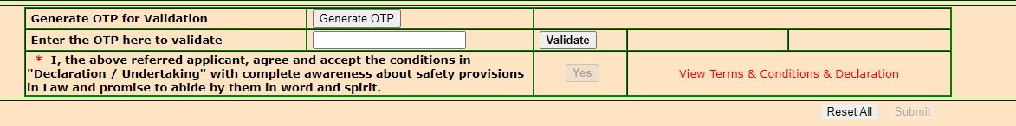

1. **Upload/Choose**

Instead of having two options Choose File and Upload, we can have any one.

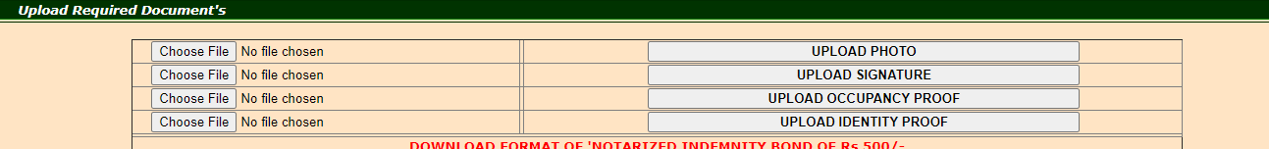

**Bugs:**

1. After Clicking Reset all, few fields are not blank

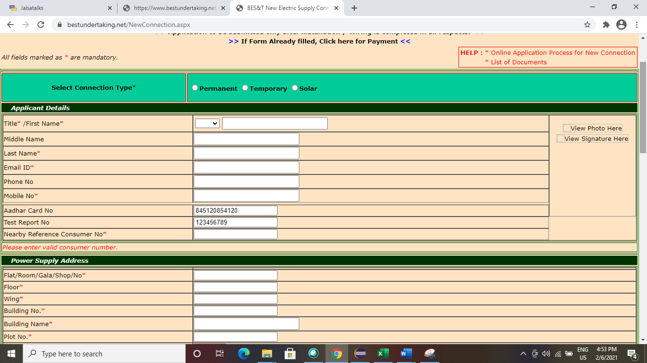

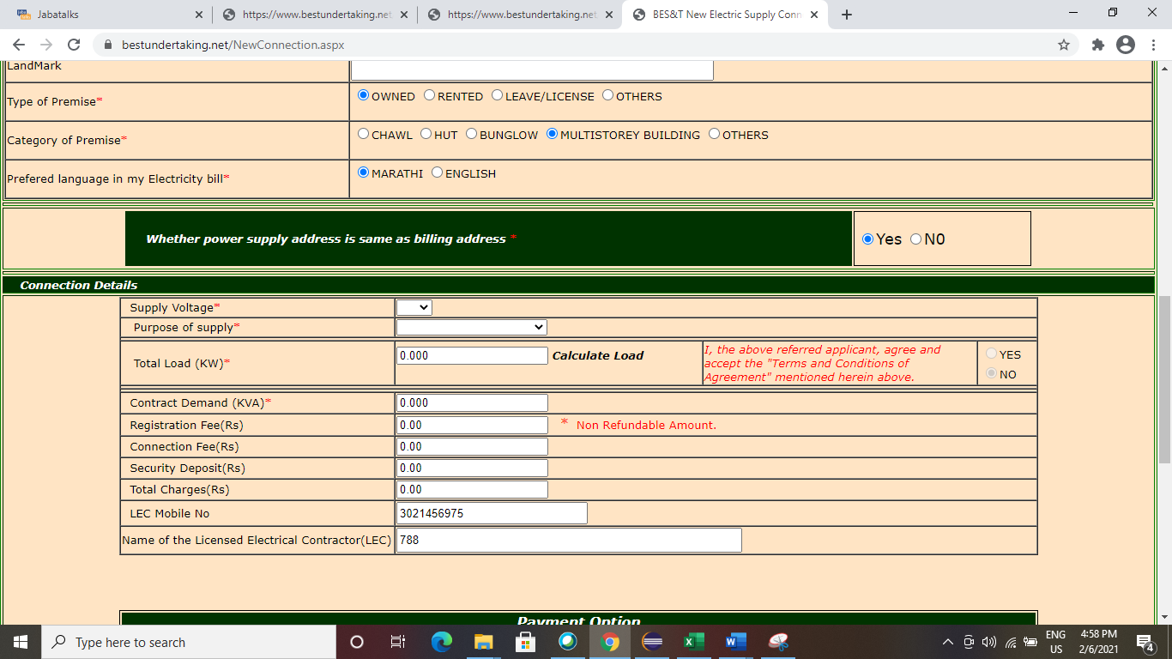

1. After selecting from Purpose of supply dropdown, the screen has shifted/Navigating Upwards

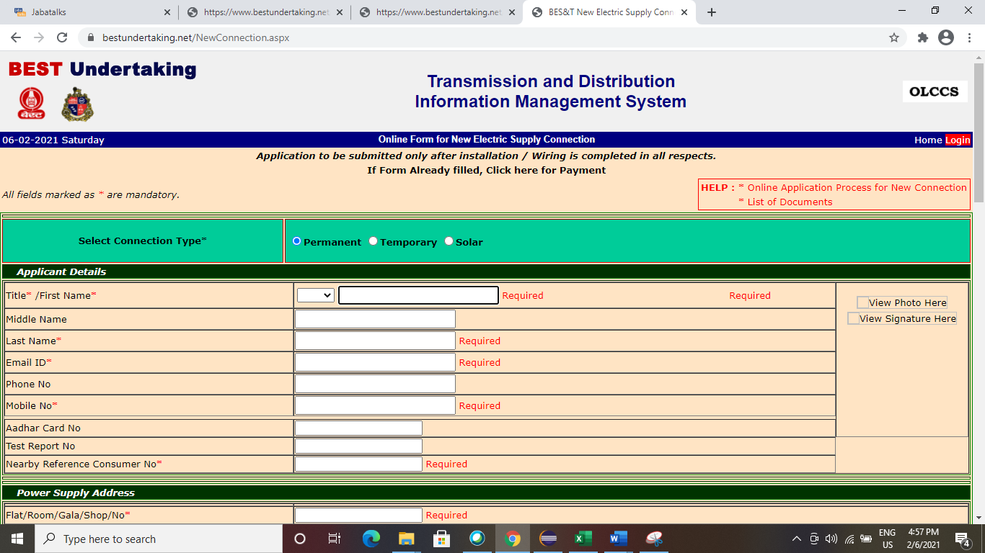

1. If an alphanumeric value is given in total load field it redirects to error page

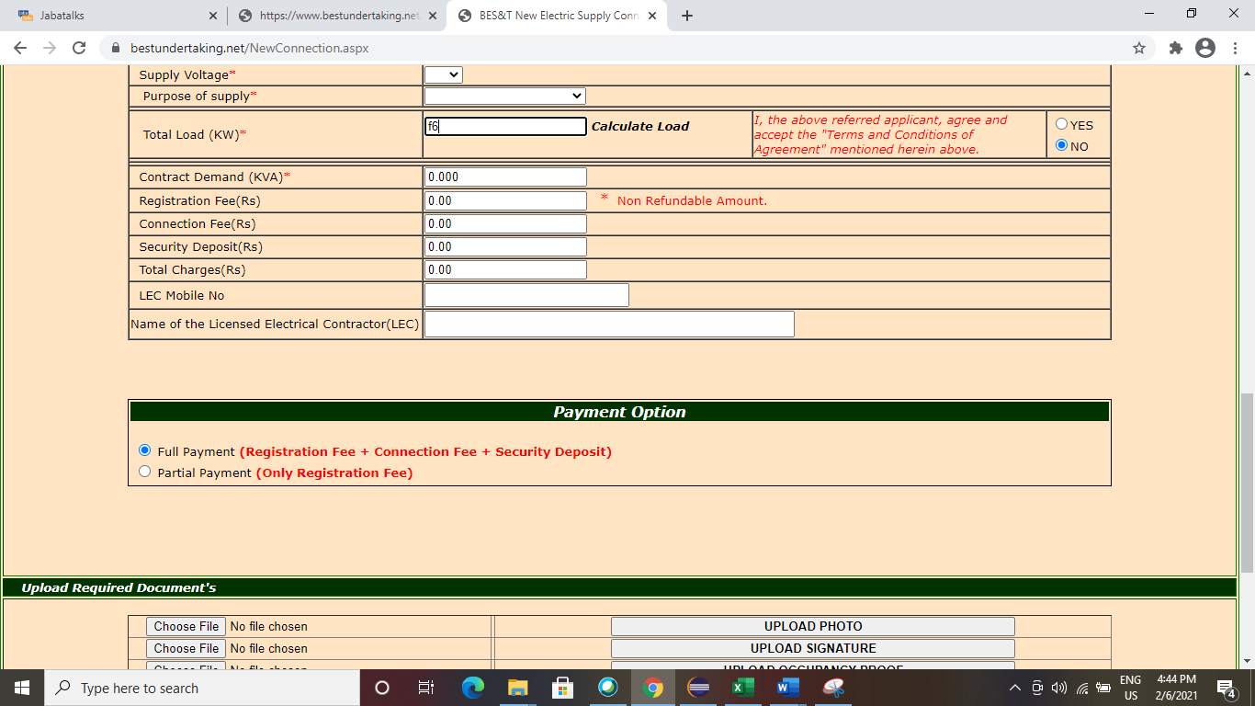

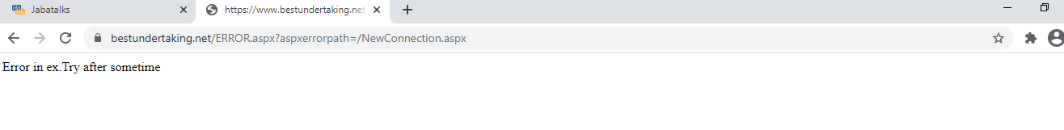

1. If we click validate button without entering OTP the Yes button is getting enabled

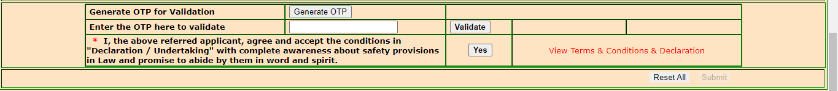

1. The validate OTP field should be mandatory field



1. When we click submit by keeping all the fields blank, Title/ First Name field is displaying Required twice

