

SCHOOL OF COMPUTING, ENGINEERING AND DIGITAL
TECHNOLOGIES
ICA REPORT
CIS4047-N-BF1 Data Science Foundations
Predicting Cancer Likelihood Using Lifestyle and Health Factors
by
Sruthi Dubba
S3544788
MODULE LEADER: Dr Ala Alkafri
Academic year:2025-2026
January 2026

Contents
1.Abstract | -----------------------------------------------------01
2.Problem overview specification | -----------------------------------------------------01
3.Introduction and background | -----------------------------------------------------01
4.Literature Review | -----------------------------------------------------02
5.Dataset overview | -----------------------------------------------------02
6.Technical implementation (developed system/model) | -----------------------------------------------------03
6.1 Data analysis and visualization | -----------------------------------------------------03
6.2 Data Science Processing | -----------------------------------------------------03
6.3 Data preparation | -----------------------------------------------------04
6.4 Machine Learning Models and Performance Evaluation | -----------------------------------------------------05
6.4.1 Logistic regression | -----------------------------------------------------05
6.4.2 Support Vector Machine (SVM) | -----------------------------------------------------06
6.4.3 Model comparison | -----------------------------------------------------06
7. Model Evaluation Metrics | -----------------------------------------------------07
8. Result | -----------------------------------------------------09
8.1 Model Performance Summary | -----------------------------------------------------09
8.2 ROC-AUC analysis | -----------------------------------------------------09
8.3 Notes | -----------------------------------------------------09
9. Discussion | -----------------------------------------------------10
10. Conclusion And Future work | -----------------------------------------------------10
11.References | -----------------------------------------------------11
12. Appendix | -----------------------------------------------------12

1.Abstract
Cancer remains one of the most significant health problems worldwide, while early diagnosis is essential for recovering patients' lives. Here we explore the use of the machine learning techniques in the prediction of cancer diagnosis with publicly available datasets that include demographic, lifestyle and biological risk factors. A complete data science pipeline was implemented, which includes data cleansing, Data exploratory analysis and data preprocessing. Two supervised classification models—logistic regression and support vector machine (SVM)—were developed and evaluated to determine the most effective predictive approach. Model performance was evaluated using accuracy, confusion matrix, and Area Under the Curve (AUC) with receiver operating characteristic (ROC) curve. The results show that the SVM model achieved slightly higher accuracy and AUC, demonstrating stronger predictive ability for this data set. In addition, logistic regression proved to be a reliable and interpretable baseline model, making it suitable for medical decision making. Overall, the findings highlight the potential of machine learning techniques to support cancer risk prediction and aid healthcare professionals in early diagnosis.

2.Problem overview specification
Cancer remains one of the leading causes of death worldwide, making early diagnosis essential to improve patient survival and enable timely medical treatment. Traditional diagnostic methods often require significant time, cost and reliance on expert clinical judgement, which can delay early intervention. With the increasing availability of health-related data, there is a growing demand for automated and data-driven solutions that can help identify cancer at an early stage.
This project focuses on developing an accurate and reliable predictive system capable of classifying individuals as cancer positive or cancer negative based on key demographic, lifestyle and biological risk factors. The data set used in this study has the variables - body mass index (BMI), genetic risk, physical activity level, smoking behaviour, alcohol consumption and cancer history, age which are often associated with the development of cancer.
The problem is formulated as a supervised binary classification task, where a machine learning model is trained using labeled data to predict clinical outcomes. The main objective is to assess and compare different classification models, with a particular focus on logistic regression and support vector machines(SVM). to select the most suitable models according to their evaluation and predictive performance criteria. The proposed approach aims to support data-driven decision-making in healthcare while maintaining model reliability and interpretability for practical clinical use.

3.Introduction and background
Cancer is one of the most important causes of death worldwide, and early detection plays an important role in improving patient survival and treatment outcomes. Traditional diagnostic techniques often involve complex medical procedures, high costs, and heavy reliance on expert clinical judgment, which can delay timely diagnosis and intervention. Therefore, we need a data-driven solution which can aid in the early assessment of cancer risk and help healthcare professionals make informed decisions.
Improvements in recent times in the machine learning had enabled us to analyze large healthcare data sets to uncover patterns related to disease incidence. Machine learning models can identify complex relationships between demographic, lifestyle and biological risk factors that are difficult to capture using traditional statistical approaches. In the healthcare sector, these models have the potential to increase screening efficiency, reduce diagnostic uncertainty and support preventive and personalized treatment strategies.
This project uses supervised machine learning techniques to predict cancer diagnosis using publicly available data sets that include important risk factors such as age, body mass index (BMI), smoking behavior, genetic risk, physical activity level, alcohol consumption and cancer history. These properties are often associated with cancer development and provide a strong basis for predictive modelling. The problem is formulated as a binary classification task, where individuals are classified as cancer-positive or cancer-negative. To evaluate the predictive performance, Logistic regression and support vector machine (SVM) were implemented as the two classification models and compared in a structured manner.
4.Literature Review
Cruz Wishart 2006 showed that ML techniques are capable to identify complex and the non linear relationships in medical data that conventional clinical tools often miss.
Kourou et al. (2015) revealed that machine learning models including SVM and logistic regression achieve better cancer prediction accuracy than conventional statistical approaches.
Shruti et al. (2022) stated that machine learning models can accurately predict various types of cancer, proving that ML algorithms are able to handle diverse clinical datasets and capture complex risk factor interactions.
Logistic regression has been widely used in medical research due to its simplicity, interpretation and ability to provide probabilistic outputs, making it suitable for clinical decision making (Hosmer and Lemeshow, 2000).
Support vector machines (SVMs) have shown strong performance in cancer prediction tasks by constructing optimal decision boundaries and efficiently handling high-dimensional and non-linear data through kernel functions (Wapnik, 1998).
K-Nearest Neighbors (KNN) is a commonly used example-based learning algorithm that classifies data points based on similarity measures and shows competitive results in cancer classification when appropriate feature scaling is used (Cover and Hart, 1967).

5.Dataset overview
The dataset is a publicly available cancer prediction dataset obtained from Kaggle, designed to support machine learning-based cancer risk analysis.
It contains approximately 1500 instances and 9 attributes, including both a predictor variable and a binary target variable.
Input features represent demographic, lifestyle, and biological risk factors, as age, bodymassindex (BMI), smoking_behavior, genetic risk, physical activity, alcohol consumption, and cancer history.
The target variable, diagnosis, is a binary label where 0 indicates non-cancer and 1 indicates cancer, making the dataset suitable for supervised binary classification.
The dataset meets the minimum requirements for a machine learning experiment with sufficient size, labeled results, and clinically relevant features.

6.Technical implementation (developed system/model)

This section outlines the overall technical framework and implementation of the data science workflow implemented in this project. It covers the key stages of analysis, they are data preprocessing, data exploratory analysis and data preparation finally, machine learning model development.

6.1 Data analysis and visualization
Exploratory data analysis (EDA) was performed to understand the feature distributions and their relationship to the target variables.
Histograms were used for continuous variables (age, BMI, physical activity, alcohol intake) to analyze data spread and heterogeneity.
Bar charts for categorical variables (sex, smoking, genetic risk, cancer history) were used to compare class distributions in cancer and non-cancer cases.

Visualizations were created using ggplot2 and arranged using GridXtra for comparative analysis.
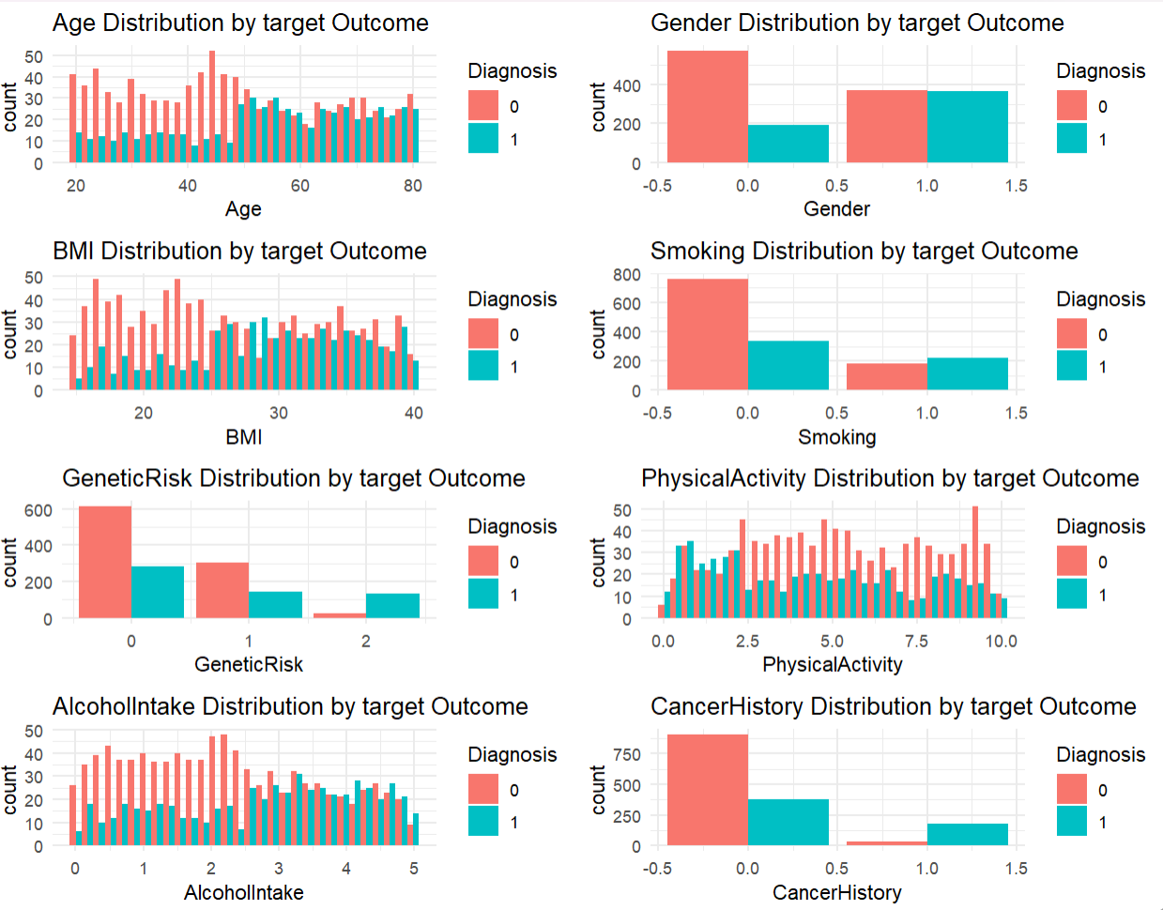

6.2 Data Science Processing
1.The dataset was collected from Kaggle and loaded into R using the read_csv() function.
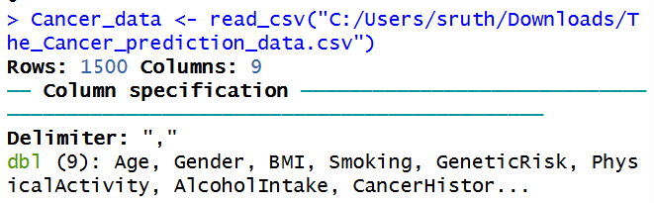
2.Initial inspection of the dataset was performed using head(), str(), and summary() to understand data types, feature ranges, and overall structure.
3.Missing values were identified using colSums(is.na()). But dataset has no missing values
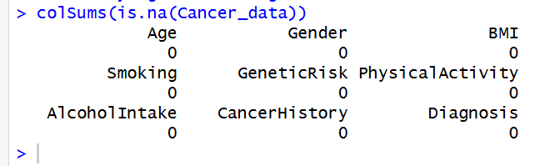
4.Numerical features (Age, BMI, PhysicalActivity, AlcoholIntake) were imputed using mean imputation, while categorical variables (Gender, Smoking, GeneticRisk, CancerHistory) were imputed using mode imputation.
5.Duplicate records were removed to ensure data consistency.
6.A new feature, Risk_level, was engineered based on medical risk factors such as BMI, smoking behaviour, genetic risk, physical activity, and cancer history.

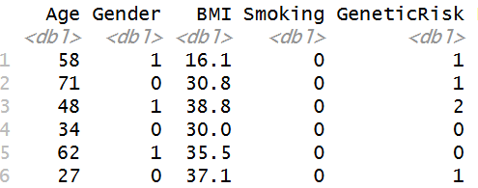
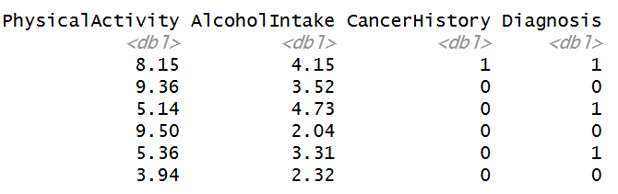
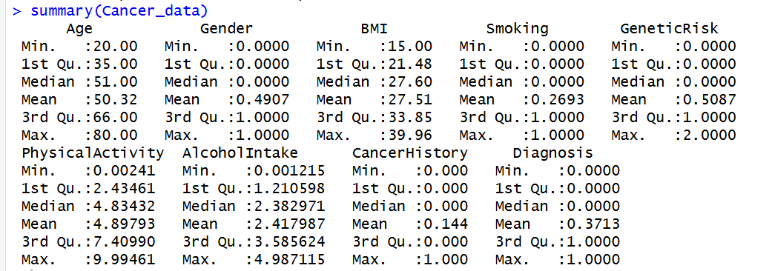
Figure 1: Initial dataset prior to preprocessing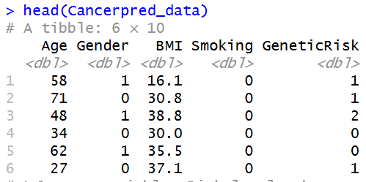
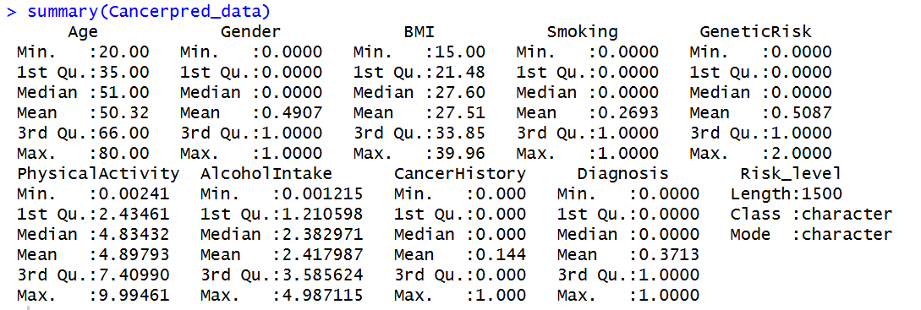
Figure 1: Cleaned and preprocessed dataset

6.3 Data preparation
The cleaned data set was divided into training and testing subsets using an 80:20 ratio, with stratified sampling used to maintain the original class distribution. To ensure that all variables contribute equally during model training, numerical functions were standardized through centering and scaling. This step was particularly important to improve model stability and overall performance. These pre-processing steps ensured that the dataset was well prepared for supervised machine learning and enabled an unbiased and unbiased evaluation of the models.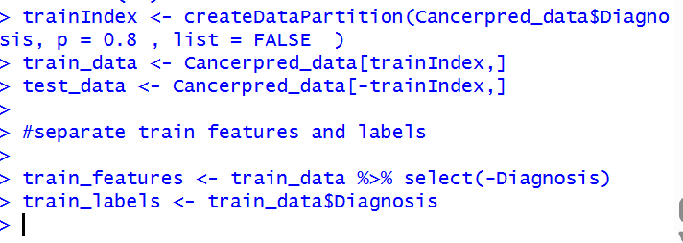
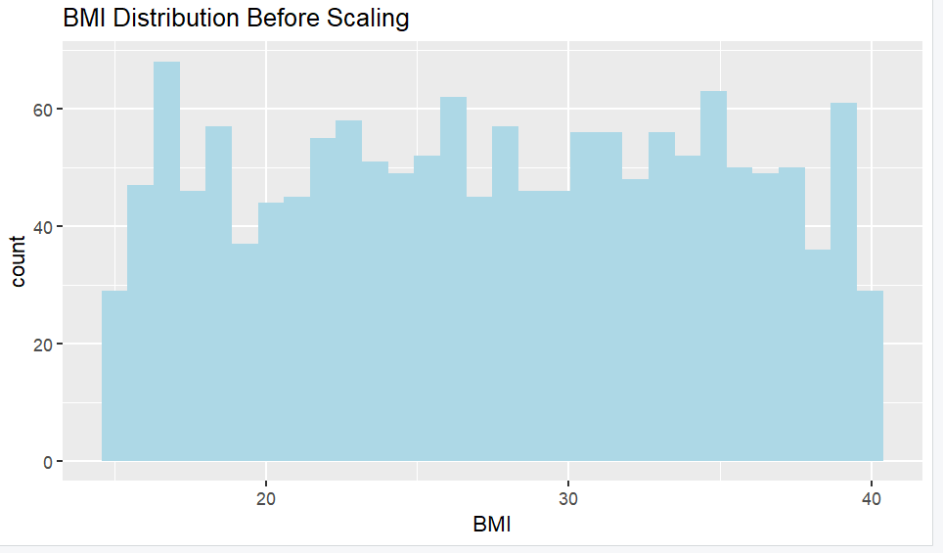
Figure 3: BMI distribution before scaling data
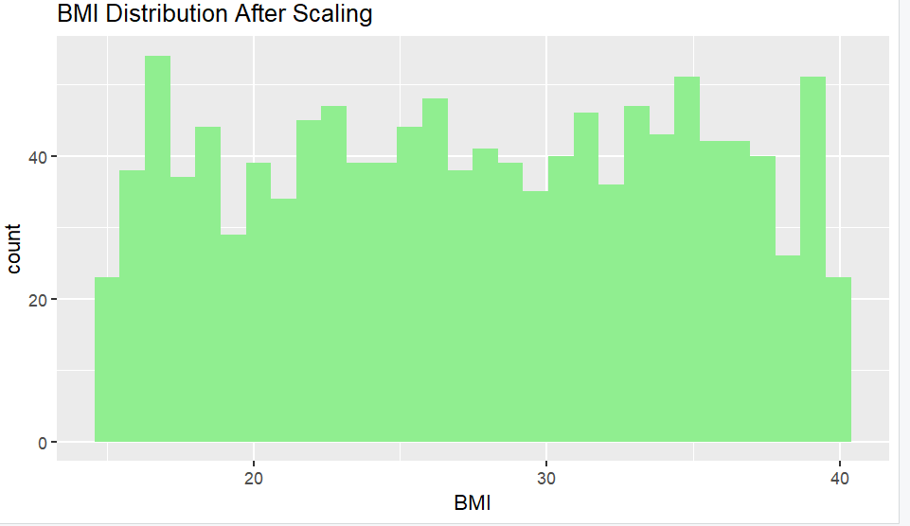
Figure 3: BMI distribution After scaling data

6.4 Machine Learning Models and Performance Evaluation
This section presents the implementation, evaluation and comparison of three supervised machine learning models – logistic regression and support vector machine (SVM)). Each model is explained in terms of selection logic, training process and performance evaluation using confusion matrix and ROC-AUC analysis.

6.4.1 Logistic regression
Logistic regression was chosen as the primary classification model because of its widespread use in medical research and its high degree of interpretability. In healthcare, it is important to understand how individual input variables affect predictions, and logistic regression provides clear probabilistic outputs that can be easily interpreted by doctors. The model estimates the probability of cancer diagnosis by applying a sigmoid function to the linear combination of input functions.
In this study, the logistic regression model was trained using the preprocessed training dataset and evaluated on the test dataset. The resulting confusion matrix shows a large number of correctly classified cancer-positive and cancer-negative cases, indicating strong predictive performance. This is particularly important in medical diagnosis, where it is important to minimize false negative predictions, as missed cases of cancer can have serious health consequences.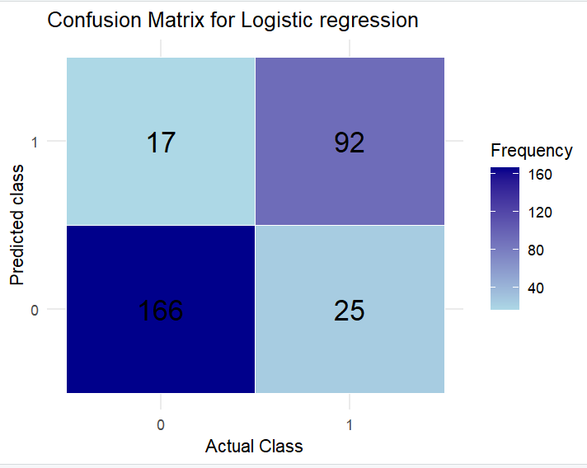
The ROC curve shows a strong separation between the two classes, and the AUC value is ~ 0.93–0.94 indicates excellent discrimination ability. This suggests that logistic regression effectively captures the relationship between lifestyle and biological risk factors and cancer diagnosis. Due to the balance between accuracy, robustness and interpretability, logistic regression was identified as the most appropriate model for this data set.
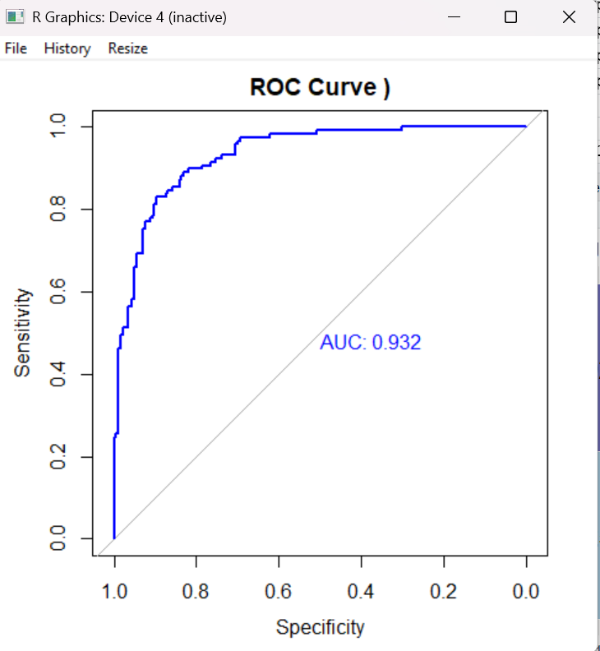

6.4.2 Support Vector Machine (SVM)
This model was used in this study to assess its ability to capture the complex and potentially non-linear relationships between cancer risk factors and clinical outcomes. SVM is a margin-based and supervised algorithm that works by identifying an optimal decision boundary that maximizes the separation between different classes. By using kernel features, By projecting non-linear data into a higher-dimensional feature space, SVM enables efficient discrimination between classes.
In this project, the SVM model was scaled into the training dataset to ensure stable optimization and accurate distance-based calculations. Feature scaling was an important preprocessing step, because SVM performance is very sensitive to variations in feature size. The test dataset has used to measure predictive performance of the Trained model
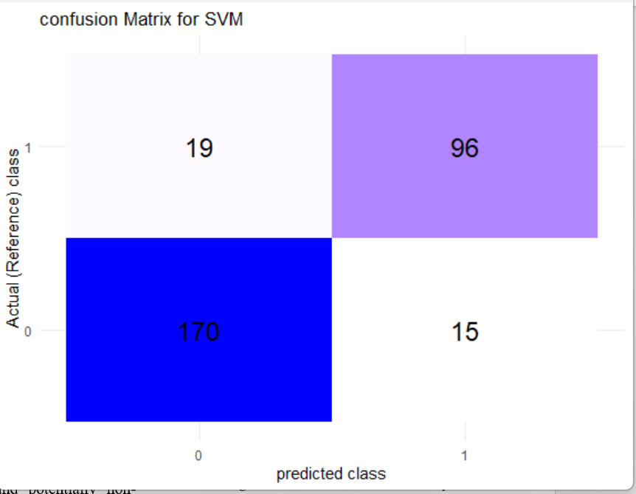
The resulting confusion matrix shows that the SVM model correctly classified a high proportion of both cancer-positive and cancer-negative cases, with relatively low misclassifications. It shows strong classification ability and balanced sensitivity across all classes. In addition, the ROC curve confirms the effectiveness of the model, achieving an area under the curve (AUC) value of approximately 0.937, indicating excellent discriminatory power. 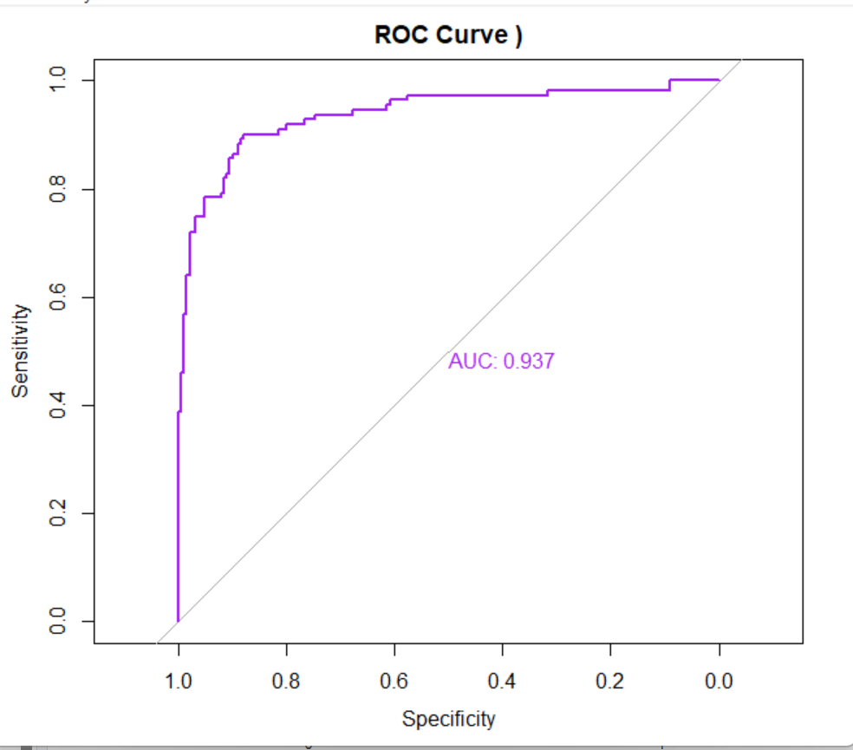

6.4.3 Model comparison
To evaluate the performance of the predictive model, logistic regression and support vector machine (SVM) were tested on the same hold-out dataset using several evaluation metrics. These metrics include classification accuracy, AUC-ROC and , confusion matrix allowing an objective and consistent comparison of model performance.
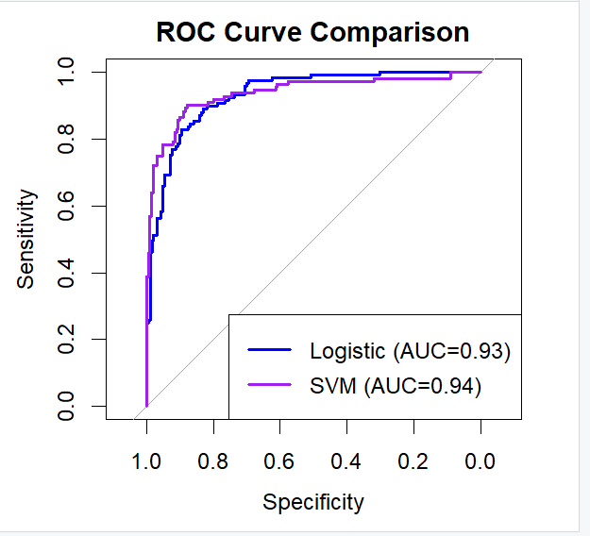
Table 1 summarizes key performance indicators for both models.
Model | Accuracy | AUC (ROC)
Logistic Regression | 0.86 | 0.932
SVM (RBF kernel) | 0.887 | 0.937
Observations:
High predictive accuracy:
a.Both models achieved strong overall accuracy, demonstrating their effectiveness in correctly classifying cancer-positive and cancer-negative cases.
b.SVM shows slightly higher accuracy (88.7% vs. 86%), highlighting its strength in capturing complex patterns in the dataset.
Excellent discrimination ability
a.Both models show high AUC values (logistic regression: 0.932, SVM: 0.937), indicating excellent ability to discriminate between cancer-positive and cancer-negative individuals.
b.This confirms that both models reliably rank patients according to cancer risk.
Interpretability and clinical relevance
a.Logistic regression provides clear insight into the contribution of individual risk factors, as BMI, genetic risk, physical activity, alcohol consumption, age, and cancer history and smoking behaviour
b.SVM effectively models the complex, potentially non-linear relationships between risk factors, and serves as a robust benchmark for predictive performance.
Conclusion:
Both logistic regression and SVM show excellent predictive performance for cancer diagnosis. Logistic regression combines strong predictive power with interpretability, making it highly suitable for clinical applications. Although SVM is slightly more accurate, it serves as a comparative benchmark to evaluate the merits of modeling non-linear relationships in the data. Together, these models highlight the effectiveness of machine learning methods in early prediction of cancer risk.

7. Model Evaluation Metrics
Accuracy:
Accuracy is a widely used metric for evaluating classification models. It represents the percentage of cases correctly predicted, including both cancer-positive and cancer-negative cases, out of all observations. This calculation gives a direct overview of how well the model makes correct predictions overall.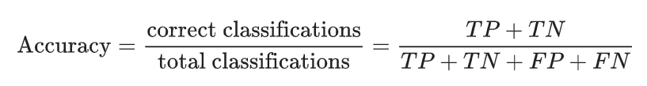
Where:
ROC Curve and Area Under the Curve
The Receiver Operating Characteristic (ROC) curve is a graphical method used to assess how well a classification model performs in distinguishing between different outcome classes. It displays the relationship between the true positive rate (sensitivity) and the false positive rate (1 − specificity) across a range of prediction thresholds.The Area Under the Curve (AUC) condenses the information from the ROC curve into as a single value between 0 and 1, here value 1 indicates correct Prediction and 0.5 reflects no discriminative ability beyond random chance.. In general, higher AUC values indicates the model is good in Predicting cancer-positive and cancer-negative cases.
- Logistic regression -ROC and AUC
The ROC curve for the logistic regression model demonstrates clear separation between cancer and non-cancer classes. The obtained AUC value of 0.932 indicates excellent discriminative performance, showing that the model can effectively rank individuals based on their likelihood of having cancer using the available risk factors. This highlights its usefulness as a reliable tool for early cancer risk assessment.
- SVM ROC and AUC
The SVM model exhibits an even stronger ROC curve, indicating slightly improved class separation compared to logistic regression. With an AUC value of 0.937, the SVM demonstrates superior overall discrimination ability. This marginal improvement suggests that SVM is better at capturing complex and potentially non-linear patterns of the dataset, which leads to enhance prediction performance.
Precision
Precision, also known as positive predictive value, measures the proportion of correctly identified cancer-positive cases among all cases predicted positively. This metric is particularly important in medical diagnosis, as it shows how correct the model positive predictions and also it reduce the risk of false alarms.
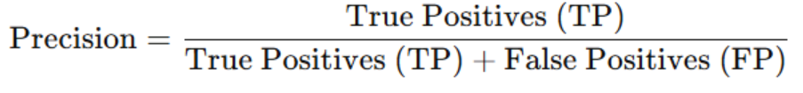
- Logistic Regression
Predicted \ Actual | 0 (Non-Cancer) | 1 (Cancer)
0 | 17 | 92
1 | 166 | 25

Precision=25/25+166​≈0.131

SVM :
Using the confusion matrix:
Predicted \ Actual | 0 (Non-Cancer) | 1 (Cancer)
0 | 19 | 96
1 | 170 | 15

Precision= 15/15+170 ≈0.081
Conclusion:
In this data set, logistic regression shows slightly higher accuracy than the SVM model, indicating that when it predicts the presence of cancer, the predictions are often correct. Precision is particularly important in medical settings, as it helps reduce false positives and reduces the potential for unnecessary follow-up tests or patient anxiety. When considered together with accuracy and AUC, accuracy provides complete evaluation of model effectiveness complementing sensitivity measures and ROC-based analysis

8. Result
ML models Support Vector Machine (SVM) and Logistic Regression had evaluated with the test data set using several metrics including accuracy, confusion matrix, ROC-AUC and precision. The results show the predictive ability of each model and provide insight into their effectiveness for cancer diagnosis.

8.1 Model Performance Summary
Both models achieved high accuracy and AUC, indicating strong overall predictive performance.
Logistic regression showed high accuracy, meaning it produced more correct positive predictions relative to the total number of positive predictions.
SVM achieved slightly higher accuracy and AUC, it shows that in the dataset it can Able to identify complex and non-linear patterns.

8.2 ROC-AUC analysis
Both models showed excellent discrimination between cancer-positive and cancer-negative cases (AUC > 0.93).
ROC curves demonstrate the ability of both models to rank patients according to cancer risk, confirming their suitability for early detection tasks.

8.3 Notes
Logistic regression provides a balance between predictive performance and interpretability, making it suitable for clinical decision making.
SVM acts as a stronger benchmark with slightly higher accuracy and AUC, effectively modeling complex patterns in the data.
Accurate analysis shows that logistic regression is more reliable in predicting positive cancer cases, which is important to reduce unnecessary interventions.
Conclusions: Both models show strong performance in predicting cancer risk. Logistic regression has been highlighted as the most suitable model for clinical applications due to its interpretability and reliable positive predictions, while SVM provides a strong comparative benchmark demonstrating the value of non-linear modeling methods.

9. Discussion
The outcomes states the ML models can effectively predict cancer risk based on demographic, lifestyle and biological factors. Both logistic regression and support vector machines (SVM) achieved strong predictive performance, indicating the robustness of these approaches in healthcare.
Main findings:
1.High predictive accuracy and discrimination
2.Both models achieved high accuracy and AUC values, with SVM slightly better than logistic regression in overall accuracy (88.7% vs 86%) and AUC (0.937 vs 0.932).
3.These results indicate that the models can reliably distinguish between cancer-positive and cancer-negative individuals, and support their use in early detection scenarios.
Accuracy and positive predictions
1.Logistic regression showed higher precision than SVM, meaning that positive predictions from logistic regression are more likely to be correct.
2.In a medical context, this is particularly important, as accurate identification of cancer-positive cases helps to reduce unnecessary interventions, testing and patient anxiety.
Interpretability and clinical relevance
Logistic regression provides clear information on how individual risk factors (eg, BMI, smoking, genetic risk) contribute to cancer prediction, increasing suitability for clinical decision-making.

Although SVM is slightly more accurate, it serves as a strong benchmark, showing the potential benefits of modeling non-linear relationships in complex datasets.
Implication
The study shows that machine learning can be used as a decision support tool in healthcare, helping doctors identify high-risk patients.
Models such as logistic regression can be particularly valuable in scenarios where interpretability and reliability of positive predictions are important, while SVM provides complementary insight into complex, non-linear patterns in the data.
Limitations
Although both models perform well on this dataset, performance may vary with larger, more varied datasets.
Further work may include integrating additional clinical features or exploring ensemble methods to increase prediction accuracy and robustness.

10. Conclusion And Future work
Project demonstrated the effectiveness of machine learning techniques to predict cancer diagnosis using demographic, lifestyle and biological risk factors. A complete data science workflow was implemented, that includes data preprocessing, data exploratory analysis along with supervised models development. Logistic regression and SVM models were trained and evaluated to assess their predictive performance.
Experimental results showed that both models achieved strong performance with high accuracy and excellent ROC-AUC values, indicating reliable discrimination between cancer-positive and cancer-negative cases. The SVM model achieved slightly higher accuracy and AUC, demonstrating Able to identify complex and non-linear patterns within the data However, logistic regression showed higher precision and offered greater interpretability, which is particularly important in healthcare where transparency and interpretability are important.
Overall, logistic regression was identified as the most appropriate model for clinical decision support due to its balanced performance, simplicity and interpretability. The SVM model acted as a robust benchmark, by stating the advantages of advanced ML methods in handling complex data patterns. and have significant potential to assist healthcare professionals in data-driven decision-making.
Future work may include evaluating additional machine learning models, incorporating more clinical features, and validating models on larger and more diverse data sets to further improve robustness and generalization.

11.References
Kumari, M. and Singh, V. (2018) “Breast Cancer Prediction system,” Procedia Computer Science, 132, pp. 371–376. Available at: https://doi.org/10.1016/j.procs.2018.05.197.
Kourou, K. et al. (2015) “Machine learning applications in cancer prognosis and prediction,” Computational and Structural Biotechnology Journal, 13, pp. 8–17. Available at: https://doi.org/10.1016/j.csbj.2014.11.005.
Cruz, J.A. and Wishart, D.S. (2006) “Applications of Machine Learning in Cancer Prediction and Prognosis,” Cancer Informatics, 2, p. 117693510600200. Available at: https://doi.org/10.1177/117693510600200030.
Kadir, T. and Gleeson, F. (2018) “ cancer prediction using machine learning and advanced imaging techniques,” Translational Lung Cancer Research, 7(3), pp. 304–312. Available at: https://doi.org/10.21037/tlcr.2018.05.15.

12. Appendix

