**Chatbot Lab Report -**

# Overall Design

The Chatbot project is designed to facilitate user interaction through a simple web interface. The architecture follows the MVC (Model-View-Controller) design pattern dividing structure into repository, service and servlet modules. The application uses JSP for the front-end, Hibernate for data management, and MySQL as the database.

# JSP Components

The JSP components include the main interface for user interaction, which allows users to submit queries and view the chatbot's responses. The key JSP file, 'chatbot.jsp', contains a form for input and a section to display chat history. JSTL tags are utilized for iterating over conversations stored in the database.

# Chatbot Logic

The chatbot logic is implemented in the ChatServlet. It processes user queries and generates appropriate responses. The HibernateUtil class serves as a utility for managing Hibernate's SessionFactory, which is essential for interacting with the database in a Hibernate application. The Conversation class is an entity class represents a record of a conversation between the user and the chatbot. The ConversationDAO class is a Data Access Object (DAO) in your Hibernate-based application that manages the persistence and retrieval of Conversation entities in the database. The ChatServlet class is a Java servlet that acts as the controller for your chatbot application. It handles HTTP requests and responses, processes user input, and manages interactions with the underlying services and data.

# Database Schema

The database schema consists of a single table named 'conversations'. The schema is as follows:

* id (INT, AUTO_INCREMENT, PRIMARY KEY): Unique identifier for each conversation.
* user_query (VARCHAR(255)): Stores the user's query or question.
* chatbot_response (VARCHAR(255)): Stores the chatbot's response to the user's query.
* timestamp (TIMESTAMP, DEFAULT CURRENT_TIMESTAMP): Records the date and time of the conversation.

# Functionality

The application allows users to submit queries through a web interface. Upon submission, the query is processed by the servlet, which simulates a response and saves the conversation in the database. Users can view their chat history, which is retrieved from the database and displayed on the interface.

**Chatbot Output –**

Initial page –

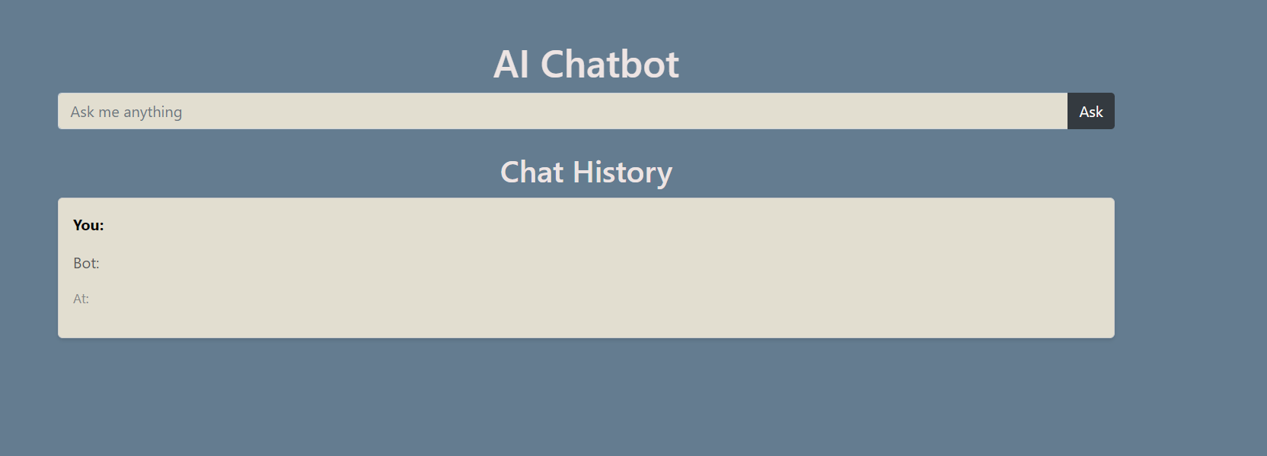

Response –

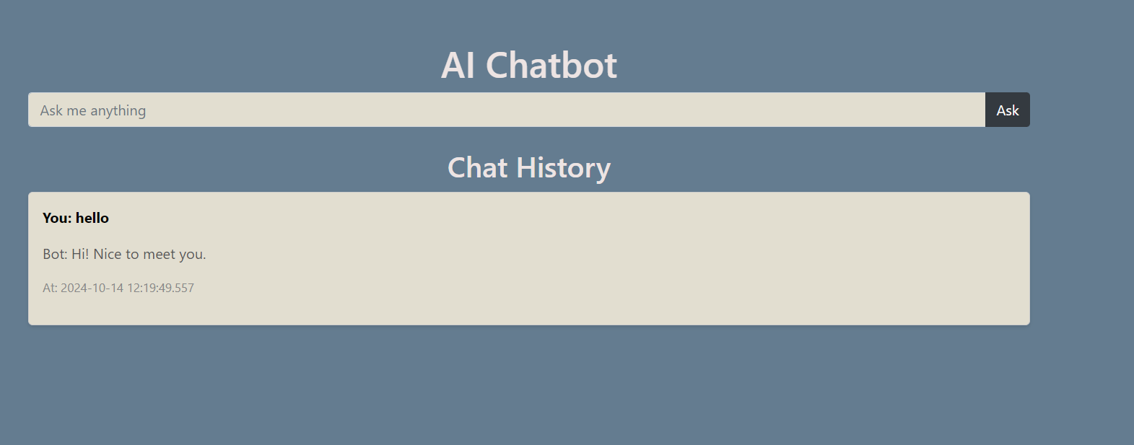  
Response stored in database -

