WEEK-5 ASSIGNMENT
Dataset Used – sample-superstoredataset
This assignment was implemented using the Sample Superstore dataset that was provided and used in the previous assignment.
Some questions in this assignment required columns that were not present in the original Superstore dataset. To answer those questions, additional columns were created from existing data or generated for demonstration purposes.
The following columns were added:
- user_id → derived from Customer ID
- transaction_date → derived from Order Date
- product_category → derived from Category
- sale_amount → derived from Sales
- price → derived from Sales
- status → created for null value handling examples
- age → generated sample values for filtering operations
- subscription → generated sample values (Basic/Premium)
- email → generated from Customer Name
- username → generated from Customer Name
- raw_timestamp → derived from Order Date
- event_time → created by casting raw_timestamp to TimestampType
- store_id → derived from Region
These additional columns were created only to satisfy the assignment requirements. The original Superstore dataset was not modified permanently; all transformations were performed within the PySpark DataFrame during execution.

Q1: What are the key limitations of traditional MapReduce that make Spark a preferred choice for modern big data processing?
- Before Apache Spark, Hadoop MapReduce was the most popular framework for processing large datasets.
Key Limitations of traditional MapReduce:
1.Disk-Based Processing:
- Intermediate results are written to disk after each stage, increasing execution time.
2.Slow Performance:
- Frequent disk Input/Output operations make mapreduce slower, especially for large datasets.
3.Not suitable for iterative Processing:
- MapReduce reloads data from disk in every iteration. The algorithms used for the mapreduce requires multiple iterations so it reloads data from disk in every iteration.
4.Complex Programming model:
- We need to write separate map and reduce functions that makes code lengthy and complex.
5.Limited APIs:
- It mainly supports batch processing and lacks built in libraries for SQL, machine learning and streaming.
To overcome these limitations, Spark is preferred:
- It performs in-memory computation, reducing disk I/O.
- Supports batch processing, streaming, machine learning, graph.
- Executes applications ,much faster than mapreduce.
- Provides high-level APIs in python, Scala, Java and R.
- Easier to write and maintain applications.
Q2: Explain how Spark uses In-Memory Computing to speed up iterative machine learning algorithms compared to disk-based systems.
- Apache spark uses In-Memory computing, which means it stores intermediate data in RAM instead of writing it to the disk after every processing stage. Since accessing data from memory is much faster than reading from and writing to the disk, Spark significantly improves processing speed.
- In iterative machine learning algorithms, the same dataset is processed multiple times to train the model, In traditional disk-based systems like Hadoop MapReduce, the data is read from disk and written back to disk during every iteration, which increases execution time due to frequent disk I/O operations.
- Spark overcomes this limitation by keeping intermediate results in memory across iterations. This minimizes disk access, reduces latency, and speeds up computations. As a result, Spark is highly efficient for machine learning, graph processing, and other iterative workloads.

Q3: Write a code snippet to remove all duplicate rows from a DataFrame based on a specific set of columns: user_id and transaction_date.
- df_clean = df.dropDuplicates(["user_id", "transaction_date"])
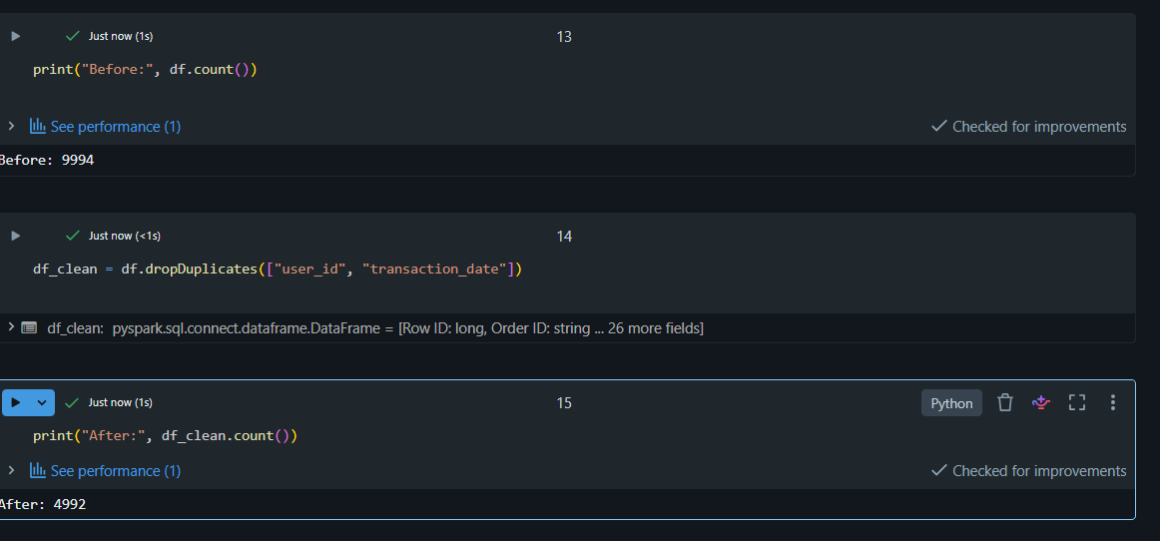
Q4: Given a DataFrame df_sales, write a query to filter for rows where the region is 'West' and then group by product_category to find the average sale_amount.
The Superstore dataset uses Category instead of product_category and Sales instead of sale_amount, so those columns were used in the implementation.
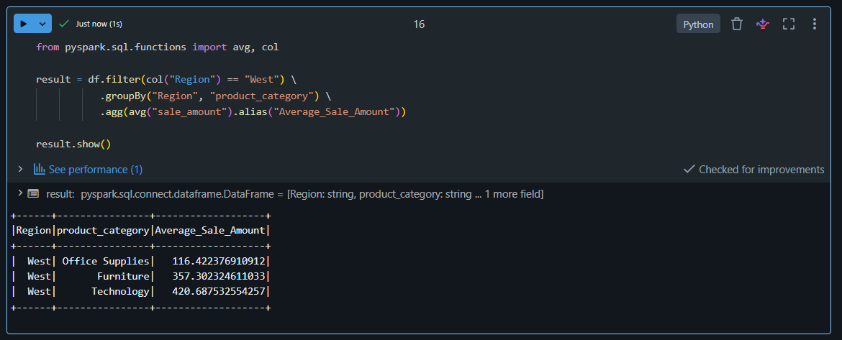
Q5: What is the difference between .na.drop() and .na.fill()? Provide a code example of filling null values in a status column with the string 'Unknown'.
.na.drop():Removes rows that contain null values.
.na.fill():Replaces null values with a specified value without deleting the rows.
Before filling, the status column contained 5191 null values. After replacing them with "Unknown", the null count became 0.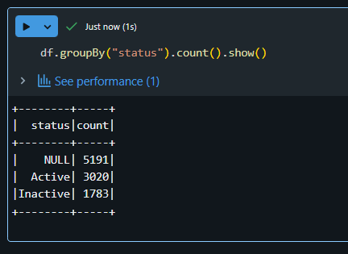
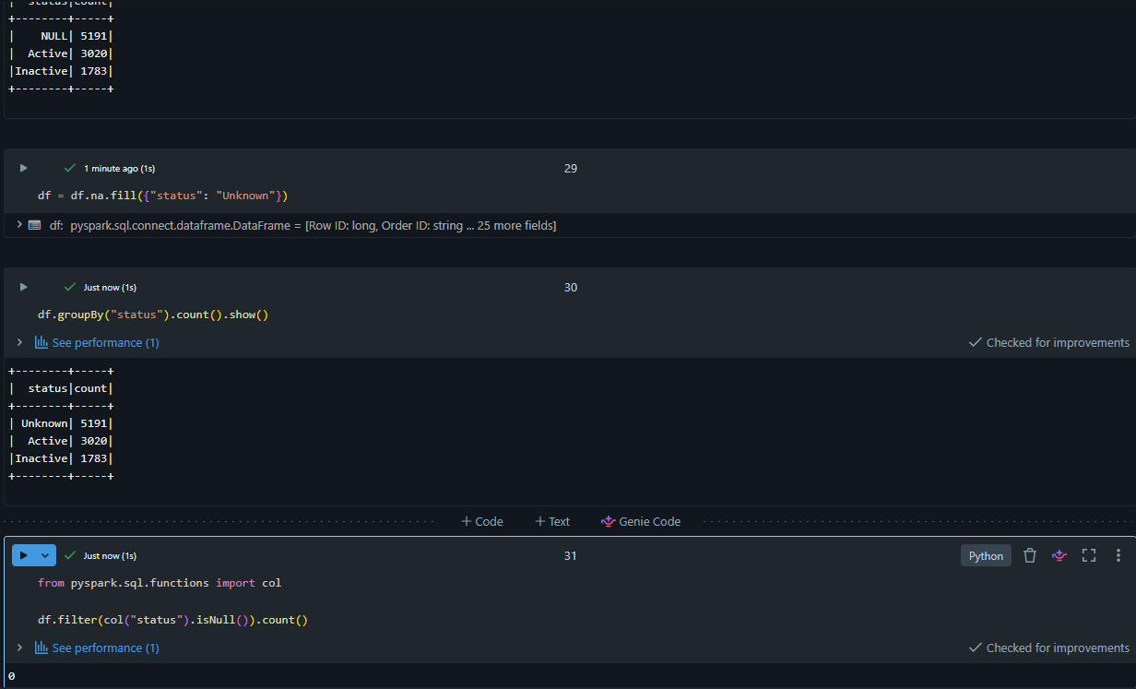
Q6: Write a query to find the total count of records for each city in a DataFrame, but only for cities where the count is greater than 100.
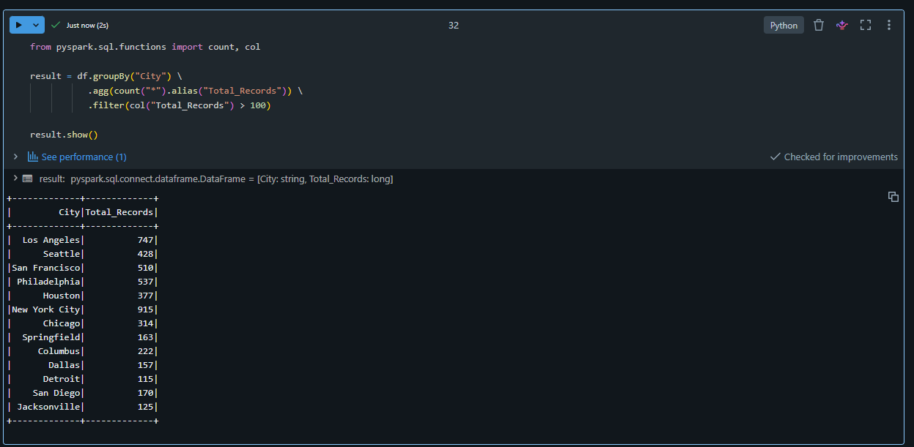
Q7: How does the immutability of Spark DataFrames affect how you perform "data cleaning" steps like dropping columns or renaming them?
- Spark DataFrames are immutable, which means they cannot be modified after they are created. Any data cleaning operation, such as dropping columns, renaming columns, or updating values, does not change the original DataFrame. Instead, Spark creates a new DataFrame containing the requested changes, while the original DataFrame remains unchanged.
This approach provides several benefits:
- Preserves the original data.
- Enables fault tolerance and easier recovery.
- Allows Spark to optimize execution through its query optimizer (Catalyst Optimizer).
Ex like:
df_new = df.drop("Discount")
df_new = df.withColumnRenamed("Sales", "sale_amount") Explanation
- drop() creates a new DataFrame without the specified column.
- withColumnRenamed() creates a new DataFrame with the updated column name.
- The original df remains unchanged unless you explicitly assign the result back to df.
Q8: Write a Spark command to filter a dataset for rows where the age is between 18 and 30 (inclusive) and the subscription is 'Premium'.
The original Superstore dataset did not contain age and subscription columns. These columns were created for demonstration purposes to implement the required filter.
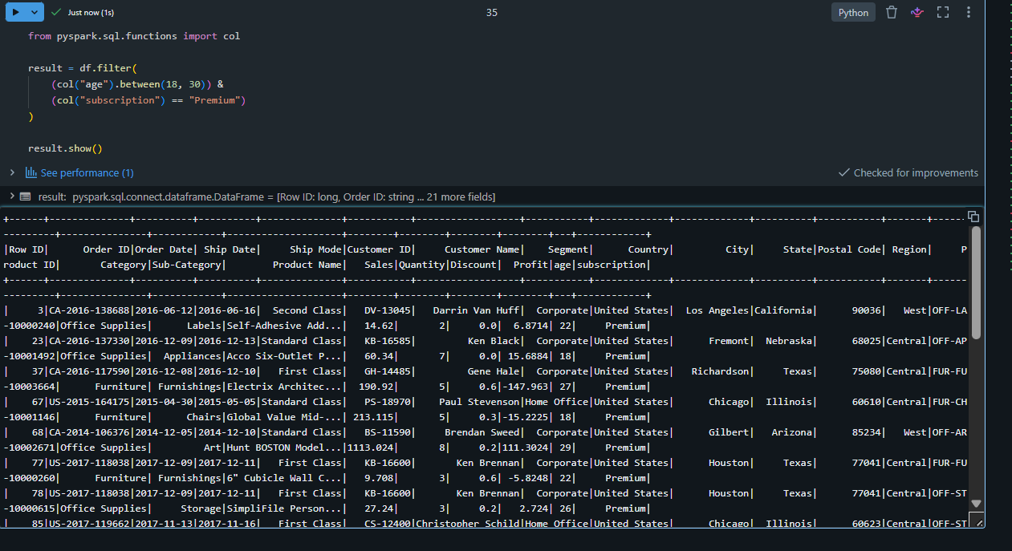
Q9: When cleaning a dataset, why is it often better to handle null values before performing mathematical aggregations like sum() or avg()?
- It is better to handle null values before performing mathematical aggregations because null values can lead to inaccurate or misleading results. Replacing or removing null values ensures that functions like sum(), avg(), min(), and max() produce meaningful and reliable results. Proper handling of null values also improves data quality and prevents errors during analysis.
- Ex:
df = df.na.fill({"price": 0})
from pyspark.sql.functions import avg
df.select(avg("price").alias("Average_Price")).show()
Q10: Write the code to revise a column named raw_timestamp by casting it to a TimestampType and renaming it to event_time.
The original dataset did not contain a raw_timestamp column, so it was created from the Order Date column before being cast to TimestampType and renamed to event_time.
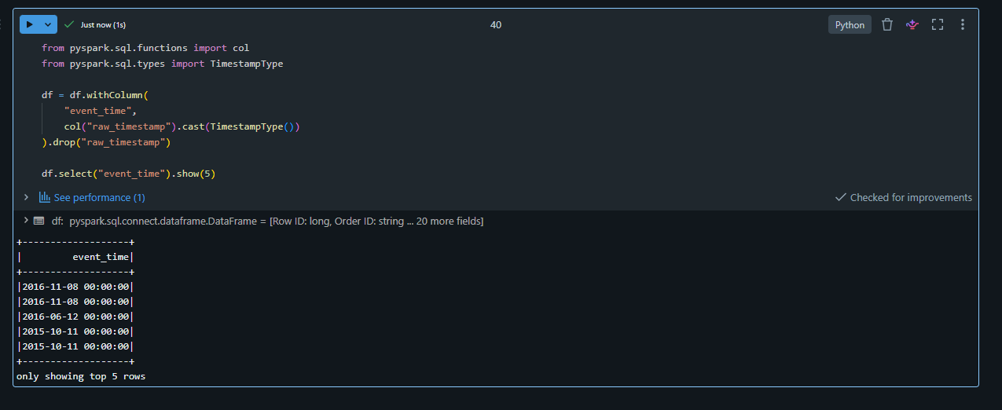
Q11: Explain the "Shuffle" process that occurs during a grouping operation. Why is it considered a wide transformation?
A shuffle is the process of redistributing data across different partitions in a Spark cluster so that records with the same key are brought together. During operations such as groupBy(), join(), and reduceByKey(), Spark moves data between executors to perform the computation correctly.
It is called a wide transformation because data from multiple partitions is exchanged across the cluster. Unlike narrow transformations (such as filter() or map()), where each output partition depends on only one input partition, a wide transformation requires data movement between partitions, which increases network I/O and execution time.
Example:
from pyspark.sql.functions import sum
result = df.groupBy("Region") \
.agg(sum("Sales").alias("Total_Sales"))
result.show()
Explanation
- groupBy("Region") triggers a shuffle because Spark must collect all records with the same Region into the same partition.
- After the shuffle, sum("Sales") calculates the total sales for each region.
Q12: Write a code snippet that identifies and removes rows where the email column contains null values OR the username is an empty string.
The email and username columns were created from the Customer Name field because they were not present in the original Superstore dataset.
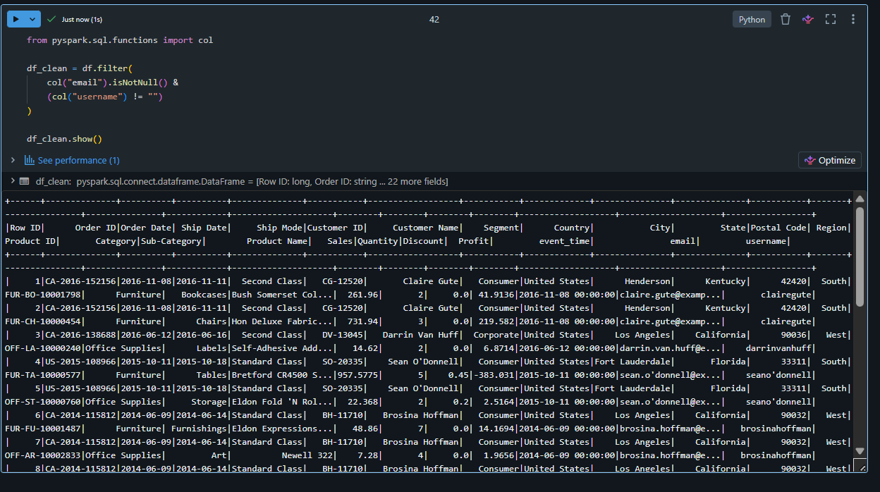
Q13: How do you use the .agg() function to calculate multiple statistics at once, such as the min, max, and mean of the price column?
The price column was derived from the Sales column.
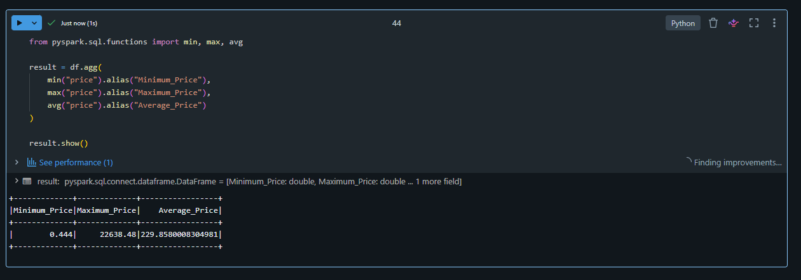
Q14: In the context of cleaning a dataset, what is the risk of using inferSchema=true when your source data contains messy or inconsistent date formats?
- Using inferSchema=true with messy or inconsistent date formats can cause Spark to incorrectly infer the data type of a column. Some date values may be interpreted as strings, become NULL, or result in incorrect data types. This can lead to data quality issues, incorrect aggregations, and errors during analysis. To avoid these problems, it is better to define the schema explicitly or use appropriate date parsing functions.
- Ex:
from pyspark.sql.functions import to_date, col
df = df.withColumn(
"Order Date",
to_date(col("Order Date"), "yyyy-MM-dd"))
df.show(5)

- inferSchema=true automatically detects column data types.
- If date formats are inconsistent (e.g., 2024-01-15, 15/01/2024, Jan 15 2024), Spark may infer the wrong type or produce NULL values.
- Using to_date() with a specified format or defining the schema manually ensures consistent and accurate date parsing.
Q15: Write a final processing pipeline that: 1. Filters out duplicates. 2. Fills null prices with 0. 3. Groups by store_id to calculate total revenue.
The store_id column was created from the Region column because the Superstore dataset did not contain a store_id field.
