Assignment-3
Objective: Analyze sales data using SQL by applying Subqueries, CTEs, and Window Functions to solve business queries. Steps: Load Superstore dataset into a table (superstore_raw). Create tables (customers, orders, products) from the dataset. Insert data into these tables using SELECT DISTINCT. Apply subqueries to filter data (above average sales, highest order per customer). Use CTEs to compute aggregations (total sales per customer). Apply window functions (ROW_NUMBER, RANK) for ranking and analysis. Combine JOIN + CTE + Window Functions for final result (customer, total sales, rank). Solve business queries (top customers, low customers, single-order customers, above-average sales). Output: SQL script / Notebook + query results + brief insights.

Dataset: Superstore Dataset
Tool: MySQL WorkBench
Tasks
Step 1: Setup Data:
- Import the Superstore dataset into a table named superstore_raw.
I was downloaded zip file from provided Kaggle source and extracted sample – superstore data set
And I created a folder called assignment3 consisting this dataset.
I opened MySQL WorkBench and imported the sample – superstore dataset by creating superstore database and renamed the sample – superstore dataset as superstore_raw.
- create database superstore;
- use superstore;
- rename table `sample - superstore` to superstore_raw;
- desc superstore_raw;
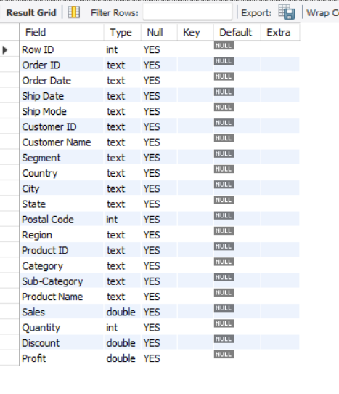
- Create these 3 tables from it:
- customers
- orders
- products
I have created 3 tables named customers,orders,products from the renamed superstore_raw dataset.
Customers table:
- create table customers(cust_id varchar(50) primary key,cust_name varchar(100),segment varchar(50),country varchar(50),city varchar(50),state varchar(50),region varchar(50) );
Products table:
- create table products(prod_id varchar(50), prod_name varchar(200),category varchar(50),subcategory varchar(50));
Orders table:
- create table orders(order_id varchar(50) ,oder_date varchar(50),ship_date varchar(50),cust_id varchar(50),prod_id varchar(50),sales double,quantity int,disc double,profit double);
- show tables;
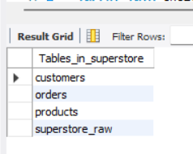
3.Insert data into these tables using SELECT DISTINCT.
Customer table:
- insert into customers select distinct `Customer ID`,`Customer Name`,Segment,Country,City,State,Region from superstore_raw;
Products table:
- insert into products select distinct `Product ID`,`Product Name`,Category,`Sub-Category` from superstore_raw;
Order table:
- insert into orders select distinct `Order ID`,`Order Date`,`Ship Date`,`Customer ID`,`Product ID`,Sales,Quantity,Discount,Profit FROM superstore_raw;

- select * from customers;

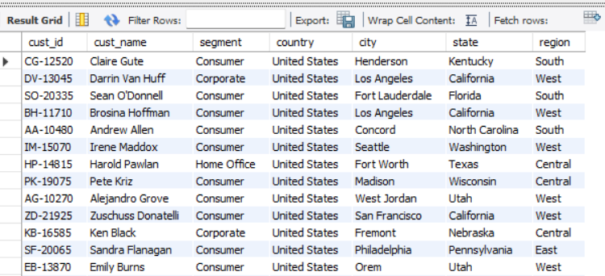

- select * from orders;
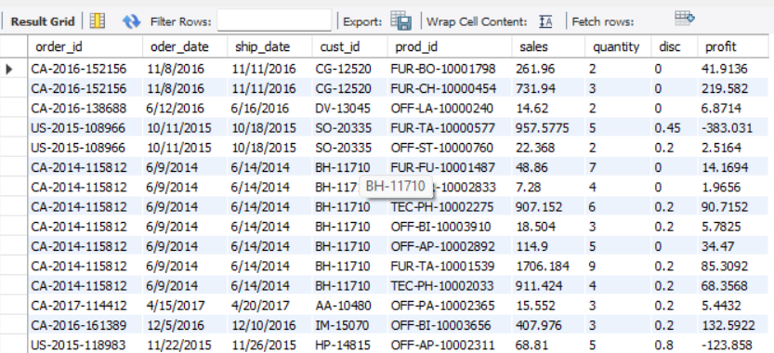

- select * from products;
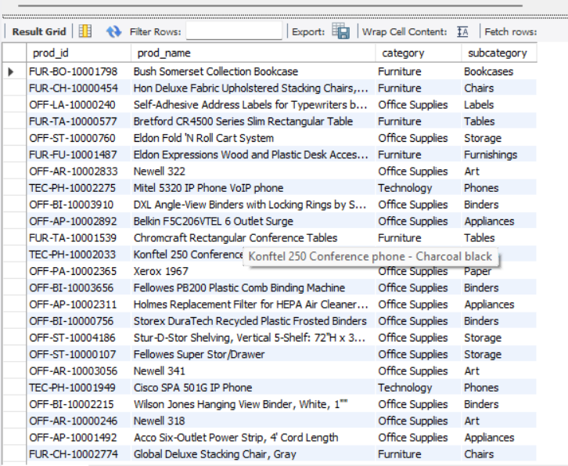

Step 2: Perform Required Queries :
Write and execute SQL queries for each of the following:
1.Find all orders where sales are greater than the average sales. (Subquery) :
- select * from orders where sales>(select avg(sales) from orders);
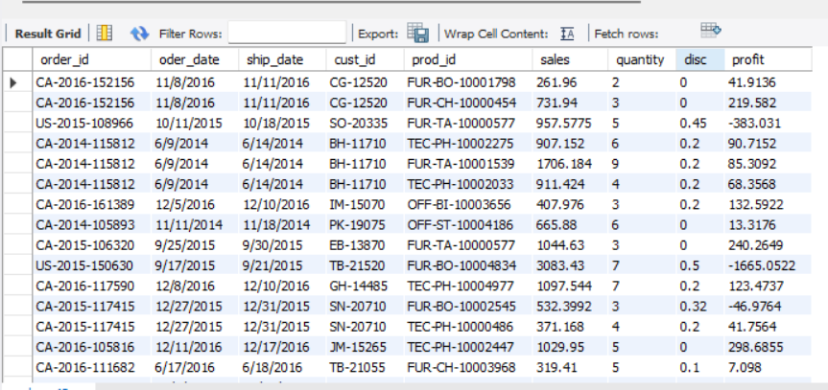
Used a subquery that finds average sales from the orders table and the outer query that retrieves all orders whose sales amount is greater than this average value.
2.Find the highest sales order for each customer. (Subquery)
- select * from orders od where sales=(select max(sales) from orders where cust_id=o.cust_id);
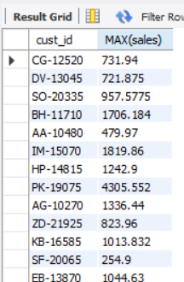

- Calculate total sales for each customer. (CTE)
- with customer_sales as(select cust_id,sum(sales) as total_sales from orders group by cust_id)
select * from customer_sales order by total_sales desc limit 10;

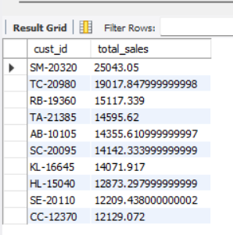
As there are many rows returned I was limited it to 10 rows by using limit.
- Find customers whose total sales are above average. (CTE + Subquery)
- with customer_sales as(select cust_id,sum(Sales) as total_sales from orders group by cust_id)
select * from customer_sales where total_sales>(select avg(total_sales) from customer_sales);
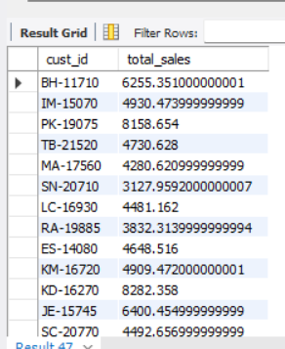

- Rank all customers based on total sales. (Window Function)
- with customer_sales as(select cust_id,sum(sales) as total_sales from orders group by cust_id)select cust_id,total_sales,rank() over(order by total_sales desc) as cust_rank from customer_sales;
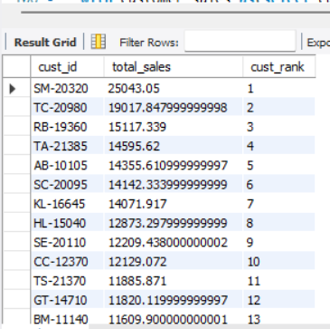
6 .Assign row numbers to each order within a customer. (Window Function + PARTITION BY)
- select order_id,cust_id,sales,row_number() over(partition by cust_id order by sales desc) as row_num from orders;
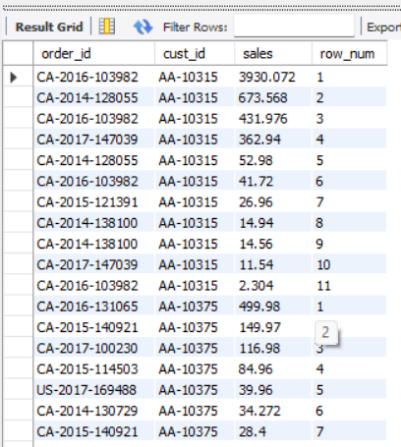

7.Display top 3 customers based on total sales. (Window Function)
- with customer_sales as (select cust_id,sum(sales) as total_sales from orders group by cust_id) select * from(select cust_id,total_sales,rank() over(order by total_sales desc) as customer_rank from customer_sales) t where customer_rank<=3;
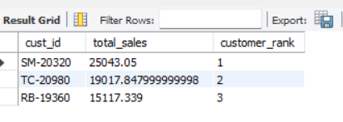
Step 3: Final Combined Query
Write one final query that shows:
- Customer Name
- Total Sales
- Rank
(Use JOIN + CTE + Window Function together)
- with customer_sales as(select cust_id,sum(sales) as total_sales from orders group by cust_id) select distinctc.cust_name,cs.total_sales,rank() over(order by cs.total_sales desc) as customer_rank from customer_sales cs join customers c on cs.cust_id=c.cust_id;
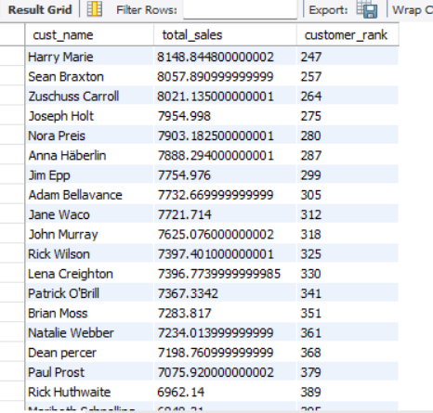

Mini Project: Customer Sales Insights
Answer the following using SQL:
- Who are the top 5 customers?
- Who are the bottom 5 customers?
- Which customers made only one order?
- Which customers have above-average sales?
- What is the highest order value per customer?
1.
- with customer_sales as(select cust_id,sum(sales) as total_sales
from orders group by cust_id) select * from(select cust_id,total_sales,rank() over(order by total_sales desc) as r from customer_sales)t where r<=5;
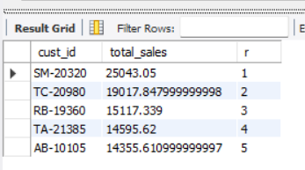
2.
- with customer_sales as(select cust_id,sum(sales) as total_sales
from orders group by cust_id) select * from(select cust_id,total_sales,rank() over(order by total_sales asc) as r from customer_sales)t where r<=5;
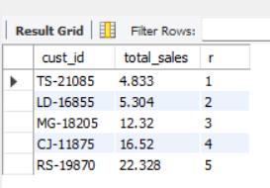

3.
- select cust_id,count(order_id) as total_orders from orders group by cust_id having count(order_id) = 1;
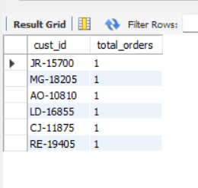
4.
- with customer_sales as(select cust_id,sum(sales) as total_sales from orders group by cust_id)
select * from customer_sales where total_sales>(select avg(total_sales) from customer_sales);

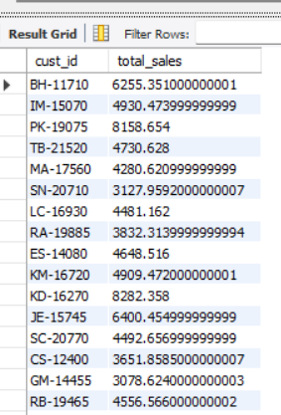

5.

- select * from orders od where sales=(select max(sales) from orders where cust_id=od.cust_id);
