Week 2 Task: E-Commerce Sales Database
Section A — SQL Basics (SELECT, Constraints, Primary Keys)
Q1. Write a query to display all columns and rows from the customer's table.
- select * from customers;
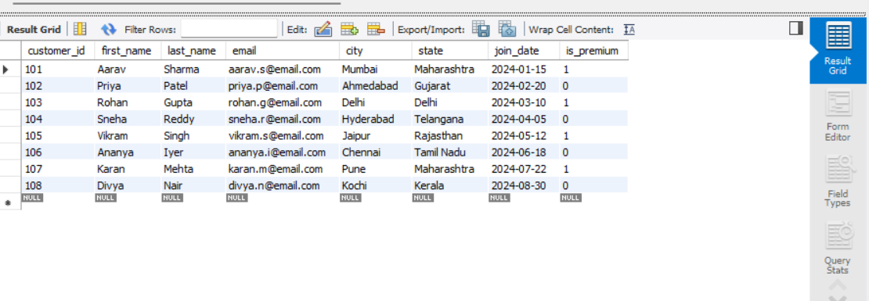
Q2. Retrieve only the first_name, last_name, and city of all customers.
- select first_name,last_name,city from customers;
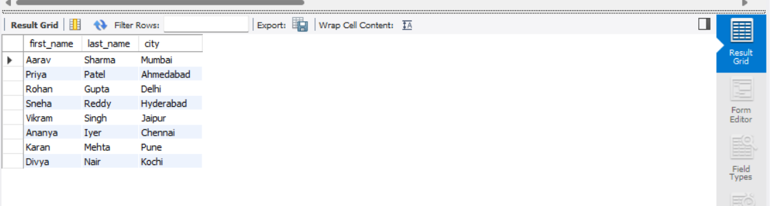
Q3. List all unique categories available in the products table.
- select distinct category from products;
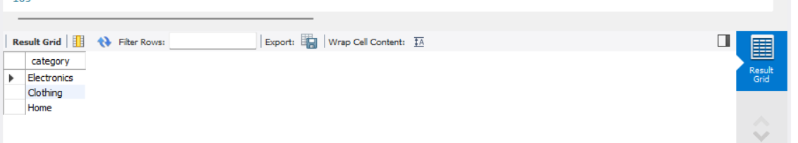
Q4. Identify the Primary Key of each table in the schema. Explain why a Primary Key must be unique and NOT NULL.
- Primary keys of customers table -> customer_id
- Primary keys of products table - > product_id
- Primary keys of Orders table -> order_id
- Primary Keys of Order_items -> item_id
A Primary key is a column or set of columns that uniquely identifies each record in a table.
A primary key must unique because no two rows should have the same identifier .This helps in distinguishing the one record from another and prevents duplicate entries.
A primary key must not be null because every record must have a valid identifier. If a Primary key contains null values ,the database would not be able to uniquely identify those records.
So these ensures data integrity,uniqueness and accurate relationships between tables.
Q5. What constraints are applied to the email column in the customers table? What would happen if you tried to insert a duplicate email?
The email column in the customer table has the UNIQUE constraint that ensures that no two customers can have the same email address. And NOT NULL ensure that every customer record must contain an email address:
email VARCHAR(100) UNIQUE NOT NULL
If I try to insert a customer with an email address that already exists in the table, the database will reject the insertion and return an error because the UNIQUE constraint is violated.
- Insert into customers values(109, 'Rahul', 'Kumar', 'aarav.s@email.com', 'Mumbai', 'Maharashtra', '2024-09-01', TRUE);
Q6. Try inserting a product with unit_price = -50. What happens and which constraint prevents it? Write both the INSERT statement and explain the error.
- Insert into products(product_id, product_name, category, brand, unit_price, stock_qty) values(999, 'Test Product', 'Electronics', 'TestBrand', -50, 10);

Section B — Filtering & Optimization (WHERE, Indexes)
Q7. Retrieve all orders with status = 'Delivered'.
- select * from orders where status="Delivered";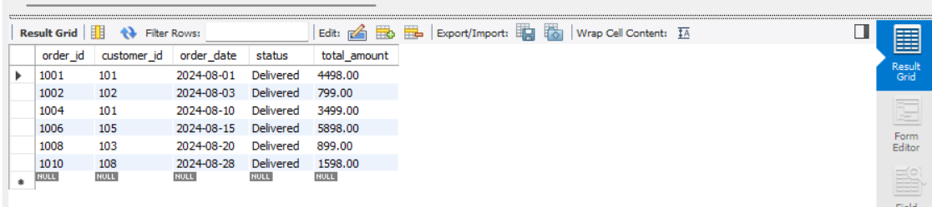
Q8. Find all products in the 'Electronics' category with a unit_price greater than ₹2000.
- select * from products where category ="Electronics" and unit_price>2000;
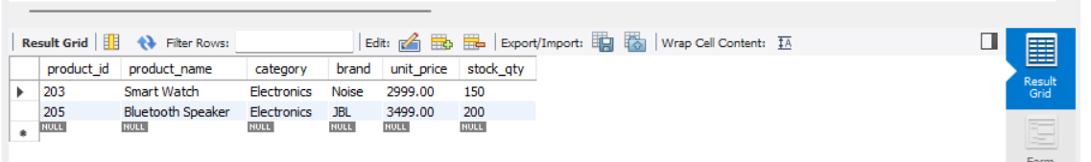
Q9. List all customers who joined in the year 2024 and belong to the state 'Maharashtra'.
- select * from customers where state="Maharashtra" and year(join_date)=2024;
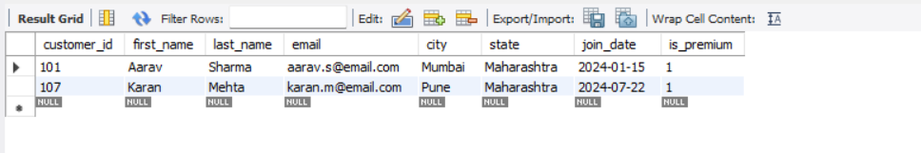
Q10. Find all orders placed between '2024-08-10' and '2024-08-25' (inclusive) that are NOT cancelled.
- select * from orders where order_date between '2024-08-10' and '2024-08-25' and status!="cancelled";
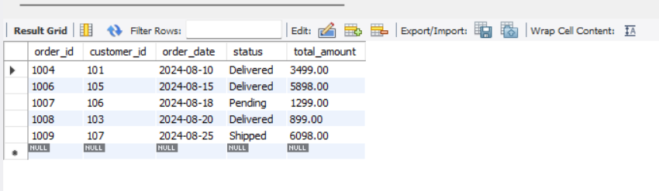
Q11. Explain what the index idx_orders_date does. How would it improve the performance of a query that filters orders by order_date? Write a sample query that would benefit from this index.
The index idx_orders_date is created on the order_date column of the orders table.
- Create index idx_orders_date on orders(order_date);
- Index works like the database can quickly locate the required records using the indexed column.
- The idx_orders_table index improves the performance of queries that filter,search, sort the data using the order_date column.
- select * from orders where order_date between "2024-08-01" and "2024-08-31";
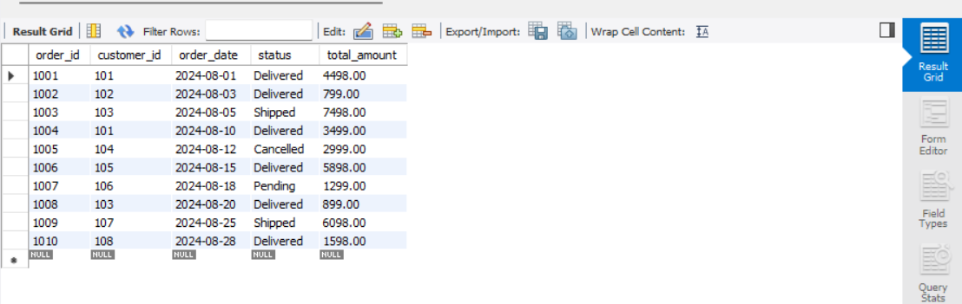
Without the index , the database may need to scan the entire table to find matching rows. With the index,it can directly locate the relevant date range,resulting in faster query execution and improved performance.
Q12. If you run: SELECT * FROM customers WHERE YEAR(join_date) = 2024; — would the index on join_date be used? Explain why or why not, and rewrite the query to be index-friendly (SARGable).
No,The index on join_date would generally not be used efficiently in the following query:
Select * from customers where year(join_date)=2024;
This is because the year() function is applied to the indexed column join_date.The database must first calculate the year for every row before comparing it with 2024. As a result the index cannot be used effieciently and the database may perform a full table scan.
A query is called SARGable when it allows the database to use an index effieciently.
SARGable version of query:
- select * from customers where join_date>="2024-01-01" and join_date<"2025-01-01";
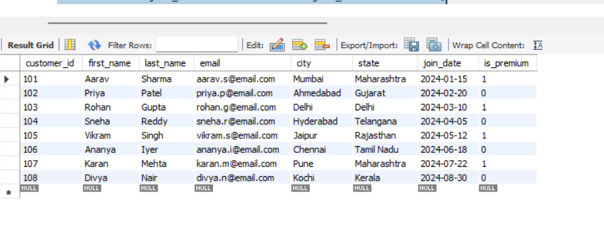
Section C — Aggregation (GROUP BY, SUM, COUNT, AVG, MIN, MAX)
Q13. Count the total number of orders in the orders table.
- select count(*) as Total_orders from orders;
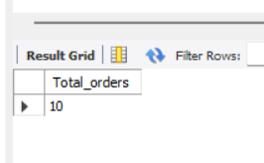
Q14. Find the total revenue (SUM of total_amount) from all 'Delivered' orders.
- select sum(total_amount) as total_revenue from orders where status="Delivered";
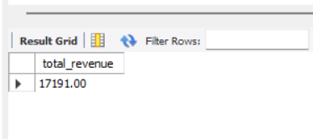
Q15. Calculate the average unit_price of products in each category.
- select category,avg(unit_price) as avg_unit_price from products group by category;
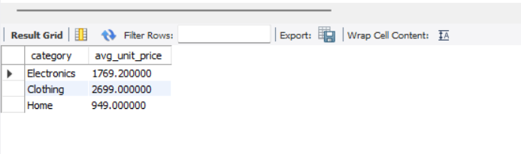
Q16. For each order status, find the count of orders and the total revenue. Sort the result by total revenue in descending order.
- select status, count(*) as order_count,sum(total_amount) as total_revenue from orders group by status order by total_revenue desc;
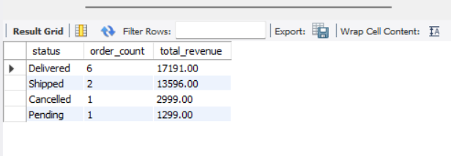
Q17. Find the most expensive (MAX) and cheapest (MIN) product in each category.
- select category,max(unit_price) as most_expensive,min(unit_price) as cheap from products group by category;
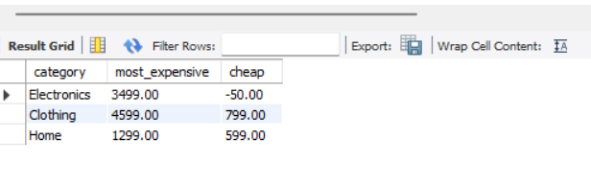
Q18. List all product categories where the average unit_price is greater than ₹2000. (Hint: Use HAVING clause)
- select category,avg(unit_price) as avg_price from products group by category having avg(unit_price)>2000;
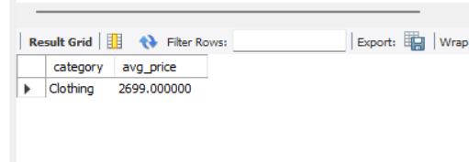
Section D — Joins & Relationships
Q19. Write an INNER JOIN query to display each order along with the customer's first_name and last_name. Show: order_id, order_date, first_name, last_name, total_amount.
- select o.order_id,o.order_date,c.first_name,c.last_name,o.total_amount from orders o inner join customers c on o.customer_id=c.customer_id;
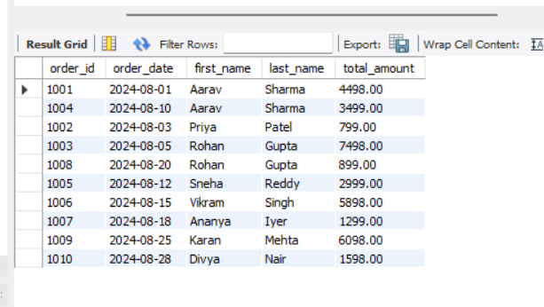
Q20. Using a LEFT JOIN, list ALL customers and their orders (if any). Customers with no orders should still appear with NULL values for order columns.
- selectc.customer_id,c.first_name,c.last_name,o.order_id,o.order_date,o.total_amount FROM customers c LEFT JOIN orders o ON c.customer_id = o.customer_id;
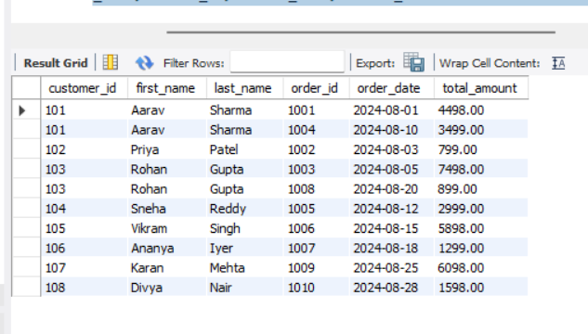
Q21. Write a query using JOINs across three tables (orders → order_items → products) to show: order_id, product_name, quantity, unit_price, and discount_pct for each order item.
- select o.order_id, p.product_name,oi.quantity,oi.unit_price,oi.discount_pct FROM orders o INNER JOIN order_items oi ON o.order_id = oi.order_id INNER JOIN products p ON oi.product_id = p.product_id;
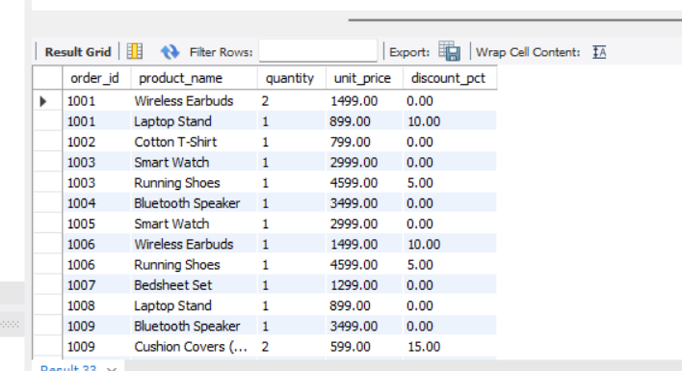
Q22. Explain the difference between LEFT JOIN and RIGHT JOIN with an example from this schema. When would you use a FULL OUTER JOIN?
1. LEFT JOIN
Returns all rows from the left table and matching rows from the right table.
- SELECT c.customer_id,c.first_name,o.order_id FROM customers c LEFT JOIN orders o ON c.customer_id = o.customer_id;
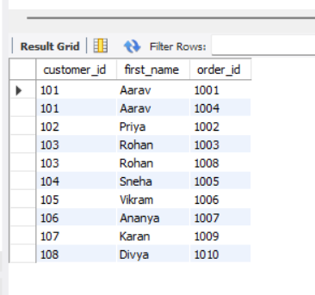
2. RIGHT JOIN
Returns all rows from the right table and matching rows from the left table
- SELECT c.customer_id,c.first_name, o.order_id FROM customers c RIGHT JOIN orders o ON c.customer_id = o.customer_id;
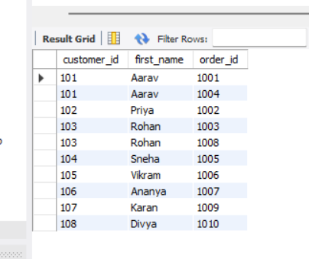
3. FULL OUTER JOIN
Returns:
- All rows from the left table
- All rows from the right table
- Matching rows merged together
- Unmatched rows from either side filled with NULL
As full outer join is not valid in mysql:
- SELECT c.customer_id, c.first_name, o.order_id FROM customers c LEFT JOIN orders o ON c.customer_id = o.customer_id UNION SELECT c.customer_id,
c.first_name, o.order_id FROM customers c RIGHT JOIN orders o ON c.customer_id = o.customer_id;
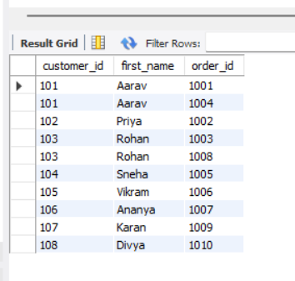
Q23. Identify all Foreign Key relationships in the schema. Explain what would happen if you tried to insert an order with customer_id = 999 (which doesn't exist in customers).
The Foreign Key relationships in the schema are:
- orders.customer_id → customers.customer_id
- order_items.order_id → orders.order_id
- order_items.product_id → products.product_id
- Foreign Keys are used to maintain referential integrity between related tables.
- If we try to insert an order with customer_id = 999 and no customer with customer_id = 999 exists in the customers table, MySQL will reject the insertion if a Foreign Key constraint is defined.
EX:
- INSERT INTO orders (order_id, customer_id, order_date, total_amount)
VALUES (201, 999, '2026-06-08', 5000);
Since customer_id = 999 does not exist in the customers table, MySQL will generate an error similar to:
This occurs because the value in orders.customer_id must match an existing value in customers.customer_id.
Foreign Keys help to:
- Maintain data integrity.
- Prevent invalid references.
- Ensure consistency between related tables.
- Prevent orphan records.
Section E — Advanced Concepts (CASE, ACID, Transactions)
Q24. Write a query using CASE to classify products into price tiers:
• 'Budget' → unit_price < 1000
• 'Mid-Range' → unit_price BETWEEN 1000 AND 3000
• 'Premium' → unit_price > 3000
Display: product_name, unit_price, price_tier.
- SELECT product_name,unit_price,
CASE
WHEN unit_price < 1000 THEN 'Budget'
WHEN unit_price BETWEEN 1000 AND 3000 THEN 'Mid-Range'
ELSE 'Premium'
END AS price_tier
FROM products;
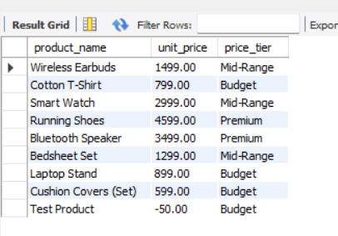
Q25. Using a CASE statement inside an aggregate function, count how many orders are 'Delivered' vs 'Not Delivered' (all other statuses). Display the result in a single row.
SELECT
SUM(CASE
WHEN status = 'Delivered' THEN 1
ELSE 0
END) AS Delivered_Orders,
SUM(CASE
WHEN status !='Delivered' THEN 1
ELSE 0
END) AS Not_Delivered_Orders
FROM orders;
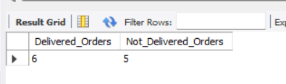
Q26. Explain each letter of ACID:
• A – Atomicity
• C – Consistency
• I – Isolation
• D – Durability
Give a real-world example (e.g., bank transfer) showing why each property is important.
ACID Properties
A – Atomicity:
A transaction is completed fully or not at all.
Ex:In a bank transfer, if money is deducted from one account but not added to another, the transaction is rolled back.
C – Consistency:
The database always remains in a valid state.
Ex:After transferring ₹1000, the total money in both accounts remains unchanged.
I – Isolation:
Multiple transactions do not interfere with each other.
Ex:Two users withdrawing money simultaneously cannot cause an incorrect balance.
D – Durability:
Once a transaction is committed, it is permanently saved.
Ex: Even if the system crashes after a bank transfer, the changes remain stored.
ACID properties ensure transactions are reliable, accurate, and safe in a database system.
Q27. Write a SQL transaction that does the following atomically:
1. Insert a new order (order_id=1011, customer_id=102, today's date, 'Pending', 1598.00)
2. Insert two order items for that order
3. Update the stock_qty of the purchased products
4. If any step fails, ROLLBACK the entire transaction. Otherwise, COMMIT.
Write the complete BEGIN...COMMIT/ROLLBACK block.
- START TRANSACTION;
INSERT INTO orders(order_id, customer_id, order_date, status, total_amount)VALUES(1011, 102, CURDATE(), 'Pending', 1598.00);
INSERT INTO order_items(order_id, product_id, quantity, unit_price)
VALUES(1011, 201, 1, 999.00),(1011, 202, 1, 599.00);

UPDATE products SET stock_qty = stock_qty – 1 WHERE product_id = 201;
UPDATE products SET stock_qty = stock_qty - 1WHERE product_id = 202;
COMMIT;
ROLLBACK;
- START TRANSACTION begins the transaction.
- The order and order items are inserted.
- Product stock is updated.
- COMMIT saves all changes permanently.
- If any step fails, ROLLBACK undoes all changes.
- COMMIT is executed if all statements succeed.
- ROLLBACK is executed only if any statement fails

