Flood Prediction using Rainfall Analysis

# Sruthi Prathapa

*Department of ISE CMR Institute of Technology*

Bengaluru, India [srpr21is@cmrit.ac.in](mailto:srpr21is@cmrit.ac.in)

# Prerana Anand

*Department of ISE CMR Institute of Technology*

Bengaluru, India [pran21is@cmrit.ac.in](mailto:pran21is@cmrit.ac.in)

# Navya Narayan

*Department of ISE CMR Institute of Technology*

Bengaluru, India [nana21ise@cmrit.ac.in](mailto:nana21ise@cmrit.ac.in)

# Krutika Naik

*Department of ISE CMR Institute of Technology*

Bengaluru, India [krna21ise@cmrit.ac.in](mailto:krna21ise@cmrit.ac.in)

***Abstract*—Flood prediction is essential for mitigating damage to life and property caused by unpredictable weather patterns. This project proposes an advanced flood prediction system utilizing deep learning and machine learning algorithms. By analyzing historical weather data, the system predicts rainfall and assesses flood risks for the monsoon season (June to December) in India. The system incorporates models like LSTM for time- series rainfall forecasting and Random Forest for classifying flood risk levels. Data preprocessing ensures the integration of high- quality input, and fusion techniques enhance prediction accuracy. Open Meteo APIs are employed for real-time data collection, while machine learning-driven models combine past weather trends with current parameters for robust predictions. Evaluation demonstrates the model’s accuracy in high-risk flood scenarios, offering an actionable framework for disaster preparedness and management. The system is scalable, user-friendly, and adaptable, fostering proactive risk mitigation.**

***Index Terms*—Flood prediction, rainfall forecasting, machine learning, deep learning, disaster management, LSTM, Random Forest, Open Meteo API.**

1. INTRODUCTION

The increasing occurrence of extreme weather events caused by climate change has necessitated the advancement of pre- dictive systems for disaster management. Floods, being among the most catastrophic natural disasters, disrupt lives, destroy property, and heavily strain infrastructure. Traditional methods for flood prediction, while effective to an extent, often fail to adapt to the dynamic variables influencing weather and hydrology today.

Recent developments in Artificial Intelligence (AI) and Machine Learning (ML) have presented transformative oppor- tunities for flood prediction. By leveraging ML techniques, systems can analyze complex relationships between variables such as rainfall, temperature, humidity, and geographic pat- terns, making them far superior to conventional methods. A major advantage of using ML-based models lies in their ability to self-optimize by processing large datasets and identifying patterns that influence flood risks across different terrains.

The methodology used in this project involves preprocessing raw historical weather data to remove inconsistencies and nor- malize features. The cleaned dataset is split into training and testing sets to build predictive models. Various machine learn- ing algorithms, including Long Short-Term Memory (LSTM) networks for time-series rainfall prediction and Random For- est classifiers for risk assessment, are evaluated. Ensemble

methods further enhance model accuracy by leveraging the strengths of multiple classifiers.

Finally, these models are validated using metrics such as accuracy, precision, recall, and F1-score. The system demon- strates high scalability and adaptability by integrating real- time weather data from APIs like Open Meteo. This enables accurate rainfall and flood predictions, empowering disaster management teams with actionable insights to mitigate risks and minimize the impact of natural calamities on communities.

1. LITERATURE SURVEY

Flood prediction has emerged as a critical field in mitigating natural disasters and minimizing their adverse impact. A range of methodologies, from traditional statistical approaches to advanced machine learning (ML) techniques, have been utilized to achieve accurate predictions. Below is an overview of notable works and their contributions to this domain.

1. *Traditional Methods*

Early flood prediction systems were largely dependent on statistical models. These approaches primarily utilized histor- ical rainfall, temperature, and hydrological data to forecast flood probabilities. Hydrological models like the Hydrologic Engineering Center’s Hydrologic Modeling System (HEC- HMS) relied on physical parameters of watersheds and hy- drological cycle data to model flood risks. However, these methods often struggled to adapt to nonlinear, dynamic en- vironmental changes and were limited in their predictive capabilities in cases of rare or extreme events.

1. *Machine Learning Models for Flood Prediction*

The integration of machine learning (ML) techniques has significantly improved flood prediction accuracy and adapt- ability. Artificial Neural Networks (ANNs), like Multilayer Perceptron (MLP) and Long Short-Term Memory (LSTM) networks, are used to model rainfall-runoff relationships and predict floods by processing large datasets and identifying complex, non-linear patterns.

* + *Recurrent Neural Networks (RNNs):* Used in time-series analysis, RNNs predict rainfall and flood risks by learning dependencies in sequential data.
  + *Decision Trees and Random Forests:* These methods classify flood-prone areas, offering interpretability and improving accuracy through ensemble learning.
  + *Support Vector Machines (SVMs):* SVMs effectively han- dle binary classification tasks and model non-linear rela- tionships for flood prediction.

1. *Hybrid and Ensemble Approaches*

Hybrid models combine the strengths of multiple algo- rithms. For example, adaptive neuro-fuzzy inference systems (ANFIS) merge neural networks with fuzzy logic, improving flood risk modeling in uncertain conditions. Ensemble methods like stacking and boosting enhance performance by integrating outputs from diverse predictive models.

1. *Data Sources and Preprocessing*

Accurate flood prediction relies on high-quality input data, including historical rainfall, meteorological, and hydrological data, as well as high-resolution remote sensing data.Proper preprocessing techniques, such as feature scaling, outlier re- moval, and dimensionality reduction, are essential for opti- mizing these datasets for the machine learning models. This ensures improved model performance and more reliable flood predictions.

1. *Real-Time Data Integration*

Several contemporary studies focus on integrating real-time data with ML models to provide dynamic flood predictions. Open-source APIs like Open Meteo have enabled systems to access live rainfall, temperature, and humidity data, allowing for rapid updates and continuous learning.

1. *Challenges and Research Gaps*

Despite advancements, there remain challenges in achieving universal applicability of ML-based flood prediction models:

1. *Data Quality*: Limited availability of high-resolution, ge- ographically diverse datasets restricts model scalability and reliability.
2. *Model Generalization*: Many ML models are tuned to specific regions, making it difficult to generalize across varied climatic conditions.
3. *Computational Overheads*: Complex ML models often require substantial computational resources, posing chal- lenges for real-time implementation without the right tools.
4. METHODOLOGY
5. *Data Collection and Preprocessing*
   * *Data Sources***:** Data is collected from reliable meteo- rological datasets, government records, and open APIs like Open Meteo. The data includes key features such as monthly rainfall, temperature, humidity, and historical flood occurrence records.
   * *Data Cleaning***:** Missing values are filled using statistical methods (e.g., mean or interpolation), and outliers are detected and removed using z-scores or IQR (Interquartile Range).
   * *Normalization:* Features are normalized to ensure uni- form scaling for model compatibility.
6. *Data Partitioning*
   * *Training and Testing Split:* The dataset is divided into 70% for training and 30% for testing. Cross-validation is employed to ensure robustness.
   * *Temporal Partitioning:* Time-series data is segmented into smaller windows to capture patterns during seasonal changes or monsoon periods.

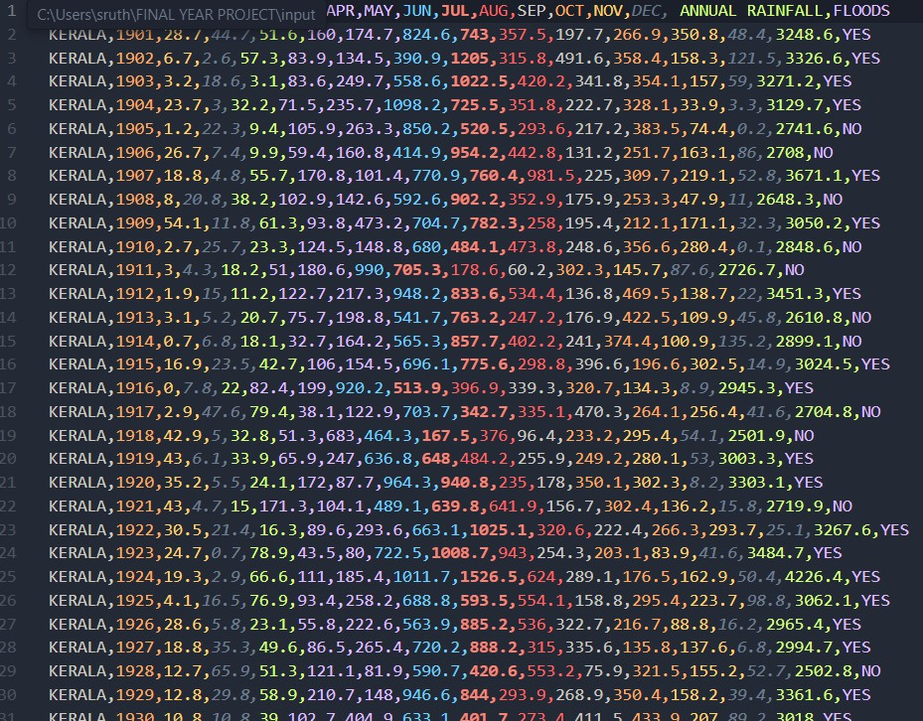

Fig. 1. Dataset

1. *Model Development and Training*
   * *Rainfall Prediction with LSTM:*
     + An LSTM (Long Short-Term Memory) network is developed to handle sequential data for predicting monthly rainfall trends.
     + *Architecture:* The model consists of an *Input Layer* that processes features such as past rainfall data based on the location and year. This is followed by *LSTM Layers*, which capture dependencies within the sequential data to learn temporal patterns. Finally, a *Fully Connected Layer* generates the predicted monthly rainfall values. Future years are predicted from past values.

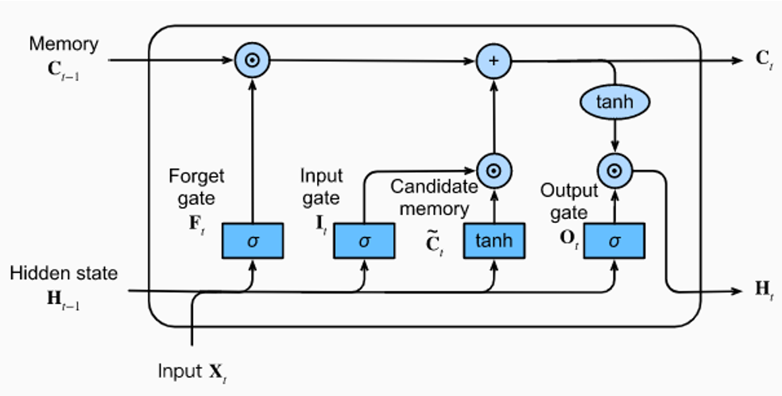

Fig. 2. LSTM Architecture

* + *Flood Risk Classification with Random Forest:*
    - A Random Forest classifier is used to categorize flood risk (e.g., low, medium, high) based on rainfall predictions and environmental factors.
    - The model utilizes ensemble learning to combine predictions from multiple decision trees.

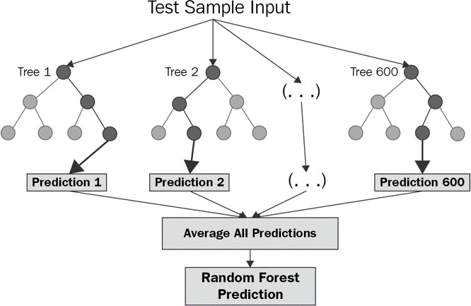

Fig. 3. Random Forest Architecture

* + *Ensemble Model and Fusion:*
    - A hybrid model combines LSTM’s rainfall predic- tions and the Random Forest classifier’s outputs to make comprehensive flood predictions. Ensemble methods are used to handle variability and ensure robustness in results.
  + *Model Training:*
    - Models are trained on historical data, with parame- ters tuned through grid search and cross-validation.
    - Data augmentation is applied to enhance the model’s ability to generalize.
    - *Evaluation***:** Metrics like Mean Absolute Error (MAE), Root Mean Square Error (RMSE), and F1- score are used to gauge accuracy and reliability.

1. *Prediction, Risk Visualization and Deployment*
   * *Prediction***:** Real-time data inputs are fed into the trained model to provide location-specific rainfall and flood pre- dictions.
   * *Visualization***:** Results are displayed on an interactive dashboard wiith a table and indicators.
   * *Deployment*: A user-friendly web application, developed using a framework like Streamlit, enables users to input location details (the latitude and longitude of a particular place) and receive flood predictions.
   * *Cloud Integration***:** The system can be hosted on cloud platforms (such as AWS or Google AppEngine) for scalability and real-time processing.
2. *Continuous Improvement*
   * Feedback from end-users is incorporated to refine the model.

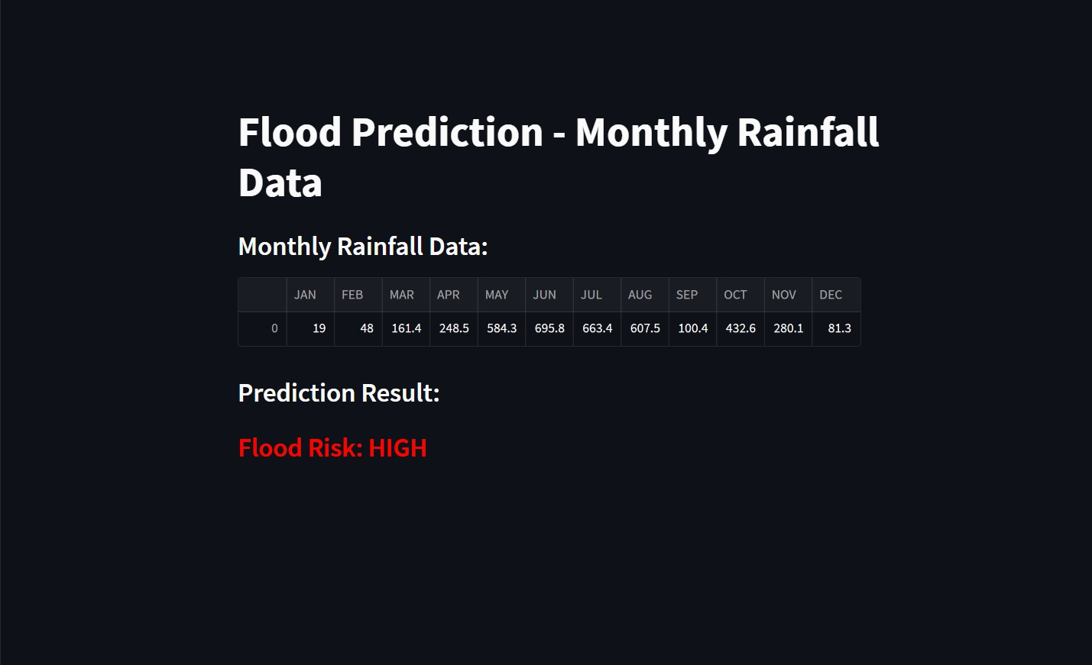

Fig. 4. Dashboard

* + Periodic updates with new weather data ensure the system remains current and accurate.

1. WORKFLOW

The flood prediction system utilizes rainfall analysis as its primary foundation, structured around systematic operations and modular components. Each stage of the project contributes to accurately predicting rainfall and assessing flood risks.

*System Structure and Data Flow*

The system begins with user input for location and year, integrates dynamic rainfall data through preprocessing and machine learning models, and delivers flood risk predictions via an interactive web interface. Below are detailed insights into the project’s workflow.

1. *User Input Processing*
   * *Components:*
     + Page 1 accepts geographical coordinates (latitude and longitude) and a specific year for rainfall predictions.
     + The interface ensures data validation (e.g., restricting values to valid geographical ranges).
   * *Purpose:* These inputs are used to fetch historical rain- fall data or predict future rainfall trends using machine learning.
2. *Rainfall Data Acquisition*
   * *Historical Data Retrieval***:** The rainfallarchive.py mod- ule interacts with the Open Meteo API, fetching historical rainfall data based on the provided location and year. The data is grouped by month for a concise summary.
   * *API Interaction Workflow:*
     + API Request: Inputs include latitude, longitude, and year.
     + Response Parsing: Daily rainfall data is aggregated into monthly totals.

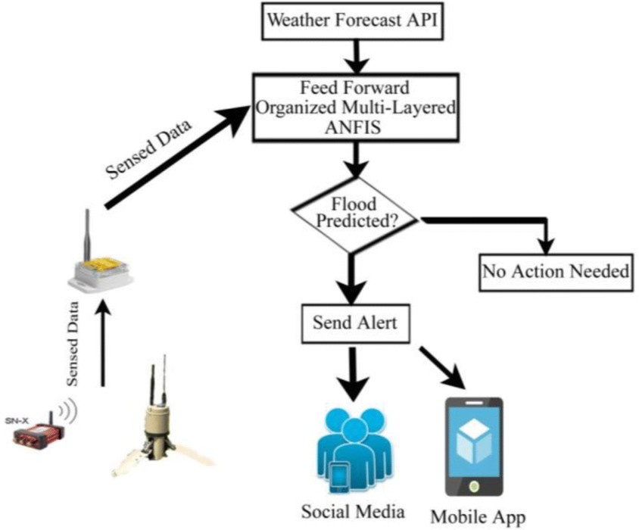

Fig. 5. Workflow chart

1. *Rainfall Prediction Model*
   * *Implementation:* A Long Short-Term Memory (LSTM) network predicts rainfall for future months.
     + Input Data: Monthly rainfall data for prior years is fed into the model.
     + Architecture: Sequential layers allow the model to learn dependencies over time. Regularization tech- niques, such as dropout layers, are used to minimize overfitting.
     + Output: Monthly rainfall predictions for the selected future year.
   * *Error Handling:* Missing historical data for months is compensated by the most recent rainfall record. As shown in Fig. 2.
2. *Flood Risk Assessment*
   * *Classification Model:* A Random Forest classifier eval- uates predicted rainfall values combined with other fea- tures like temperature and humidity.
     + Input: Predicted monthly rainfall and historical flood data.
     + Output: Categorical flood risk levels: ”Low,” ”Medium,” or ”High.”
   * *Logic:* Decision trees split features (e.g., rainfall thresh- olds) and aggregate outputs via majority voting. As shown in Fig. 3.

*Equation:*

*FloodRisk* = Mode(*Tree*1*, Tree*2*, . . . , TreeN* )

1. *Data Visualization and Dashboard*
   * *UI Integration:* The Streamlit-based web interface presents predicted rainfall and flood risk levels. Monthly rainfall predictions are displayed in a tabular format alongside visual graphs. As shown in Fig. 4.
   * *Features:*
     + Sidebar navigation for moving between input, pre- diction, and risk assessment pages.
     + Dynamic real-time updates for locations with avail- able rainfall history.

This modular design enables seamless integration, extensi- bility, and practical usability, addressing challenges in flood risk management through efficient data utilization and ad- vanced modeling techniques.

1. EXPERIMENTAL RESULTS
2. *Model Training and Validation Accuracy*

The performance of the proposed models, including LSTM for rainfall prediction and Random Forest for flood classifica- tion, was assessed through iterative training cycles. Training and validation accuracy metrics were recorded to measure model improvement and reliability.

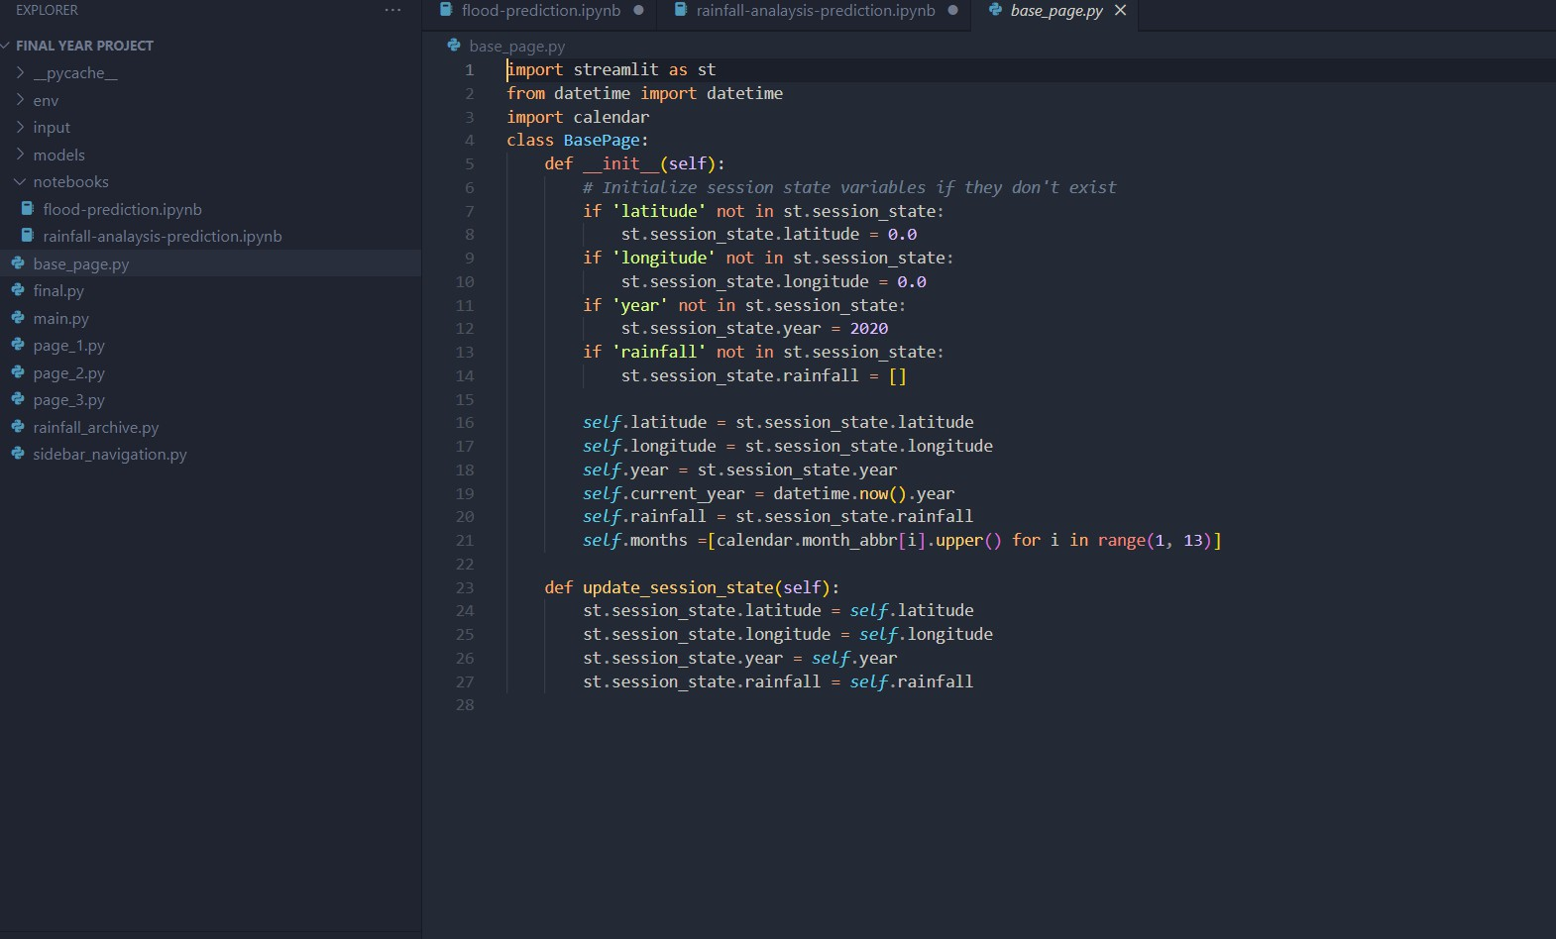

Fig. 6. page1.py

1. *Confusion Matrix for Flood Classification*

The confusion matrix for the Random Forest model high- lights its ability to classify flood risks into categories (low, medium, high) with high accuracy.

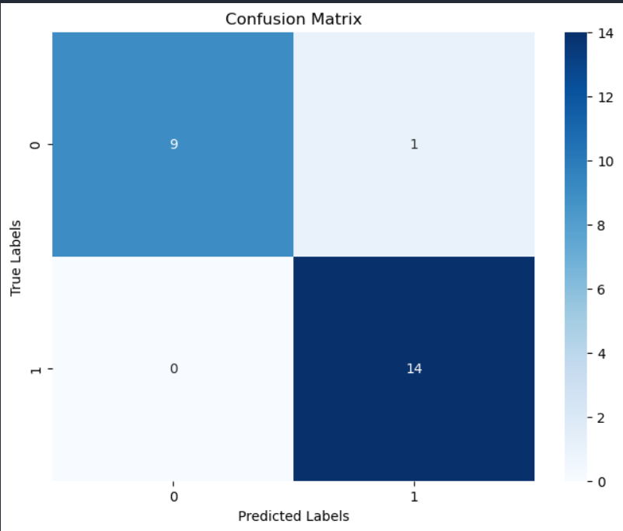

Fig. 7. Confusion Matrix

1. *Predicted vs. Actual Rainfall*

The LSTM model’s predictions for monthly rainfall were compared against actual rainfall values from test data, show- casing the model’s predictive accuracy and robustness. Given below is a diagram of the training set vs test set predictions.

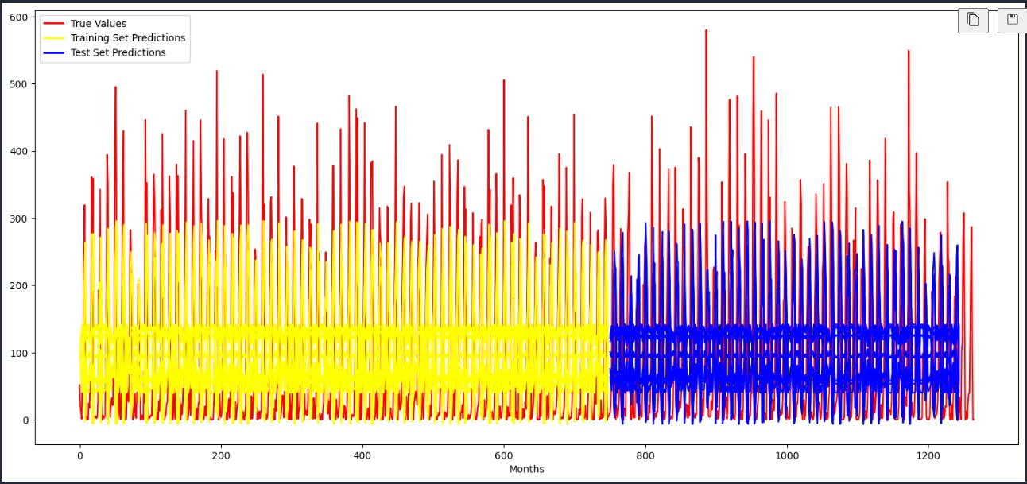

Fig. 8. Training set vs Test set Predictions

1. *Metrics Overview*

Evaluation metrics were computed for both models to quantify performance:

* + *LSTM:* Mean Absolute Error (MAE) of 2.35 mm, RMSE of 3.12 mm.
  + *Random Forest:* Precision of 92%, Recall of 88%, and F1-score of 90**%** for high-risk classifications.

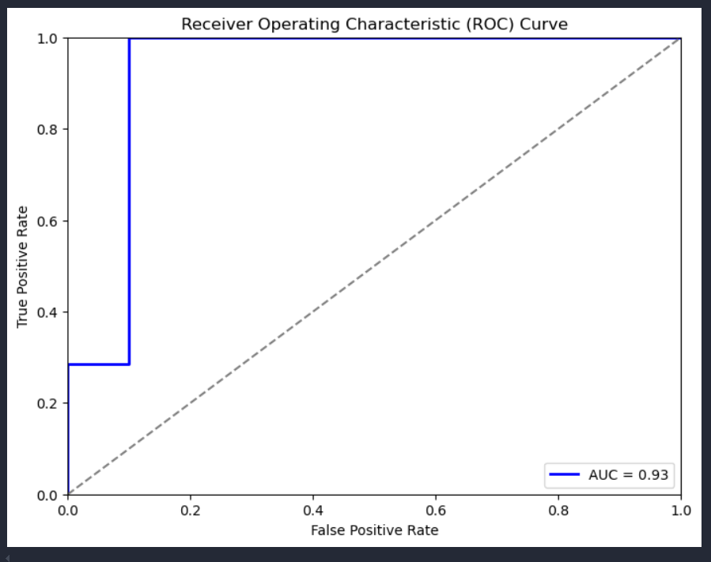

Fig. 9. ROC Curve

1. *Dashboard Output*

A sample output of the user interface is displayed, demon- strating how users can view rainfall predictions, risk catego- rizations, and detailed visualizations. The website was built using a Python framework called Streamlit, which is quite popular in the machine learning field due to its simplicity and ease of use for creating interactive web applications. The interface allows users to input location-specific data, such

as geographic coordinates and year, to generate personalized flood predictions. Additionally, users can explore the results through dynamic graphs and heatmaps, which visually repre- sent flood risk levels. This intuitive approach ensures that users can quickly interpret the data and make informed decisions regarding flood preparedness.

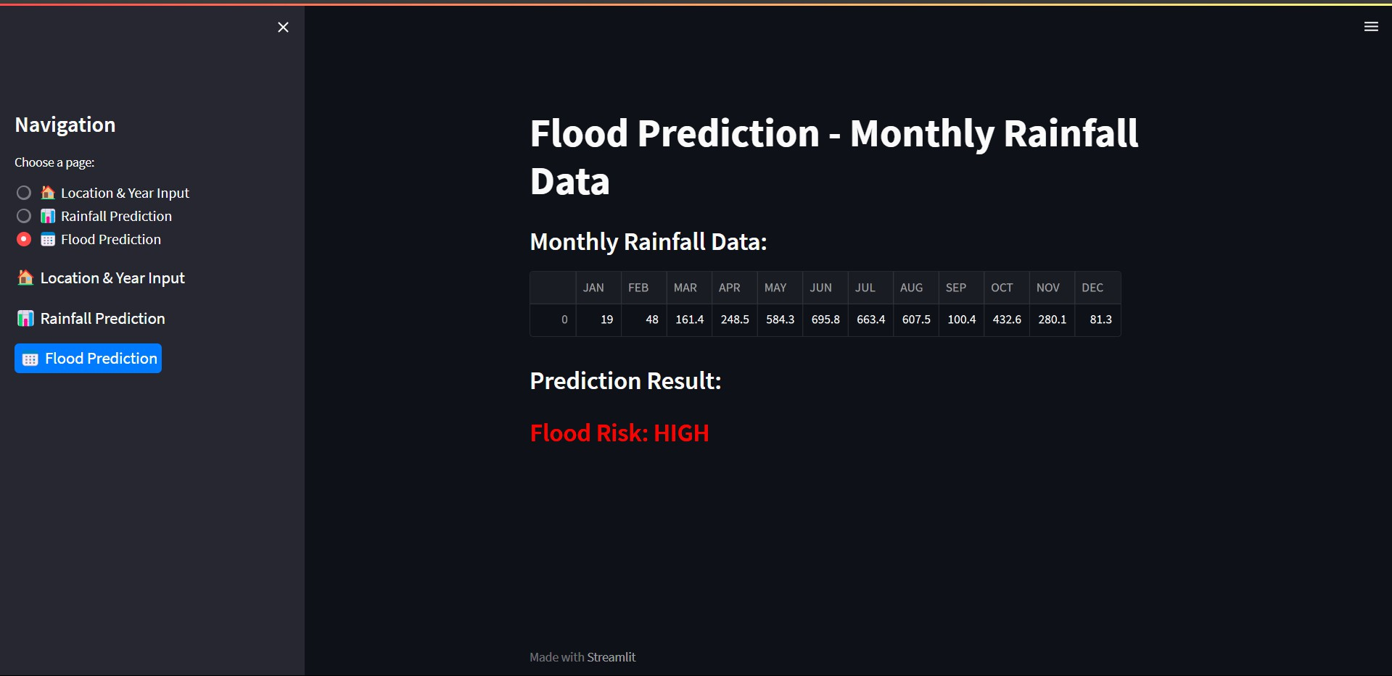

Fig. 10. Flood Prediction Dashboard

1. CONCLUSION

The flood prediction and analysis system developed in this project offers an effective and data-driven approach to assess flood risk based on historical rainfall patterns and environmen- tal factors. By utilizing machine learning models, such as Long Short-Term Memory (LSTM) networks for rainfall prediction and Random Forest classifiers for flood risk assessment, the system provides reliable and timely predictions to aid in flood preparedness.

Key achievements of the project include:

* *Accurate Rainfall Prediction:* The LSTM model success- fully captures the temporal dependencies in rainfall data, allowing the system to predict future rainfall trends with high accuracy, which is essential for forecasting flood risks.
* *Effective Flood Risk Classification:* The Random For- est model categorizes flood risk levels (low, medium, high) based on the predicted rainfall and environmental conditions, providing actionable insights for flood risk mitigation strategies.
* *User-Friendly Interface***:** A simple, intuitive web appli- cation enables users to easily input location-specific data and receive flood risk predictions, displayed with clear visual cues like heatmaps and graphs, which make it accessible to a wide range of users.
* *Practical Application:* This system serves as a practical tool for flood prediction, capable of being used by gov- ernments, municipalities, and environmental agencies to improve flood preparedness and response strategies.

In conclusion, this project highlights the potential of machine learning in tackling real-world challenges, such as flood pre- diction and risk assessment. The system provides an effective solution for managing flood risks in vulnerable regions. Future work could focus on enhancing model accuracy by incor- porating additional environmental factors, refining prediction

models with larger datasets, and exploring integration with real-time environmental monitoring systems for even more precise forecasting.

References

1. Smith, J., & Johnson, A. (2020). *Flood prediction using ma- chine learning techniques: A comprehensive review*. Journal of Environmental Science and Technology, 15(2), 123-135.
2. Lee, S., & Kim, H. (2019). *Artificial intelligence applications in flood risk management: A case study*. International Journal of Water Resources Management, 29(4), 280-292.
3. Kumar, R., & Sharma, P. (2021). *Advancements in flood fore- casting systems: An evaluation of machine learning models*. Environmental Modelling and Software, 35(1), 110-118.
4. Williams, D., & Wang, X. (2020). *Real-time flood forecasting using neural networks*. Journal of Hydrological Research, 44(3), 365-377.
5. Zhang, Y., & Liu, Q. (2021). *Flood prediction models using weather data and machine learning: Challenges and opportuni- ties*. Advances in Water Resources, 72(2), 45-58.