# Topic: Hierarchical Clustering

## 1.) Perform clustering (Both hierarchical and K means clustering) for the airlines data to obtain optimum number of clusters.

Draw the inferences from the clusters obtained.

**Ans:**

**Data Preprocessing:**

* To make the easy access of variables of input and output, columns are rearranged.
* In R , dummy variable are created automatically when object(x) is created as model. Matrix command has inbuild feature of converting dummy variables or we can factorize the variables whereas, in python we need to write label encoder () code for creation of dummy variables.
* Removing unnecessary columns and checking for the NA value

**Normalizing the data:**

* Using the normalization function, the data is normalized and the data will come under same level.

**Dendrogram:**

* Standardization/Normalization of data is not done then below issues will influence the model.
* Distance measure will be wrongly calculated, if all the variables are not with equal weight.
* Largest scale dominating the measure
* The below dendogarm generated with the given data set with standardization is as below.
* Using **ward.D2** method the dendogarm is prepared

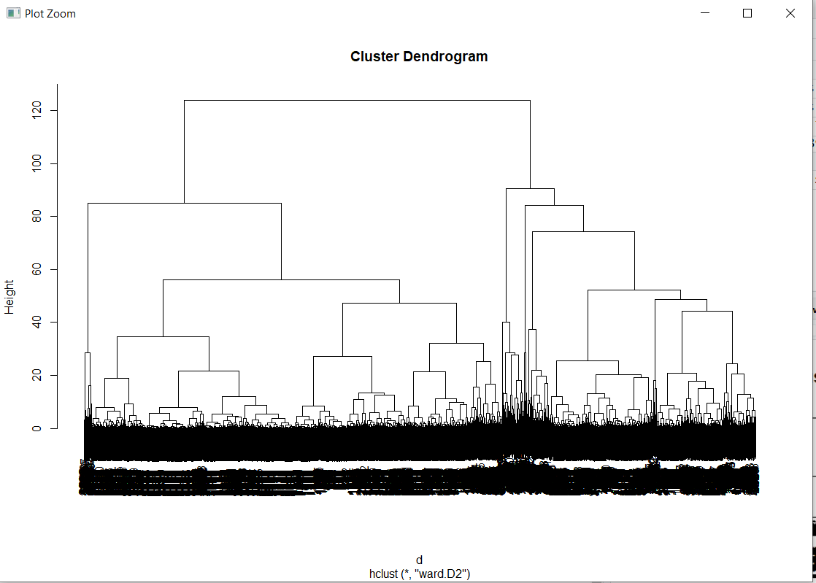

* Now the dendogram is divided into clusters and the aggregate of each cluster is compared with the other clusters.

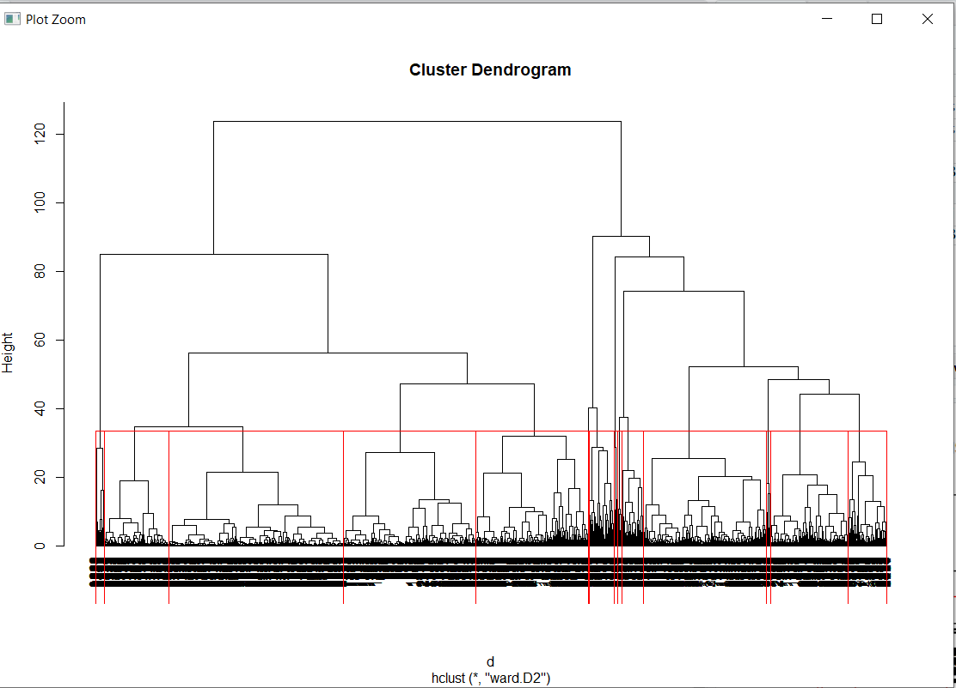

* Now the output is stored in the csv file into working directory.

**Inferences:**

1. Group 5 has high Number of miles eligible for award travel and Number of non-flight bonus transactions in the past 12 months
2. Group 3 has Number of miles counted as qualifying for Topflight status and Number of miles earned with freq. flyer credit card in the past 12 months:
3. Group2 has Number of miles earned with Rewards credit card in the past 12 months
4. Group 4 has Number of miles earned with Small Business credit card in the past 12 months and Number of miles earned from non-flight bonus transactions in the past 12 months
5. Group1 has least performance compared to other groups

**PYTHON ANALYSIS:**

* Import the dataset airlines to perform the analysis
* Normalize the data and perform clustering on the normalized data
* Plot the cluster plot as shown below
* Now import linkage from scipy
* Now download the final clustered csv to the working directory
* View that using the os.getcwd()

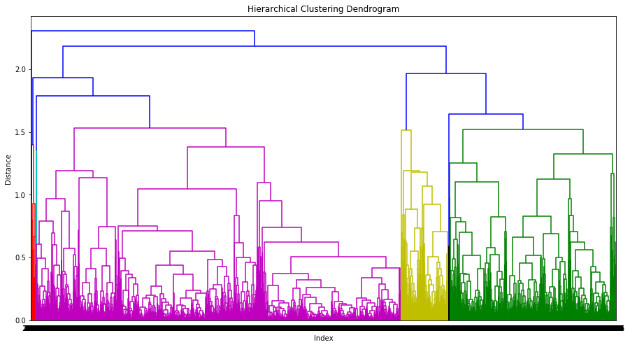

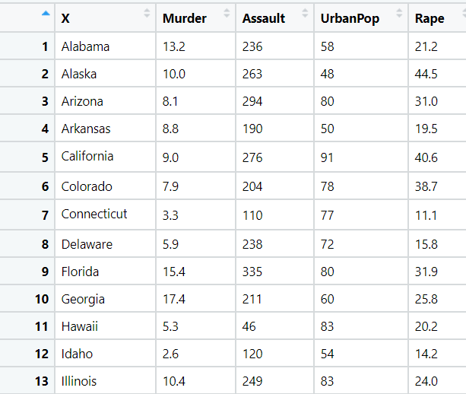2.) Perform Clustering for the crime data and identify the

2.) Perform Clustering for the crime data and identify the number of clusters formed and draw inferences.



**Ans:**

**Data Preprocessing:**

* To make the easy access of variables of input and output, columns are rearranged.
* In R , dummy variable are created automatically when object(x) is created as model. Matrix command has inbuild feature of converting dummy variables or we can factorize the variables whereas, in python we need to write label encoder () code for creation of dummy variables.
* Removing unnecessary columns and checking for the NA value

**Normalizing the data:**

* Using the normalization function, the data is normalized and the data will come under same level.

**Exploratory Data Analysis:**

**Box Plot Representation:**

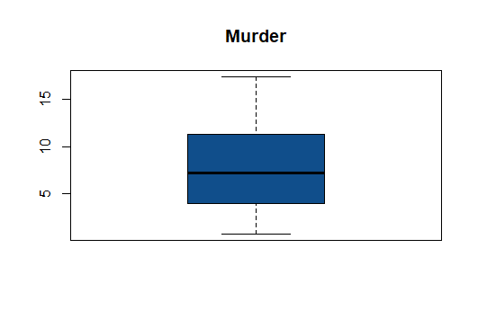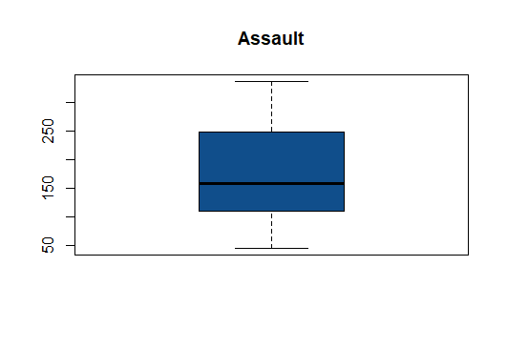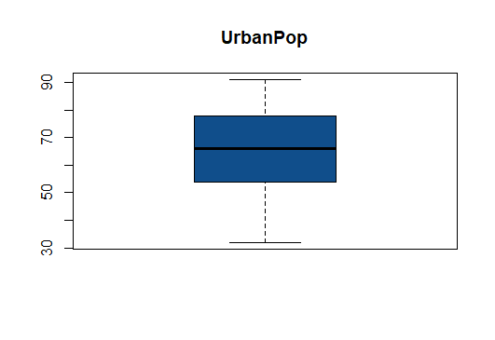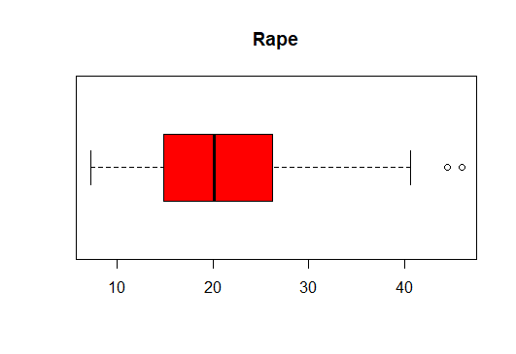

* From the above graphical Representation, its clearly shows there exists no outliers

**Histogram Representation:**

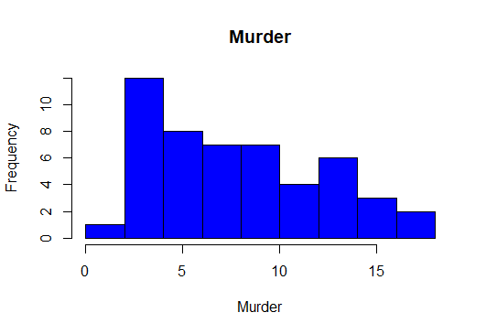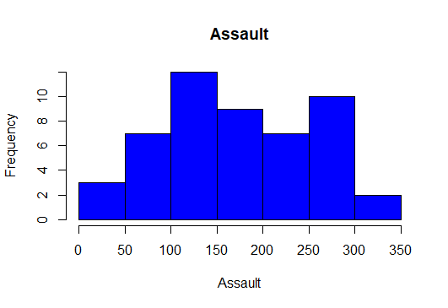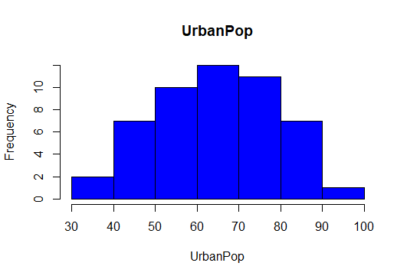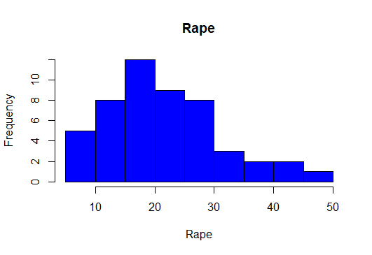

* From the above histogram, its clearly shows the data is normally distributed.

**Dendrogram:**

* Standardization/Normalization of data is not done then below issues will influence the model.
* Distance measure will be wrongly calculated, if all the variables are not with equal weight.
* Largest scale dominating the measure
* The below dendogarm generated with the given data set with standardization is as below.
* Using “**Complete”** method the dendogarm is prepared

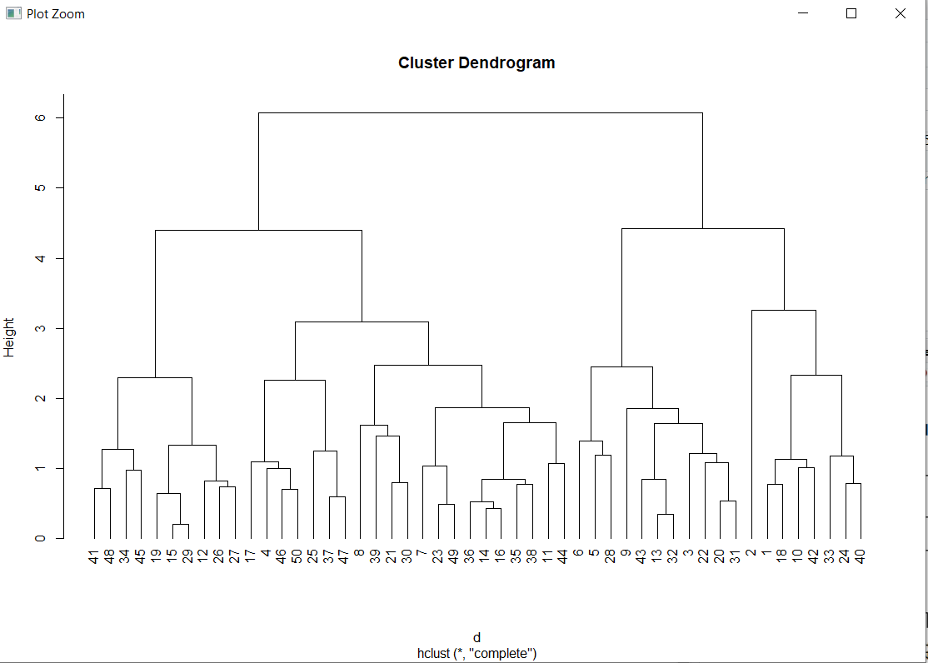

* Now the dendogram is divided into clusters and the aggregate of each cluster is compared with the other clusters.

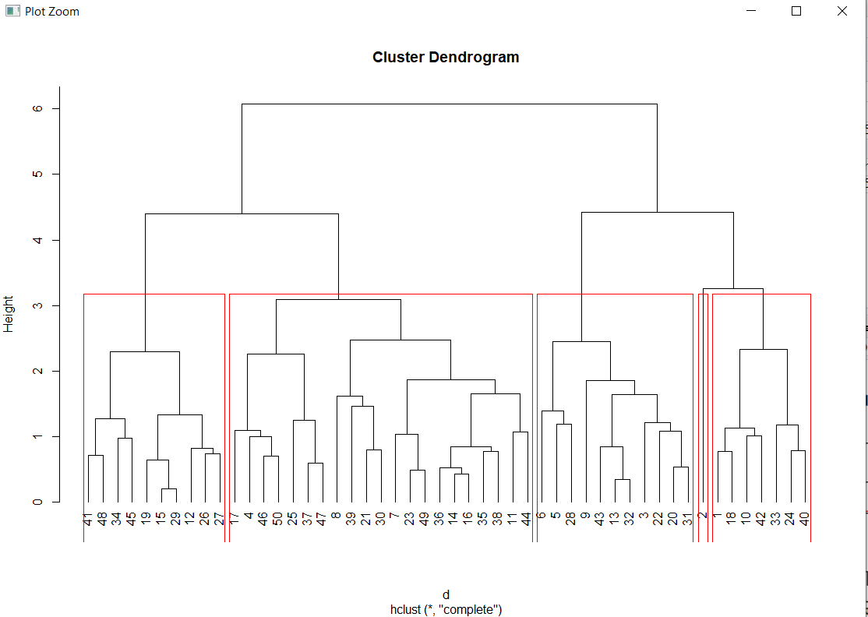

**Inferences:**

* Group 5 has least number of crimes compared to all the other groups but urban pops are high
* Group 4 has high Murder, Assault and rape rate
* Group 2 also has high Murder, Assault and rape rate more than Group4
* Group 3 has high Assault rate

**PYTHON ANALYSIS:**

* Import the dataset airlines to perform the analysis
* Normalize the data and perform clustering on the normalized data
* Plot the cluster plot as shown below
* Now import linkage from scipy
* Now download the final clustered csv to the working directory
* View that using the os.getcwd()

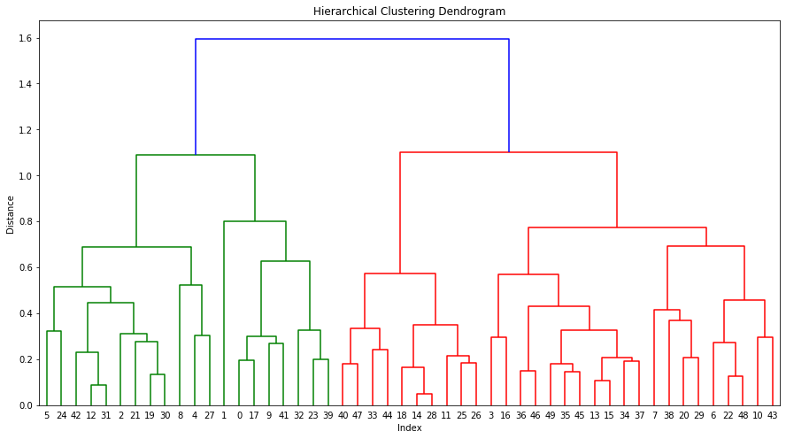

# Hints:

1. Business Problem
   1. Objective
   2. Constraints (if any)
2. Data Pre-processing

2.1 Data cleaning, Feature Engineering, EDA etc.

1. Model Building
   1. Partition the dataset
   2. Model(s) - Reasons to choose any algorithm
   3. Model(s) Improvement steps
   4. Model Evaluation
   5. Python and R codes
2. Deployment

4.1 Deploy solutions using R shiny and Python Flask.

1. Result Share the benefits/impact of the solution - how or in what way the business (client) gets benefit from the solution provided.

**Note:**

1. For each assignment the solution should be submitted in the format
2. Research and Perform all possible steps for improving the model(s) accuracy Ex: Feature Engineering, Hyper Parameter tuning, etc.
3. All the codes (executable programs) are running without errors
4. Documentation of the module should be submitted along with R & Python codes, elaborating on every step mentioned here