**Probability**

**Class link:** <https://www.youtube.com/watch?v=ZE718YLHRtw&list=PLLgJVrtHe9RrphFnUSJOB7ZIEF31Ggyuf>

**Probability:**

Probability is a numerical description of how likely an event is to occur or how likely it is that a proposition is true. Probability is a number between 0 and 1, where, roughly speaking, 0 indicates impossibility and 1 indicates certainty.

* The probability of all the events in a sample space sums up to 1.
* **For example**, when we toss a coin, either we get Head OR Tail, only two possible outcomes are possible (H, T). But if we toss two coins in the air, there could be three possibilities of events to occur, such as both the coins show heads or both shows tails or one shows heads and one tail, i.e.(H,H), (H,T),(T,T).

**Formula for Probability:**

The probability formula is defined as the possibility of an event to happen is equal to the ratio of the number of favourable outcomes and the total number of outcomes.

**Probability of event to happen P(E) = Number of favourable outcomes/Total Number of outcomes**

**Ex:** In a class there are 12 boys and 8 girls, find the probability the selected student will be a boy?

**Ans:** Here Total outcome = 20(no of students in a class)

Favourable outcome = 12 (No of boys in a class)

P(E) = Favourable outcome/total outcome

12/20 =0.6

## Probability of an Event:

Assume an event E can occur in r ways out of a sum of n probable or possible **equally likely ways**. Then the probability of happening of the event or its success is expressed as;

P(E) = r/n

The probability that the event will not occur or known as its failure is expressed as:

P(E’) = n-r/n = 1-r/n

E’ represents that the event will not occur.

Therefore, now we can say;

**P(E) + P(E’) = 1**

This means that the total of all the probabilities in any random test or experiment is equal to 1.

### **What are Equally Likely Events?**

When the events have the same theoretical probability of happening, then they are called equally likely events. The results of a sample space are called equally likely if all of them have the same probability of occurring. For example, if you throw a die, then the probability of getting 1 is 1/6. Similarly, the probability of getting all the numbers from 2,3,4,5 and 6, one at a time is 1/6. Hence, the following are some examples of equally likely events when throwing a die:

* Getting 3 and 5 on throwing a die
* Getting an even number and an odd number on a die
* Getting 1, 2 or 3 on rolling a die

are equally likely events, since the probabilities of each event are equal.

### **Complementary Events:**

The possibility that there will be only two outcomes which states that an event will occur or not. Like a person will come or not come to your house, getting a job or not getting a job, etc. are examples of complementary events. Basically, the complement of an event occurring in the exact opposite that the probability of it is not occurring. Some more examples are:

* It will rain or not rain today
* The student will pass the exam or not pass.

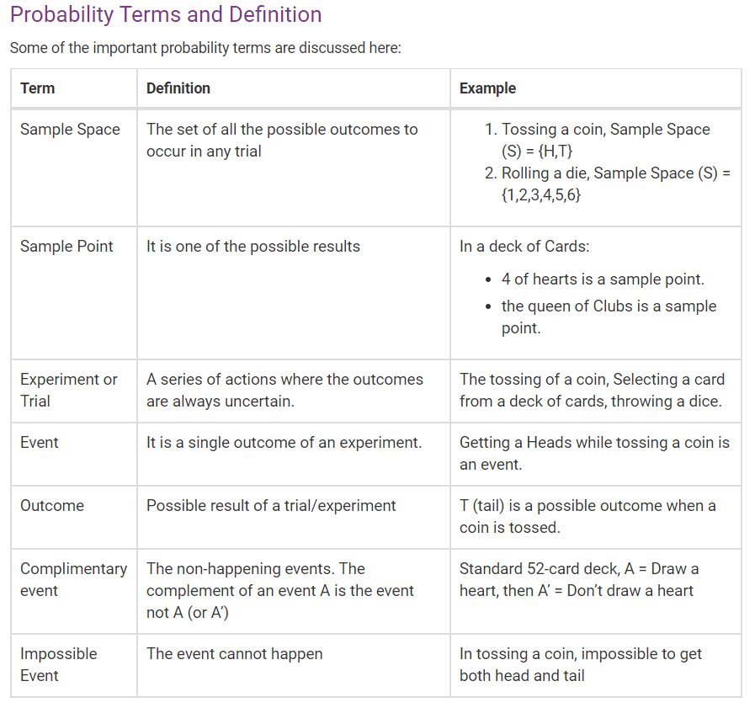

**Sets:**

* A set is a well-defined collection of objects.
* Each object in a set is called an element of the set.
* Two sets are equal if they have exactly the same elements in them.
* A set that contains no elements is called a null set or an empty set.
* If every element in Set A is also in Set B, then Set A is a subset of Set B.
* The empty set, written as /0 or {}, is the set with no elements.

**Set Union:**

The union of two sets A and B, written A∪B, is the set of all elements that belong to A, or to B, or to both. Thus **A∪B = {x|x ∈ A or x ∈ B or both}**

**Set Intersection:**

The intersection of two sets A and B, written A∩B, is the set of all elements that belong to both the set A and to the set B. Thus **A∩B = {x|x ∈ A and x ∈ B}**

**Complete Notes on set :** <https://www.math.tamu.edu/~epstein/eHW/C1a.pdf>

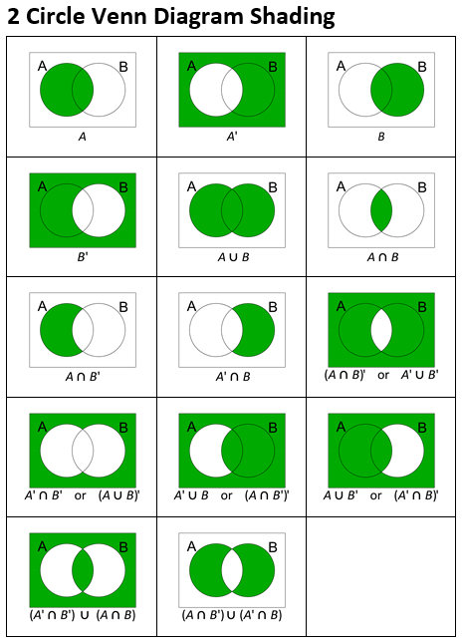

**The addition law:**

Events, like sets, can be combined to produce new events.

• A ∪ B denotes the event that event A or event B (or both) occur when the experiment is performed.

• A ∩ B denotes the event that both A and B occur together.

In this Section we obtain expressions for determining the probabilities of these combined events, which are written P(A ∪ B) and P(A ∩ B) respectively.

**Types of events:**

There are two types of events you will need to able to identify and work with: mutually exclusive events and independent events.

**Mutually exclusive events:**

Mutually exclusive events are events that by definition cannot happen together. For example, when tossing a coin, the events ‘head’ and ‘tail’ are mutually exclusive; when testing a switch ‘operate’ and ‘fail’ are mutually exclusive; and when testing the tensile strength of a piece of wire, ‘hold’ and ‘snap’ are mutually exclusive. In such cases, the probability of both events occurring together must be zero. Hence, using the usual set theory notation for events A and B, we may write: P(A ∩ B) = 0, provided that A and B are mutually exclusive events

If two events A and B are mutually exclusive then P(A ∪ B) = P(A) + P(B)

If two events are A and B then P(A ∪ B) = P(A) + P(B) − P(A ∩ B) If A ∩ B = ∅, i.e. A and B are mutually exclusive, then P(A ∩ B) = P(∅) = 0, and this general expression reduces to the simpler case.

This rule can be extended to three or more events, for example: P(A ∪ B ∪ C) = P(A) + P(B) + P(C) − P(A ∩ B) − P(A ∩ C) − P(B ∩ C) + P(A ∩ B ∩ C)

**Conditional probability - dependent events:**

P(B|A) = P(A ∩ B) P(A) or, equivalently P(A ∩ B) = P(B|A)P(A)

The Multiplication Law

If A and B are independent events then P(A ∩ B) = P(A) × P(B) In words ‘The probability of independent events A and B occurring is the product of the probabilities of the events occurring separately.’

**Laws of Elementary Probability:**

Let a sample space S consist of the n simple distinct events E1, E2 . . . En and let A and B be events contained in S. Then:

(a) 0 ≤ P(A) ≤ 1. P(A) = 0 is interpreted as meaning that the event A cannot occur and P(A) = 1 is interpreted as meaning that the event A is certain to occur.

(b) P(A) + P(A0 ) = 1 where the event A0 is the complement of the event A

(c) P(E1) + P(E2) + · · · + P(En) = 1 where E1, E2, . . . En form the sample space

(d) If A and B are any two events then P(A ∪ B) = P(A) + P(B) − P(A ∩ B)

(e) If A and B are two mutually exclusive events then P(A ∪ B) = P(A) + P(B)

(f) If A and B are two independent events then P(A ∩ B) = P(A) × P(B).

**Bayes’ Theorem:**

is a way of finding a [probability](https://www.mathsisfun.com/data/probability.html) when we know certain other probabilities.

The formula is:

