Report and Meeting minutes

**USE- CASE:**

## **We have different elements of this use case diagram:**

## System

## -> The project that we are developing in a system.

## Actor

## -> Anyone who use to perform a certain function.

## Use Cases

## -> All the functionalites that system does in use case.

## Relationship

## -> We draw solid line Between actor and the use case to show the relationship.

## Use case diagram :

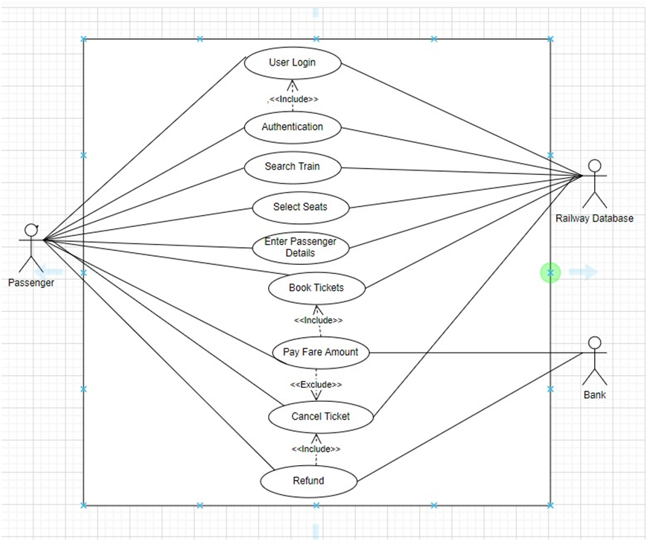

# **User Stories:**

## => Passenger need to login through the app, if the passenger is already used this app then it authenticates as valid user if not it shows invalid user as he need to give his personal details to create account to that app.

## => Valid passenger will go to the main menu of that app and invalid passenger will remain at the login page only.

## => Then the passenger has to search for the train and if there is availability he/she can book the tickets.

## => Then the passenger should pay the payment for booking his/her ticket to the bank and that data will be collected by that app.

## =>=> After the reservation successfully completed the Passenger can check the status of his/her ticket.

## => A passenger can apply for cancellation if they don’t want to travel due to some reasons.

## => After that passenger will get confirmation pop up will be displayed and then the passenger has to click ok button to confirm the final cancellation of train ticket.

## => A passenger he/she can be refunded after couple of days.

ER - DIAGRAM:

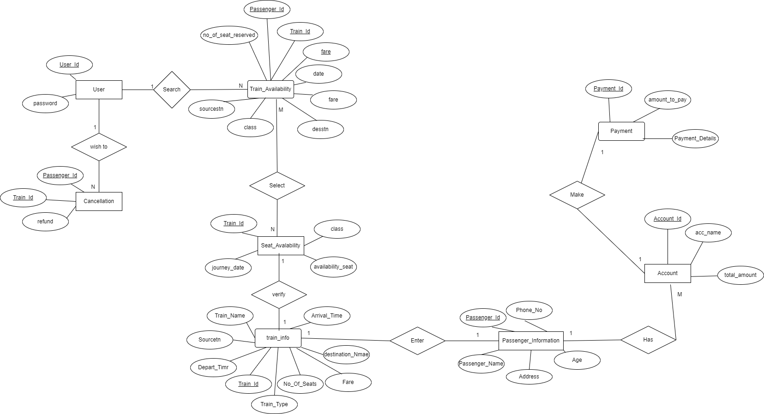

**Meeting minutes**

| **Week 1** | **date** | **Duration** | **platform** |
| --- | --- | --- | --- |
|  | **11 – 2 - 2022** | **20 minutes** | **Microsoft teams**  The meeting focused on the type of work that would be assigned to each team member, as well as a deadline for completing the task and reviewing it by the 15th. |
|  | **15 – 2- 2022** | **21 minutes** | **Microsoft teams**  The focus of this meeting was on the work that my team members had completed; we discussed it and adjusted some elements, and then my team members successfully finished the week 1 task. |