BugTrack_SruthiVejju_PES1UG24CS472_BPS#41
Bug Tracking project

- Bug Tracking Board created
The screenshot shows the successfully created Bug Tracking project board and shows all five reported bugs available on the Bug Tracking board.
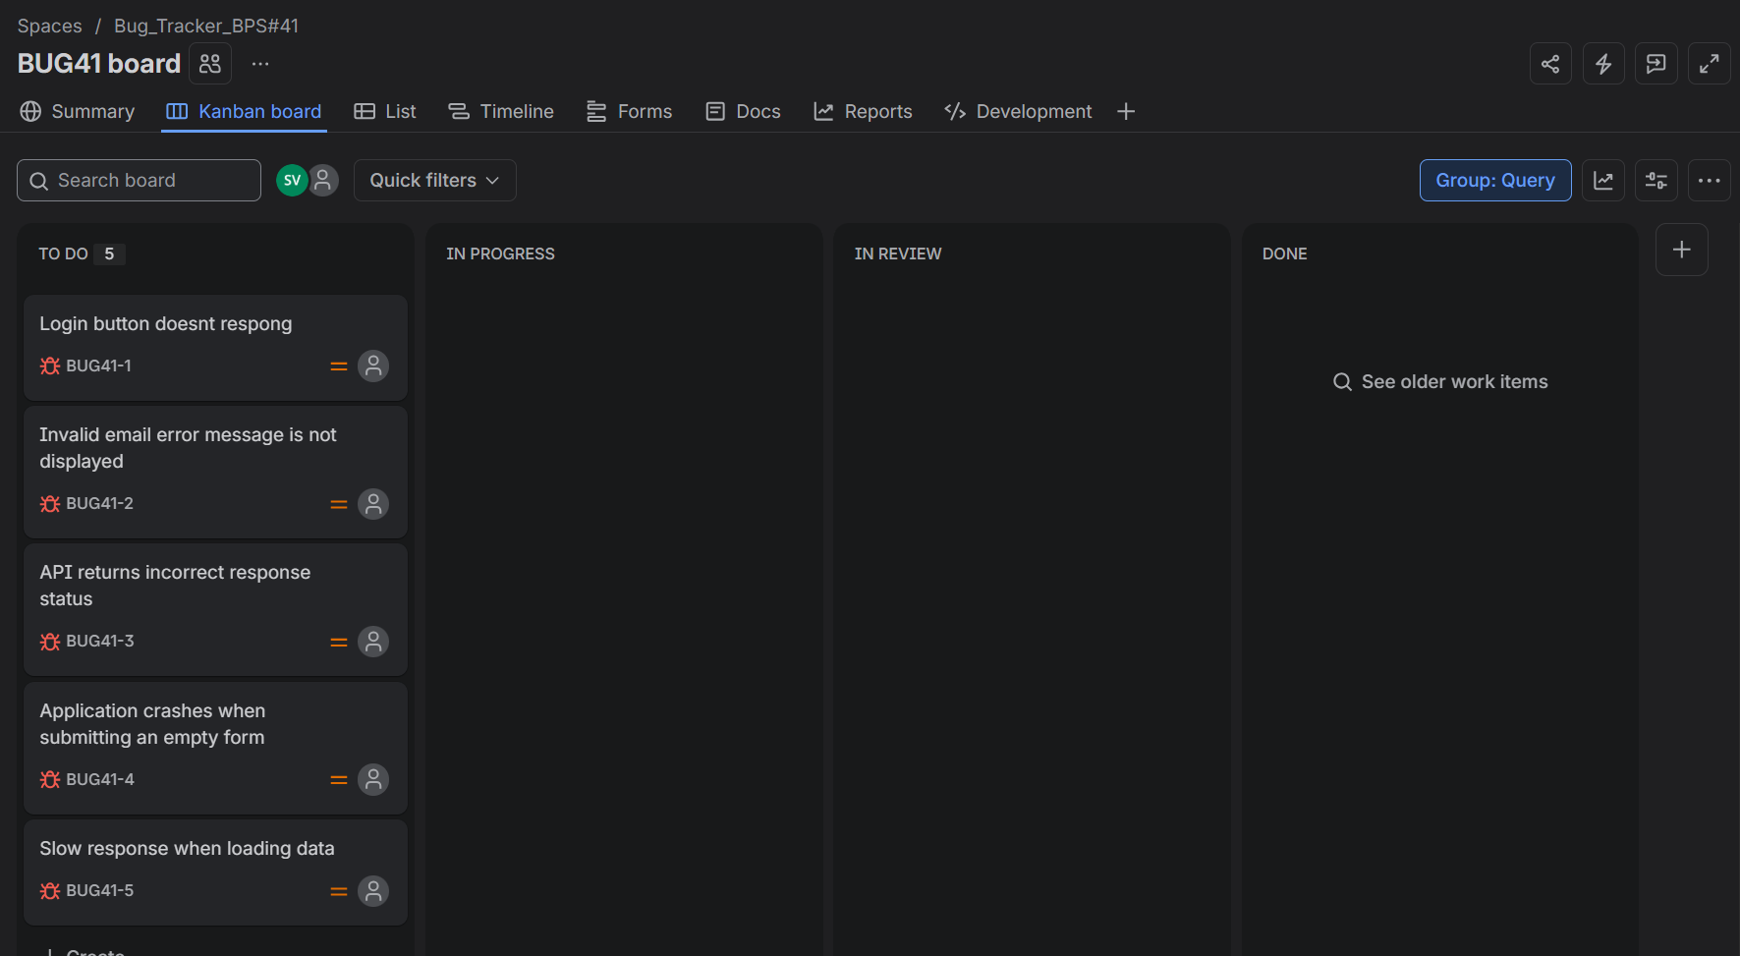

- Description adding
The screenshot shows the detailed description added to a reported bug.
