Kanban_SruthiVejju_PES1UG24CS472_BPS#41
Kanban Project
1. Board Creation – 5 FRs and 2 NFRs and Epic Assignment
The Kanban project board was created and populated with the five Functional Requirements (FR-001 to FR-005) and two Non-Functional Requirements (NFR-001 and NFR-002).
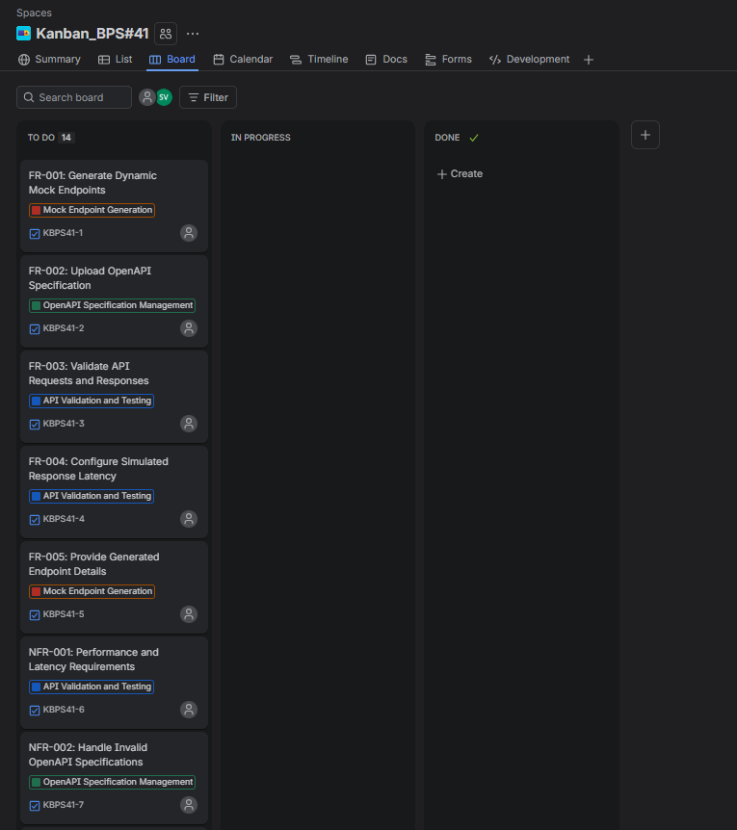
2. All Seven Stories
A separate story was created for each of the seven requirements/use cases, giving a total of seven stories.
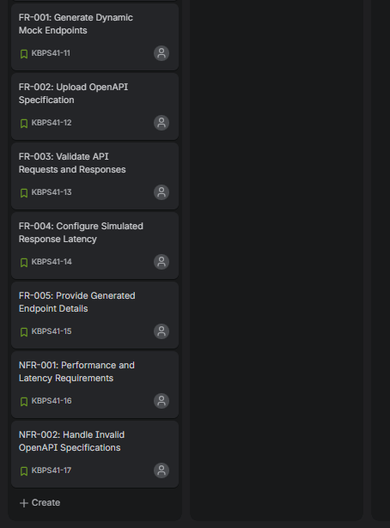
3. Task and Subtask Creation
Tasks and subtasks were added for all the Functional and Non-Functional Requirements. The following screenshots provide evidence of the created subtasks for FR-001 to FR-005 and NFR-001 to NFR-002.
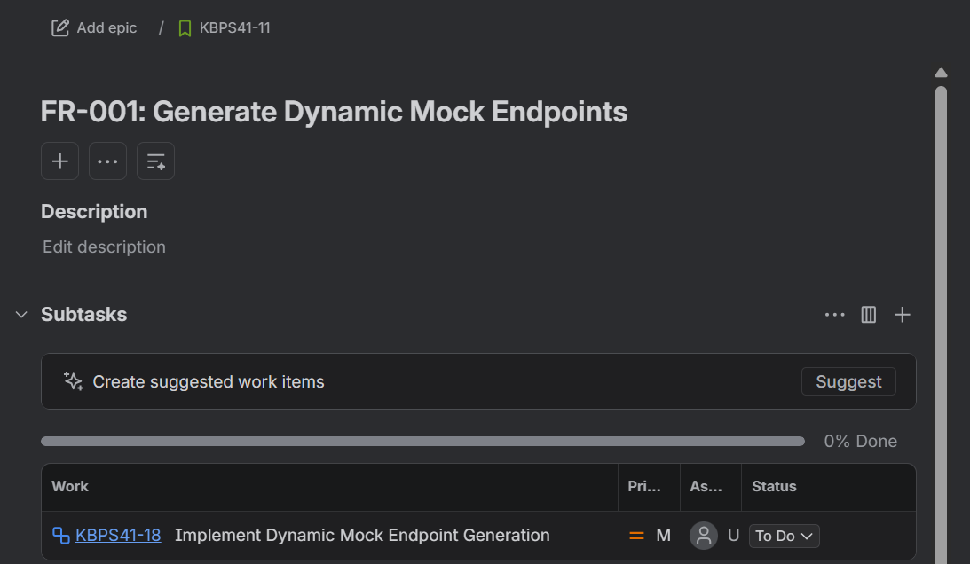
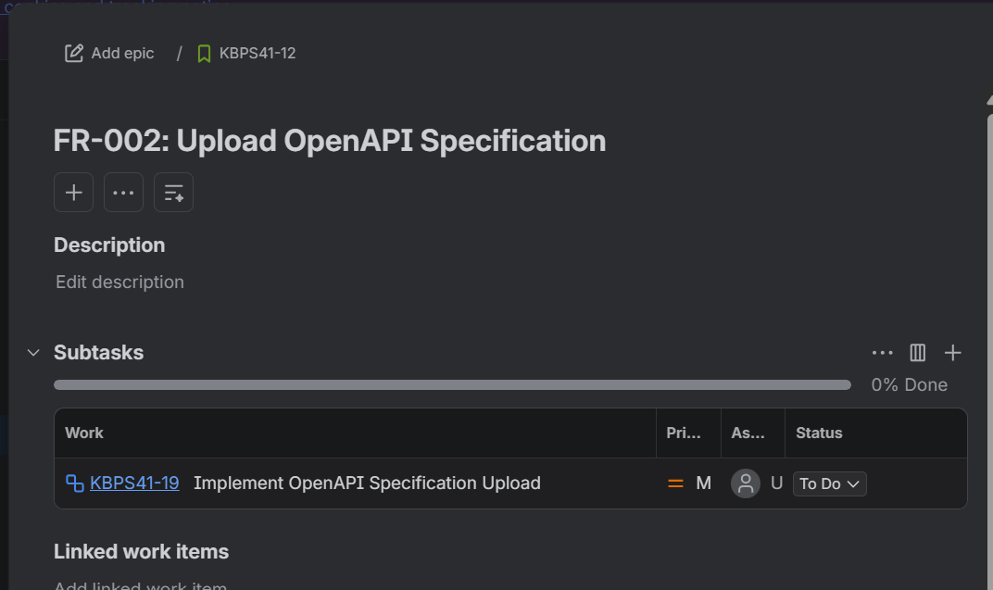
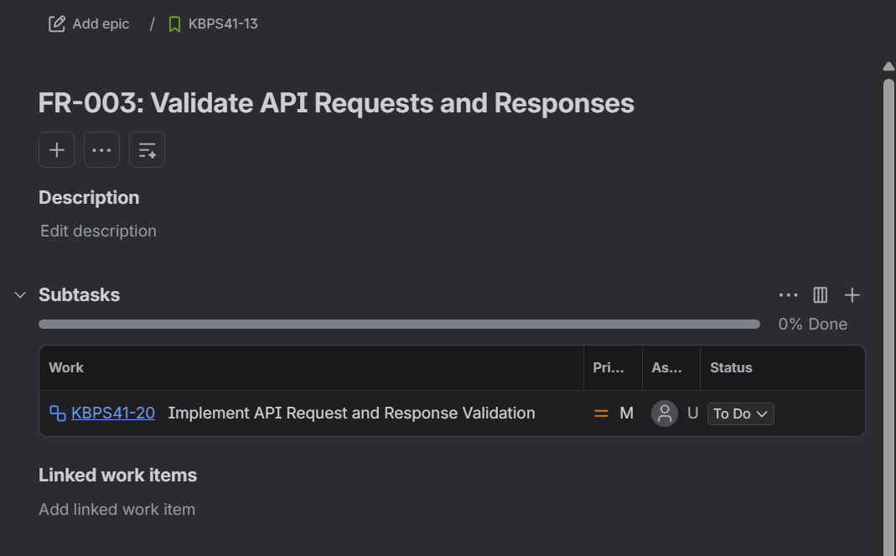

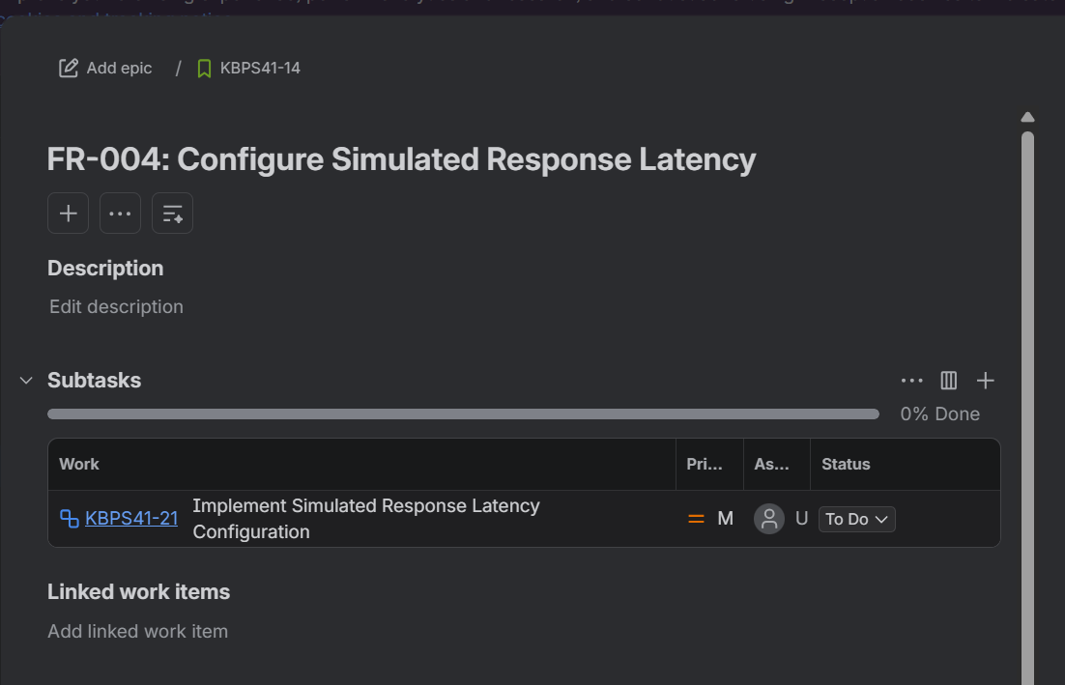
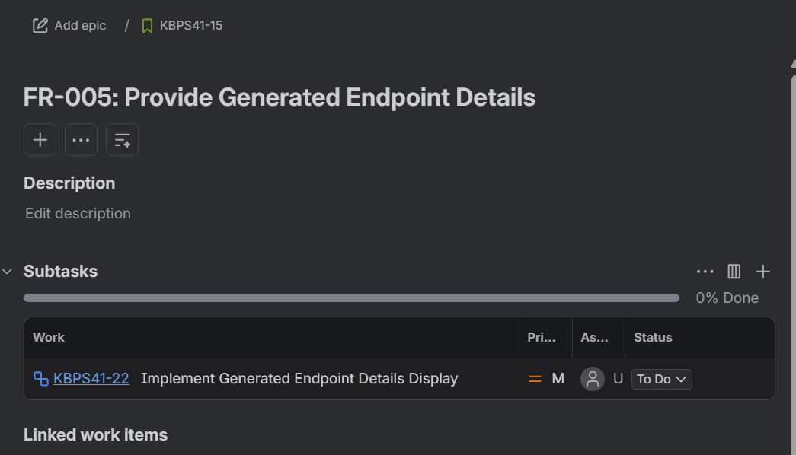
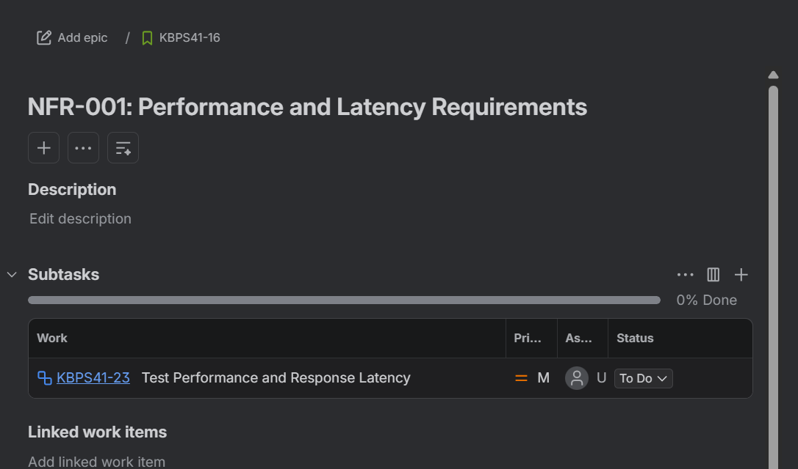
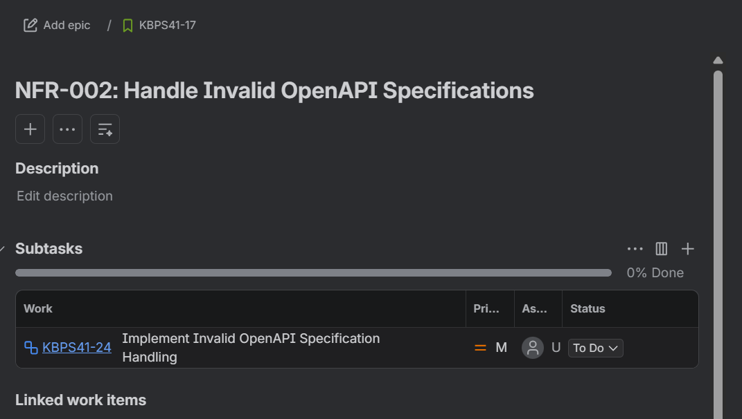
4. Backlog Creation
The seven stories were organised in the project backlog, ready for planning and assignment.
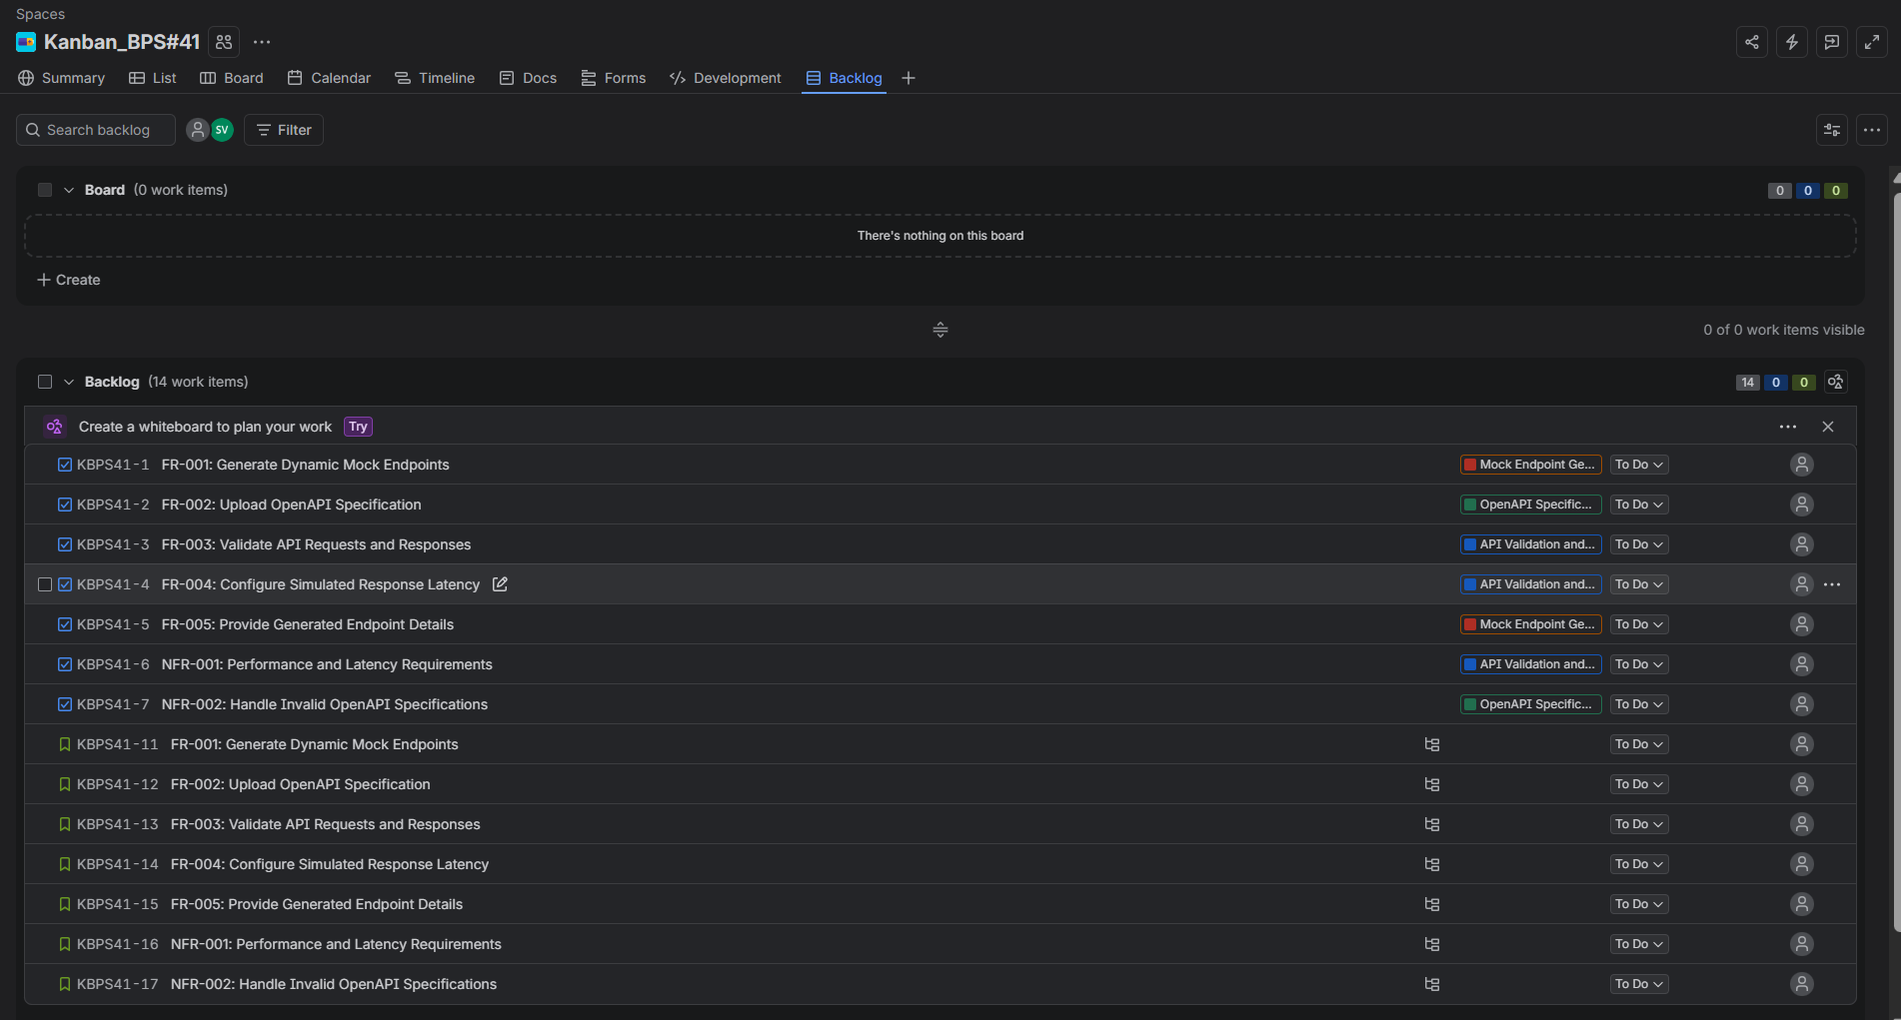

5. Sprints Enabled
The Sprints feature was enabled for the project so that backlog work items could be planned and managed within a sprint.
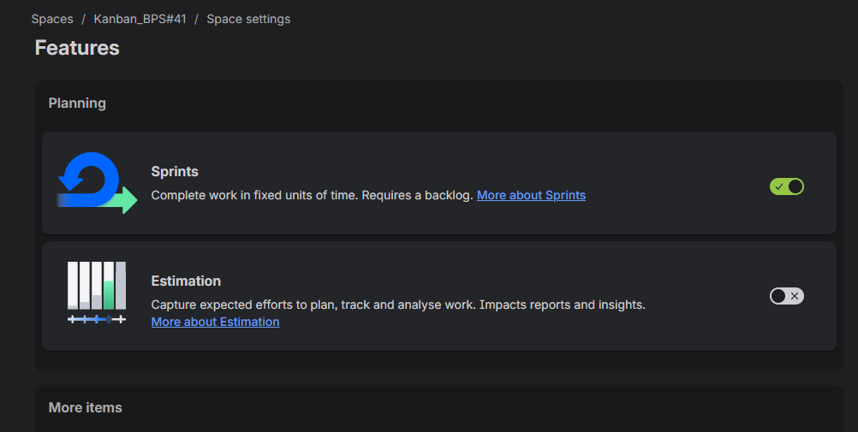
6. Stories Added to Sprint
The stories were added to the sprint, with the sprint configuration showing the planned work items and sprint dates.
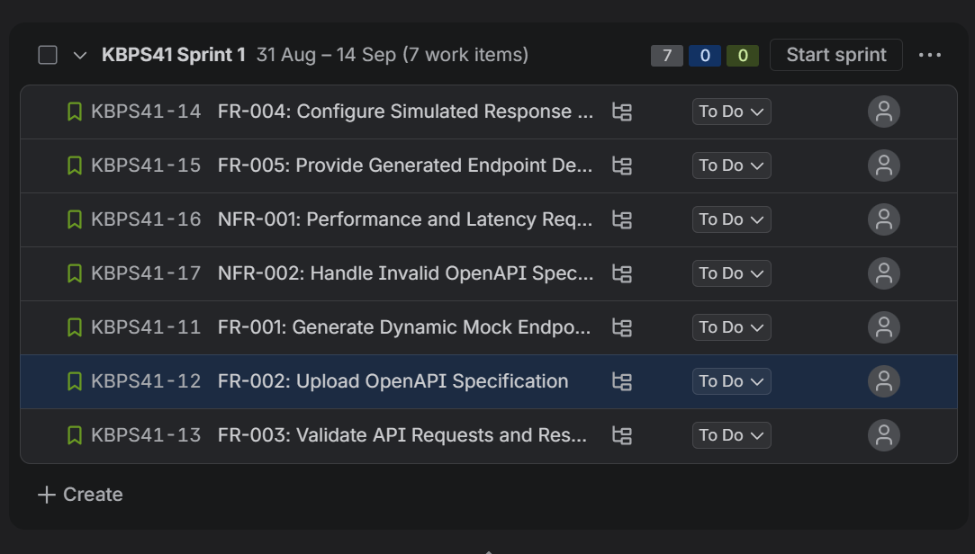

7. Epic Assignment to Stories
The backlog stories were assigned to the appropriate Epics: OpenAPI Specification Management, Mock Endpoint Generation, and API Validation and Testing.
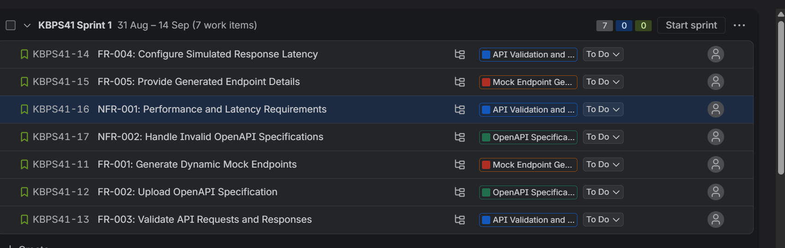
8. Sprint Started
The sprint was started successfully, and its work items were displayed on the board according to their workflow status.
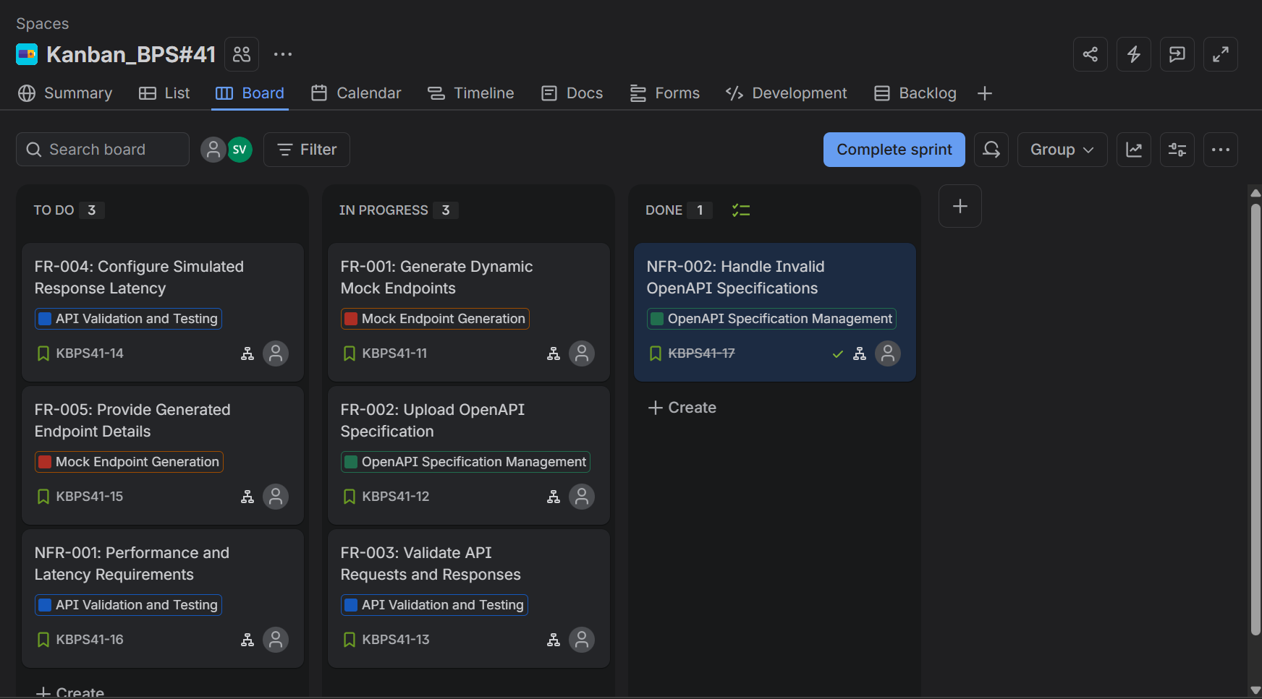

9. Sprint Completion
The sprint completion process was performed. Completed work remained completed, while incomplete work items were handled as open items and moved as required by the sprint completion workflow.
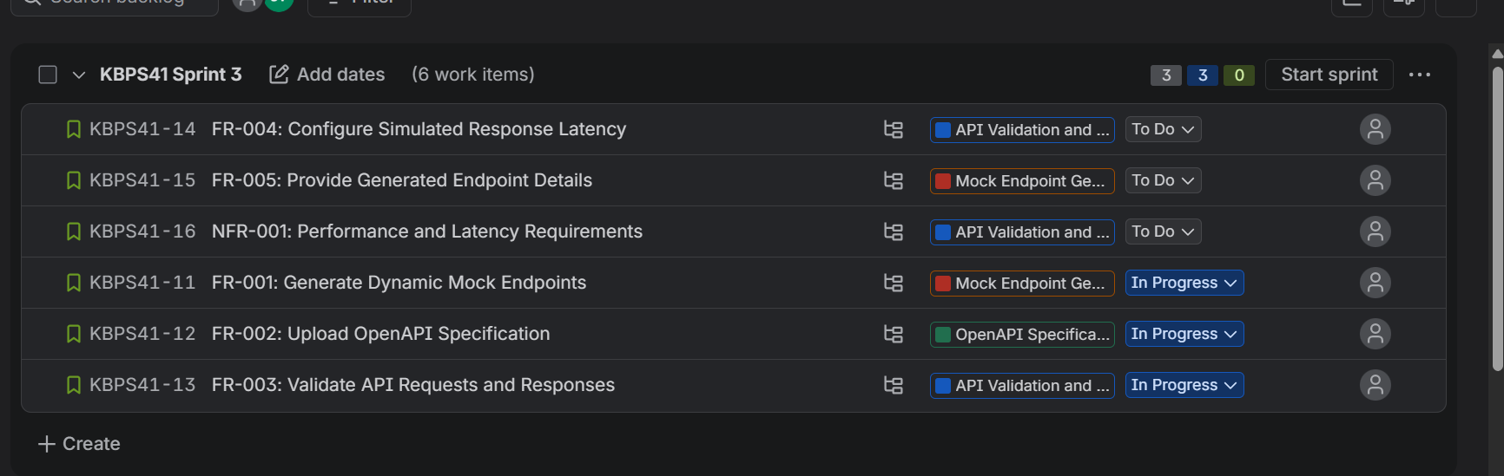

10. Burndown Chart
The burndown chart shows the remaining work items in the sprint over time compared with the ideal progress guideline.
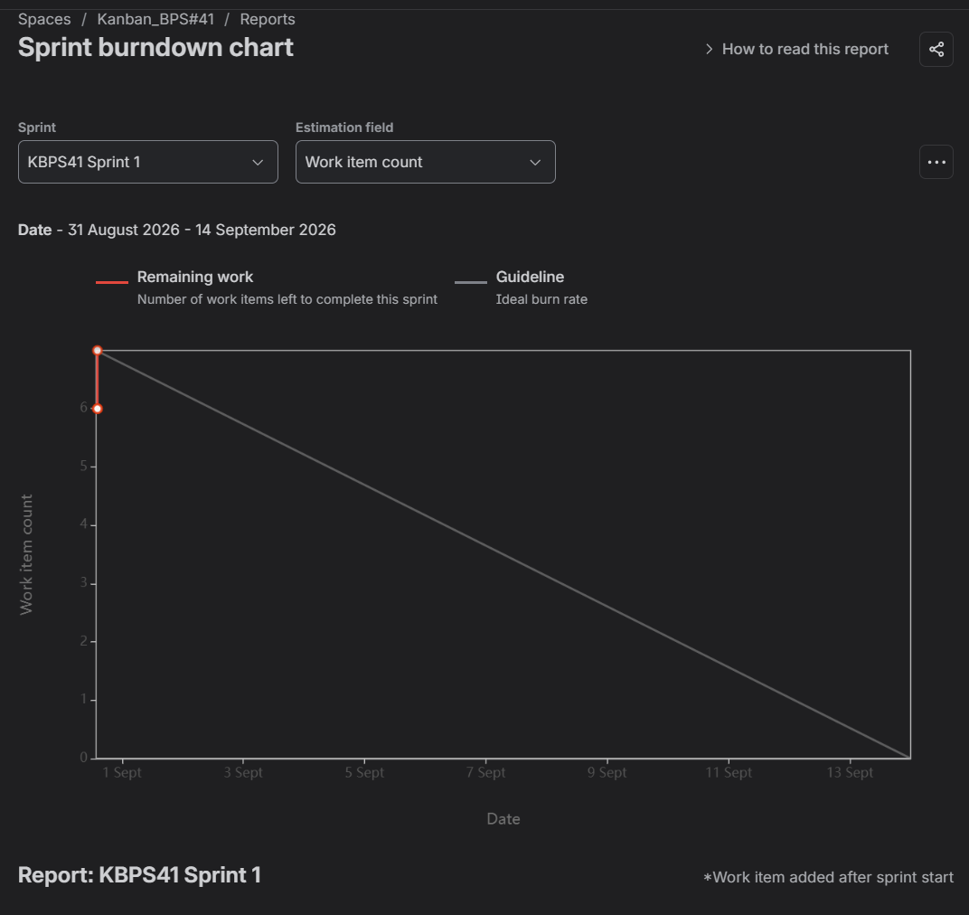

Reflection Questions
1. Did your estimations reflect the actual effort?
Yes, the estimations reasonably reflected the expected effort, as the work items were planned and distributed according to their complexity.
2. Was your backlog well-prioritized?
Yes, the backlog was prioritized by organizing the functional and non-functional requirements and assigning them appropriately for the sprint.
3. How did your simulated sprint align with your plan?
The simulated sprint generally aligned with the plan, with work items moving through the To Do, In Progress, and Done stages.
4. What insights did the burndown chart give about your team’s capacity?
The burndown chart showed the amount of remaining work and helped indicate the team's capacity and progress during the sprint.

