ScrumProject_Sruthi Vejju_PES1UG24CS472_BPS#41
Scrum Project

- Task Creation – 5 FRs and 2 NFRs and Epic Assignment
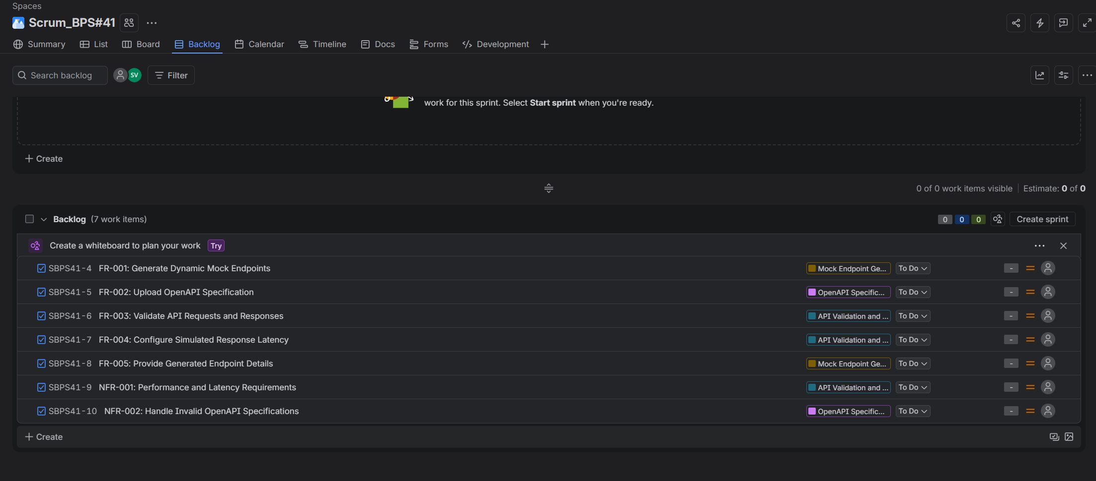
Screenshot of the Scrum backlog showing all seven requirements as user stories, with the corresponding epics assigned.

- SubTask Creation

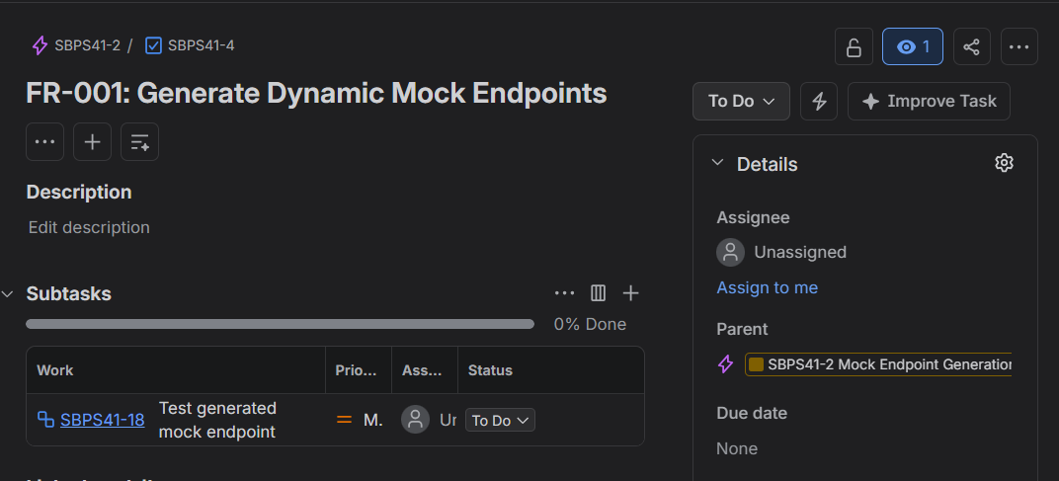
Screenshot showing the FR-001 user story with its subtask, demonstrating the breakdown of work into a smaller actionable item.
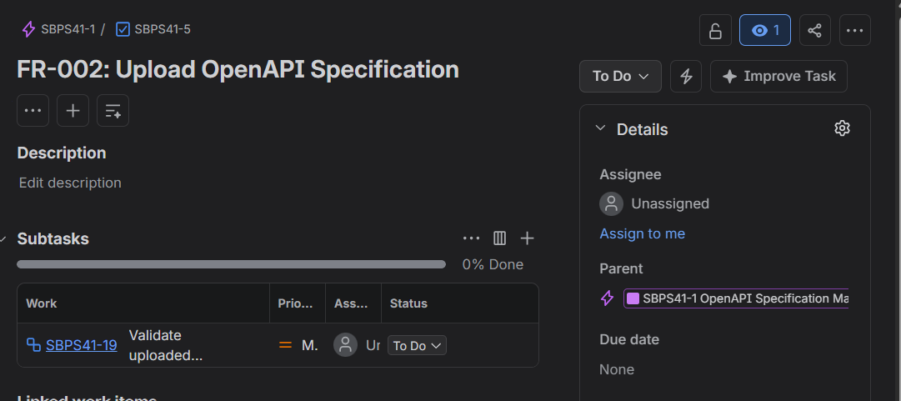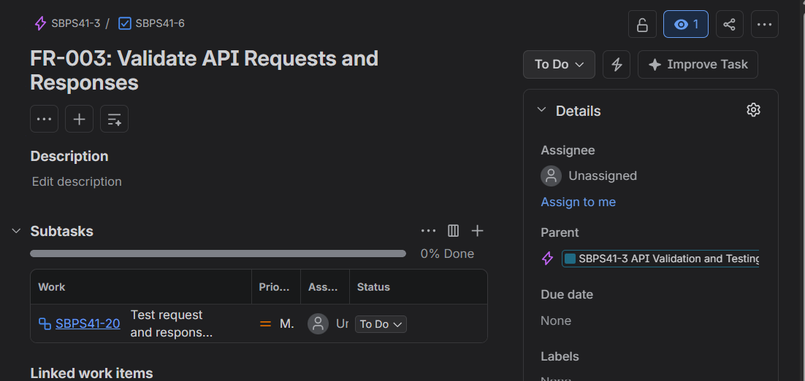
Screenshot showing the FR-002 user story with its associated subtask for managing the OpenAPI specification.
Screenshot showing the FR-003 user story with a subtask created for API request and response validation.
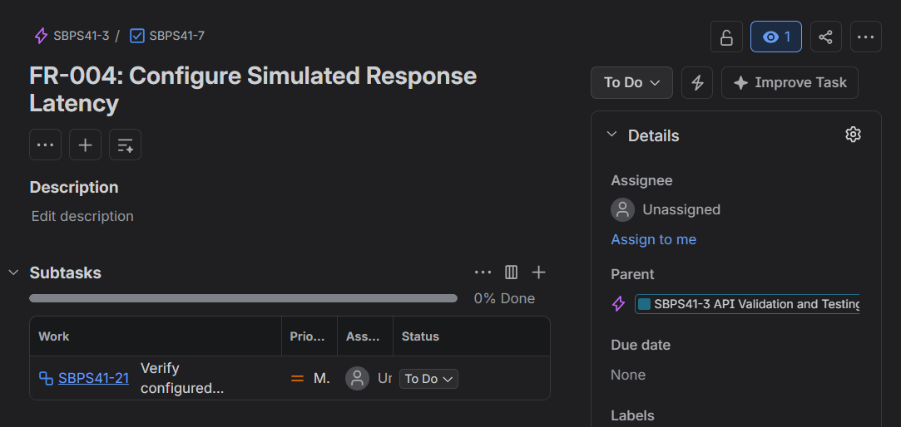
Screenshot showing the FR-004 user story with a subtask created for configuring simulated response latency.

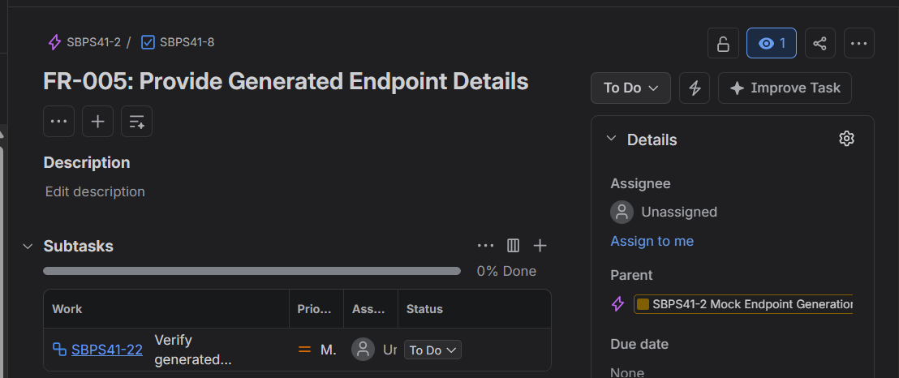
Screenshot showing the FR-005 user story with a subtask created for providing generated endpoint details.
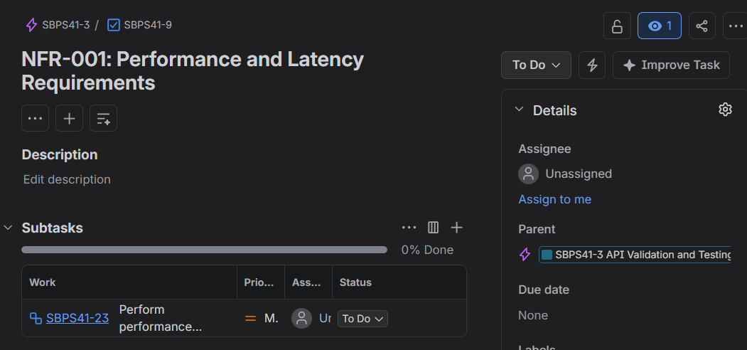
Screenshot showing the NFR-001 user story with a subtask for addressing performance and latency requirements.
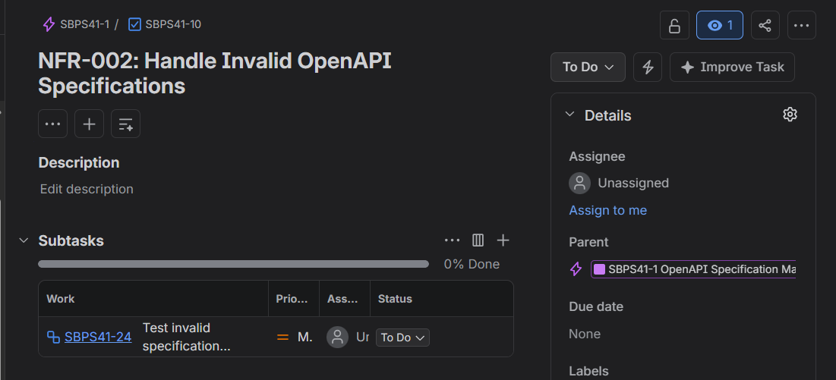
Screenshot showing the NFR-002 user story with a subtask for handling invalid OpenAPI specifications.

- Story creation and Epic assignment
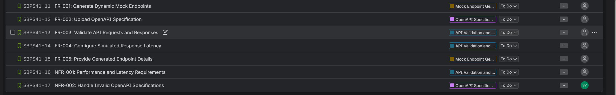
Screenshot of the backlog list showing all seven user stories organized with their respective epic assignments.

- Sprint Creation with story point and priority

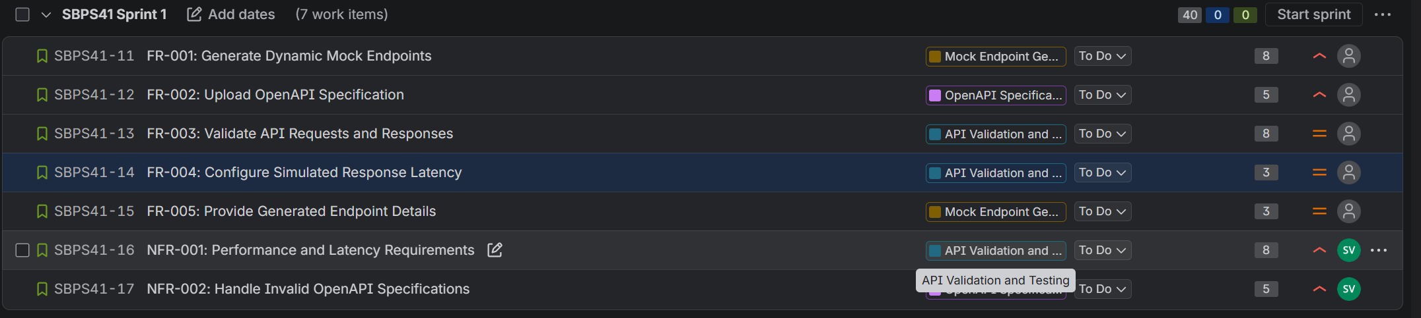
Screenshot showing the complete set of backlog items with epics and workflow status visible.

- Sprint Started 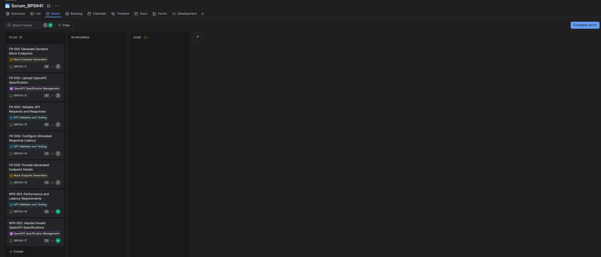
Screenshot showing the Scrum project backlog and sprint planning area before the work items are organized into sprints.
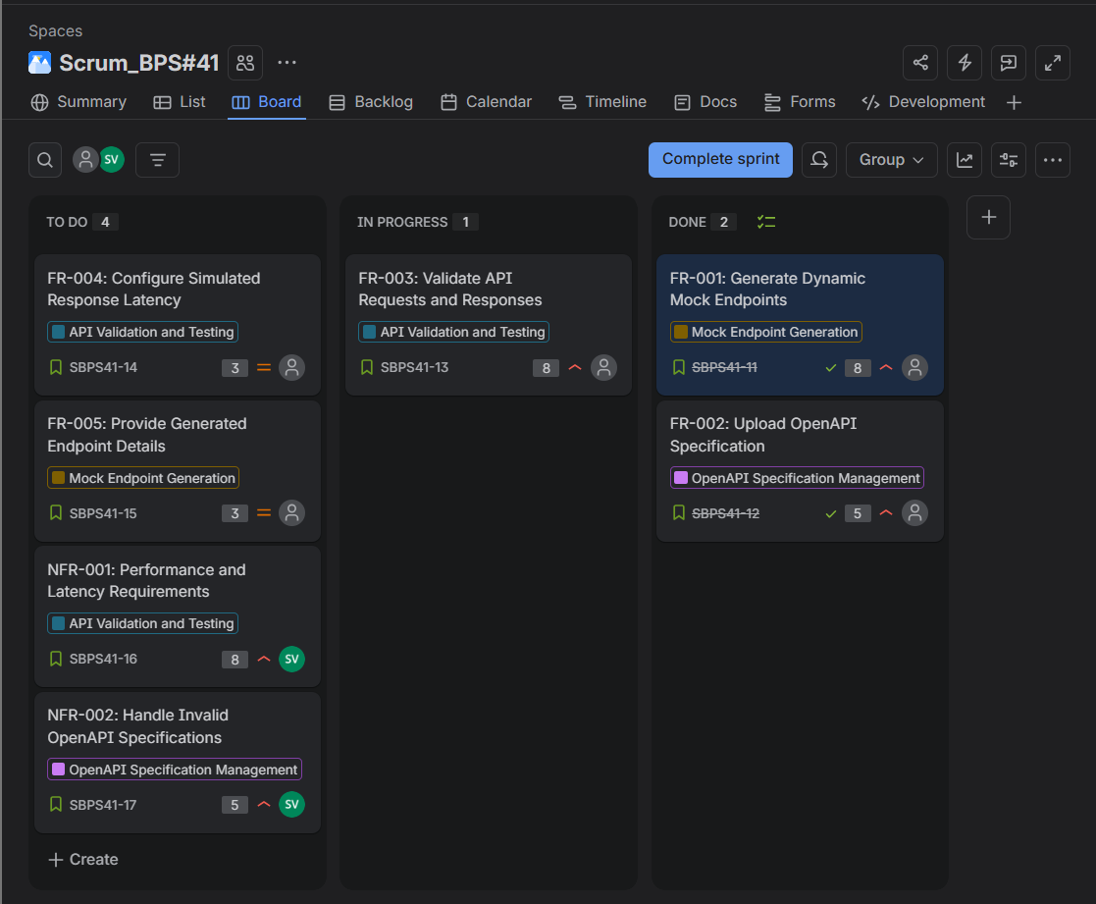
Screenshot of the Scrum board showing user stories distributed across the To Do, In Progress, and Done workflow columns.

- Second Sprint Started
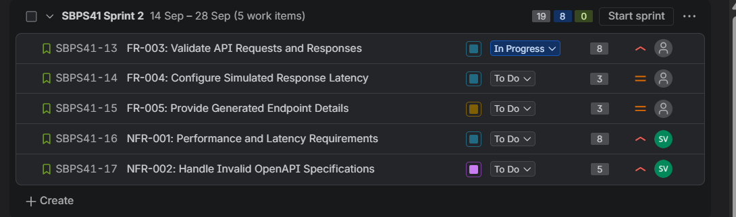
Screenshot showing Sprint 2 with the planned work items, their story points, priorities, and current statuses.
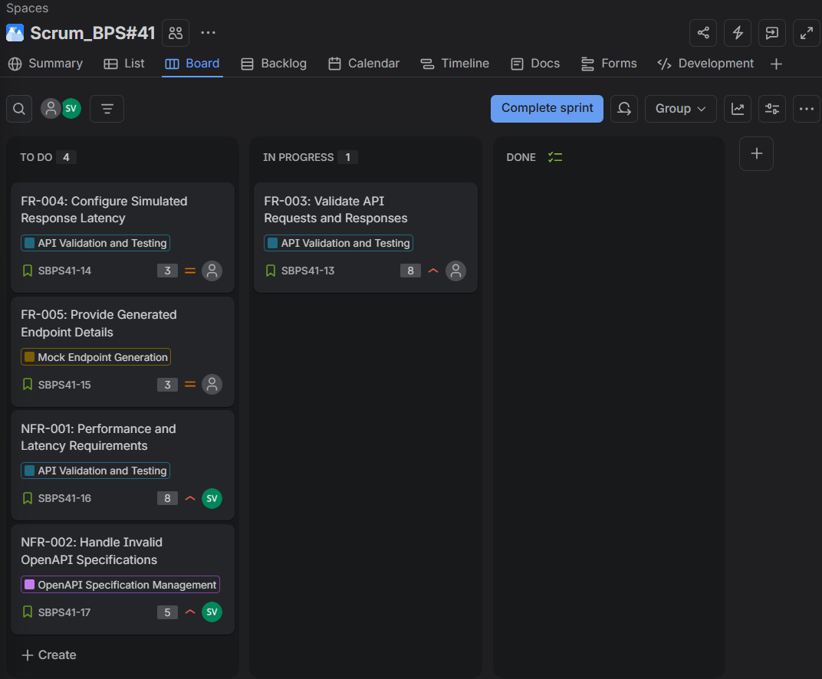
Screenshot showing the Scrum board after sprint planning, illustrating the distribution and progress of the sprint work items.
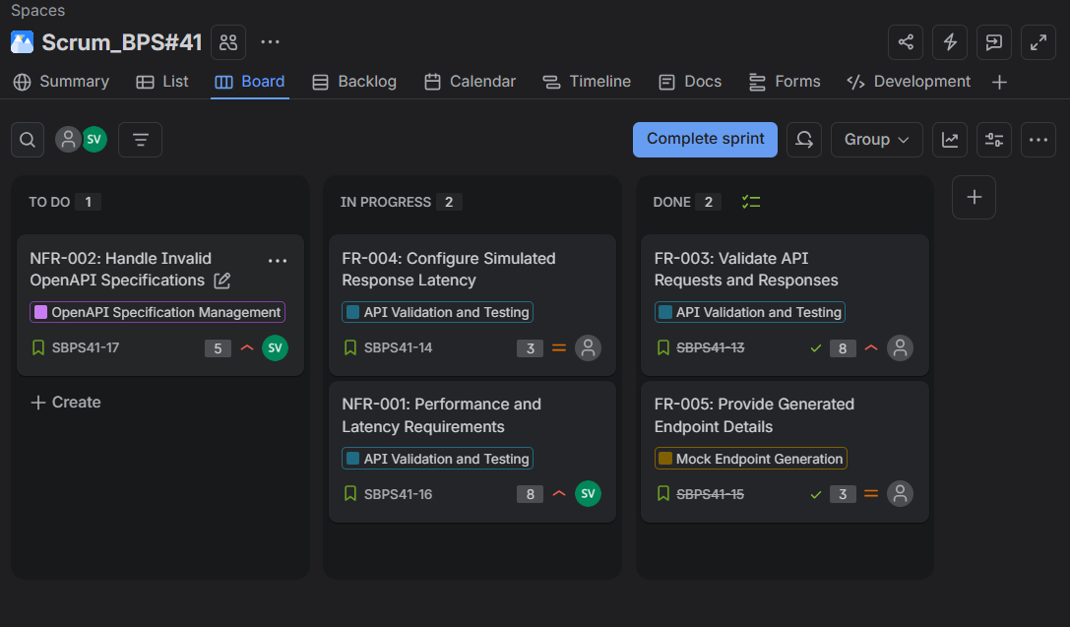
Screenshot of the active Scrum board showing the movement of work items across workflow stages during the simulated sprint.

- Burndown Chart

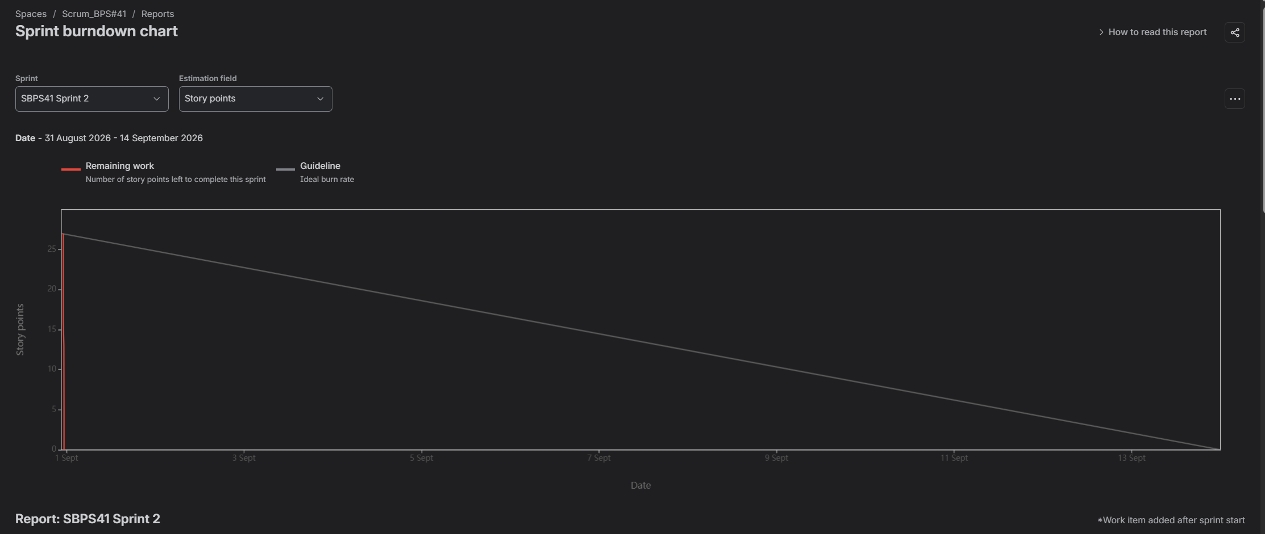
Sprint Burndown Chart: This chart visualizes the remaining story points throughout the sprint and compares the actual progress with the ideal burndown guideline.

Reflection Questions
1. Did your estimations reflect the actual effort?
Yes, the story point estimations reasonably reflected the relative effort and complexity of the user stories during the simulated sprints.
2. Was your backlog well-prioritized?
Yes, the backlog was prioritized based on the importance and impact of the functional and non-functional requirements.
3. How did your simulated sprint align with your plan?
The simulated sprints generally followed the planned workflow, with stories progressing through the To Do, In Progress, and Done stages.
4. What insights did the burndown chart give about your team's capacity?
The burndown chart showed how the remaining story points decreased during the sprint and provided an indication of the team's capacity to complete planned work.

