**Q.1. (a) Write a program in assembly language to print the numbers from 0 to 9.**

**CODE:**

**ORG 100h**

**MOV CX, 10**

**MOV AL, 0**

**print_loop:**

**ADD AL, '0'**

**MOV DL, AL**

**MOV AH, 02h**

**INT 21h**

**SUB AL, '0'**

**INC AL**

**LOOP print_loop**

**MOV AH, 4Ch**

**INT 21h**

**END**

**Output:  
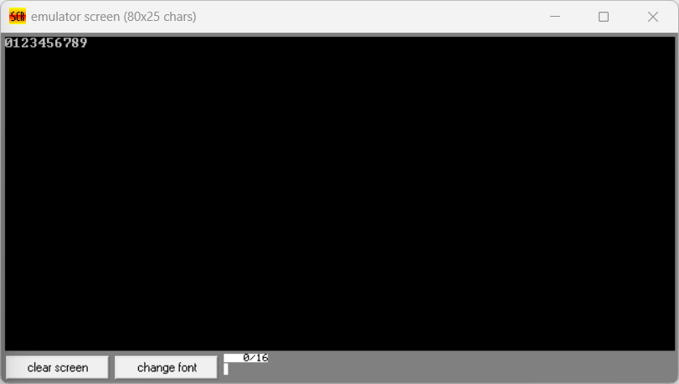  
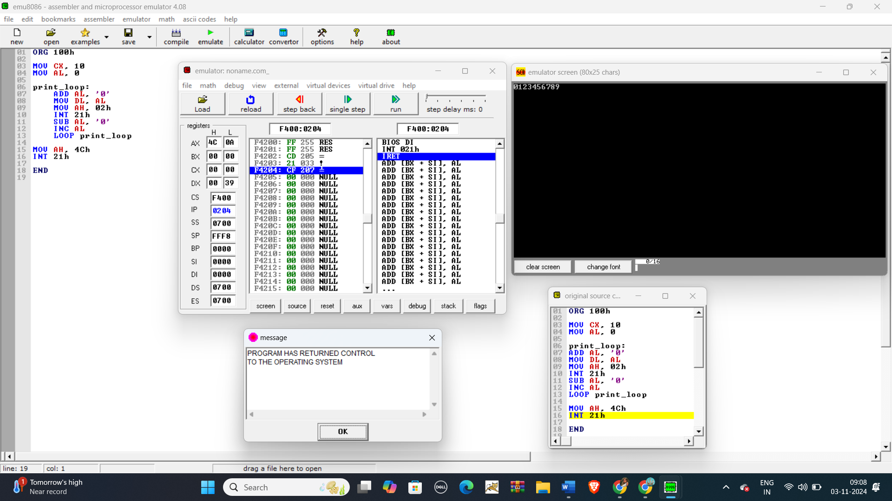**

**Q 1. (b) Write an assembly language program to print the characters from A to Z in reverse order.**

**CODE:**

**ORG 100h**

**MOV CX, 26**

**MOV AL, 'Z'**

**print_loop:**

**MOV DL, AL**

**MOV AH, 02h**

**INT 21h**

**DEC AL**

**LOOP print_loop**

**MOV AH, 4Ch**

**INT 21h**

**END**

**Output:**

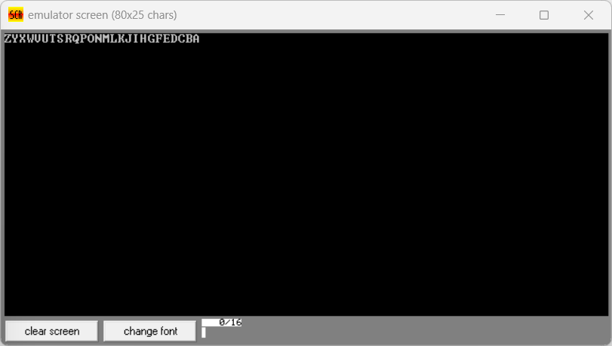

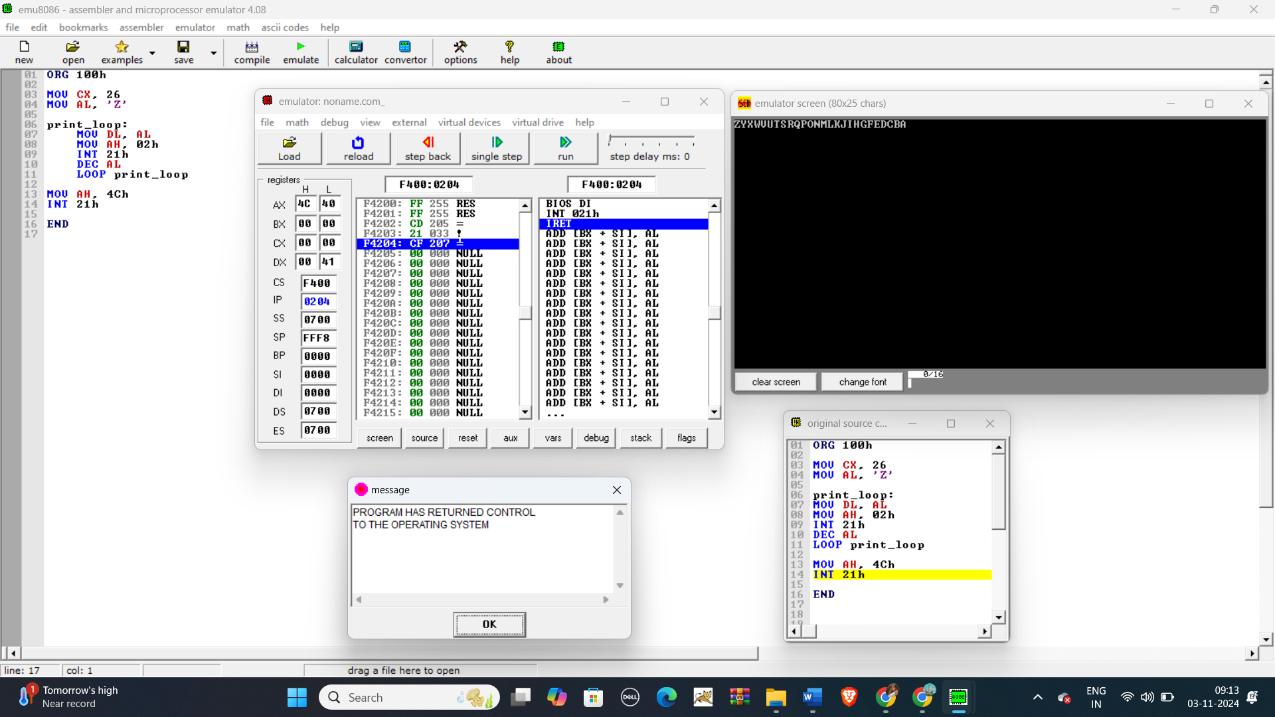

**Q 2. (a) Write a program in assembly language to print the numbers from 0 to 9 in reverse order.**

**CODE:**

**ORG 100H**

**MOV CX, 10**

**MOV DL, '9'**

**PRINT_LOOP:**

**MOV AH, 2**

**INT 21H**

**DEC DL**

**LOOP PRINT_LOOP**

**MOV AH, 4CH**

**INT 21H**

**Output:** 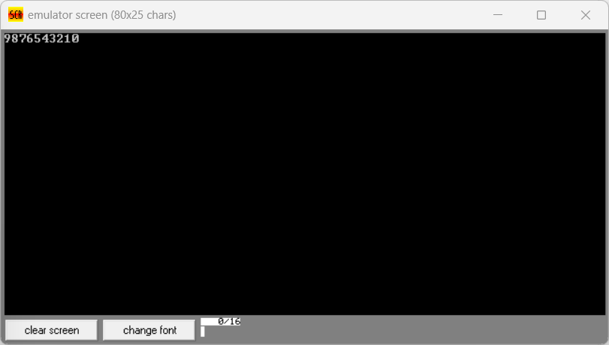

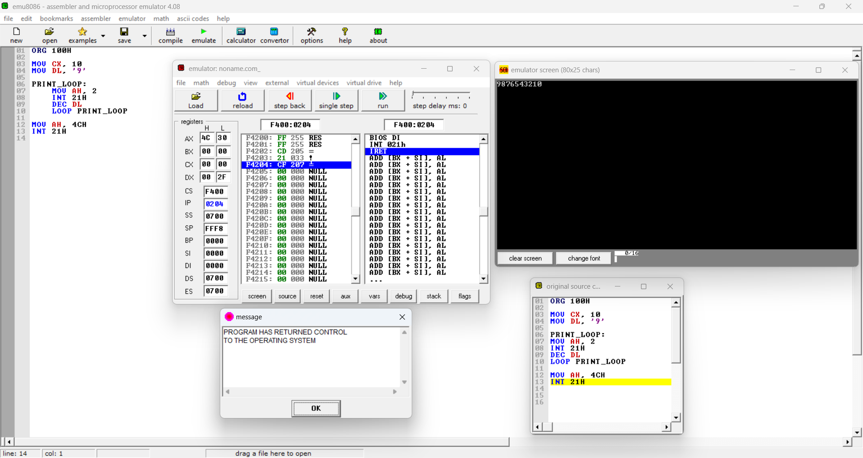

**Q 2. (b) Write an assembly language program to print the characters from A to Z.**

**CODE:**

**ORG 100H**

**MOV CX, 26**

**MOV DL, 'A'**

**PRINT_LOOP:**

**MOV AH, 2**

**INT 21H**

**INC DL**

**LOOP PRINT_LOOP**

**MOV AH, 4CH**

**INT 21H**

**Output:**

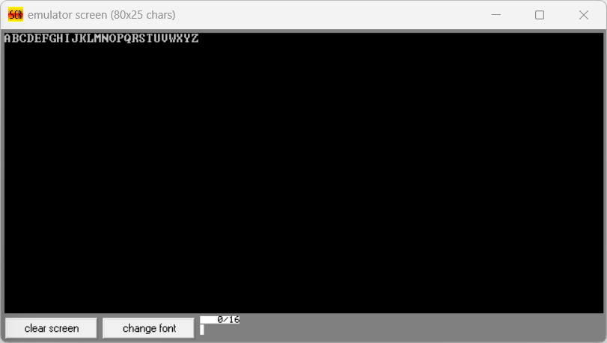

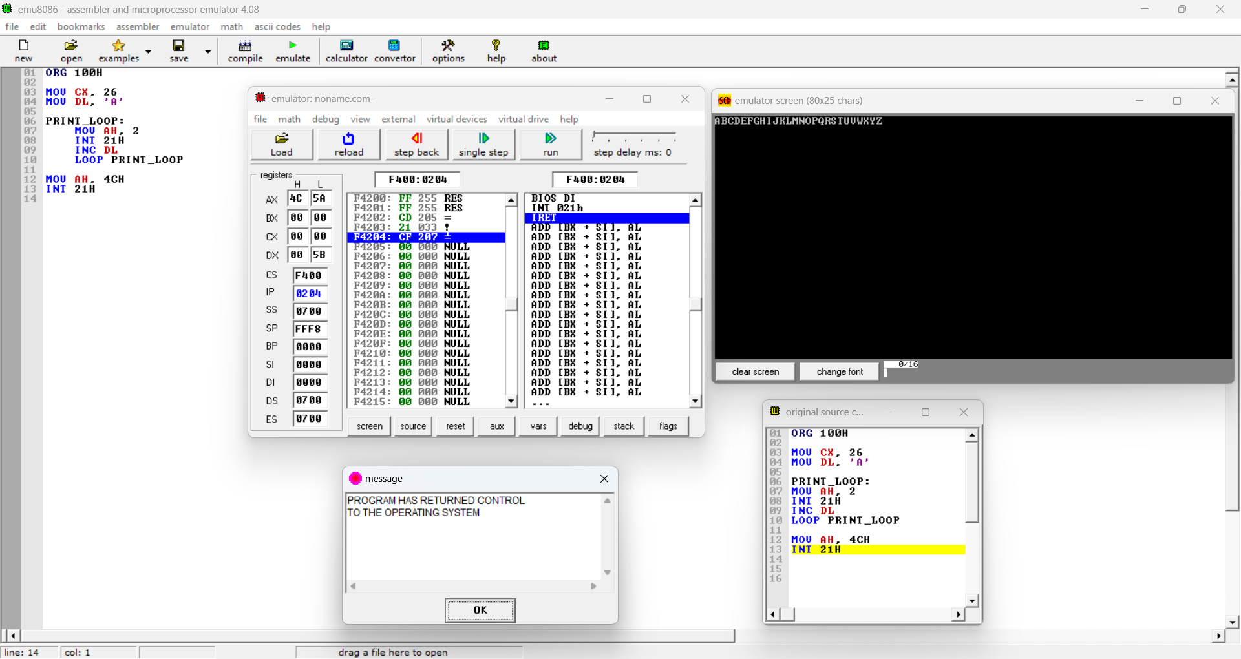

**Git hub Repository link:**

[**https://github.com/SruthiVihitha/COA-Lab_task-10.git**](https://github.com/SruthiVihitha/COA-Lab_task-10.git)