**Q.1. (a) Write a program in assembly language to find L.C.M of two single-digit numbers.**

**CODE:**

**.model small**

**.stack 100h**

**.data**

**num1 db 8**

**num2 db 17**

**gcd_res db 0**

**lcm_res dw 0**

**msg db 'LCM is: $'**

**.code**

**main:**

**mov ax, @data**

**mov ds, ax**

**mov al, num1**

**mov bl, num2**

**call gcd**

**mov gcd_res, al**

**mov al, num1**

**mov ah, 0**

**mov dl, num2**

**mul dl**

**mov cl, gcd_res**

**div cl**

**mov lcm_res, ax**

**mov ah, 09h**

**lea dx, msg**

**int 21h**

**mov ax, lcm_res**

**call print_num**

**mov ah, 4Ch**

**int 21h**

**gcd proc**

**cmp bl, 0**

**je end_gcd**

**gcd_loop:**

**mov ah, 0**

**div bl**

**mov al, bl**

**mov bl, ah**

**cmp bl, 0**

**jne gcd_loop**

**end_gcd:**

**ret**

**gcd endp**

**print_num proc**

**mov cx, 0**

**mov bx, 10**

**convert_loop:**

**xor dx, dx**

**div bx**

**push dx**

**inc cx**

**cmp ax, 0**

**jne convert_loop**

**print_digits:**

**pop dx**

**add dl, '0'**

**mov ah, 02h**

**int 21h**

**loop print_digits**

**ret**

**print_num endp**

**end main**

**Output:  
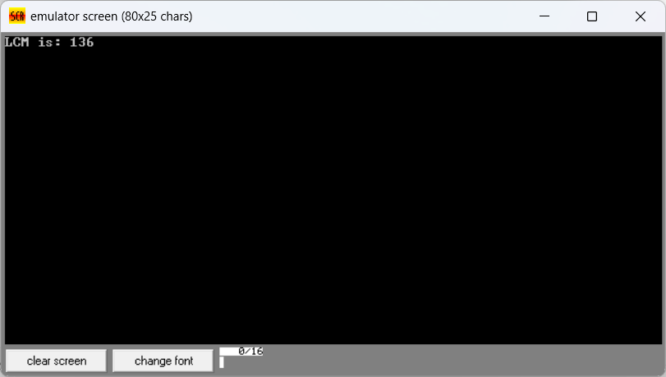  
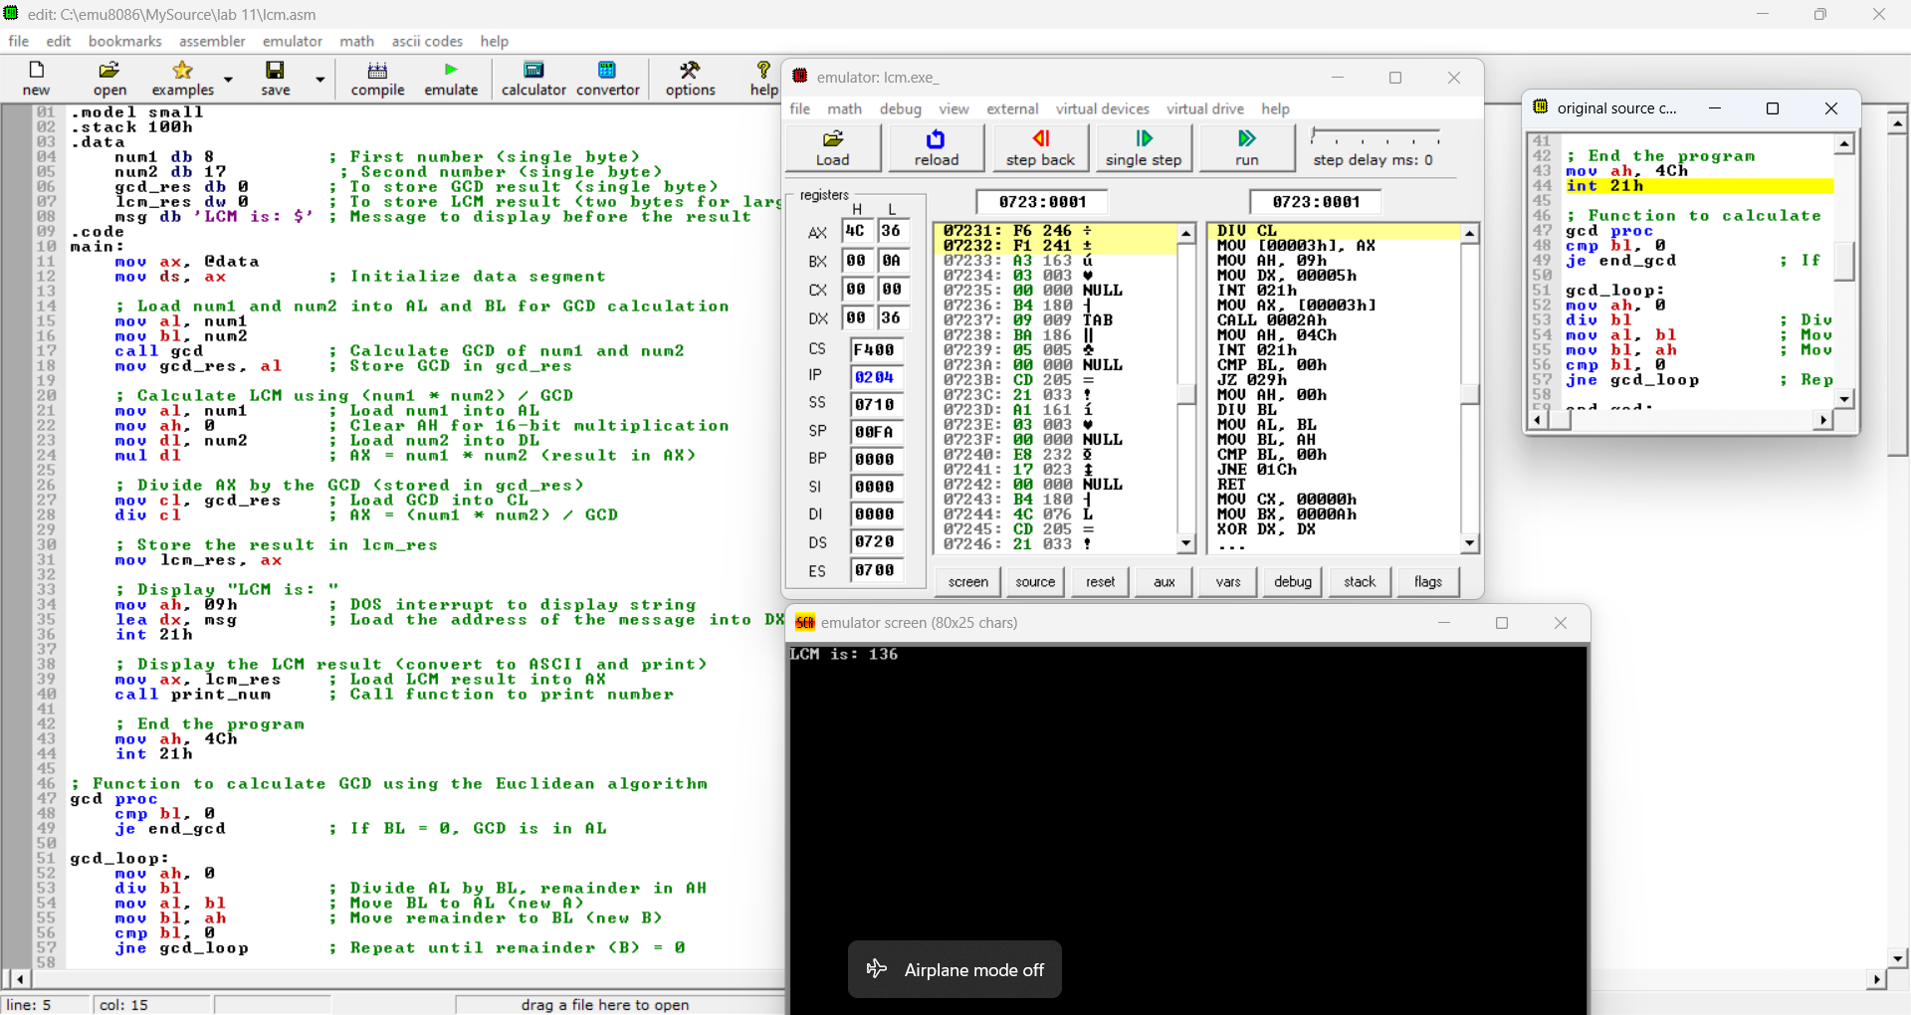**

**Q 1. (b) Write an assembly language program to display the nth term of a fibonacci series. “n” must be a single digit number which may be taken from the user.**

**CODE:**

**.model small**

**.stack 100h**

**.data**

**prompt db 'Enter a single digit number (0-9) for n: $'**

**result_msg db 0Dh,0Ah,'The nth Fibonacci number is: $'**

**fib dw 0**

**.code**

**main proc**

**mov ax, @data**

**mov ds, ax**

**mov ah, 09h**

**lea dx, prompt**

**int 21h**

**mov ah, 01h**

**int 21h**

**sub al, '0'**

**mov cl, al**

**cmp cl, 1**

**jbe single_digit_fib**

**mov ax, 0**

**mov bx, 1**

**fib_loop:**

**dec cl**

**jz store_result**

**add ax, bx**

**xchg ax, bx**

**jmp fib_loop**

**store_result:**

**mov fib, ax**

**single_digit_fib:**

**cmp cl, 0**

**je show_fib0**

**mov fib, bx**

**jmp display_result**

**show_fib0:**

**mov fib, ax**

**display_result:**

**mov ah, 09h**

**lea dx, result_msg**

**int 21h**

**mov ax, fib**

**call print_number**

**mov ah, 4Ch**

**int 21h**

**main endp**

**print_number proc**

**mov cx, 10**

**mov bx, 0**

**reverse_digits:**

**xor dx, dx**

**div cx**

**push dx**

**inc bx**

**test ax, ax**

**jnz reverse_digits**

**display_digits:**

**pop dx**

**add dl, '0'**

**mov ah, 02h**

**int 21h**

**dec bx**

**jnz display_digits**

**ret**

**print_number endp**

**end main**

**Output:**

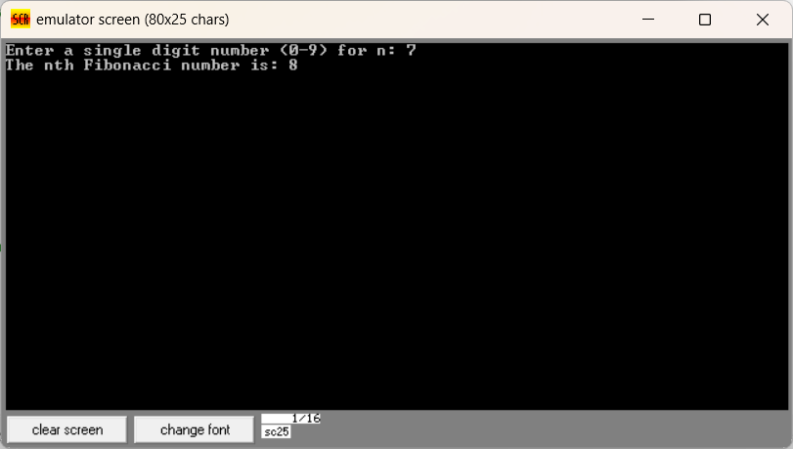

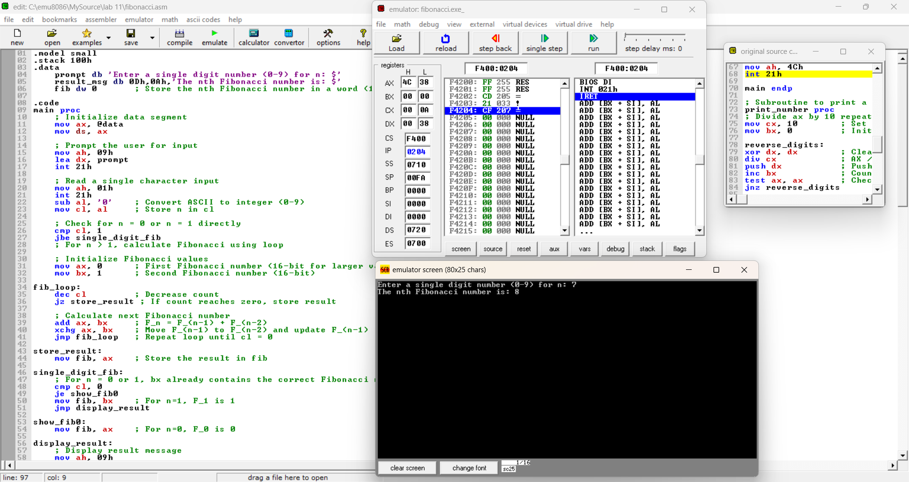

**Q 2. Write an assembly language program to find the factorial of a given single-digit number.**

**CODE:**

**.model small**

**.stack 100h**

**.data**

**prompt db 'Enter a single digit number (0-9): $'**

**result_msg db 0Dh,0Ah,'The factorial is: $'**

**factorial dw 1**

**.code**

**main proc**

**mov ax, @data**

**mov ds, ax**

**mov ah, 09h**

**lea dx, prompt**

**int 21h**

**mov ah, 01h**

**int 21h**

**sub al, '0'**

**mov bl, al**

**cmp bl, 0**

**jne calculate_factorial**

**mov factorial, 1**

**jmp display_result**

**calculate_factorial:**

**mov cx, bx**

**mov ax, 1**

**factorial_loop:**

**mul cx**

**loop factorial_loop**

**mov factorial, ax**

**display_result:**

**mov ah, 09h**

**lea dx, result_msg**

**int 21h**

**mov ax, factorial**

**call print_number**

**mov ah, 4Ch**

**int 21h**

**main endp**

**print_number proc**

**mov cx, 10**

**mov bx, 0**

**reverse_digits:**

**xor dx, dx**

**div cx**

**push dx**

**inc bx**

**test ax, ax**

**jnz reverse_digits**

**display_digits:**

**pop dx**

**add dl, '0'**

**mov ah, 02h**

**int 21h**

**dec bx**

**jnz display_digits**

**ret**

**print_number endp**

**end main**

**Output:**

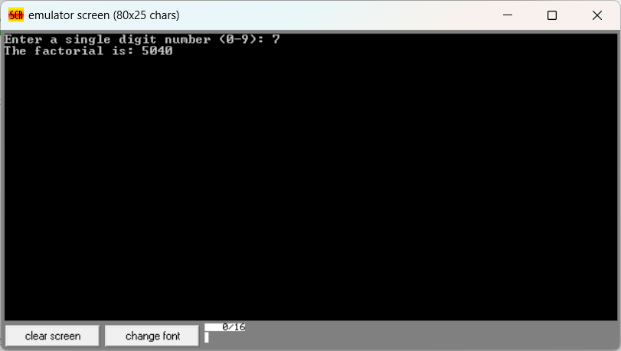

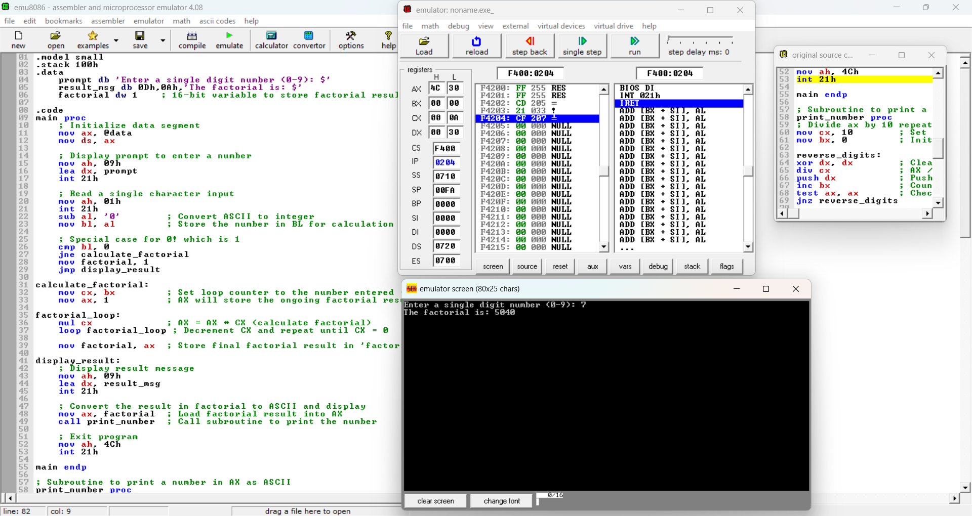

**Git hub Repository link:**

[**https://github.com/SruthiVihitha/COA-Lab_task-11.git**](https://github.com/SruthiVihitha/COA-Lab_task-11.git)