**Q 1. Write an assembly language program to perform multiplication of 8-bit data.**

CODE:

org 100h

mov al, 13h

mov bl, 05h

mul bl

mov bl, al

mov ah, al

and al, 0F0h

shr ah, 4

add ah, 30h

cmp ah, 39h

jle print_digit1

add ah, 7

print_digit1:

mov dl, ah

mov ah, 02h

int 21h

mov ah, bl

and ah, 0Fh

add ah, 30h

cmp ah, 39h

jle print_digit2

add ah, 7

print_digit2:

mov dl, ah

mov ah, 02h

int 21h

mov ah, 4Ch

int 21h

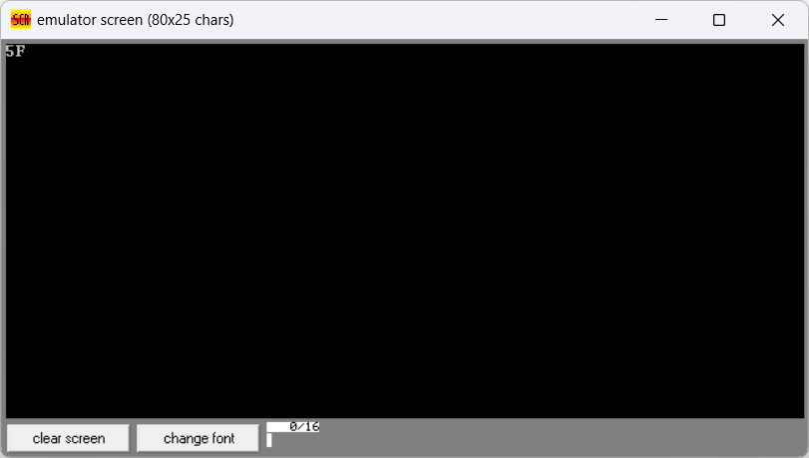**Output:**

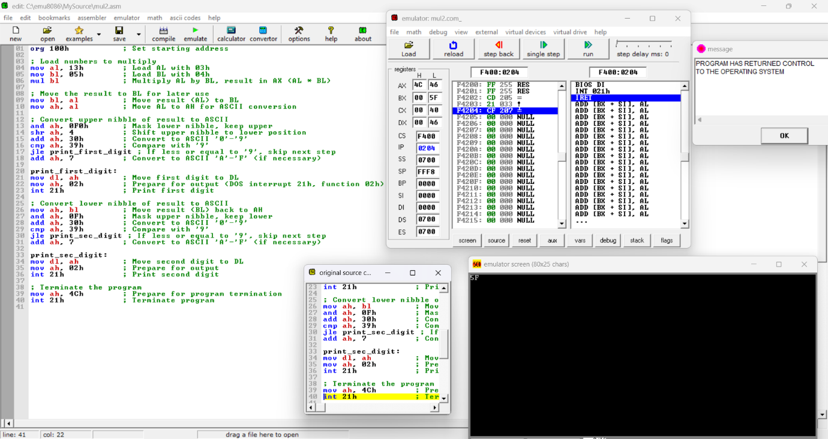

**Q 2. Write a program in assembly language to perform multiplication of 16-bit data.**

CODE:

org 100h

mov ax, 0012h

mov bx, 0102h

mul bx

mov bx, ax

mov ah, bh

shr ah, 4

add ah, 30h

cmp ah, 39h

jle print_high_nibble

add ah, 7

print_high_nibble:

mov dl, ah

mov ah, 02h

int 21h

mov ah, bh

and ah, 0Fh

add ah, 30h

cmp ah, 39h

jle print_low_nibble

add ah, 7

print_low_nibble:

mov dl, al

mov al, 02h

int 21h

mov ah, bl

shr ah, 4

add ah, 30h

cmp ah, 39h

jle print_high_nibble2

add ah, 7

print_high_nibble2:

mov dl, ah

mov ah, 02h

int 21h

mov ah, bl

and ah, 0Fh

add ah, 30h

cmp ah, 39h

jle print_low_nibble2

add ah, 7

print_low_nibble2:

mov dl, al

mov al, 02h

int 21h

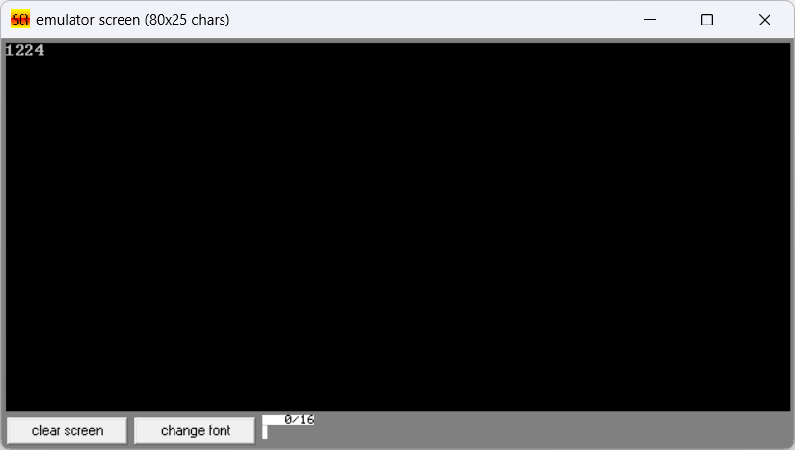Output:

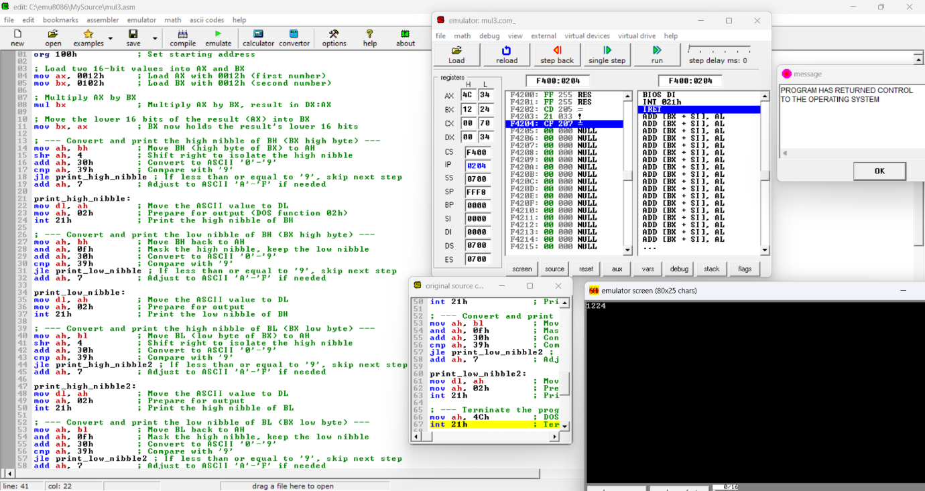

Git hub Repository link:

<https://github.com/SruthiVihitha/COA-Lab_task-4.git>