**Q 1. Write an assembly language program to perform division of 8-bit data.**

CODE:

org 100h

mov al, 96h

mov bl, 10h

idiv bl

mov bl, al

mov bh, ah

and al, 0F0h

shr al, 4

add al, 30h

cmp al, 39h

jle print_digit1

add al, 7

print_digit1:

mov dl, al

mov ah, 02h

int 21h

mov al, bl

and al, 0Fh

add al, 30h

cmp al, 39h

jle print_digit2

add al, 7

print_digit2:

mov dl, al

mov ah, 02h

int 21h

mov al, bh

and al, 0F0h

shr al, 4

add al, 30h

cmp al, 39h

jle print_first_rem_digit

add al, 7

print_first_rem_digit:

mov dl, al

mov ah, 02h

int 21h

mov al, bh

and al, 0F0h

shr al, 4

add al, 30h

cmp al, 39h

jle print_second_rem_digit

add al, 7

print_second_rem_digit:

mov dl, al

mov ah, 02h

int 21h

**Output:**

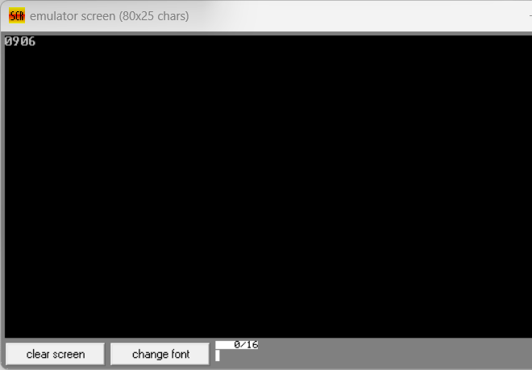

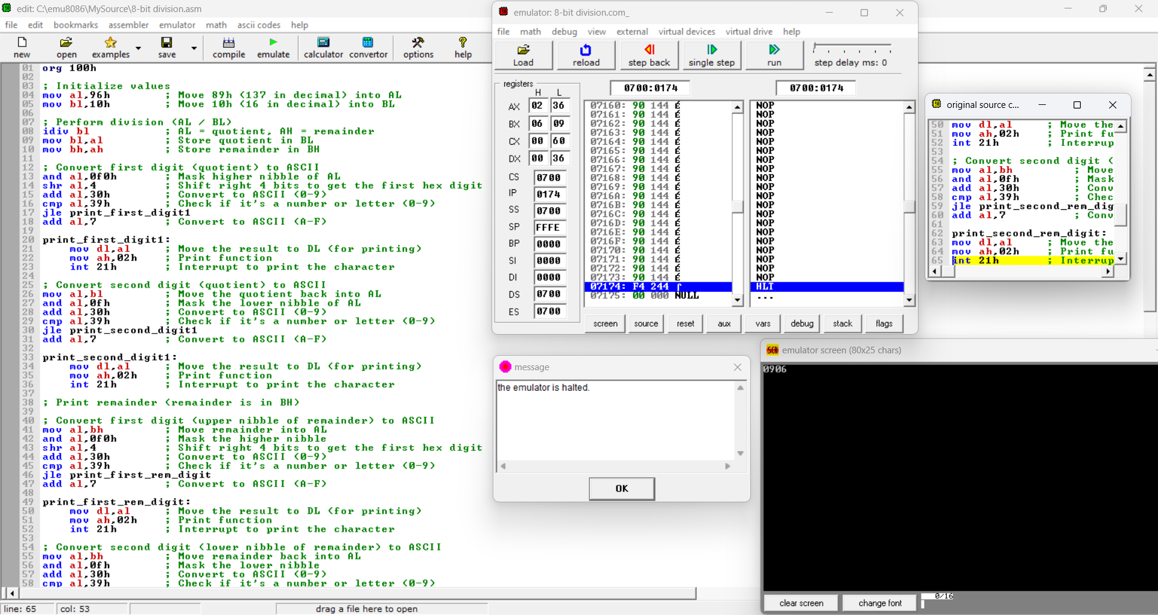

**Q 2. Write a program in assembly language to perform division of 16-bit data.**

CODE:

org 100h

mov ax, 1982h

mov bx, 1000h

div bx

mov bx, ax

mov cx, dx

mov ah, ch

and ah, 0F0h

shr ah, 4

add ah, 30h

cmp ah, 39h

jle print_high_nibble32

add ah, 7

print_high_nibble32:

mov dl, ah

mov ah, 02h

int 21h

mov ah, ch

and ah, 0Fh

add ah, 30h

cmp ah, 39h

jle print_low_nibble32

add ah, 7

print_low_nibble32:

mov dl, ah

mov ah, 02h

int 21h

mov ah, cl

and ah, 0F0h

shr ah, 4

add ah, 30h

cmp ah, 39h

jle print_high_nibble24

add ah, 7

print_high_nibble24:

mov dl, ah

mov ah, 02h

int 21h

mov ah, cl

and ah, 0Fh

add ah, 30h

cmp ah, 39h

jle print_low_nibble24

add ah, 7

print_low_nibble24:

mov dl, ah

mov al, 02h

int 21h

mov ah, bh

and ah, 0F0h

shr ah, 4

add ah, 30h

cmp ah, 39h

jle print_high_nibble

add ah, 7

print_high_nibble:

mov dl, ah

mov ah, 02h

int 21h

mov ah, bh

and ah, 0Fh

add ah, 30h

cmp ah, 39h

jle print_low_nibble

add ah, 7

print_low_nibble:

mov dl, ah

mov ah, 02h

int 21h

mov ah, bl

and ah, 0F0h

shr ah, 4

add ah, 30h

cmp ah, 39h

jle print_high_nibble2

add ah, 7

print_high_nibble2:

mov dl, ah

mov ah, 02h

int 21h

mov ah, bl

and ah, 0Fh

add ah, 30h

cmp ah, 39h

jle print_low_nibble2

add ah, 7

print_low_nibble2:

mov dl, ah

mov al, 02h

int 21h

mov ah, 4ch

int 21h

Output:

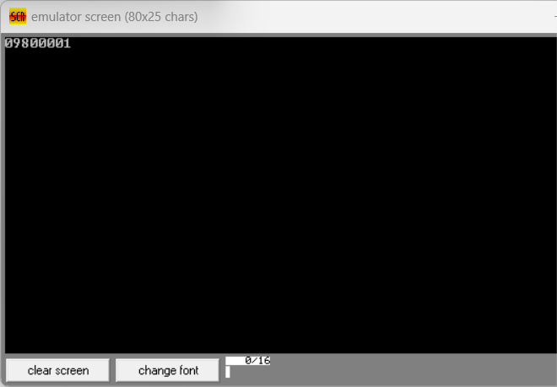

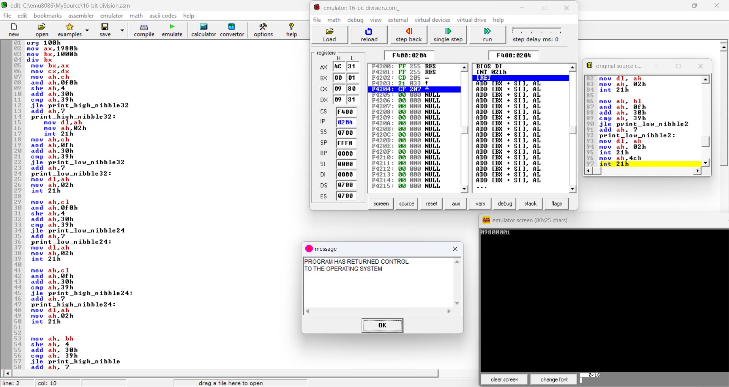

Git hub Repository link:

<https://github.com/SruthiVihitha/COA-Lab_task-5.git>