**Q 1. a) Write a program in assembly language to print single character on screen.**

CODE:

ORG 100h

MOV AH, 09h

MOV DX, OFFSET msg_enter_input

INT 21h

MOV AH, 01h

INT 21h

MOV BL, AL

MOV AH, 09h

MOV DX, OFFSET msg_entered_input

INT 21h

MOV DL, BL

MOV AH, 02h

INT 21h

MOV AH, 4Ch

INT 21h

msg_enter_input DB 'Enter the input: $'

msg_entered_input DB 0Dh, 0Ah, 'The entered input is: $'

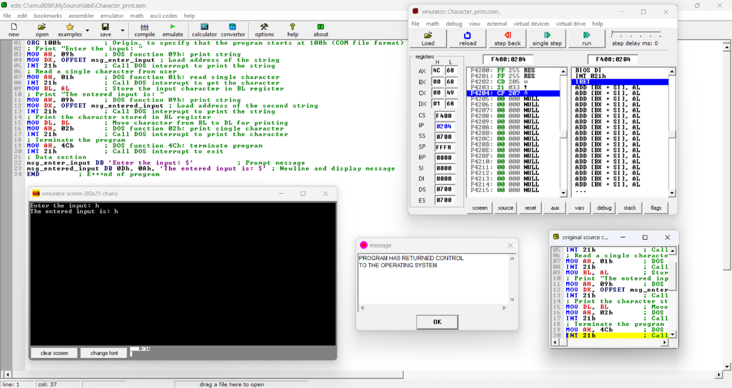END

**Output:**

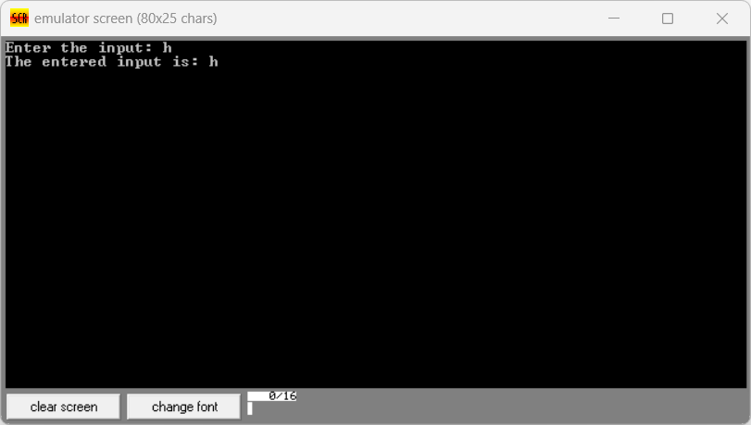

**Q 1. b) Write an assembly language program to convert an upper-case letter to the corresponding lower-case letter.**

CODE:

ORG 100h

MOV DX, OFFSET prompt_message

MOV AH, 09h

INT 21h

MOV AH, 01h

INT 21h

MOV DL, AL

CMP AL, 'A'

JL NotUpperCase

CMP AL, 'Z'

JG NotUpperCase

ADD AL, 20h

MOV BL, AL

MOV DX, OFFSET output_message

MOV AH, 09h

INT 21h

MOV AL, BL

MOV DL, AL

MOV AH, 02h

INT 21h

JMP EndProgram

NotUpperCase:

MOV DX, OFFSET error_message

MOV AH, 09h

INT 21h

EndProgram:

MOV AH, 4Ch

INT 21h

prompt_message DB 'Input an uppercase letter: $'

output_message DB 0Dh, 0Ah, 'Lowercase version is: $'

error_message DB 0Dh, 0Ah, 'Error: Input is not an uppercase letter! $'

END

Output:

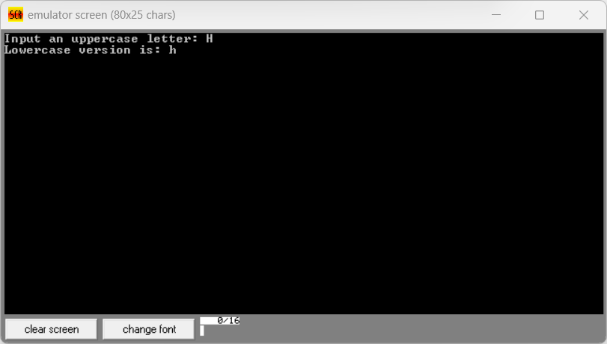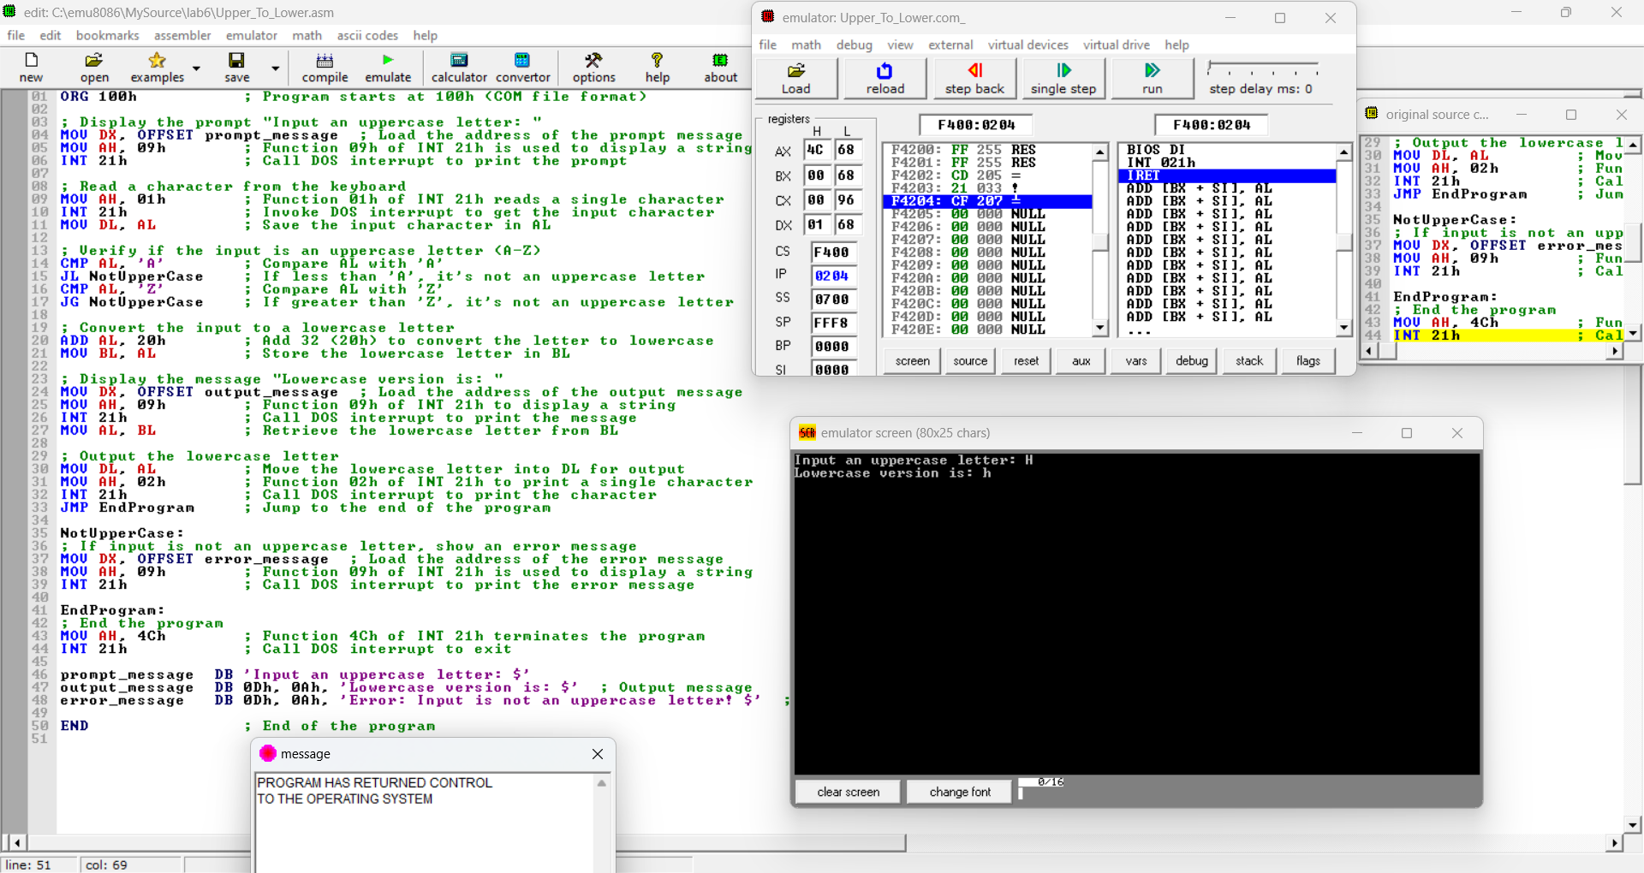

**Q 2. a) Write a program in assembly language to print multiple characters on screen.**

CODE:

ORG 100h

MOV AH, 09h

MOV DX, OFFSET msg_enter_input

INT 21h

MOV AH, 0Ah

MOV DX, OFFSET input_buffer

INT 21h

MOV AL, '$'

LEA DI, input_buffer+2

MOV CL, [input_buffer+1]

ADD DI, CX

MOV [DI], AL

MOV AH, 09h

MOV DX, OFFSET msg_entered_input

INT 21h

LEA DX, input_buffer+2

MOV AH, 09h

INT 21h

MOV AH, 4Ch

INT 21h

msg_enter_input DB 'Enter the input: $'

msg_entered_input DB 0Dh, 0Ah, 'The entered input is: $'

input_buffer DB 10, 0

END

Output:

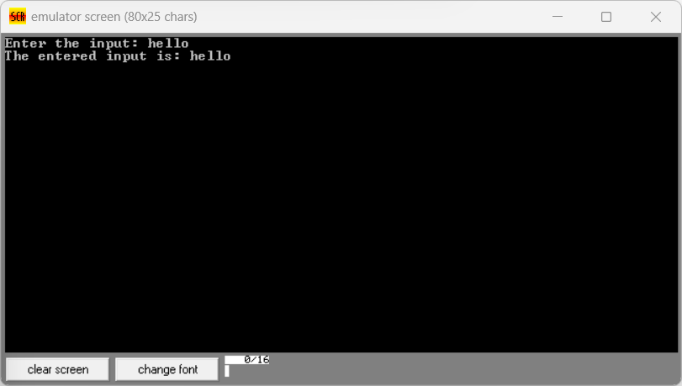

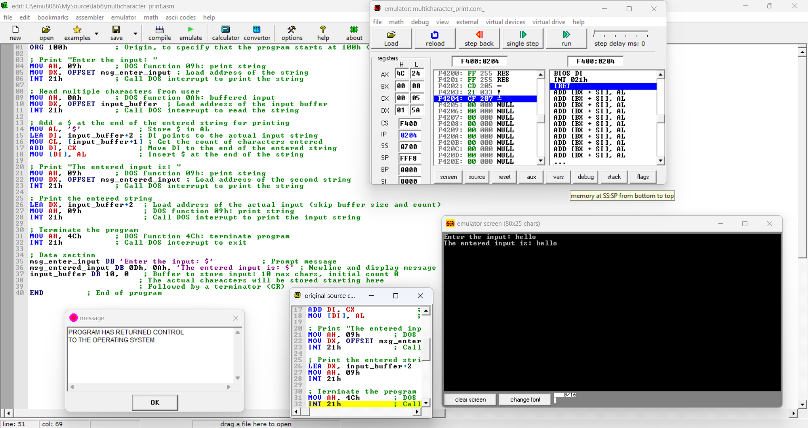

**Q 2. b) Write an assembly language program to convert a lower-case letter to the corresponding upper-case letter.**

CODE:

ORG 100h

MOV DX, OFFSET msg_input

MOV AH, 09h

INT 21h

MOV AH, 01h

INT 21h

MOV DL, AL

CMP AL, 'a'

JL NotLowerCase

CMP AL, 'z'

JG NotLowerCase

SUB AL, 20h

MOV BL, AL

MOV DX, OFFSET msg_output

MOV AH, 09h

INT 21h

MOV AL, BL

MOV DL, AL

MOV AH, 02h

INT 21h

JMP EndProgram

NotLowerCase:

MOV DX, OFFSET msg_error

MOV AH, 09h

INT 21h

EndProgram:

MOV AH, 4Ch

INT 21h

msg_input DB 'Enter a lowercase letter: $'

msg_output DB 0Dh, 0Ah, 'The uppercase letter is: $'

msg_error DB 0Dh, 0Ah, 'Error: Not a lowercase letter! $'

END

Output:

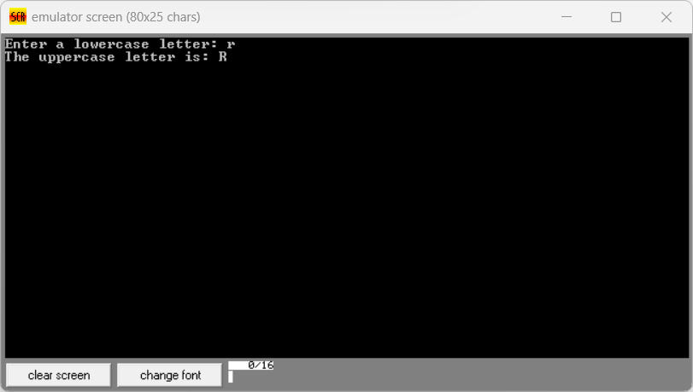

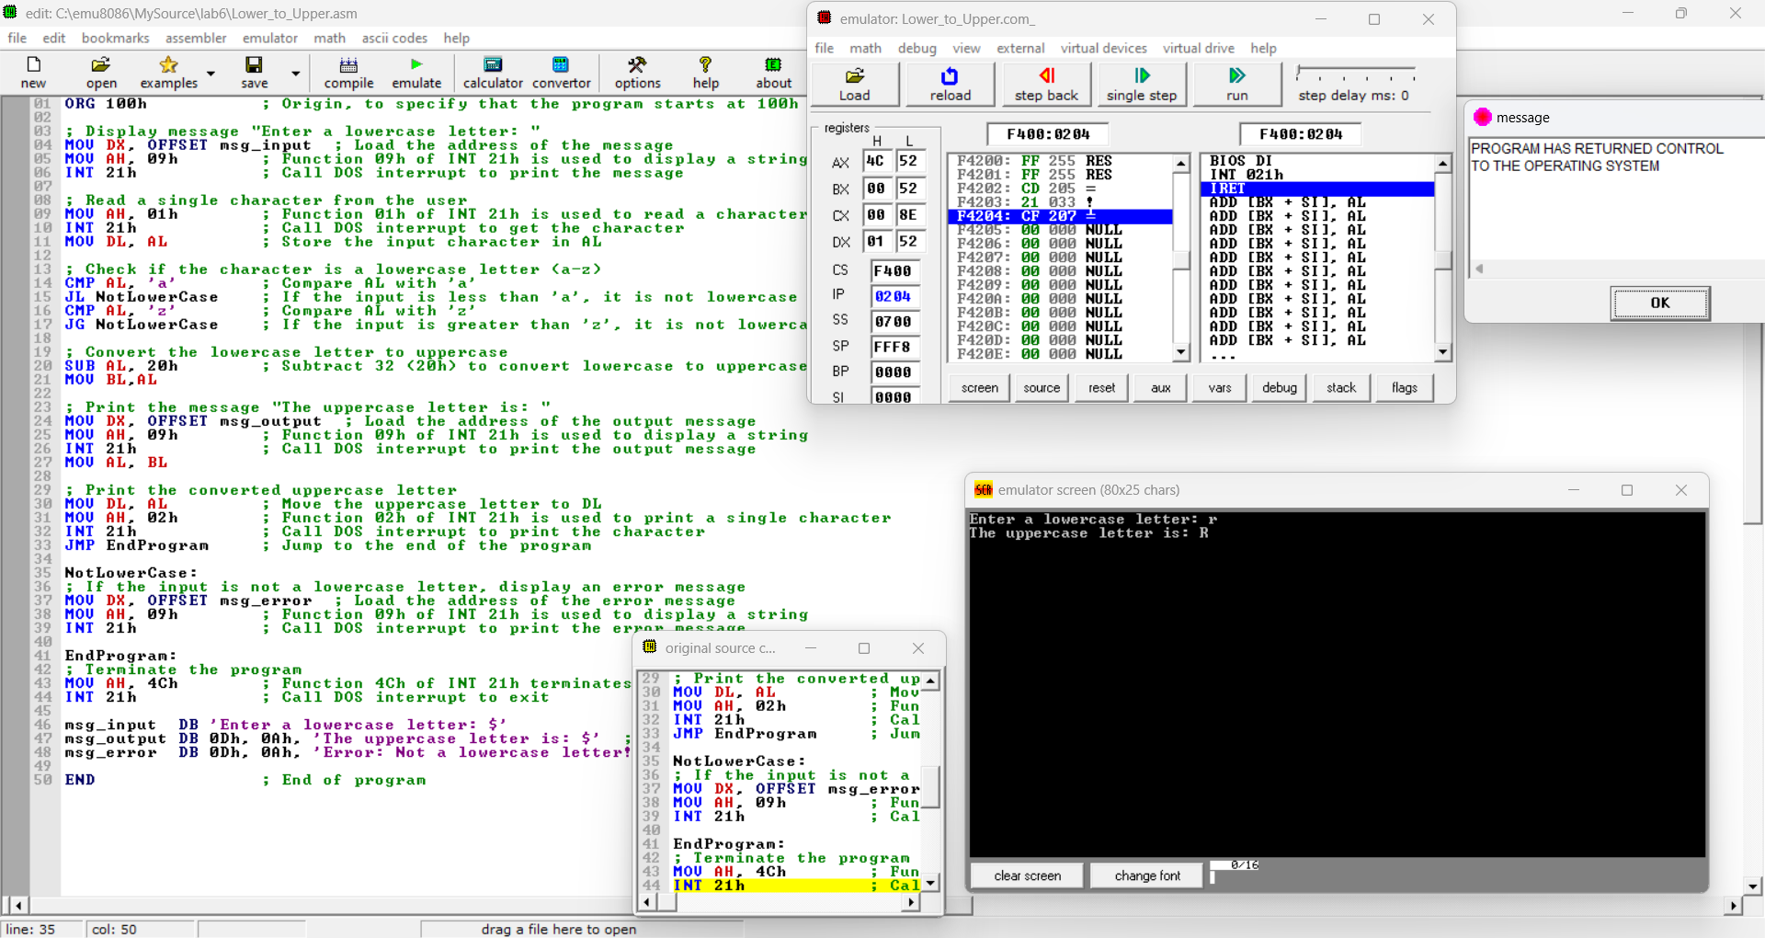

Git hub Repository link: