**Q 1. Write a program in assembly language to take a single-digit integer from the user and print it on the screen.**

CODE:

org 100h

mov ah, 09h

mov dx, OFFSET msg_input

int 21h

mov ah, 01h

int 21h

mov bl, al

cmp al, ‘0’

jl InvalidInput

cmp al, ‘9’

jg InvalidInput

mov ah, 09h

mov dx, OFFSET msg_output

int 21h

mov dl, bl

mov ah, 02h

int 21h

jmp EndProgram

InvalidInput:

mov ah, 09h

mov dx, OFFSET msg_error

int 21h

EndProgram:

mov ah, 4ch

mov 21h

msg_input DB 'Enter a single digit: $'

msg_output DB 0Dh, 0Ah, 'The entered digit is: $ ‘

msg_error DB 0Dh, 0Ah, 'Error: Invalid input! $ ‘

END

**Output:**

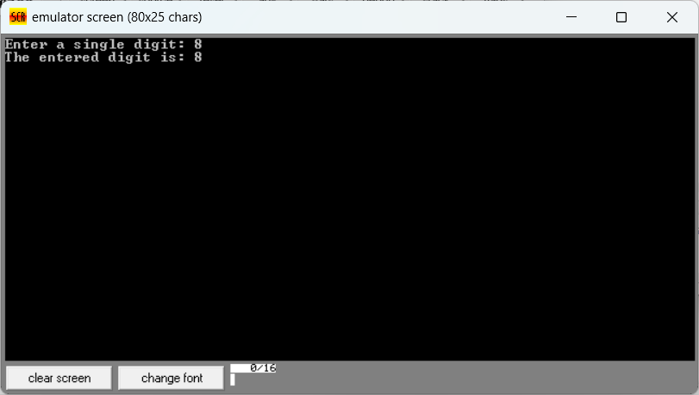

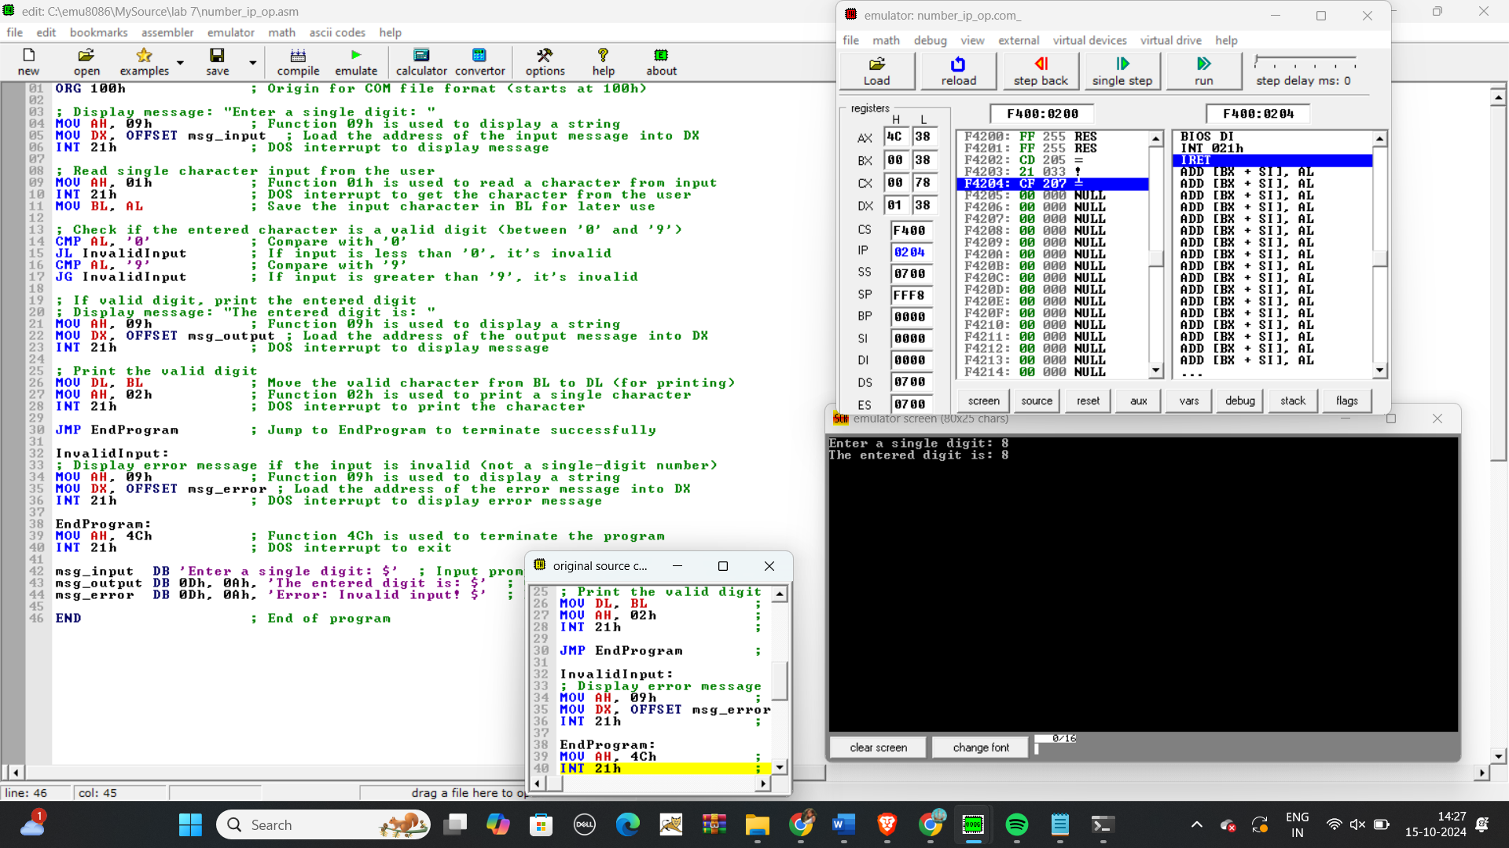

**Q 2. Write a program in assembly language to take two single-digit integers from the user and print the result of subtraction on the screen.**

CODE:

org 100h

mov ah, 09h

mov dx, OFFSET msg_input1

int 21h

mov ah, 01h

int 21h

sub al, ‘0’

mov bl, al

mov ah, 09h

mov dx, OFFSET msg_input2

int 21h

mov ah, 01h

int 21h

sub al, ‘0’

mov bl, al

sub bl, bh

mov ah, 09h

mov dx, OFFSET msg_output

int 21h

cmp bl, 0

jge PrintResult

mov dl, ’-‘

mov ah, 02h

int 21h

neg bl

PrintResult:

mov bl, ‘0’

mov dl, bl

sub al, 02h

int 21h

mov ah, 4ch

mov 21h

msg_input DB 'Enter the first single digit: $'

msg_output DB 0Dh, 0Ah, 'Enter the second single digit: $'

msg_error DB 0Dh, 0Ah, 'The result of subtraction is: $ ‘

END

Output:

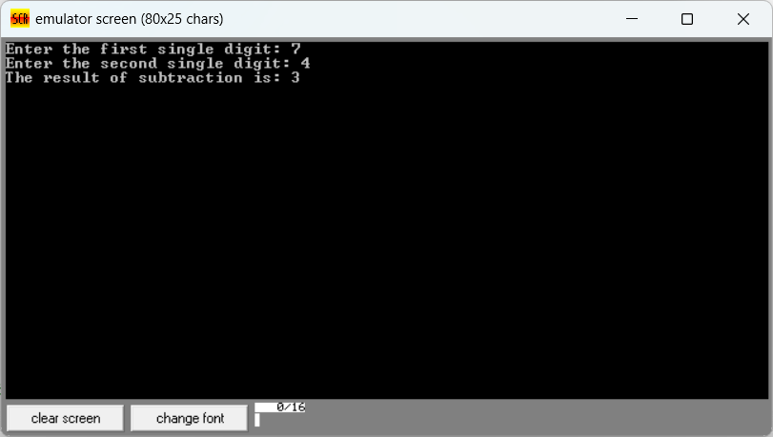

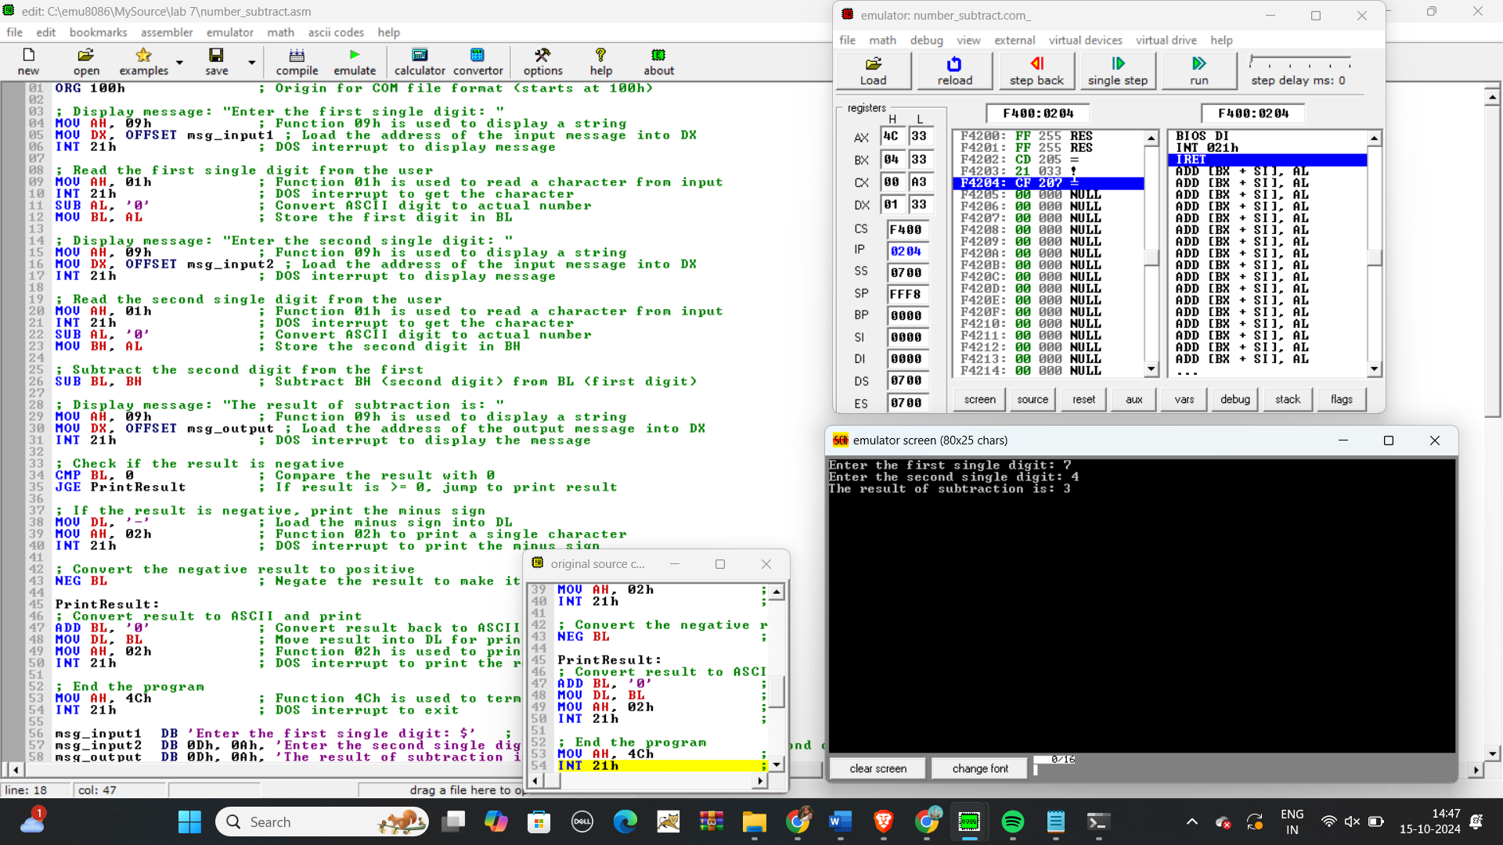

Git hub Repository link:

<https://github.com/SruthiVihitha/COA-Lab_task-7.git>