**Q 1. Write a program in assembly language to display a two-digit number on the screen. The two-digits number is required to be taken in the program itself.**

CODE:

org 100h

mov al, 58d

mov bl, 10

div bl

mov bh, al

mov bl, ah

mov ah, 09h

mov dx, OFFSET msg

int 21h

add bh, ‘0’

mov dl, bh

mov ah, 02h

int 21h

add bh, ‘0’

mov dl, bl

mov ah, 02h

int 21h

mov ah, 4ch

int 21h

msg DB 'The two digit number is: $'

END

**Output:**

**For 58d**

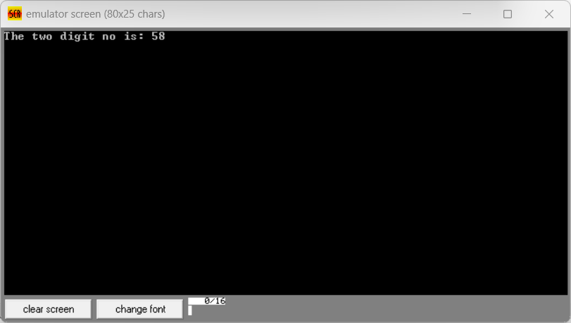

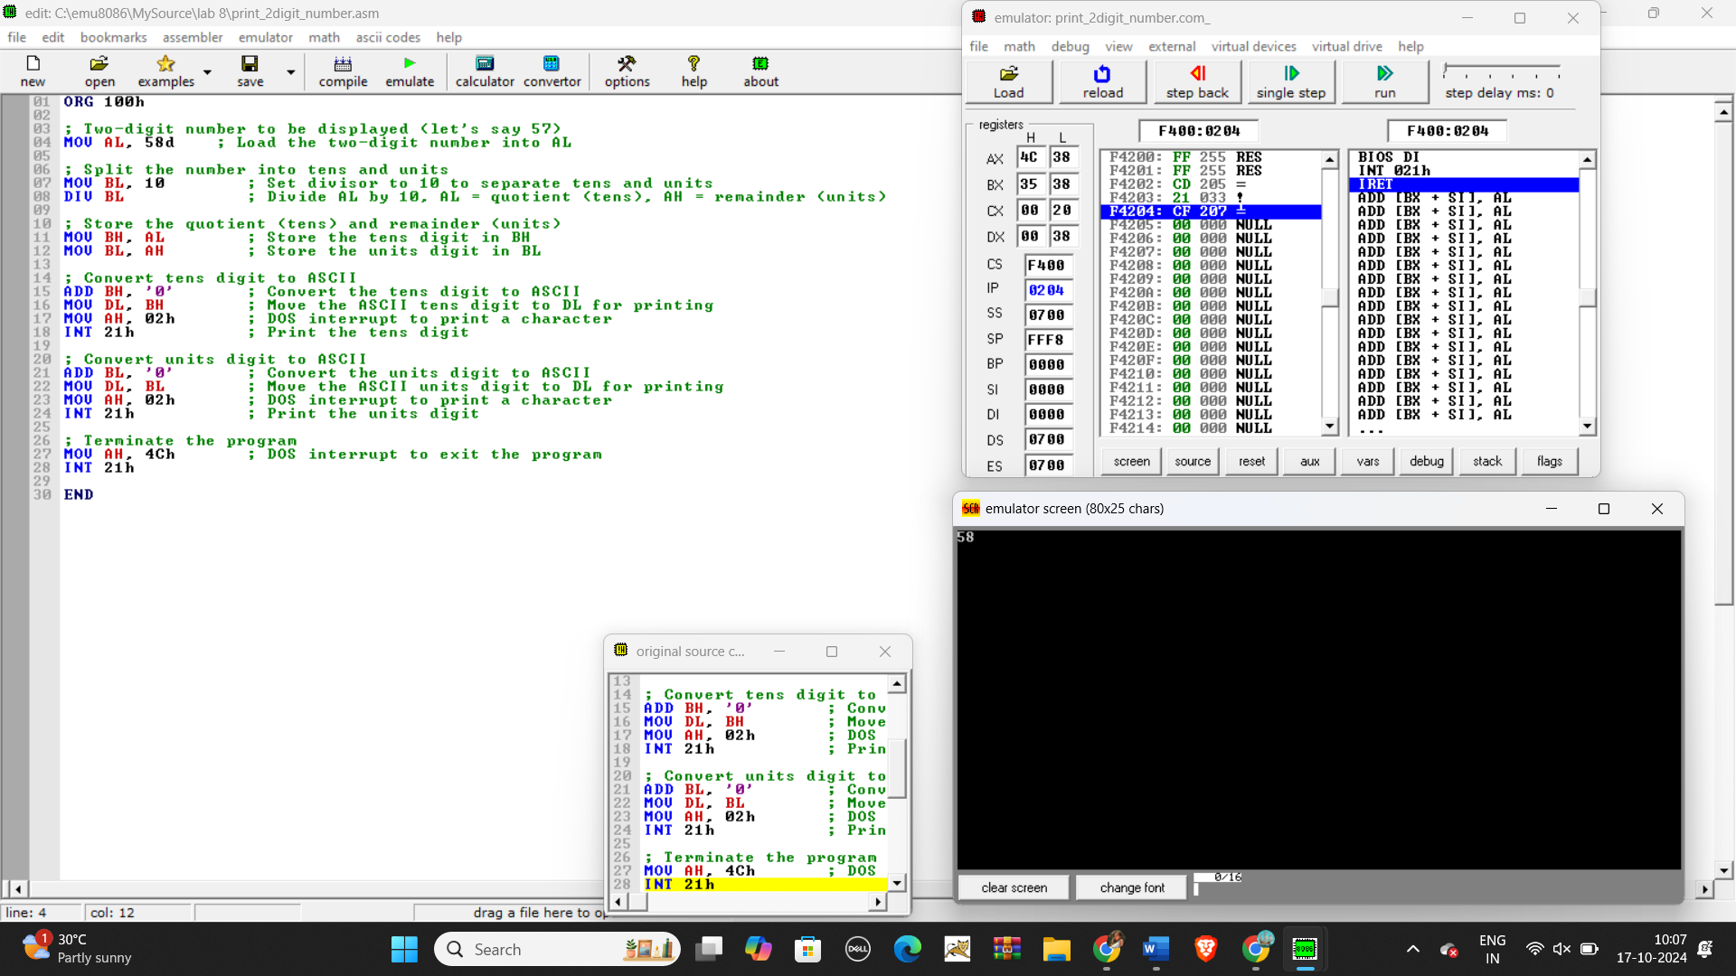

**For 5Fh**

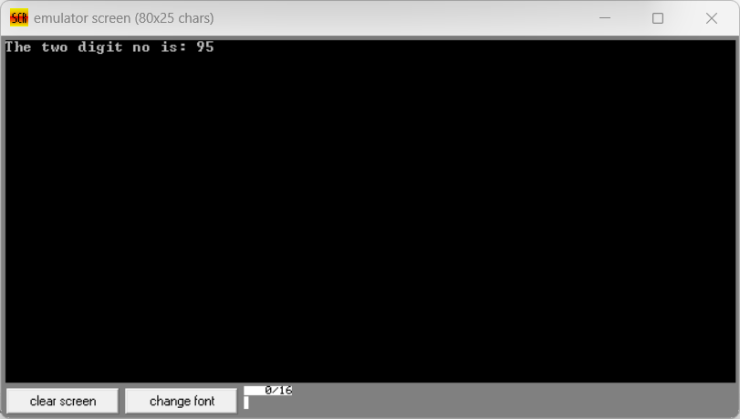

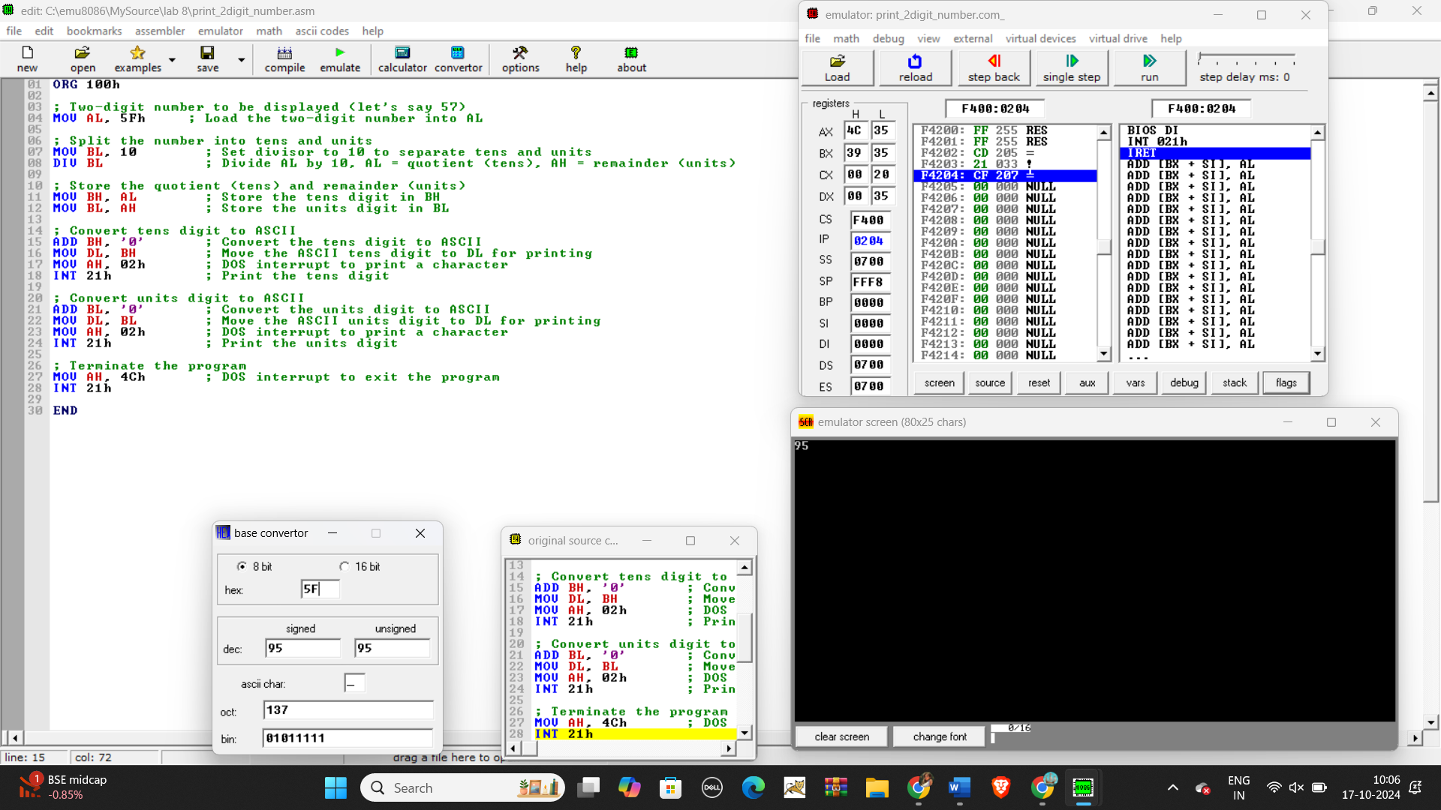

**Q 2. Write an assembly language program to take two single-digit integers from the user and print the result of addition on the screen.**

CODE:

org 100h

mov dx, OFFSET msg_input1

mov ah, 09h

int 21h

mov ah, 01h

int 21h

sub al, ‘0’

mov bl, al

mov dx, OFFSET msg_input2

mov ah, 09h

int 21h

mov ah, 01h

int 21h

sub al, ‘0’

mov cl, al

add bl, cl

add bl, ‘0’

mov dx, OFFSET msg_output

mov ah, 09h

int 21h

mov dl, 0dh

mov ah, 02h

int 21h

mov dl, 0Ah

int 21h

mov ah, 4ch

mov 21h

msg_input DB 'Enter the first single digit: $'

msg_output DB 0Dh, 0Ah, 'Enter the second single digit: $'

msg_error DB 0Dh, 0Ah, 'The result of addition is: $ ‘

END

Output:

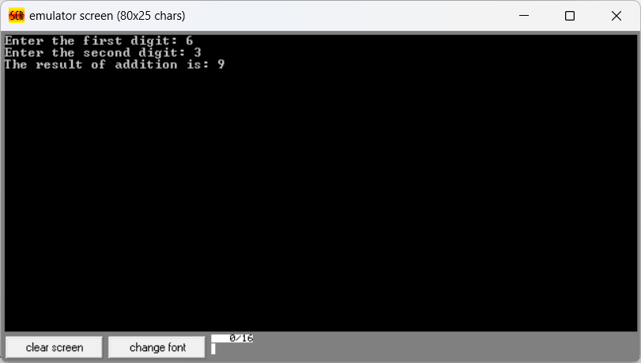

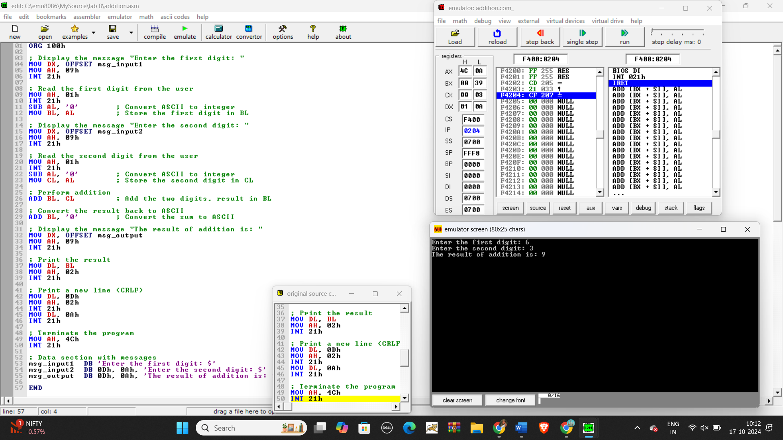

Git hub Repository link:

<https://github.com/SruthiVihitha/COA-Lab_task-8.git>