**Q 1. Write a program in assembly language to take two single-digit numbers as input and display whether they are equal or not.**

CODE:

ORG 100h

MOV DX, OFFSET msg_input1

MOV AH, 09h

INT 21h

MOV AH, 01h

INT 21h

SUB AL, '0'

MOV BL, AL

MOV DX, OFFSET msg_input2

MOV AH, 09h

INT 21h

MOV AH, 01h

INT 21h

SUB AL, '0'

MOV CL, AL

CMP BL, CL

JE digits_equal

MOV DX, OFFSET msg_not_equal

MOV AH, 09h

INT 21h

JMP end_program

digits_equal:

MOV DX, OFFSET msg_equal

MOV AH, 09h

INT 21h

end_program:

MOV DL, 0Dh

MOV AH, 02h

INT 21h

MOV DL, 0Ah

INT 21h

MOV AH, 4Ch

INT 21h

msg_input1 DB 'Enter the first digit: $'

msg_input2 DB 0Dh, 0Ah, 'Enter the second digit: $'

msg_equal DB 0Dh, 0Ah, 'The digits are equal.$'

msg_not_equal DB 0Dh, 0Ah, 'The digits are not equal.$'

END

**Output:**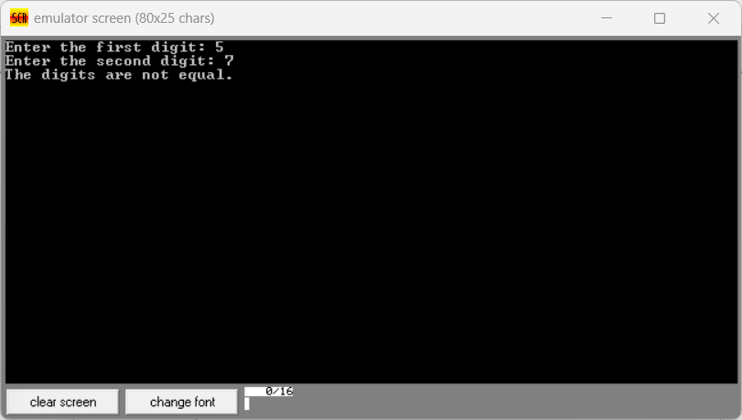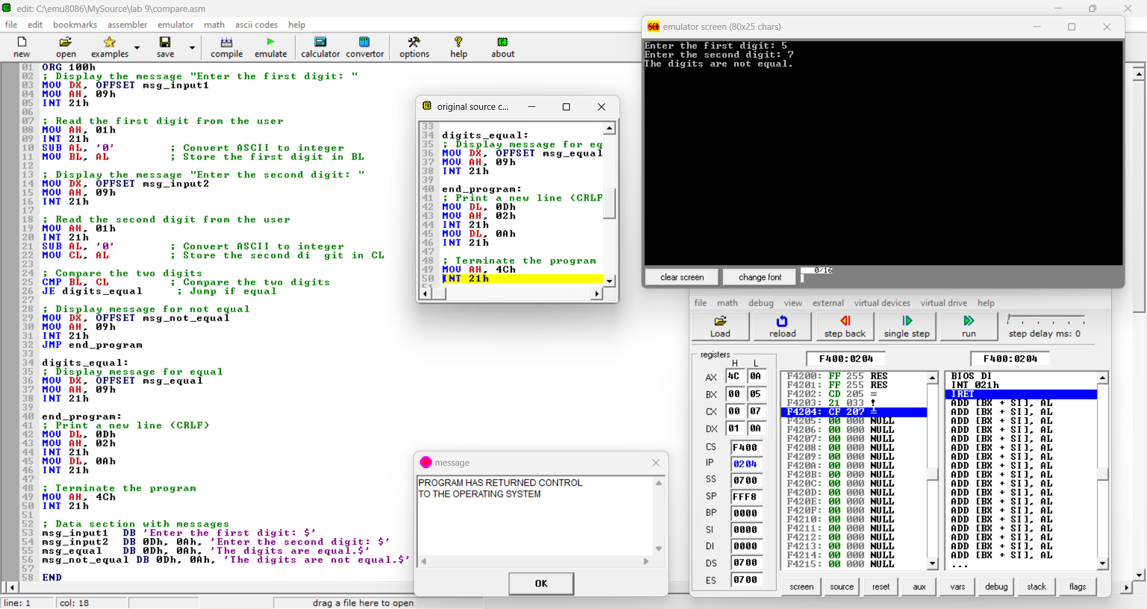

**Q 2. Write a program in assembly language to check whether a single-digit number is odd or even.**

CODE:

ORG 100h

MOV DX, OFFSET msg_input

MOV AH, 09h

INT 21h

MOV AH, 01h

INT 21h

SUB AL, '0'

CMP AL, 0

JB invalid_input

CMP AL, 9

JA invalid_input

AND AL, 1

JZ even_number

MOV DX, OFFSET msg_odd

MOV AH, 09h

INT 21h

JMP end_program

even_number:

MOV DX, OFFSET msg_even

MOV AH, 09h

INT 21h

JMP end_program

invalid_input:

MOV DX, OFFSET msg_invalid

MOV AH, 09h

INT 21h

end_program:

MOV AH, 4Ch

INT 21h

msg_input DB 'Enter a single-digit number: $'

msg_even DB 0Dh, 0Ah, 'The number is even.$'

msg_odd DB 0Dh, 0Ah, 'The number is odd.$'

msg_invalid DB 0Dh, 0Ah, 'Invalid input. Please enter a single-digit number (0-9).$'

END

Output:

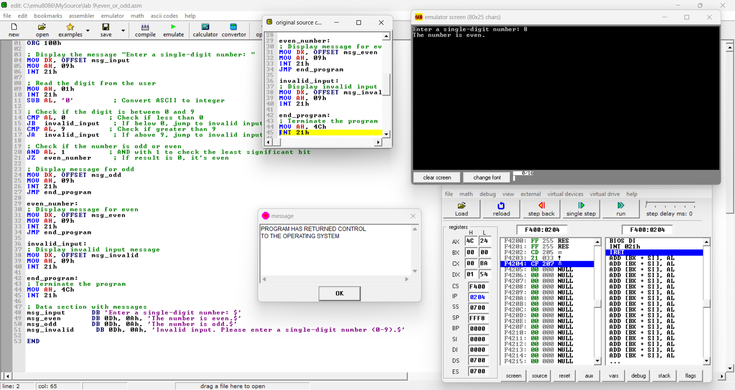 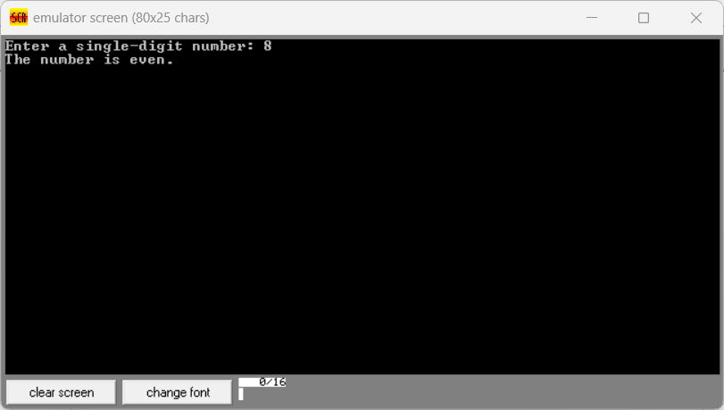

Git hub Repository link:

CODE:

org 100h

mov al, 58d

mov bl, 10

div bl

mov bh, al

mov bl, ah

mov ah, 09h

mov dx, OFFSET msg

int 21h

add bh, ‘0’

mov dl, bh

mov ah, 02h

int 21h

add bh, ‘0’

mov dl, bl

mov ah, 02h

int 21h

mov ah, 4ch

int 21h

msg DB 'The two digit number is: $'

END

**Output:**

**For 58d**

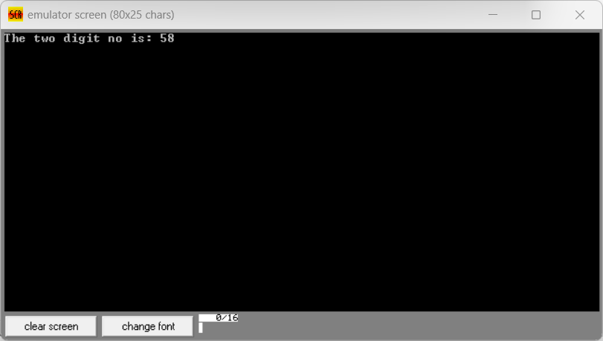

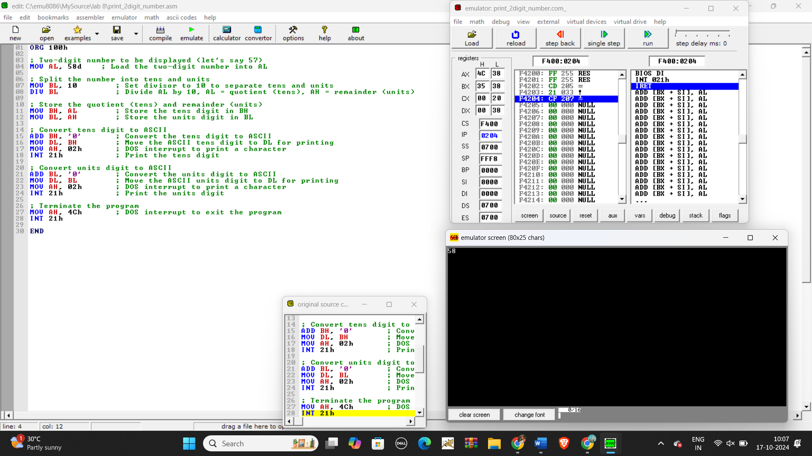

**For 5Fh**

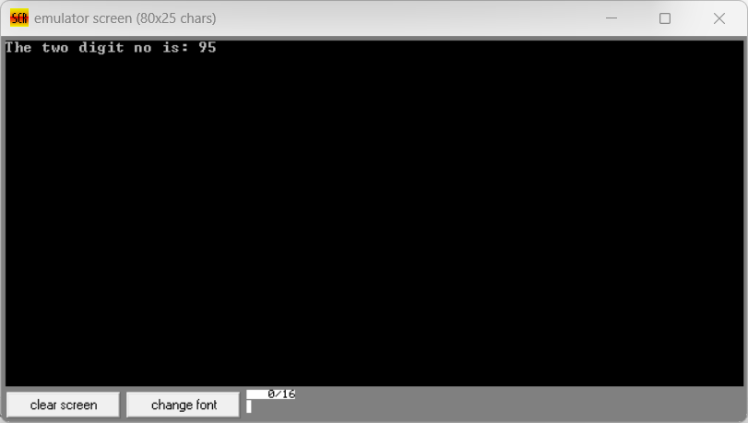

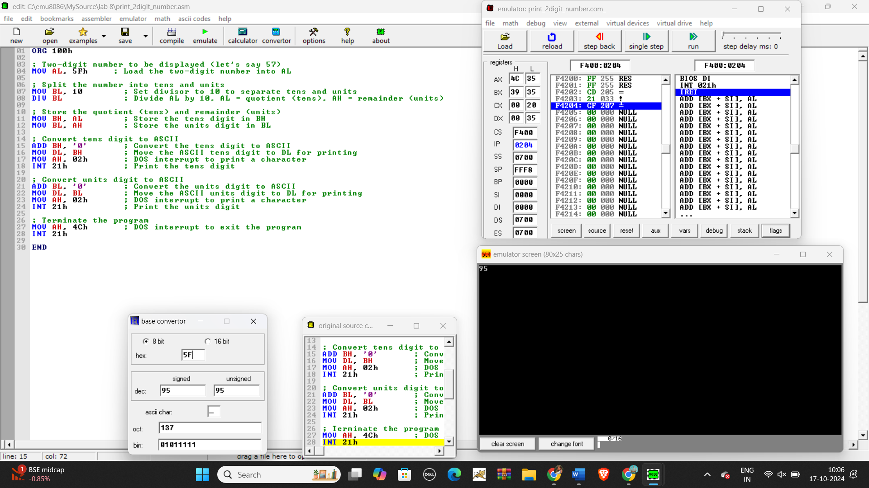

**Q 2. Write an assembly language program to take two single-digit integers from the user and print the result of addition on the screen.**

CODE:

org 100h

mov dx, OFFSET msg_input1

mov ah, 09h

int 21h

mov ah, 01h

int 21h

sub al, ‘0’

mov bl, al

mov dx, OFFSET msg_input2

mov ah, 09h

int 21h

mov ah, 01h

int 21h

sub al, ‘0’

mov cl, al

add bl, cl

add bl, ‘0’

mov dx, OFFSET msg_output

mov ah, 09h

int 21h

mov dl, 0dh

mov ah, 02h

int 21h

mov dl, 0Ah

int 21h

mov ah, 4ch

mov 21h

msg_input DB 'Enter the first single digit: $'

msg_output DB 0Dh, 0Ah, 'Enter the second single digit: $'

msg_error DB 0Dh, 0Ah, 'The result of addition is: $ ‘

END

Output:

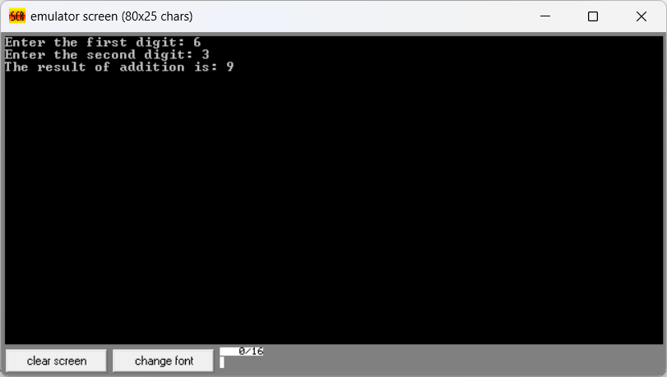

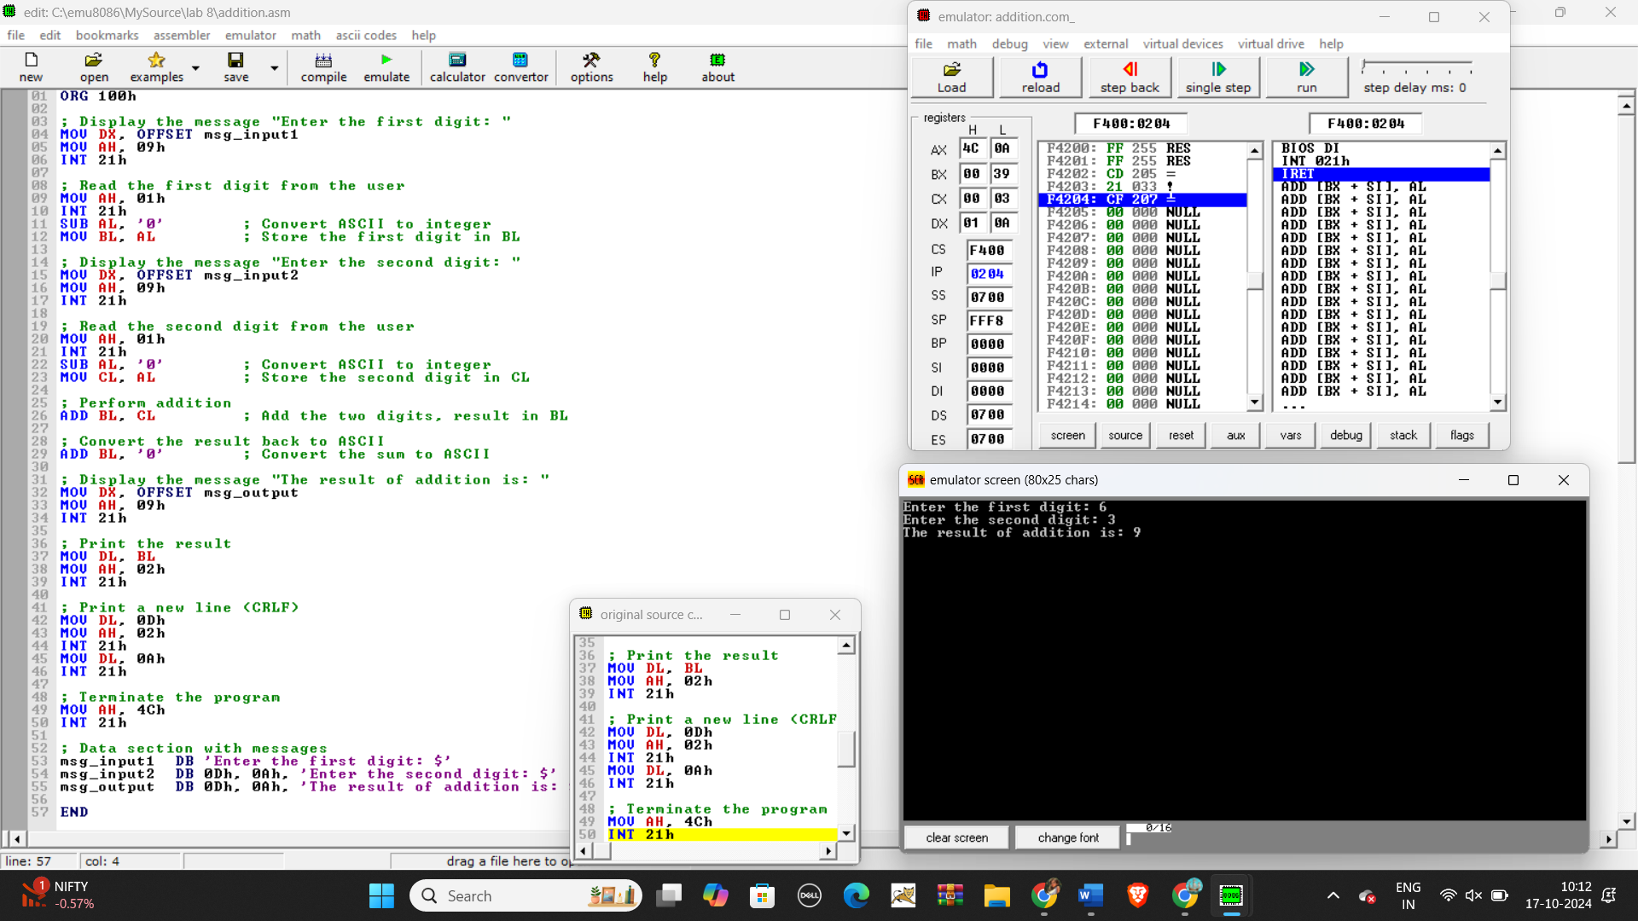

Git hub Repository link:

<https://github.com/SruthiVihitha/COA-Lab_task-8.git>