**Q 1. Write an assembly language program to perform subtraction of 8-bit data.**

CODE:

num1 db 19h

num2 db 15h

start:

mov al, num1

sub al, num2

mov bl, al

mov ah, bl

and al, 0F0h

shr ah, 4

sub ah, 30h

cmp ah, 39h

jle print_digit1

sub ah, 7

print_digit1:

mov dl, ah

mov ah, 02h

int 21h

mov ah, bl

and ah, 0Fh

sub ah, 30h

cmp ah, 39h

jle print_digit2

sub ah, 7

print_digit2:

mov dl, ah

mov ah, 02h

int 21h

mov ah, 4Ch

int 21h

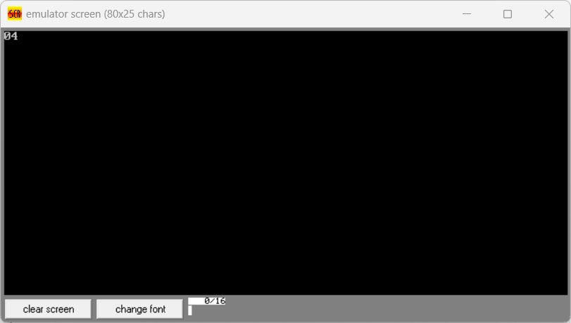

**Q 2. Write a program in assembly language to perform subtraction of 16-bit data.**

CODE:

org 100h

jmp start

num1 dw 9C6Bh

num2 dw 1656h

start:

mov ax, num1

sub ax, num2

mov bx, ax

mov ah, bh

mov al, ah

call print_hex

mov al, bl

call print_hex

mov ah, 4Ch

int 21h

print_hex:

mov ah, al

and al, 0F0h

shr ah, 4

sub ah, 30h

cmp ah, 39h

jle print_high_nibble

add ah, 7

print_high_nibble:

mov dl, ah

mov ah, 02h

int 21h

mov al, al

and al, 0F0h

add ah, 30h

cmp ah, 39h

jle print_low_nibble

add ah, 7

print_low_nibble:

mov dl, al

mov al, 02h

int 21h

ret

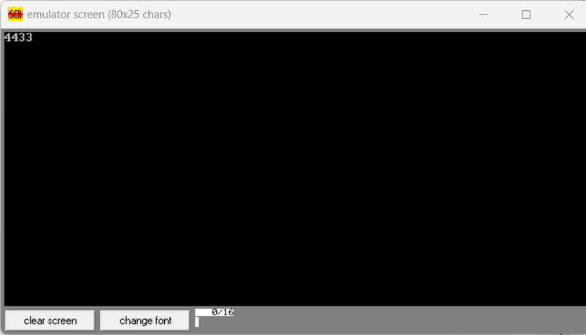

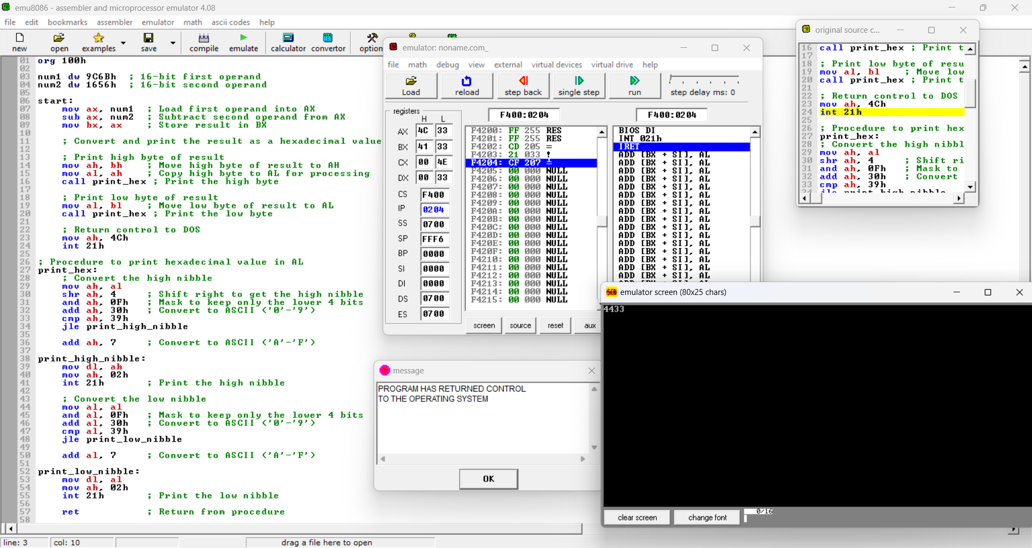

Git hub Repository link: <https://github.com/SruthiVihitha/COA_lab_task-3.git>