STUDENT DATA ANALYSIS USING PANDAS
Internship Task 3 :
1. Title
Student Data Analysis using Pandas
2. Objective
The objective of this project is to analyze student data using Pandas.
The project demonstrates CSV loading, data cleaning, filtering, grouping, and generating summary statistics.
3. Problem Statement
Educational institutions generate large amounts of student data.
This project helps analyze student performance and generate useful insights using Python and Pandas.
4. Features Implemented
- CSV data loading
- Data cleaning
- Data filtering
- Grouping operations
- Summary statistics generation
5. Technologies Used
Technology |  | Purpose
Python 3.x |  | Programming Language
Pandas |  | Data Analysis
CSV |  | Dataset Storage

6. Dataset Used
students.csv
Dataset contains: students Name, Department, Marks, Age

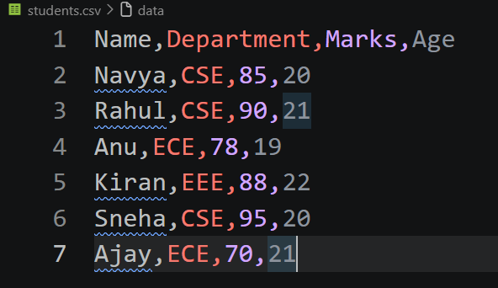
7. Source Code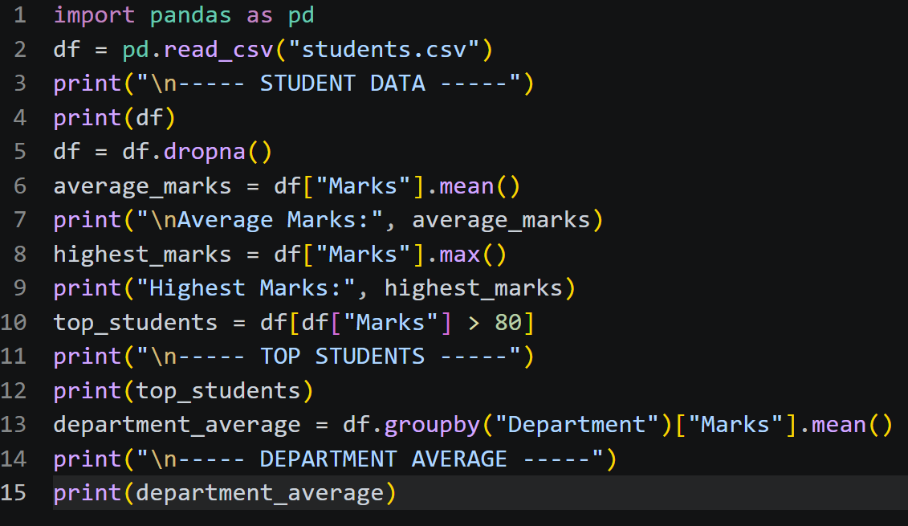

8. Sample Output
- Install pandas : pip install pandas
- Output:
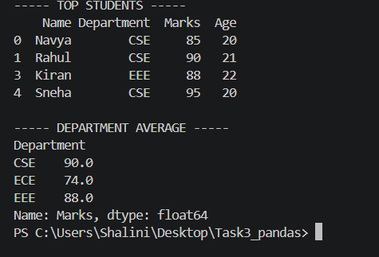

9. Insights Generated
- Average student marks calculated
- Highest marks identified
- Top-performing students filtered
- Department-wise average generated

10. Conclusion
This project successfully demonstrates data analysis using Pandas.
The project includes CSV handling, cleaning, filtering, grouping, and generating meaningful insights from the dataset.

