**Machine Learning**

**Introduction**

Machine learning is a technique where we will be training machines to work on complex problems using the predefines statements and procedures

We can train it to find the hidden pattern within. This hidden data is further analysed for finding the future events.

Machine Learning techniques uses data and its final output and discover the rules behind that.

**Steps Involved:**

1. **Data Collection**
2. **Data Optimisation**
3. **Data splitting (Test & Train)**
4. **Evaluation & optimisation**

Its well known that the Machine Learning is dependent on Probability theory

With out this proper probability analysis we can’t obtain the accurate answer

**Types of Machine Learning approaches**

1. **Supervised Learning**
2. **Un supervise Learning**
3. **Reinforcement Learning**

**Supervised Learning**

**H**uman interference is required here in this step in giving the relation between input and output

So, if the similar type of computation is required then the algorithm itself maps the relation and gives the output

**Classification VS Regression**

The output of supervised learning model could fall under a category form the input set called **Classification**

Sometimes the output can also be a number (Scalar) then it is said to be **Regression**

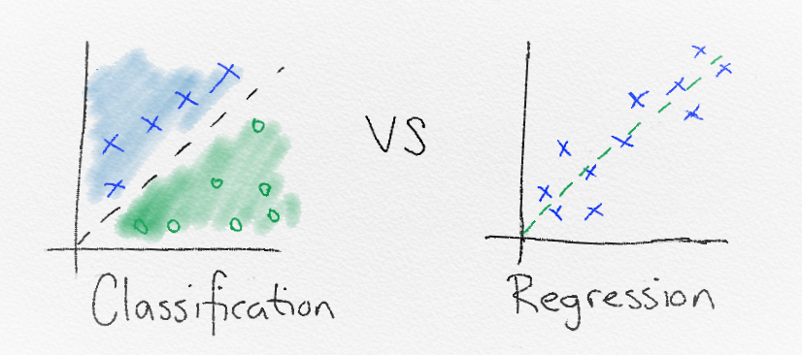

**Unsupervised Learning**

Here only the input data is given and no output is framed. Here in this case, it helps us to unleash the hidden patterns and relations within and grouped accordingly.

**Reinforcement Learning**

This method of learning algorithm learns from the mistakes it has done at the first step.

Suppose, If the input is apple picture and output is recognised as Mango then it works as feedback and corrects itself.

Human interaction is needed for this method of learning