SWIFTML: ACCELERATING MACHINE LEARNING JOURNEYS
Ms. P.Bharathi ¹ D.Harshitha² K.Sruthika³ K.Varsha⁴
¹ Asst.Professor, Department of Information Technology, Gokaraju Rangaraju Institute of Engineering and Technology, JNTUH, Bachupally, Hyderabad, India.
² Student, Department of Information Technology, Gokaraju Rangaraju Institute of Engineering and Technology, JNTUH, Bachupally, Hyderabad, India.
³ Student, Department of Information Technology, Gokaraju Rangaraju Institute of Engineering and Technology, JNTUH, Bachupally, Hyderabad, India.
⁴ Student, Department of Information Technology, Gokaraju Rangaraju Institute of Engineering and Technology, JNTUH, Bachupally, Hyderabad, India.
ABSTRACT:
SwiftML is a very promising tool with the purpose to make the process of automatic gadget mastering models simple. SwiftML is a non-expert accessible tool. SwiftML is an end-user accessible tool in which userscan analyze the performance of different algorithms mostly based on their datasets and pick a satisfactory or suitable one. SwiftML works significant roles in conjunction withpreprocessing, model testing and training. SwiftML accommodates all supervised and unsupervised getting to know obligations. Customers can easily incorporate datasets, select algorithms, and view real-time results through an easy-to-use Streamlit interface. Pickle library integration allows customers to save and download trained models for offline deployment, making it ideal for manufacturing deployments or personal applications.SwiftML accommodates a wide range of 10-15 machine-getting-to-know algorithms. Therefore, users can quickly access a variety of models without extensive knowledge in machine mastering. Upon training, it provides clear performance results comprising Mean Absolute Error, R2, Mean Square Error, and Root Mean Square Error, which enables users without issues compare and select the nice version. With the PyCaret library, SwiftML optimizes training and evaluating models, which helps save shop effort and time. SwiftML has emerged as a go-to tool for statistics scientists, data analysts, and literally anyone who wants to implement device learning models with no domain experts or mass coding.
Keywords: Automated system-learning, PyCaret, Streamlit
Domain: Machine learning
1 INTRODUCTION
The rapid advancement of technology and increased accessibility to data have revolutionized problem-solving approaches across industries. Machine Learning (ML) stands out as a transformative discipline, empowering systems to learn from data and make predictions without explicit programming. While ML’s applications span critical domains like healthcare, finance, and cybersecurity, its widespread adoption is often limited by the technical expertise required to build and deploy models. This complexity creates a barrier for individuals with minimal programming or data science knowledge, preventing them from fully leveraging the potential of ML.
To bridge this gap, SwiftML emerges as a low-code, user-friendly AutoML platform that simplifies the entire machine learning workflow. Developed using Python libraries like Streamlit and PyCaret, SwiftML allows users to upload datasets, choose learning tasks, and evaluate models—all through a web-based graphical user interface. Streamlit provides the front-end experience, enabling intuitive interaction, while PyCaret automates key backend tasks such as data preprocessing, model selection, and hyperparameter tuning. Together, they enable users to experiment with multiple ML algorithms quickly and effectively, without the need for extensive coding or statistical expertise.
SwiftML supports both supervised and unsupervised learning, providing functionality for classification, regression, and clustering. It evaluates model performance using metrics like MAE, MSE, RMSE, and R² Score, giving users actionable insights into model accuracy. Additionally, models can be saved using the Pickle library for future use, making deployment seamless and efficient. By combining automation, accessibility, and ease of use, SwiftML aims to democratize machine learning, empowering students, analysts, and professionals to apply intelligent solutions to real-world problems with minimal technical barriers.

2 LITERATURE REFERENCE
[1] Shubhra Kanti Karmaker Santu, Md. Mahadi Hassan, Micah J. Smith, and Lei Xu, in their 2020 paper arXived with the title AutoML to Date and Beyond: Challenges and Opportunities, suggested a seven-level taxonomy to categorize AutoML frameworks based entirely on the degree of autonomy. Guide bottlenecks in current AutoML pipelines were identified by the authors and considered in detail the challenges in achieving full automation of the field. Their research points out major areas that also need studies and development to make AutoML definitely autonomous.
[2] Shiwei Liu, Xiang Wang, and Guodong Long provided their paper in the journal Knowledge-Based Systems, Volume 212, on January 5, 2021. They focused on classifying AutoML methods in terms of the different ranges of the machine learning pipeline. Their approach gives a better understanding of how AutoML equipment can be reliant and employed across different domain names, thus making gadget-learning of higher order accessible to clients with minimal expert knowledge.
[3] Imrus Salehin, Md. Shamiul Islam, Pritom Saha, S.M. Noman, Azra Tuni, Md. Mehedi Hasan, and Md. Abu Baten performed a scientific review entitled AutoML: A Systematic Review on Automated Machine Learning with Neural Architecture Search, which became published in the Journal of Information and Intelligence in 2024. Their observation examined information processing needs and introduced Neural Architecture Search (NAS) algorithms. The evaluation highlighted that NAS is able to automatically find the best-performing model architectures and thus improve model selection as well as hyperparameter optimization.
[4] In rational software environments, researchers are now unveiling the practicability of the application of AutoML tools to real-world domain-specific issues. Youngho Park, in a 2024 journal article in the Journal of Minimally Invasive Surgery, demonstrated employing AutoML in the R programming environment. With code-based completely tutorials, Park demonstrated how AutoML automates tasks like records preprocessing, model selection, and hyperparameter adjustment, even for non-technical users. His work is particularly valuable in the scientific topic where specialists require actionable knowledge with ut the expense of profound ML comprehension. In covering the gap between clinical know-how and facts analysis, AutoML tools such as those outlined with the assistance of Park are leveraging innovation in clinical investigation and operational decision-making.

[5] Likewise, the evaluation of specific AutoML libraries such as AutoKeras has attracted attention. In 2024, Kabilan Elangovan, Gilbert Lim, and Daniel Ting released a comparative examine in Scientific Reports, during which they compared the general performance of AutoKeras with uniquely designed deep gaining knowledge of models. Their results found that AutoKeras, despite being absolutely computerized, competes evenly with human-tuned buildings. This difference underpins the contention that AutoML structures are not best user-friendly but also strong sufficient for real-world deployment, reducing the resource cost of version layout even as achieving similar, if not superior, overall performance levels.
[6] To place these developments historically and prognostically, Mitra Baratchi, Can Wang, Steffen Limmer, Jan N. Van Rijn, and Holger Hoos gave a holistic overview of their 2024 booklet entitled Automated Machine Learning: Past, Present and Future. This research, published as Article Number 122 in Volume 57, was focused at the development of AutoML technology, particularly emphasizing the emerging importance of Hyperparameter Optimization (HPO) and Neural Architecture Search (NAS). The authors provided context on the historical path of AutoML and charted emerging trends, including adaptive getting to know systems and meta-getting to know. Their work is both a technical and philosophical roadmap for grasping the trajectory in which AutoML is headed—towards end-to-end automation with the aid of smart comments loops and optimization heuristics.
[7] Finally, Felix Conrad, Mauritz Mälzer, Felix Lange, Hajo Wiemer, and Steffen Ihlenfeldt, from their 2024 review reported in Procedia Computer Science, validated an entirely automated process learning knowledge pipeline targeted towards time series analysis. Their work had entailed implementing a pipeline addressing automated preprocessing of information, feature engineering, model training, and testing—all in a setting wrapped around an AutoML framework. Through automating featurization as well, their pipeline cut down human effort significantly, bringing time series evaluation within reach and sustainable for industries with a dependence on forecasting and trend forecasting. This study highlights the manner in which AutoML isn't just simplest theoretical but also nearly applicable to complex analytical tasks conventionally needing extensive statistical expertise.

3. METHODOLOGIES
The development of SwiftML follows a modular, automated, and low-code approach that facilitates the complete machine learning (ML) lifecycle—from data ingestion to model deployment—without requiring extensive programming skills. The methodology is divided into several key components, each responsible for specific functionalities within the SwiftML platform.
3.1 System Architecture
SwiftML is developed using Python, integrating the Streamlit framework for building the user interface and PyCaret for automating machine learning tasks. The system is designed as a web-based application that allows users to interactively upload datasets, preprocess them, choose machine learning tasks (classification, regression, clustering), and evaluate model performance visually.
Streamlit serves as the front-end interface, while backend functionality is driven by machine learning libraries and custom classes for data manipulation. This design ensures that users can perform ML tasks entirely through a Graphical User Interface (GUI), eliminating the need for manual coding.
3.2 Data Ingestion
The platform supports uploading datasets in various formats, including .csv, .json, and .xlsx. Upon uploading, the dataset is temporarily saved and converted into a structured pandas.DataFrame for further processing. An ingestion confirmation step allows the user to preview and verify the uploaded data, which is then stored locally (sourcefile.csv) for use in downstream processes.
3.3 Data Preprocessing
Data preprocessing is handled by a dedicated class named Dataset Preprocessor, which includes the following steps:
• Handling Missing Values: Users can choose from strategies such as mean, median, mode, and interpolation to fill missing numerical values. For categorical variables, the most frequent category is used.
• Column Cleaning: This includes data type coercion, normalization of string values, removal of trailing spaces, and consistent labeling for fields like gender (e.g., mapping m, male to male).
• Feature Scaling: Both StandardScaler and MinMaxScaler from scikit-learn are implemented, allowing users to normalize or standardize features as needed.
• Train-Test Split: Users can specify the ratio for splitting the dataset, enabling evaluation of model generalization.
The preprocessed datasets are saved and made available for download, ensuring reproducibility and deployment-readiness.
3.4 Model Selection and Training
SwiftML supports both supervised and unsupervised learning tasks:
3.4.1 Supervised Learning
Users select between classification and regression tasks, after which the system leverages PyCaret to:
• Initialize the modeling environment using setup().
• Automatically preprocess data (if not done manually), encode features, and balance classes (if required).
• Compare multiple models using built-in compare_models() functionality.
• Display and evaluate the best-performing model using evaluate_model() with metrics such as:
- Mean Absolute Error (MAE)
- Mean Squared Error (MSE)
- Root Mean Squared Error (RMSE)
- R² Score
- Accuracy, Precision, Recall, F1-Score (for classification)
3.4.2 Unsupervised Learning
The Clustering module allows users to perform KMeans clustering, converting unlabeled data into supervised format by appending a cluster_label column. This feature supports applications like customer segmentation, where behavioral clusters can be further used in supervised modeling.
3.5 Model Evaluation and Export
After model training and evaluation, SwiftML enables:
• Real-time visualization of model performance through Streamlit's interactive widgets.
• Exporting trained models using Python’s pickle library for later reuse.
• Downloadable datasets (train/test) and predictions to aid reproducibility and deployment.
This end-to-end support streamlines the transition from raw data to deployable ML models, making SwiftML suitable for both experimental and production environments.
3.6 User Interface and Interaction
All interactions—dataset uploads, preprocessing configuration, model selection, and evaluation—are performed through a GUI built with Streamlit. This no-code interface allows users from non-technical backgrounds to perform complex ML operations through simple dropdowns, sliders, and buttons, significantly lowering the barrier to entry.
4 RESULTS
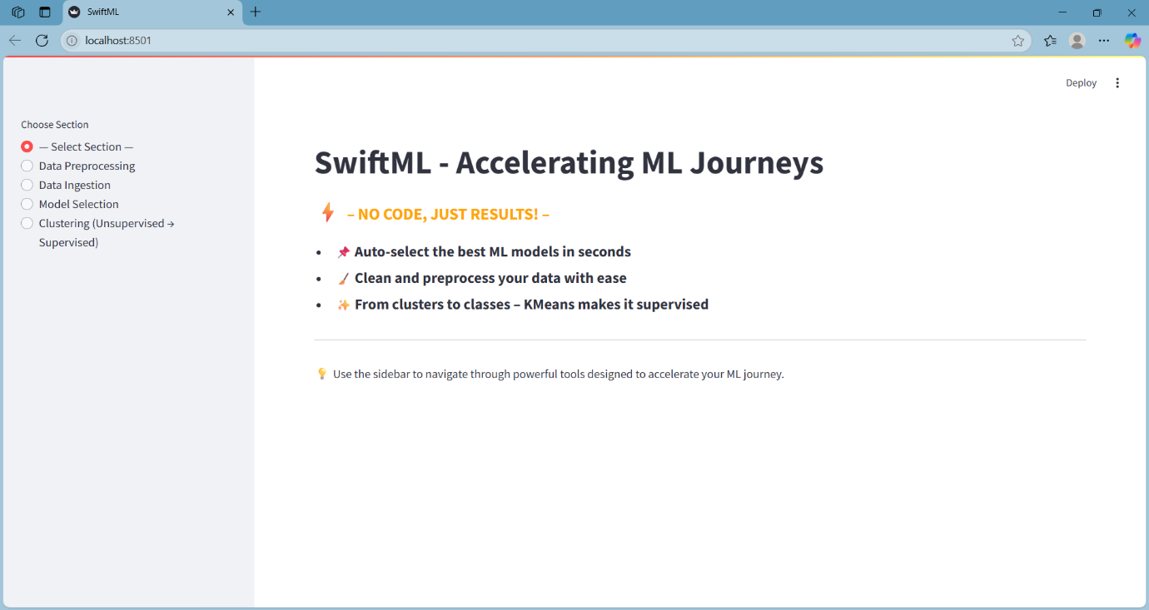
FIG-1. Result of Home Page
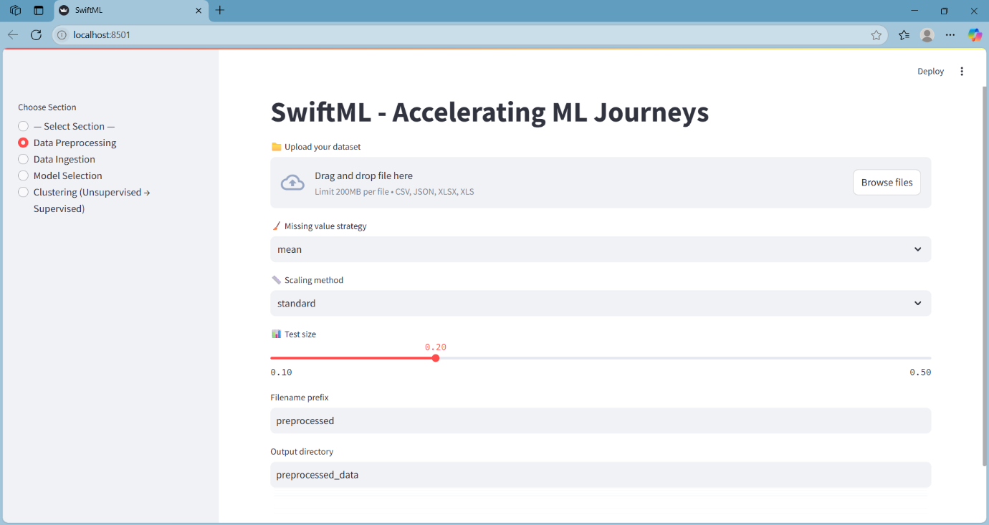
FIG-2. Result of data preprocessing section
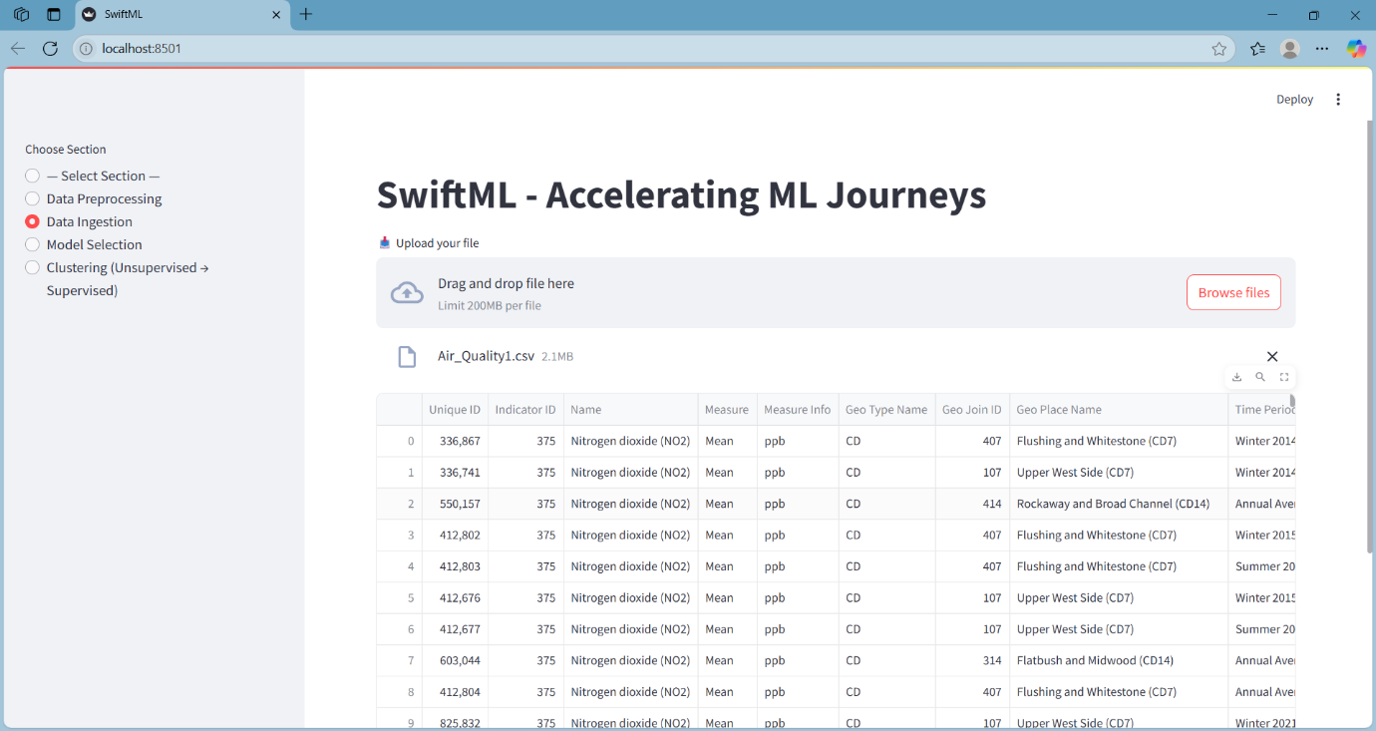
FIG-3 Result of Data Ingestion

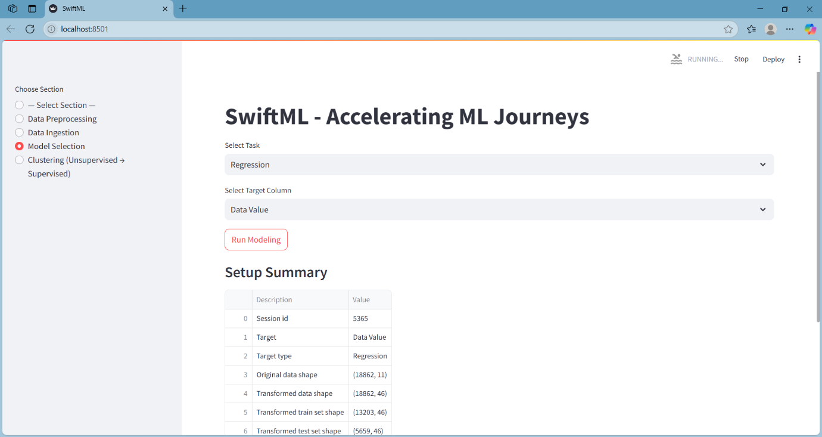
FIG-4. Result of Model Selection Section.

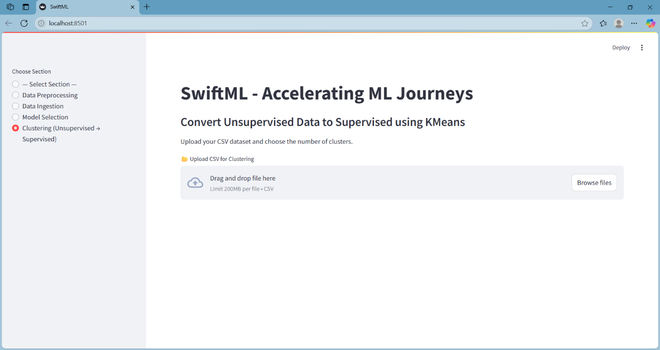
FIG-5. Result of uploading unsupervised datasets
5 CONCLUSION
SwiftML effectively constructs the gap between sophisticated machine learning methodologies and user accessibility via the interface without coding. It enables users to conduct core features like data preprocessing, model selection and grouping with less technical effort. The organized workflows and autobind properties of the platform enable rapid use, thus being perfect for students, analysts and professionals, who obtain rapid insights from data. The modular structure promotes flexibility, whereas the spontaneous interface provides a fluent learning status to novices of machine learning.
6 FUTURE PROSPECTS
6.1 Integration with Cloud Services
In future implementations, SwiftML can be incorporated with cloud platforms like AWS, Google Cloud, or Microsoft Azure to host scalable storage, real-time data streaming, and model deployment. That way, users would be able to train models on big datasets without being constrained by local hardware, and seamless deployment of trained models as APIs or microservices to production environments.
6.2 AutoML Model Enhancement
Though SwiftML uses PyCaret for model automation and selection in the present version, later updates might use sophisticated AutoML environments like H2O.ai, AutoKeras, or Google's AutoML. Such feature enhancements may result in increased accuracy of the model, inclusion of neural architecture search, and added support for deeper learning processes—enabling its usage over a broader class of more sophisticated and high-dimensional data.
6.3 Explainable AI (XAI) Integration
One of the key developments in the pipeline is the incorporation of Explainable AI methods. SHAP (SHapley Additive exPlanations) and LIME (Local Interpretable Model-agnostic Explanations) are two such tools that may be employed to assist users in interpreting how specific features impact model predictions. This would not only position SwiftML as a modeling platform but as an educational tool for obtaining greater insight into model behavior and data trends, enhancing trust and understandability.
6.4 Deep Learning and NLP Support
Presently concentrating on traditional ML algorithms, SwiftML may further be capable of supporting deep learning models through frameworks like TensorFlow and PyTorch. Also, with the integration of Natural Language Processing (NLP) functionalities, it will be possible for users to handle unstructured text data. This will make it possible to leverage applications like sentiment analysis, text classification, and chatbot training, making the tool applicable for more industries like media, customer service, and legal analytics.
6.5 Multi-User Environment and Collaboration
There is also a vision for a multi-user, collaborative version of SwiftML. This would include user authentication, access control based on roles, and shared workspaces in which several users could collaborate on datasets and model construction in real time. Version control, project history, and team dashboards might make SwiftML suitable for enterprise and academic environments alike.
6.6 Mobile and Edge Deployment
With growing adoption of edge computing and mobile machine learning, SwiftML can be made deployable on lightweight platforms in mobile or embedded devices. By supporting export of models to formats such as ONNX or TensorFlow Lite, the software would facilitate offline inference in limited-resource environments. This would bring new opportunities for real-time decision-making in health monitoring, IoT, and smart devices.
REFERENCES
[1] S. K. K. Santu, M. M. Hassan, M. J. Smith, and L. Xu, "AutoML to Date and Beyond: Challenges and Opportunities," arXiv preprint arXiv:2003.06560, 2020.
[2] X. Wang, S. Liu, and G. Long, "A Survey on AutoML: Categorization and Applications," Knowledge-Based Systems, vol. 212, pp. 106622, Jan. 2021.
[3] I. Salehin, M. S. Islam, P. Saha, S. M. Noman, A. Tuni, M. M. Hasan, and M. A. Baten, "AutoML: A Systematic Review on Automated Machine Learning with Neural Architecture Search," Journal of Information and Intelligence, 2024.
[4] Y. Park, "Application of AutoML in R for Medical Data Analysis," Journal of Minimally Invasive Surgery, 2024.
[5] K. Elangovan, G. Lim, and D. Ting, "Performance Comparison of AutoKeras and Manually Built Deep Learning Models," Scientific Reports, 2024.
[6] M. Baratchi, C. Wang, S. Limmer, J. N. Van Rijn, and H. Hoos, "Automated Machine Learning: Past, Present and Future," Volume 57, Article 122, 2024.
[7] F. Conrad, M. Mälzer, F. Lange, H. Wiemer, and S. Ihlenfeldt, "Automated Time Series Analysis using an End-to-End AutoML Pipeline," Procedia Computer Science, 2024.

