A Project Report On

SWIFTML: ACCELERATING MACHINE LEARNING JOURNEYS

Mini project submitted in partial fulfilment of the requirements for the
award of the degree of

BACHELOR OF TECHNOLOGY IN
INFORMATION TECHNOLOGY (2022-2026)
BY

D.HARSHITHA 22241A1280
K. SRUTHIKA 22241A1296
K. VARSHA 22241A1295

Under the Esteemed Guidance of
P. BHARATHI

Assistant Professor



DEPARTMENT OF INFORMATION TECHNOLOGY
GOKARAJU RANGARAJU INSTITUTE OF ENGINEERING AND TECHNOLOGY (AUTONOMOUS)
HYDERABAD
2024-25



CERTIFICATE

This is to certify that it is a Bonafide record of Mini Project work entitled “SWIFTML: ACCELERATING MACHINE LEARNING JOURNEYS” done by D. HARSHITHA (22241A1280), K. SRUTHIKA (22241A1296), K. VARSHA (22241A1295) of B. Tech in
the Department of Information of Technology, Gokaraju Ranga Raju Institute of Engineering and Technology during the period 2022-2026 in the partial fulfilment of the requirements for the award of degree of BACHELOR OF TECHNOLOGY IN INFORMATION TECHNOLOGY from GRIET, Hyderabad.

P. Bharathi Dr. Y. J. Nagendra Kumar
Assistant Professor Head of the Department
(Internal Guide)

(Project External)

ACKNOWLEDGEMENT

We take immense pleasure in expressing gratitude to our internal guide, Mrs. P. Bharathi, Assistant Professor, Dept of IT, GRIET. We express our sincere thanks for his encouragement, suggestions and support, which provided the impetus and paved the way for the successful completion of the project work.

We wish to express our gratitude to Dr Y J Nagendra Kumar, HOD IT, and our Project Coordinators Mr. P.K. Abhilash and Mrs. T Nishitha for their constant support during the project

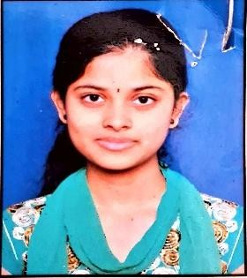
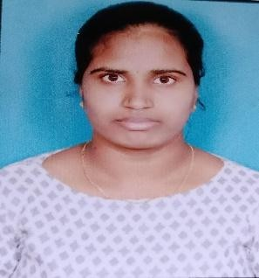
We express our sincere thanks to Dr. Jandhyala N Murthy, Director, GRIET, and Dr. J. Praveen, Principal, GRIET, for providing us a conductive environment for carrying through our academic schedules and project with ease. We also take this opportunity to convey our sincere thanks to the teaching and non-teaching staff of GRIET College, Hyderabad

￼
Email: harshithadandige01@gmail.com Email: katipallisruthika@gmail.com

Contact No: 7702474450 Contact No: 9963827738
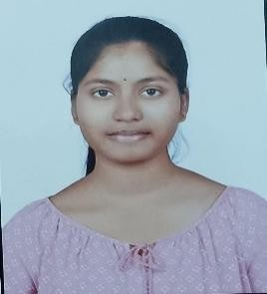
Email: sreevarsha.14111@gmail.com
Contact No: 8247736504

DECLARATION

This is to certify that the mini project entitled “SWIFTML: ACCELERATING MACHINE LEARNING JOURNEYS” is a Bonafide work done by us in partial fulfilment of the requirements for the award of the degree BACHELOR OF TECHNOLOGY IN INFORMATION TECHNOLOGY from Gokaraju Ranga Raju Institute of Engineering and Technology, Hyderabad.

We also declare that this project is a result of our effort and has not been copied or imitated from any source. Citations from any websites, books and paper publications are mentioned in the Bibliography.

This work was not submitted earlier at any other University or Institute for the award of any degree.

D. HARSHITHA 22241A1280
K. SRUTHIKA 22241A1296
K. VARSHA 22241A1295

TABLE OF CONTENTS

S NO | Name | Page no
 | Certificates | ii
 | Contents | v
 | Abstract | vii
1 | INTRODUCTION | 1
1.1 | Introduction to project | 1
1.2 | Existing System | 3
1.3 | Proposed System | 3
2 | REQUIREMENT ENGINEERING | 5
2.1 | Hardware Requirements | 5
2.2 | Software Requirements | 5
3 | LITERATURE SURVEY | 6
4 | TECHNOLOGY | 9
5 | DESIGN REQUIREMENT ENGINEERING | 12
5.1 | UML Diagrams | 12
5.2 | Use-Case Diagram | 14
5.3 | Class Diagram | 15
5.4 | Activity Diagram | 16
5.5 | Sequence Diagram | 17
5.6 | Deployment Diagram | 18
5.7 | Architecture | 19
6 | IMPLEMENTATION | 20
7 | SOFTWARE TESTING | 25
7.1 | Unit Testing | 25
7.2 | Integration Testing | 25
7.3 | Functional Testing | 26
7.4 | Security Testing | 26
7.5 | Testing on our System | 27
8 | RESULTS | 28
9 | CONCLUSION AND FUTURE ENHANCEMENTS | 31
10 | BIBLIOGRAPHY | 32

LIST OF DIAGRAMS

S NO | Figure Name | Page no
1 | Applications of python | 9
2 | Concept of UML | 13
3 | Use Case Diagram | 14
4 | Class Diagram | 15
5 | Activity Diagram | 16
6 | Sequence Diagram | 17
7 | Deployment Diagram | 18
8 | Architecture | 19

ABSTRACT

SwiftML is an exciting tool designed to simplify the procedure of automatic gadget mastering models. It is a tool that is accessible even to non-experts. It is a consumer-friendly tool in which users can evaluate the performance of various algorithms primarily based on their datasets and select a satisfactory or appropriate version. SwiftML plays important roles together with preprocessing, model training and testing. SwiftML supports each supervised and unsupervised getting to know responsibilities. With an intuitive Streamlit interface, customers can without problems add datasets, pick algorithms, and consider real-time outcomes. The Pickle library integration lets in customers to store and download skilled models for offline use, making it perfect for manufacturing deployment or personal use.SwiftML supports an extensive variety of 10-15 machine-getting-to-know algorithms. Hence, users can fast get admission to multiple models without deep understanding in machine mastering. After education, it gives distinct performance metrics consisting of Mean Absolute Error, R2, Mean Square Error, and Root Mean Square Error, which facilitates users without problems evaluate and pick out the pleasant version. Using the PyCaret library, SwiftML techniques the training and evaluating fashions, which allows shop effort and time. SwiftML has emerge as a valuable resource for statistics scientists, analysts, and absolutely everyone looking to put into effect device studying models without any domain professionals or widespread coding.

Keywords: Automated system-learning, PyCaret, Streamlit
Domain: Machine learning

INTRODUCTION

Introduction to Project

The fast improvements in era and the growing availability of records have significantly transformed the manner businesses and individuals approach problem-fixing. Among those advancements, Machine Learning (ML) has emerged as a recreation-converting discipline that permits structures to learn from facts and make predictions or selections without being explicitly programmed.

Today, ML performs a crucial position throughout various domain names along with healthcare, finance, schooling, e-trade, cybersecurity, and greater. However, regardless of its great capability, the adoption of ML remains hindered through the technical knowledge required to construct, train, and deploy efficient models. For individuals with confined programming or data technological know-how backgrounds, this poses a great venture.

To address this issue and lower the entry barrier to machine getting to know, we present SwiftML—a person-friendly, low-code, computerized gadget mastering tool designed to simplify the complete version development lifecycle. SwiftML allows users to build and compare ML fashions via an intuitive Graphical User Interface (GUI), eliminating the need for complex programming or deep statistical information. The challenge leverages effective Python libraries like Streamlit, PyCaret to offer a seamless cease-to-give up revel in, from information enter to version deployment.

Streamlit is a present-day framework for creating interactive and records-centric web programs the use of pure Python. It lets in the design of stylish and responsive consumer interfaces with minimal effort. In SwiftML, Streamlit serves because the front-end layer that interacts with the user, making the utility handy even to people with minimum technical heritage. Users can upload datasets, pick between supervised or unsupervised learning responsibilities, choose ML algorithms, and think about results—all from a single web interface.

PyCaret, the spine of the ML functionality, is an open-source, low-code ML library that simplifies the process of appearing machine mastering experiments. It automates critical duties which includes:
- Data preprocessing (handling missing values, encoding specific variables, function scaling, and so forth.)
- Model choice and evaluation throughout more than one algorithm.
- Hyperparameter tuning for optimized overall performance.

- Evaluate the use of standardized metrics.
- Visualization of version insights.

By integrating PyCaret into SwiftML, users can quickly evaluate one-of-a-kind models and choose the excellent-performing one without writing vast code. This significantly reduces the time and effort required for version improvement.

One of the standout functions of SwiftML is its guide for both supervised and unsupervised learning. In supervised getting to know, users can carry out category (e.g., predicting if a mail is unsolicited mail or not) and regression (e.g., predicting residence fees). For unsupervised learning, the tool offers clustering techniques (e.g., segmenting clients based on behaviour). After schooling, the performance of fashions is evaluated using standard metrics such as:

- Mean Absolute Error (MAE) – Provides the average value of mistakes in predictions.
- Mean Squared Error (MSE) – Emphasises larger errors by squaring them.
- Root Mean Squared Error (RMSE) – Offers blunders significance within the same devices as the original statistics.
- R² Score (Coefficient of Determination) – Indicates how well the model explains the range of the goal variable.

To enhance the usability of trained fashions, SwiftML consists of capability for saving and reusing models the use of the Pickle library. This function lets in customers to persist their models and set up them later for actual-international programs without retraining, which is particularly useful in production environments.

The overarching goal of SwiftML is to democratize gadget learning via making it available, efficient, and practical for a wide audience. Whether it’s a pupil exploring ML standards for the first time, a facts analyst acting predictive modelling, or a professional wanting brief insights, SwiftML caters to all use cases with simplicity and efficiency. It abstracts away the technical complexity even as preserving the ability to test with a couple of algorithms and datasets.

In conclusion, SwiftML is a comprehensive AutoML platform designed to empower customers from all backgrounds to leverage device studying correctly. By focusing on ease of use, automation, and deployment readiness, the device brings the energy of ML in the direction of individuals who want it most—without the steep knowledge of the curve. Through SwiftML, we

propose to foster a brand-new wave of statistics-literate users capable of solving issues intelligently and independently.

Existing System
The existing machine learning system often requires users' advanced knowledge of algorithms, data preparation and model assessment. This can be an obstacle to non-experts who want to take advantage of machine learning for practical applications. Typically, the process consists of several stages such as functional technique, model choices and Hyperpieme setting, which can be complex and time-consuming. Existing automatic tools can offer simplified interfaces, but they still need some technical understanding. SwiftML wants to cope with these challenges by offering a simple, user-friendly platform that streamlines the machine learning workflow, making it available to a wider audience.
- 1. Google AutoML
- Professionals: High accuracy, easy integration with cloud services, minimal coding.
- Opposition: Payment service, Internet access requires, limited adaptation.
- 2. H2O AutoML
- Professionals: Open sources, many ML models, support good performance.
- Opposition: Complex user interface, heavy setup, not favourable for beginners.
- 3. Auto-vicar
- Professionals: Professional model choices and attitude, open-SUS.
- Opposition: No graphic interface, python skills, or complex setup is required.
- 4. Package
- Professionals: Low codes, many models, support time savings.
- Opposition: No GUI, users must write code, not interactive for beginners.

Proposed System
The proposed gadget, SwiftML – Accelerating Machine Learning Journeys, is designed to simplify the device getting-to-know technique for non-specialists. It utilizes Streamlit as the frontend interface and integrates PyCaret, an open-source machine gaining knowledge of library, together with Pickle for model serialization. SwiftML automates key stages of system mastering, including information preprocessing, version selection, training, assessment, and deployment. Users can absolutely upload their datasets, choose their target variable, and allow SwiftML to deal with the relaxation, from data cleaning to providing excellent version recommendations. The system provides a clean-to-apprehend interface, getting rid of the need for technical expertise at the same

time as retaining flexibility and high performance, and making machine studying greater accessible and quicker for people and organizations.

REQUIREMENT ENGINEERING

Hardware Requirements

Processor – i5 and above (64-bit OS).
Memory – 4GB RAM (8GB or above is recommended for better performance) Input devices – Keyboard, Mouse, Webcam

Software Requirements

- Visual Studio Code
- Python
- Datasets
- Python Libraries 1.pandas 2.numpy 3.pycaret 4.scikit-learn 5.streamlit

LITERATURE SURVEY

Shubhra Kanti Karmaker Santu, Md. Mahadi Hassan, Micah J. Smith, and Lei Xu, in their 2020 paper posted on arXiv titled AutoML to Date and Beyond: Challenges and Opportunities, proposed a seven-tier taxonomy to classify AutoML structures based totally on their level of autonomy. The authors identified guide bottlenecks in present AutoML workflows and carefully examined the challenges in reaching complete automation within the field. Their work highlights key areas that also require studies and development to make AutoML certainly self-reliant. [1]

Xiang Wang, Shiwei Liu, and Guodong Long offered their work in the journal Knowledge-Based Systems, Volume 212, on January 5, 2021. They centered on categorising AutoML techniques based on the distinct ranges of the machine learning pipeline. Their method presents a clearer expertise of how AutoML gear can be dependent and used throughout diverse domain names, making gadget-gaining knowledge of greater accessible to customers with minimal expert expertise.[2]

Imrus Salehin, Md. Shamiul Islam, Pritom Saha, S.M. Noman, Azra Tuni, Md. Mehedi Hasan, and Md. Abu Baten conducted a scientific review titled AutoML: A Systematic Review on Automated Machine Learning with Neural Architecture Search, which turned into published in the Journal of Information and Intelligence in 2024. Their observation analyzed information processing requirements and presented Neural Architecture Search (NAS) algorithms. The assessment emphasised that NAS can automatically discover the most advantageous model architectures, thereby enhancing both model choice and hyperparameter tuning [4]

In sensible software settings, researchers are beginning to reveal the feasibility of the usage of AutoML tools for actual-world domain-unique troubles. Youngho Park, in a 2024 article within the Journal of Minimally Invasive Surgery, showcased using AutoML within the R programming environment. Through code-based totally tutorials, Park illustrated how AutoML automates obligations such as records preprocessing, model choice, and hyperparameter tuning, even for non- technical customers. His paintings are especially precious within the scientific subject wherein

experts need actionable insights with ut the overhead of deep ML understanding. By bridging the distance between medical expertise and facts analytics, AutoML equipment like those described with the aid of Park are using innovation in clinical research and operational selection-making. [5]

Similarly, the evaluation of particular AutoML frameworks like AutoKeras has garnered interest. In 2024, Kabilan Elangovan, Gilbert Lim, and Daniel Ting published a comparative have a look at in Scientific Reports, wherein they analyzed the overall performance of AutoKeras in opposition to custom-built deep gaining knowledge of models. Their findings discovered that AutoKeras, in spite of being fully computerized, plays competitively with manually tuned architectures. This contrast supports the argument that AutoML frameworks are not most effective user-pleasant but additionally robust enough for actual-global deployment, decreasing the resource price of version layout even as reaching comparable, if now not better, overall performance degrees. [6]

To contextualize these advancements traditionally and predictively, Mitra Baratchi, Can Wang, Steffen Limmer, Jan N. Van Rijn, and Holger Hoos provided a complete overview of their 2024 booklet titled Automated Machine Learning: Past, Present and Future. This study, published as Article Number 122 in Volume 57, centered at the evolution of AutoML technology, especially highlighting the developing significance of Hyperparameter Optimization (HPO) and Neural Architecture Search (NAS). The authors supplied insights into the historical trajectory of AutoML and mapped out rising trends, which includes adaptive getting to know systems and meta-getting to know. Their paintings serves as each a technical and philosophical guide for understanding the course wherein AutoML is headed—in the direction of complete-stack automation supported by clever comments loops and optimization heuristics..[7]

Lastly, Felix Conrad, Mauritz Mälzer, Felix Lange, Hajo Wiemer, and Steffen Ihlenfeldt, of their 2024 have a look at published in Procedia Computer Science, verified a fully automated system gaining knowledge of pipeline focused on time series analysis. Their paintings involved the

development of a workflow that covered automated information preprocessing, feature engineering, version training, and evaluation—all embedded inside an AutoML framework. By automating featurization specifically, their pipeline decreased manual effort extensively, making time series evaluation more reachable and green for industries relying on forecasting and trend prediction. This research emphasizes how AutoML isn't simplest theoretical however additionally almost relevant to complicated analytical obligations traditionally requiring deep statistical understanding. [8].

TECHNOLOGY

  - ABOUT PYTHON
The statistical evaluation skills of Python are growing with the evolution of its surroundings. It efficiently reconciles scale and class. Python locations a high value on clarity and performance. Its format prioritizes application readability, and its basic syntax is simple enough for novices to understand even as nonetheless allowing programmers to express their code in fewer traces specially when using indentation. The dynamic machine and automatic reminiscence control gadget functions are this excessive degree language's uniqueness.

APPLICATIONS OF PYTHON
Python is used in many application domains. It makes its presence in every emerging field. It is the fastest-growing programming language and may be used to create any type of application.
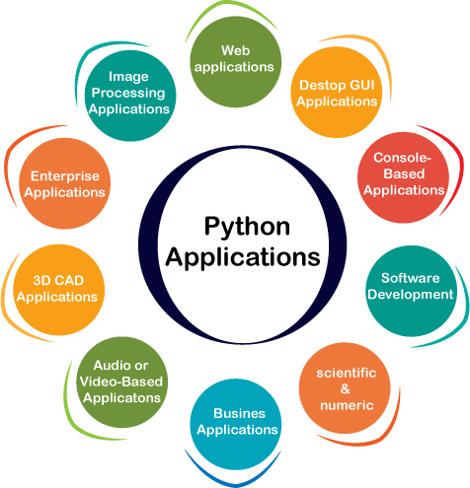
[Fig – 1] Applications of python

PYTHON IS WIDELY USED IN DATA SCIENCE
We utilise Python, an open-source, flexible language, for data science. It provides functions related to mathematics and scientific functions. We presumably use it because of its extensive library and These are the main Python libraries used in data science.

PANDAS
A Python library for examining, cleaning, altering, and evaluating statistics. A dataset often includes a large number of useful and pointless statistics. They become more readable and pertinent with pandas.

NUMPY
A library in Python for reading, cleaning, investigating, and modifying statistics. A common dataset contains both valuable and useless data. They become readable and relevant with pandas.

SCIKIT-LEARN
Scikit-Larn is a popular Open Source Python library used for machine learning and data analysis. It provides simple and effective tools for construction and training models.

PYCARET
PyCaret is an open-source, low-code gadget getting to know library in Python that helps automate the complete gadget mastering workflow. It's designed to be easy and green, making it clean to train and examine fashions with just a few strains of code.

STREAMLIT
Streamlit is an open source python library that helps you create interactive webapper for computer science and machine learning projects with minimum codes.

DATASET DESCRIPTION
Different datasets serve specific purposes. Model prediction uses supervised datasets that contain both input features and target labels. Preprocessing datasets are raw and require cleaning, transformation, and formatting before training. Unsupervised learning datasets have only input features and are used to find patterns or groupings without labels. Sometimes, these unlabeled datasets are converted into supervised ones by assigning pseudo-labels through clustering, enabling the use of supervised algorithms even when original labels are unavailable.

DESIGN REQUIREMENT ENGINEERING

CONCEPT OF UML:

Unified Modelling Language (UML) is a well-defined language used to describe software systems and their components. It is a tool that offers a series of diagrams and shapes or symbols that show the aspects of a system and parts of it, as well as the relations of the various components; it is used in designing, describing and sharing the structure and the docket of any software development project among the various people involved.
UML assists in the detailed design of complicated software systems through offering systematic and well-understood babel with the developers, analysts, and the stakeholders. Thumbs up for it, as it accommodates the object-orientated ideas and is also good at practising the number one rules of software engineering and is a good tool for planning, structuring, and organising the software projects.

- UML DIAGRAMS

UML is a modelling language that is platform agnostic and can be used with any programming language and with any sort of development methodology, and because it is a standard, most software developers will be familiar with it. That is to say, although many engineers may not prefer the use of diagrams, they are useful in an Agile development environment as they gradually add value while contributing positively to the flow and pace of work. It will be helpful if you treat UML diagrams not only as additional and rather fancy artefacts but also as part of documentation. UML diagrams can assist engineering teams in several ways: UML diagrams can assist engineering teams in several ways:
- To welcome a new member on the team or an experienced developer, who joined a new team at the company.
- How to effectively behave for source code.

- This involves coming up with new features in a project before the programming phase of the

project is started.

- Enabling easier understanding of the information where there may be an interaction with both the technical and non-technical observers.

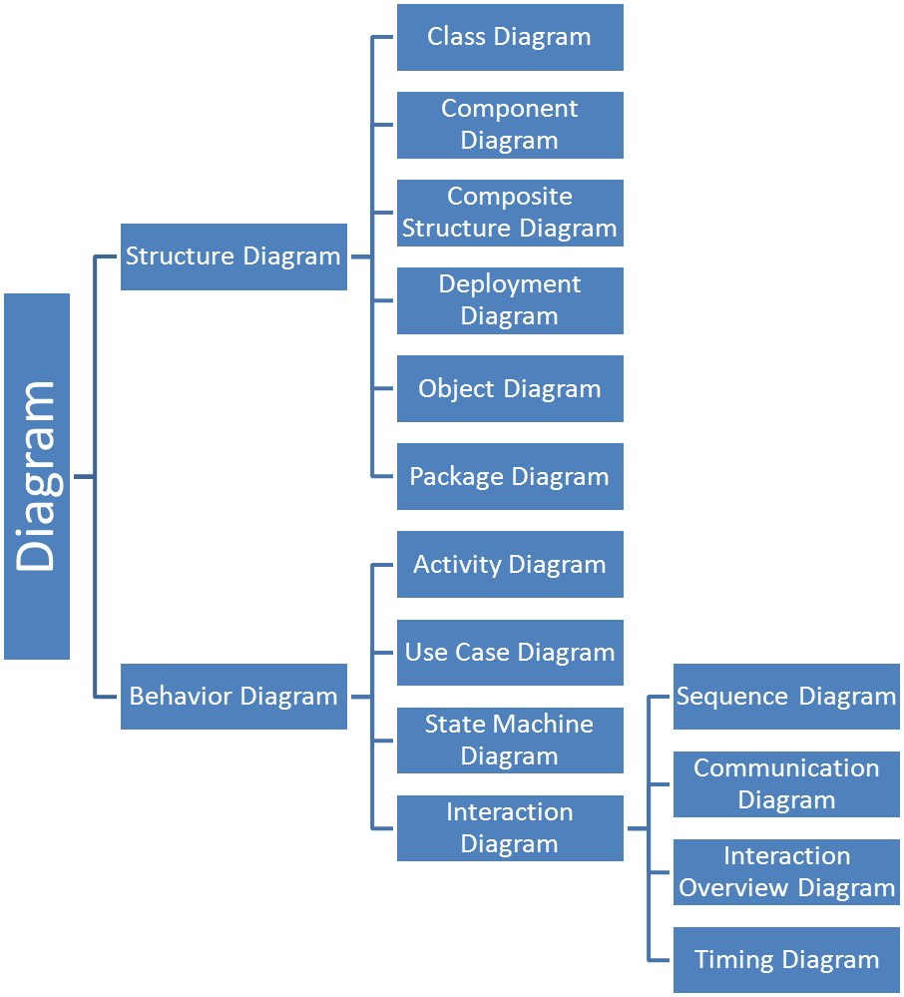

[Fig -2]: Concepts of UML

  - Use Case Diagram

The use case diagrams create a picture view of the actors active in the software program tool. As structures that show device skills, they provide help for builders to contemplate how use instances relate to personas and define what a device is expected to do.
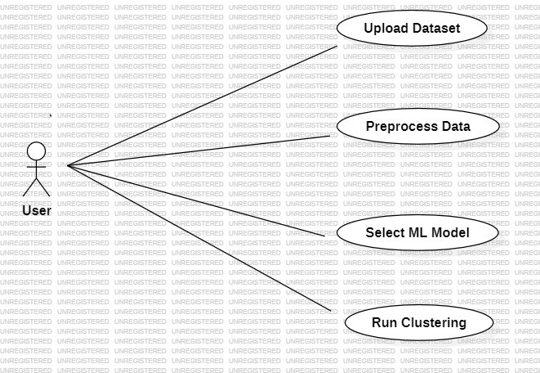

[Fig - 3] Use Case Diagram

Class Diagram:

A UML elegance diagram is an element of a fundamental schema of any object-orientated option. This sketch represents a rigid thing-orientated machine, which defines initiatives supported by using schooling, properties and procedures. In other words, it denotes the teaching in a machine and the working of each one.

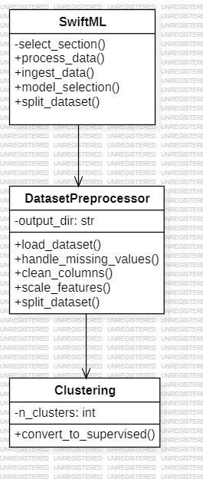

[Fig – 4] Class Diagram

Activity diagram

A UML activity diagram is a flow chart that will display all the activity of a given system. It proposes the entire thing from start to end, outlining the demanding situations and the distinct selection routes and stages that appear to look like they are transitioning from one hobby to every other. The steps may be arranged in time, as a timeline, branches from a timeline, or parallel.
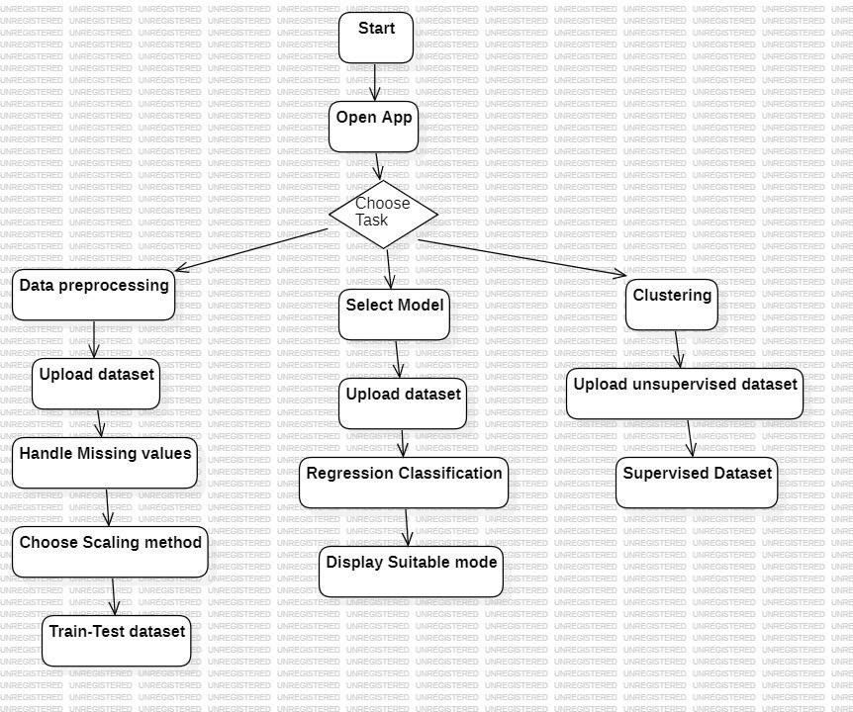
[Fig – 5] Activity Diagram

Sequence Diagram:

Another of the UML diagrams of the collection is the collection sequence diagram, also frequently known as the occurrence diagram, that presents the sequential flow of your gadgets. This includes the very threads of your character pieces and the schemes and dialogues of characters with your gizmos, along with the conversations amongst these gizmos to fulfil a particular purpose.

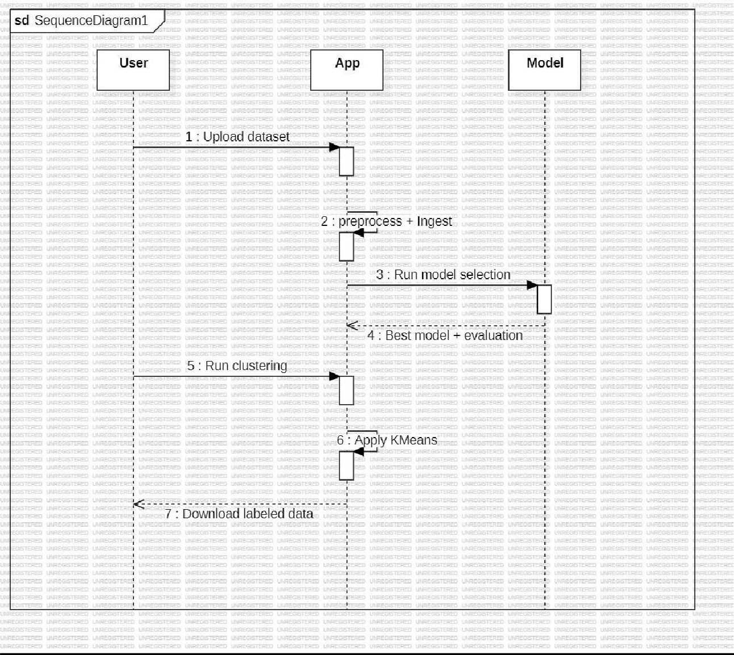

[Fig – 6] Sequence Diagram

  - Deployment Diagram:

A deployment diagram shows the envisioned distribution of nodes and all the additions that remain thereon. In its simplest form, it portrays how the nodes in a distributed environment are joined physically. These diagrams are mainly helpful during the time of designing software that should effectively work on distinct physical platforms.
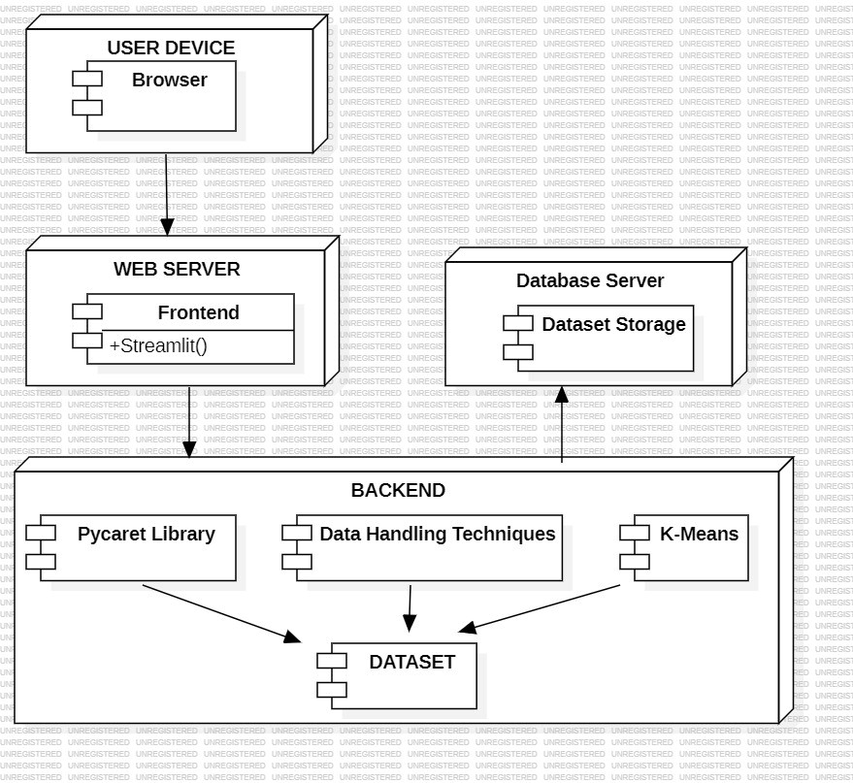

[Fig – 7] Deployment Diagram

Architecture

The SwiftML structure is designed to simplify the machine mastering technique for non-experts through an intuitive, automatic workflow. The User Interface (UI), constructed using Streamlit, permits customers to easily add records, choose goal variables, and think about consequences through an interactive dashboard. The Data Preprocessing module automatically handles responsibilities like facts cleansing, missing price imputation, scaling, and splitting. The Model Selection and Training module utilises PyCaret to select and train the satisfactory-acting machine learning fashions, with automated hyperparameter tuning. After training, the Model Evaluation module assesses the version's performance using numerous metrics and visualisations, such as confusion matrices. The Model Deployment factor serialises the skilled version with Pickle for future use or deployment.
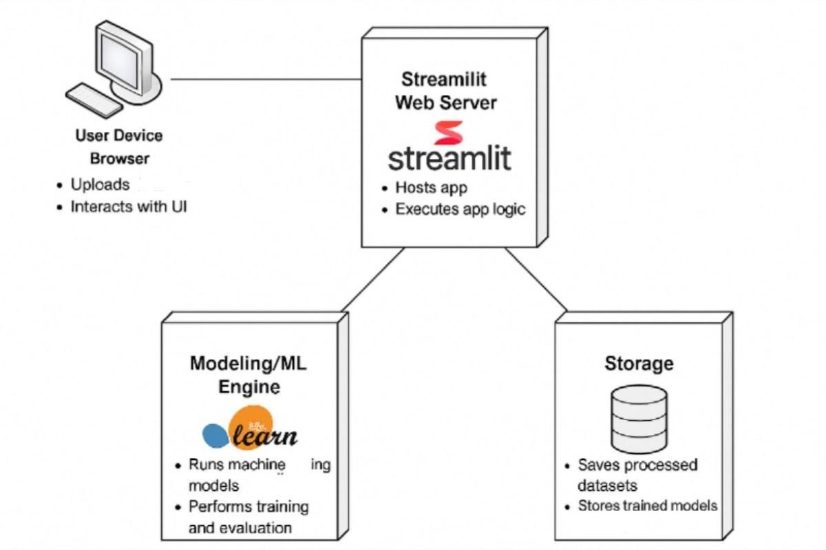
[Fig – 8] System Architecture

IMPLEMENTATION

Library Imports:

- Imports Streamlit for building the web interface.
- Uses pandas and NumPy for data handling and manipulation.
- Imports preprocessing modules (MinMaxScaler, StandardScaler) and clustering algorithms (KMeans, DBSCAN) from sklearn.
- Uses pycaret.classification for automated model training and comparison.
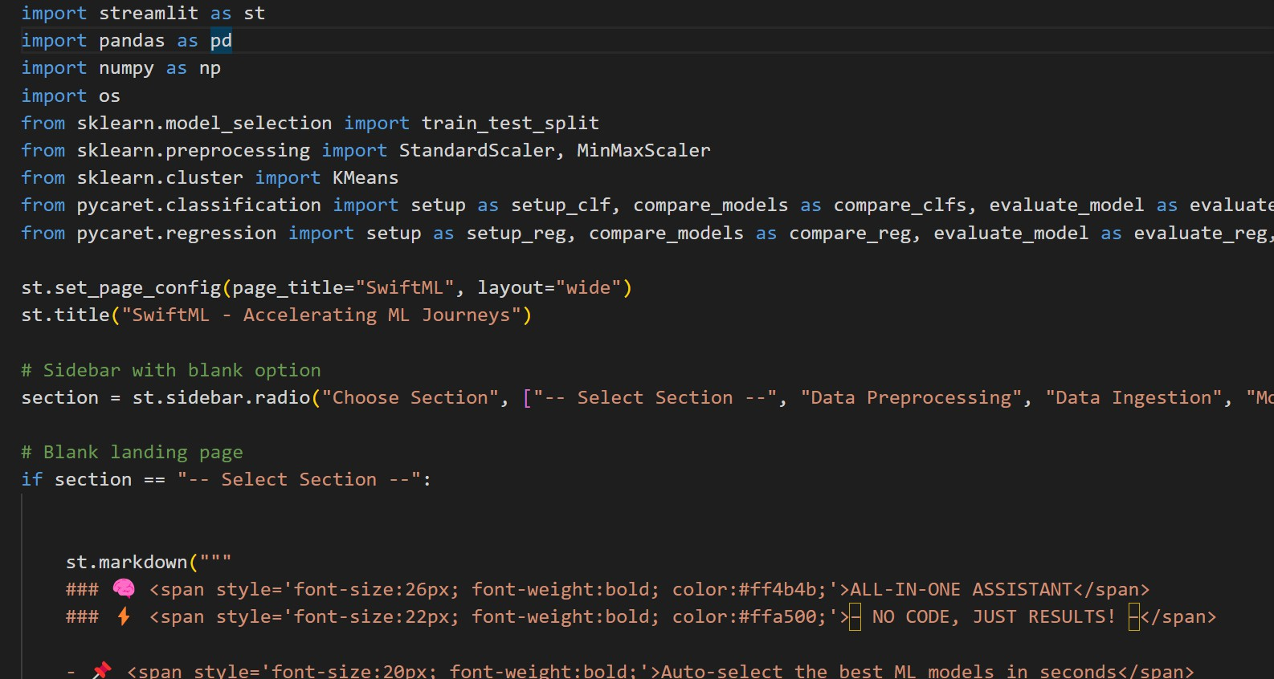

Streamlit Configuration:
- Sets up the web app layout to be wide using st.set_page_config(layout="wide").
- Displays the app title: "SwiftML – Accelerating ML Journeys".

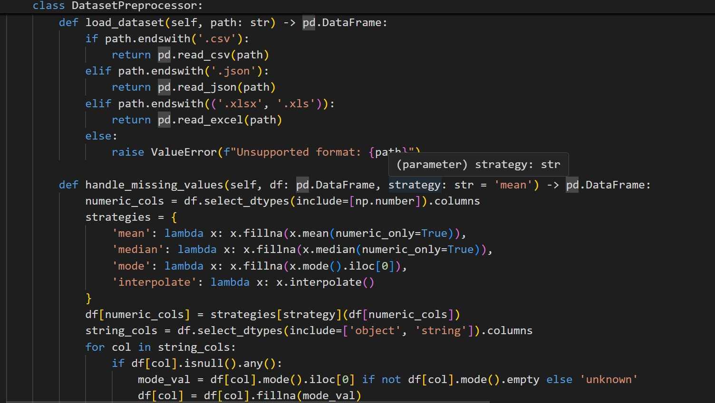

Streamlit Configuration:

- Sets up the web app layout to be wide using st.set_page_config(layout="wide").
- Displays the app title: "SwiftML – Accelerating ML Journeys".

Sidebar Navigation:

Provides a selection box to choose between:

- Data Preprocessing

- Data Ingestion

- Model Selection

- Clustering

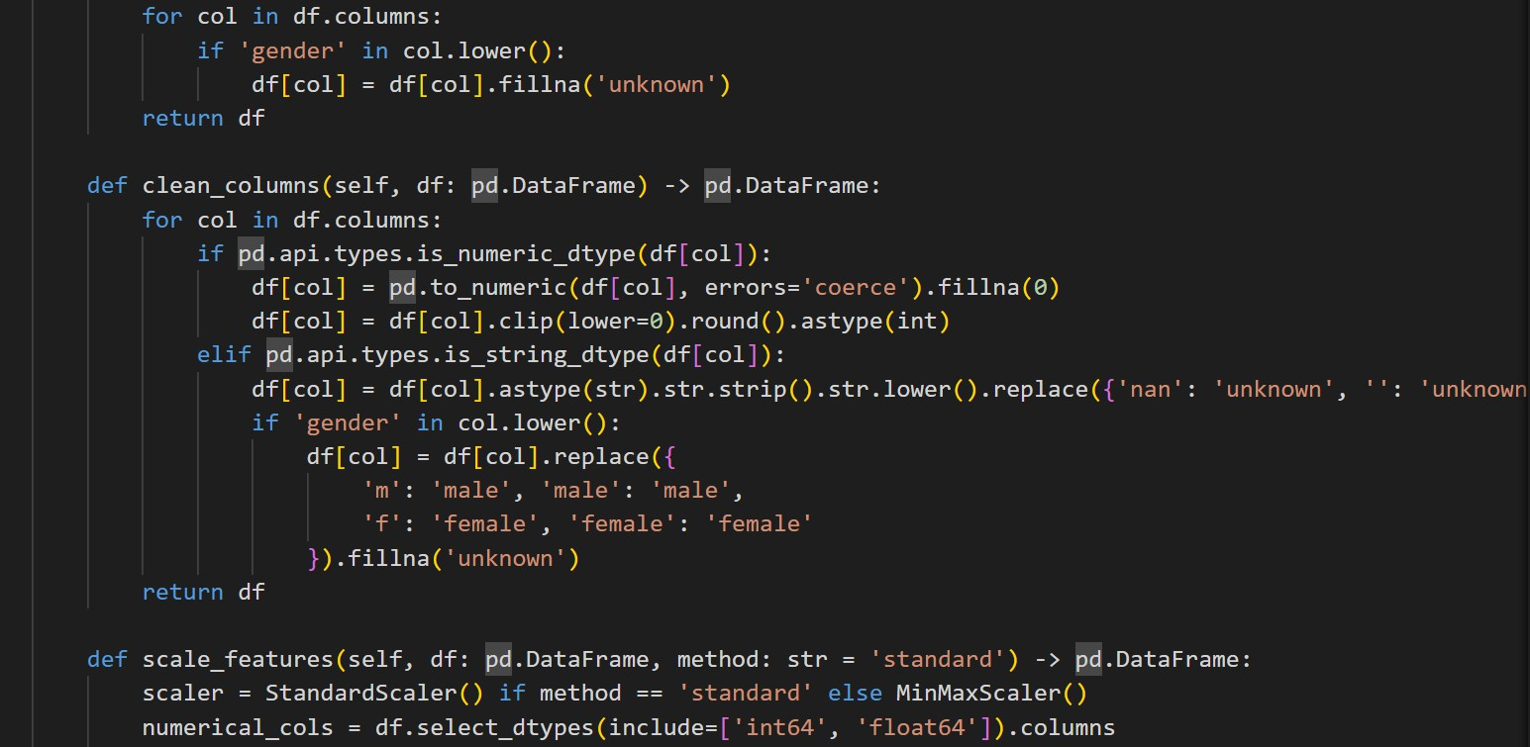

Default View (Welcome Page):

- If no option is selected, a welcome message with markdown is displayed to guide users on the app’s capabilities.

Data Preprocessing:

- Users upload a CSV file.

- Choose between MinMaxScaler or StandardScaler.

- The app processes the data accordingly and displays the scaled output.

Data Ingestion:

- Allows CSV upload.

- Displays the uploaded dataset using a data table.

- Reports the shape of the dataset (number of rows and columns).

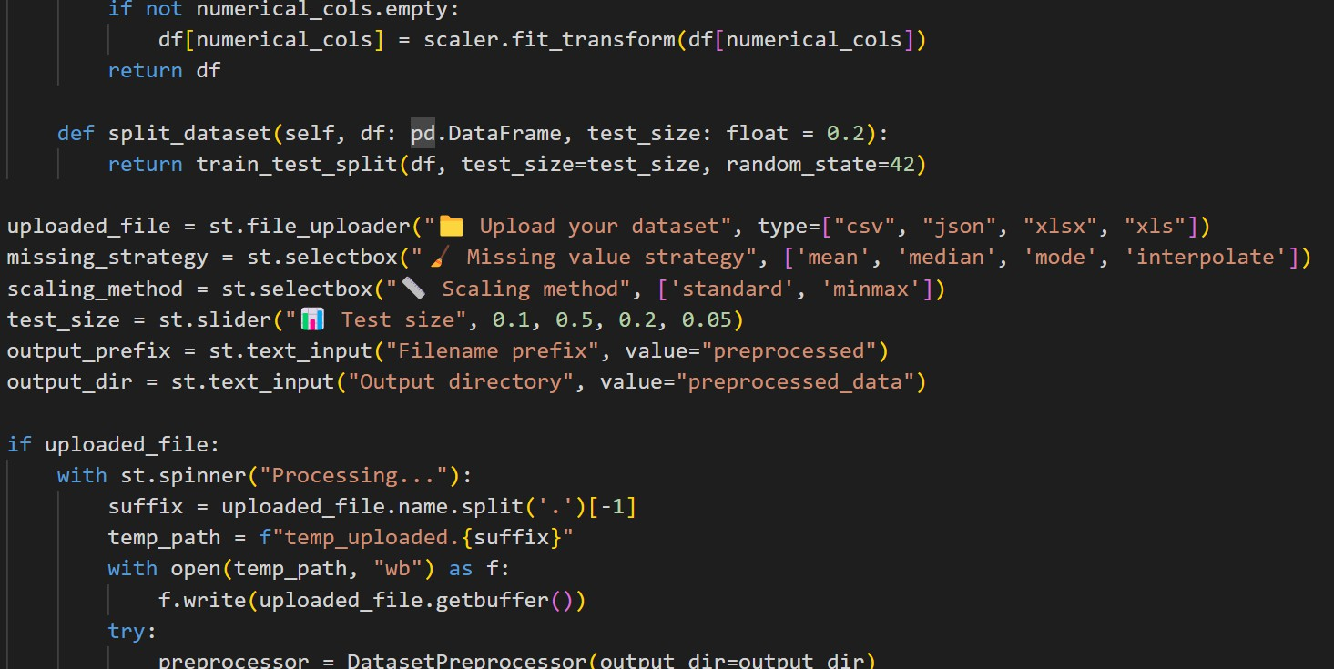

Model Selection:

- Users upload a CSV with labeled data.

- Select the target column.

- Automatically sets up classification using PyCaret.

- Compares models and displays performance metrics using compare_models().

Clustering:

- Users upload a dataset.

- Choose clustering algorithm: KMeans or DBSCAN.

- Select columns to include.

- For KMeans: allows specifying number of clusters.

- Performs clustering and adds cluster labels to the data.

- Displays the data with the new cluster column.

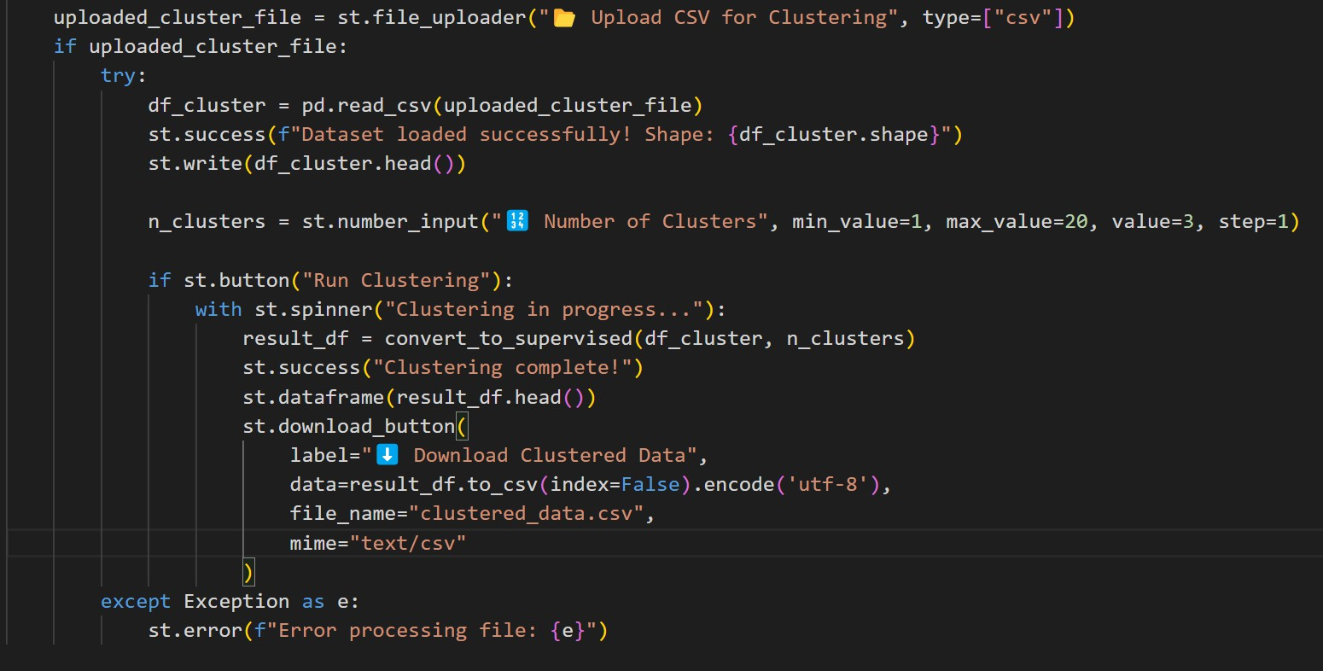

SOFTWARE TESTING

Software testing, as defined, is a type of testing that is done before actual software is fully run. The primary purpose of testing the software is the outcome, which is expected to meet requirements with limited or no errors or defects.

Unit Testing:

Unit checking out focuses on testing personal features or components of the application in isolation. The goal is to make certain that each characteristic plays its task correctly without considering how it interacts with different parts of the gadget. In your utility, examples of such features include:
- handle_missing_values(df, strategy)
- clean_columns(df)
- scale_features(df, approach)
- split_dataset(df, target_column, test_size)
- preprocess_data(df, alternatives)

For each of those, you will take a look at cases to affirm predicted outputs for valid inputs and area instances. For instance, handle_missing_values should be tested to check behaviour whilst using strategies like 'suggest', 'drop', or 'ffill', which include while the DataFrame is empty or includes non-numeric records. Testing may be performed with the use of Python's unittest or pytest, and you can mock information with the use of pandas DataFrames to avoid report I/O.

Integration Testing:

Integration trying out examines how a couple of additives of the utility paintings collectively. The goal is to check the records flow and interplay among functions. For example: After importing a CSV record, does the facts preprocessing pipeline (clean_columns → handle_missing_values → scale_features → preprocess_data) work efficiently when chained? Does the processed DataFrame get successfully passed to the schooling or clustering degree?
- Do UI factors (like sidebar picks) successfully cause underlying common sense?

Here, you are checking if mixed features and modules behave correctly when included, even supposing they work pleasantly individually. You may also use integration test frameworks or structured pytest test files with setup and teardown steps to simulate complete workflows.

Functional Testing:

Functional checking out guarantees that each feature of your utility works as predicted in keeping with the user requirements. This form of trying out validates the what of the system, not the how. For your Streamlit app, this means:
- The user can add datasets effectively.
- After preprocessing, the person can download the wiped-clean dataset.
- The sidebar shall let users pick out preprocessing alternatives, and the UI responds correctly.
- The navigation bar switches pages between "Data Ingestion" and "Model Training". "Clustering" and "Download".
Tools like Selenium or Playwright can be used for automatic browser-primarily-based useful checking out, simulating actual consumer interactions to affirm that each one UI control works as meant.

Security Testing:

- Security testing tests for vulnerabilities and ensures the software protects statistics and resists attacks. For your gadget, this could encompass:
- Uploading potentially malicious or malformed files (e.g., executable code disguised as CSV) to test report coping with.
- Testing for injection attacks or attempts to access confined components of the file device.
- Verifying that person-entered data (e.g., column names, report names) is sanitised earlier than processing.
Security check cases need to simulate adversarial input and verify that the app fails effectively— with the aid of rejecting entry, logging errors, and by no means exposing internal logic or stack traces.

Performance and Stress Testing:

- This checking out determines how the application behaves underneath heavy load or with massive files. Key areas encompass:
- Uploading large datasets (e.g., 50MB CSV) and monitoring reminiscence usage.
- Running complex preprocessing (e.g., encoding, scaling, lacking cost managing) and measuring execution time.
- Simultaneous customers uploading and processing statistics (in a deployed version).

RESULTS

- Upload and clean their dataset
- Automatically select and evaluate the best ML models
- Apply clustering to convert unlabeled data into labelled data
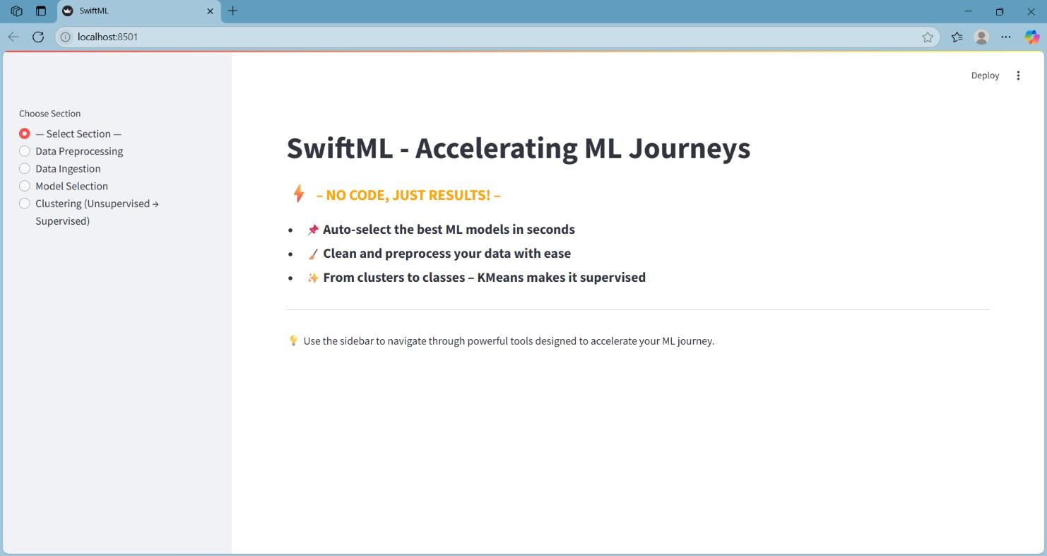

Clustering (Unsupervised → Supervised)
- This section turns unlabeled data into labeled data using KMeans clustering.
- You upload a dataset (without a target).
- Choose how many clusters you want (e.g., 3 groups).

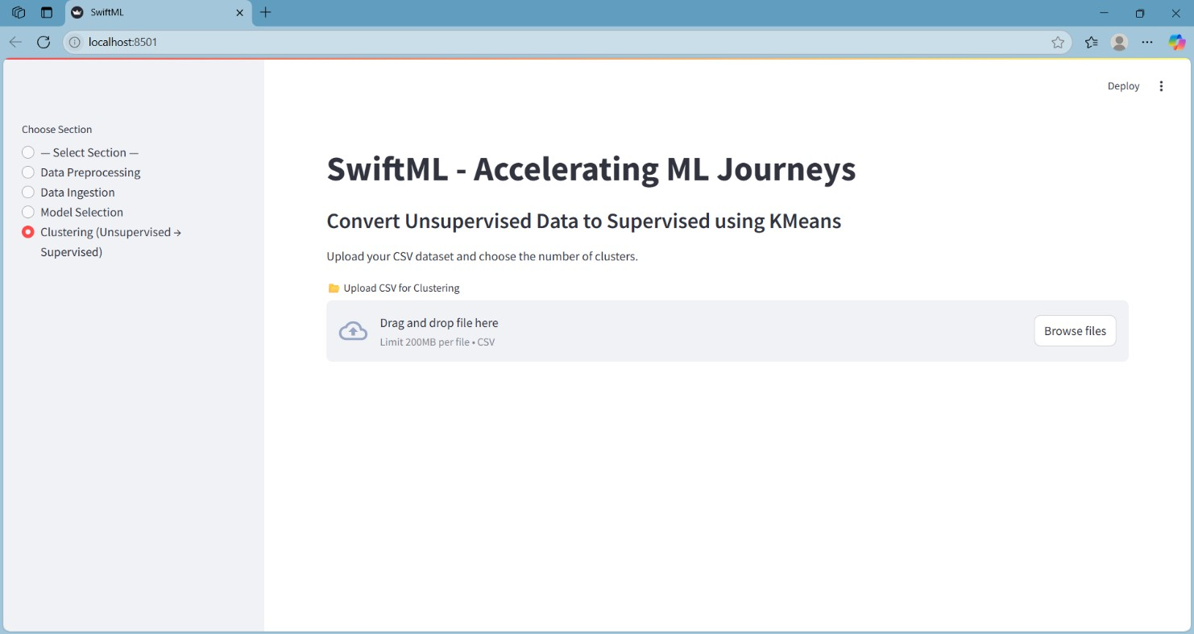

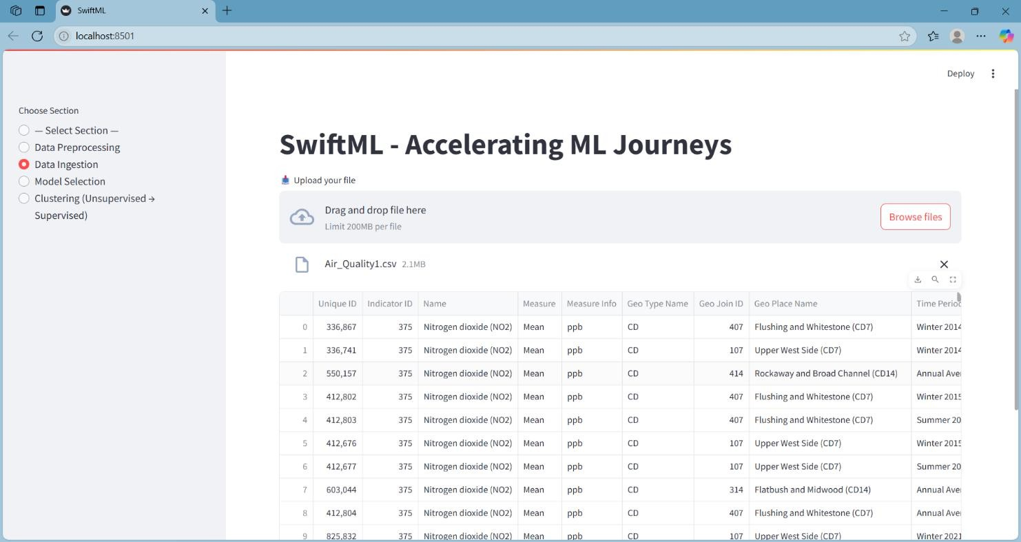

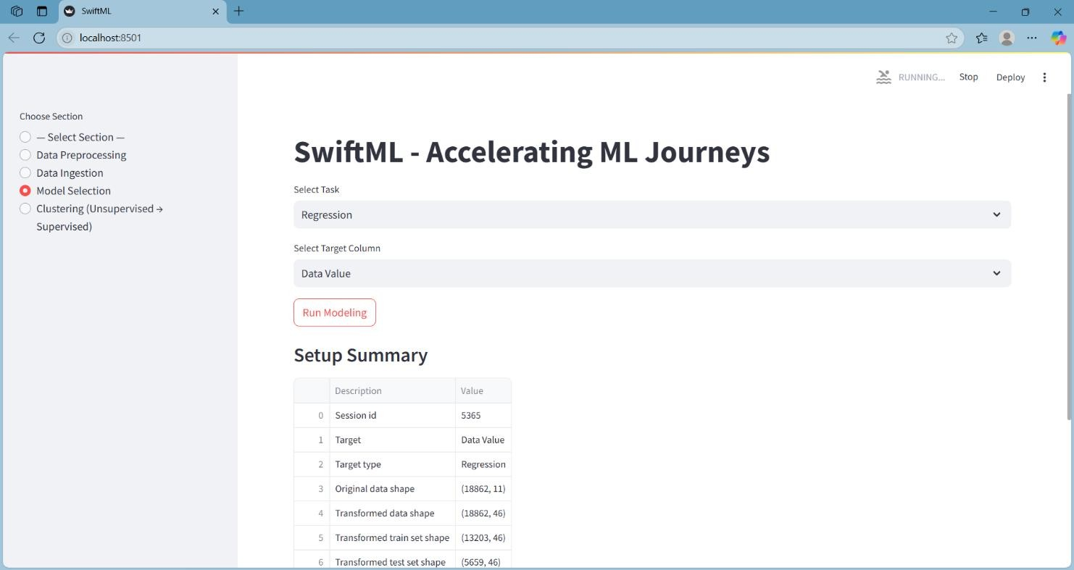

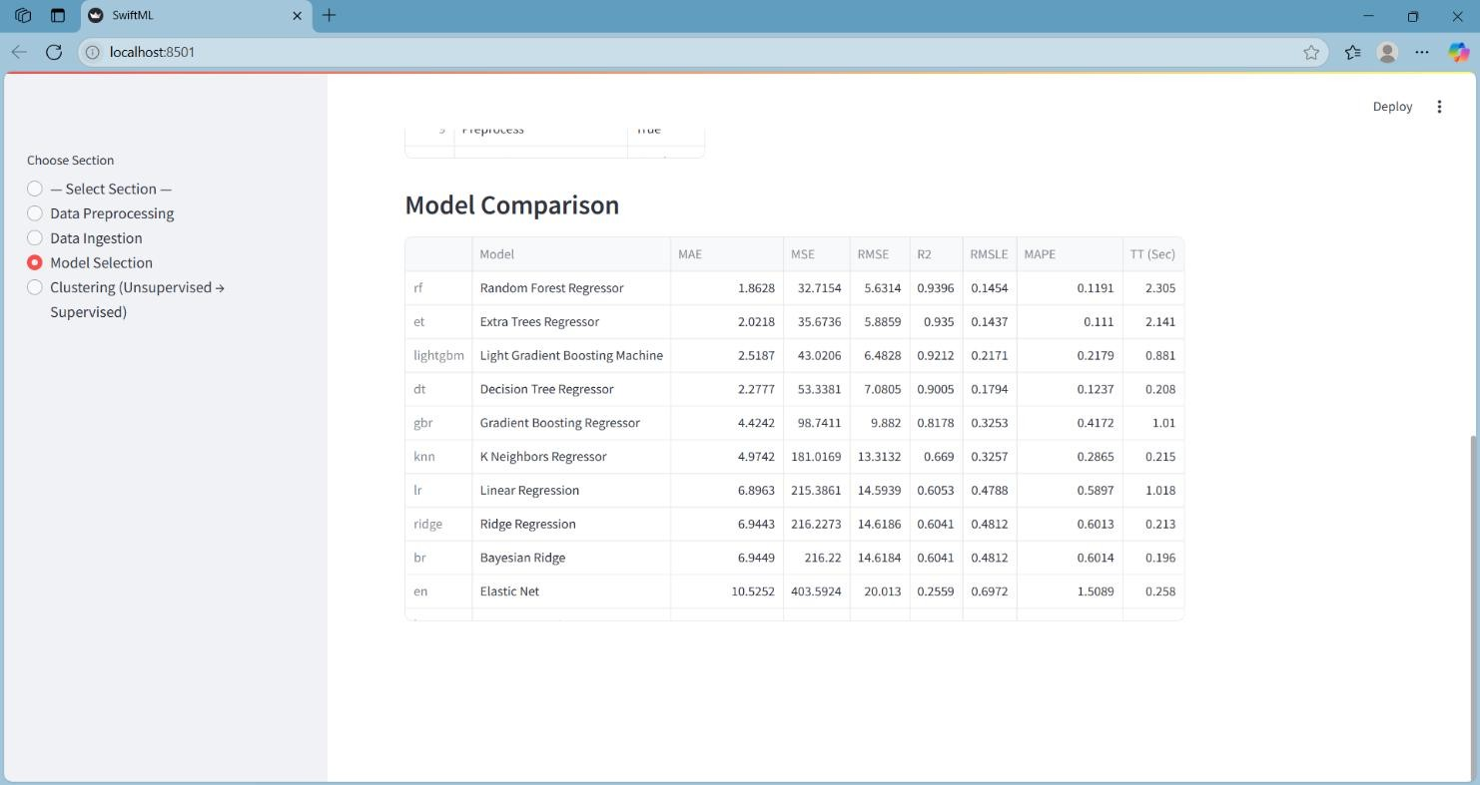

CONCLUSION AND FUTURE ENHANCEMENTS

SwiftML successfully builds the difference between complex machine learning processes and user access through the interface without code. This allows users to perform essential features such as data preprocessing, model selection and grouping with minimal technical effort. The structured workflows and automatic properties of the platform allow for quick use, making it ideal for students, analysts and professionals, who gain quick insights from data. The modular design ensures flexibility, while the spontaneous interface supports a smooth learning status for beginners in machine learning.

Thoughts of future growth:

Model Paree's and Prediction: Add features to store, load and distribute models with real-time prediction skills for end-to-end ML solutions.
Advanced EDA and Preprying Tools: Visual Tools (Hemies, PCAS, Box Tomots) and Outliers, Feature Engineering and several options to handle more options for handling text/image data.
User's individualization and clarity: Users introduce the AI tools such as login, session story and better model transparency and user experience user experience.

BIBLIOGRAPHY

- Geron, A. (2019). Hands-on machine learning with Scikit-Learn, Keras and TensorFlow. O'Reilly Media.
- Covers machine learning concepts and tools, including libraries used in this project.

- Raschka, S., Mirjalili, V. (2017). Python Machine Learning. Packet Publishing.

- Provides an introduction to data preprocessing, scikit-learn, and model evaluation.

- McKinney, W. (2017). Python for Data Analysis. O'Reilly Media.

- Focuses on pandas and data manipulation techniques.

