What is Cyber Security?
Cybersecurity is the practice of protecting digital devices, networks, and sensitive data from threats like hacking, malware, and phishing

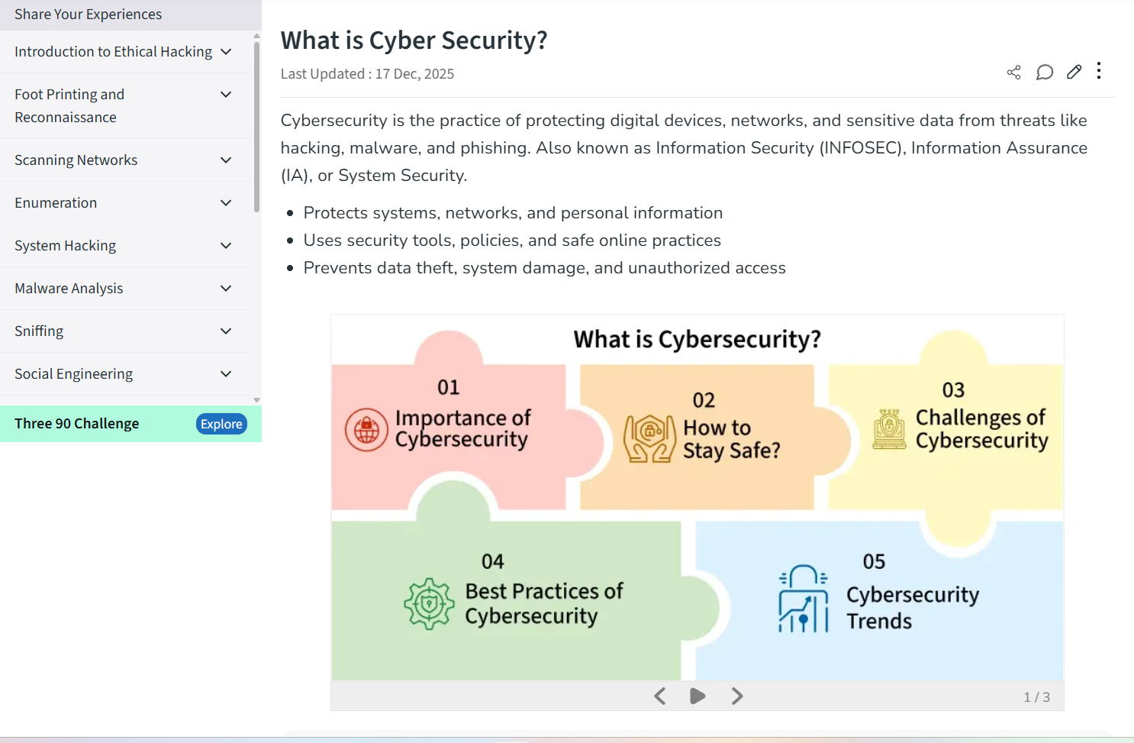

Types of Cybersecurity
There are seven types of cyber security
1.Network Security
2.Application Security
3.Information and data Security
4.Cloud Security
5.Endpoint Security
6.Operarional S
7.Internet of Things Security

CIA TRAID:

Cybersecurity protects digital systems, focusing on the CIA TRAID: Confidentiality (keeping data private via encryption/passwords), Integrity (ensuring data accuracy with digital signatures/hashing), and Availability (guaranteeing access through backups/redundancy)

Confidentiality: Preventing unauthorized access to sensitive information; keeping secrets secret.
- Banking Example: Your bank uses encryption and multi-factor authentication (MFA) so only you can see your balance or transfer funds, preventing hackers from stealing your financial details.
- Social Media Example: Strong passwords and privacy settings stop strangers from reading your private messages or seeing your personal posts.

Integrity: Ensuring data is complete, accurate, and hasn't been altered without authorization.

- Banking Example: Digital signatures verify that a transaction amount hasn't been changed from $100 to $1,000 during transfer.
- Social Media Example: Prevents attackers from changing your profile bio or posting malicious links from your account.

Availability: data can be accessible .enuring data is complete, accurate, and hasn't been altered without authorization.
- Banking Example: Redundant servers and disaster recovery plans ensure ATMs and online banking remain operational, even during outages.
- Social Media Example: Prevents denial-of-service (DoS) attacks that would make the platform unusable for everyone

TYPES OF ATTACKERS

Cyber threat actors can be categorized by their motivations, skill levels, and resources. The primary types of attackers, as identified by credible security sources, are script kiddies, insiders, hacktivists, and nation-state actors, each with distinct objectives and methods.

Script Kiddies :
Script Kiddies Inexperienced individuals who use existing, pre-written scripts and tools developed by others to launch attacks, often without a deep understanding of the underlying technology.
Motivation: Their primary drivers are typically amusement, curiosity, personal satisfaction, or the desire to impress peers, rather than financial gain or political change.
Impact: While they lack advanced skills, their attacks can still cause significant disruption, such as defacing websites or launching denial-of-service (DoS) attacks against poorly protected systems.

Insiders:
Insiders Individuals who have legitimate, authorized access to an organization's systems and data, and who misuse that access, either maliciously or accidentally.
Motivation: Malicious insiders may be motivated by personal grievances, financial incentives, or corporate espionage, while unintentional insiders cause harm through carelessness or human error (e.g., falling for a phishing scam).
Impact: They pose a significant threat because their insider access allows them to bypass many security measures, potentially leading to data theft, sabotage, or system damage.

Hacktivists:
Hacktivists Threat actors who use hacking techniques to promote a political, social, or ideological cause.
Motivation: They are not typically motivated by financial profit, but rather by a desire to bring public attention to their message, protest perceived injustices, or damage the reputation of a target organization or government.
Impact: Their actions often involve website defacement, data leaks, and DoS attacks, which can cause reputational harm and service disruptions.

ATTACK SURFACES:

Attack surfaces represent the total sum of all potential entry points where an unauthorized user could gain access to a system to extract data or disrupt services

Key common attack surfaces include:

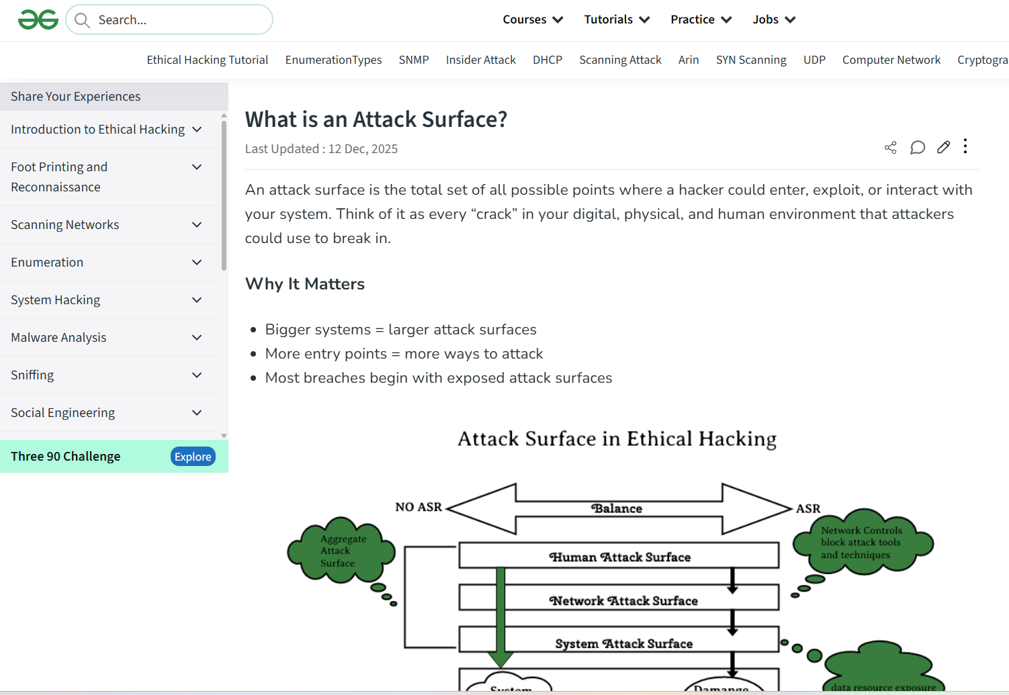

Web Applications
Web applications are a primary target due to their internet accessibility and complex codebases [1].
Vulnerabilities: Common issues include SQL injection, cross-site scripting (XSS), and insecure configurations, often stemming from poor coding practices or outdated components [1].
Risk: They process sensitive user data and are constantly exposed to automated scanning and manual attacks from the internet.

Mobile Apps
The rapid proliferation of mobile devices has made mobile apps a significant attack vector.
Vulnerabilities: Risks include insecure data storage on the device, weak server-side controls, inadequate transport layer protection, and unintended data leakage [1].
Risk: Mobile apps often access extensive device permissions (location, camera, contacts), which attackers can exploit to compromise user privacy and corporate networks.

APIs (Application Programming Interfaces)
APIs are the backbone of modern software architecture, connecting different services and data sources.
Vulnerabilities: Common issues involve broken object level authorization (BOLA), excessive data exposure, and lack of resource limits [1].
Risk: An insecure API can grant attackers direct access to backend systems and databases, bypassing traditional perimeter defenses.

Networks
The traditional network infrastructure remains a foundational attack surface.
Vulnerabilities: This includes open ports, unpatched software on network devices (routers, firewalls, switches), weak authentication protocols, and compromised VPNs [1].
Risk: A breach here can lead to full network compromise, allowing attackers to move laterally and access critical internal resources.

Cloud Infrastructure
The move to the cloud (AWS, Azure, GCP) has introduced new, dynamic attack surfaces.
Vulnerabilities: Misconfigurations are the most common vulnerability, such as improperly secured Amazon S3 buckets, overly permissive Identity and Access Management (IAM) roles, and insecure default settings [1].
Risk: Cloud environments consolidate vast amounts of data and computing power; a single misconfiguration can expose an entire organization's digital assets.

SUMMARY
# cyber-security-
Cyber security is a practice of protecting internet connected systems,data from digital attacks,theft,damage and unauthorized access .
there are 7 types of cyber security ,they are network security,application security,end point security,Iot security,information security,cloud security and operational security

**CIA TRAID**
CIA stands for confidentiality,integrity and availability
where confidentiality refers to keeping data private
Integrity refers to accuracy of data(no altration with out authentication)
Availability refers to accessabily of data free from altration and with accuracy

**TYPES OF ATTACKERS**
the are basically categorized by their motivations, skill levels, and resources.
Script kiddies:they are inexperienced,uses pre exitsing tool to do cyber attack
INsiders:they belong or were belonged to group of authoried team.and misuse they authorization to damage the reputation of the group or company
Hackitivists:experienced.use hackinking techniques to promote social,political or ideaological thoughts.
National state actors:These attackers work for a nation (government) and carry out cyberattacks to spy, steal secrets, disrupt systems, or gain power over other countries.

**TYPES OF ATTACKS**
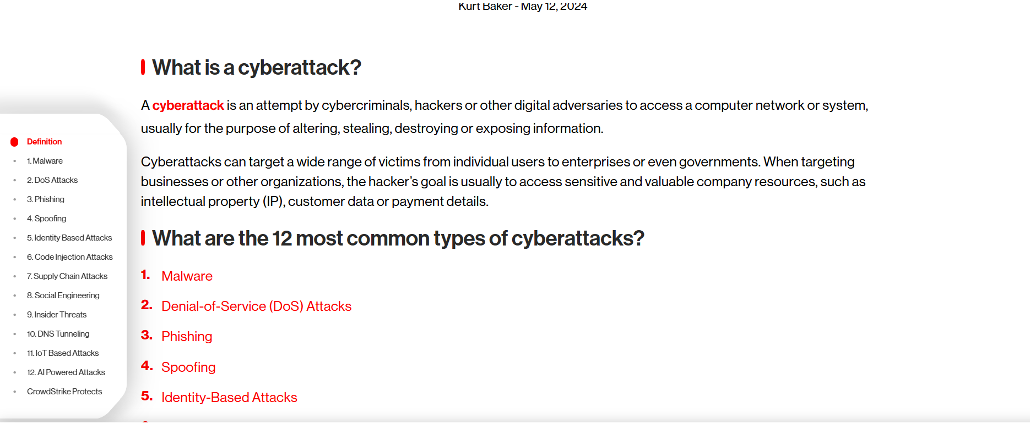
1.Malware-harmful software used by attackers are known as malware.when a mislinious link is been click this malware get installed and become active
2. Phishing – Fake emails or messages that trick you into sharing personal information.
3. Spoofing – Attackers pretend to be someone you trust to fool you.
4. Backdoor trojan– A hidden program that lets hackers control your device secretly.
5. Ransomware– Locks your files and asks for money to unlock them.
6. Password attacks – Hackers try to steal or guess your passwords.
7. IoT attack– Hackers attack smart devices like cameras or smart lights.
8. Cryptojacking– Hackers use your device to mine cryptocurrency without permission.
9. Drive-by download – Malware gets downloaded just by visiting an unsafe website.
10. Denial-of-Service (DoS) attack – Floods a system with traffic to make it stop working.

**Attacker Surface**
An attack surface means all the possible places where a hacker can try to enter or attack a system
1. Web Applications
Web applications (like online shopping sites or login pages) are common targets.
Attackers exploit weak passwords, insecure forms, or poor input validation to steal data or gain access.
2. Mobile Applications
Mobile apps can be attacked if they store data insecurely or use unsafe permissions.
Hackers may steal user data or inject malware through fake or modified apps.
3. APIs (Application Programming Interfaces)
APIs allow different software systems to communicate.
If APIs lack proper authentication or authorization, attackers can access or manipulate sensitive data.
4. Networks
Networks include Wi-Fi, routers, and internal connections.
Attackers may intercept data, perform man-in-the-middle attacks, or gain access through unsecured networks.
5. Cloud Infrastructure
Cloud systems store data and run applications online.
Misconfigured storage, weak access controls, or exposed credentials can allow attackers to steal or delete data.

**OWASP Top 10 vulnerability description**
Broken Access Control – Users can see or do things they are not allowed to.
Cryptographic Failures – Sensitive data is not properly protected or encrypted.
Injection – Hackers put harmful code into input fields to control the system.
Insecure Design – The application is poorly planned with weak security from the start.
Security Misconfiguration – Wrong or default settings make the system unsafe.
Vulnerable and Outdated Components – Old software with known problems is still being used.
Identification and Authentication Failures – Weak login systems allow attackers to steal accounts.
Software and Data Integrity Failures – Hackers can change software or data without being detected.
Security Logging and Monitoring Failures – Attacks are not noticed because logging is weak.
Server-Side Request Forgery (SSRF) – Hackers trick servers into accessing internal systems

