1. Install a Linux Virtual Machine (VM)
I have installed virtualbox from its official website. And also downloaded ubuntu from its website
After setting up every thing ,I have created a a virtual machine named ubuntu26
I had taken the help fron youtub video for above work
Link: https://youtu.be/ma8PgwT8fAU?si=4A9QGYTkBq4EbYQL

2. User Accounts, Permissions & Access Control
I have learn basics about user account,permissions and access control from chat gpt
And tried to understand them in better way by running some commands in linux terminal
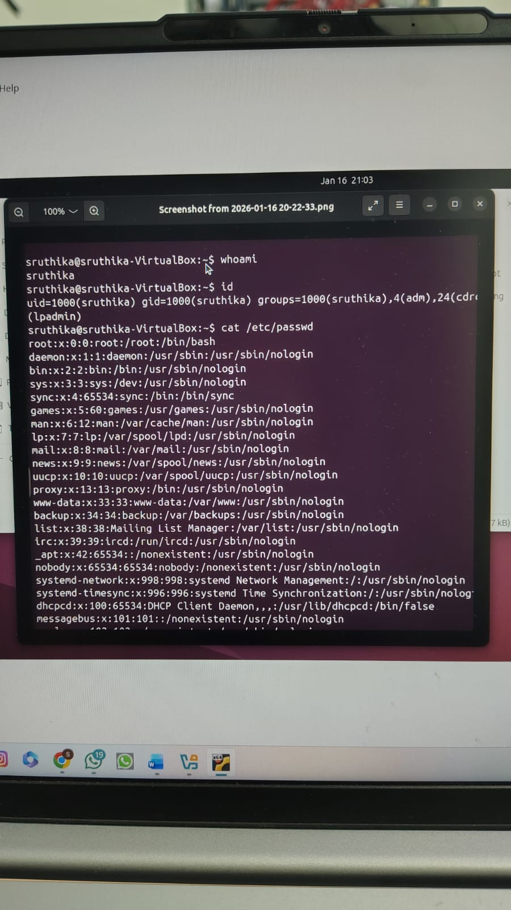

3. File Permissions (chmod, chown, ls -l)
Learned how to create,access,display,change permission of files using commands in terminal
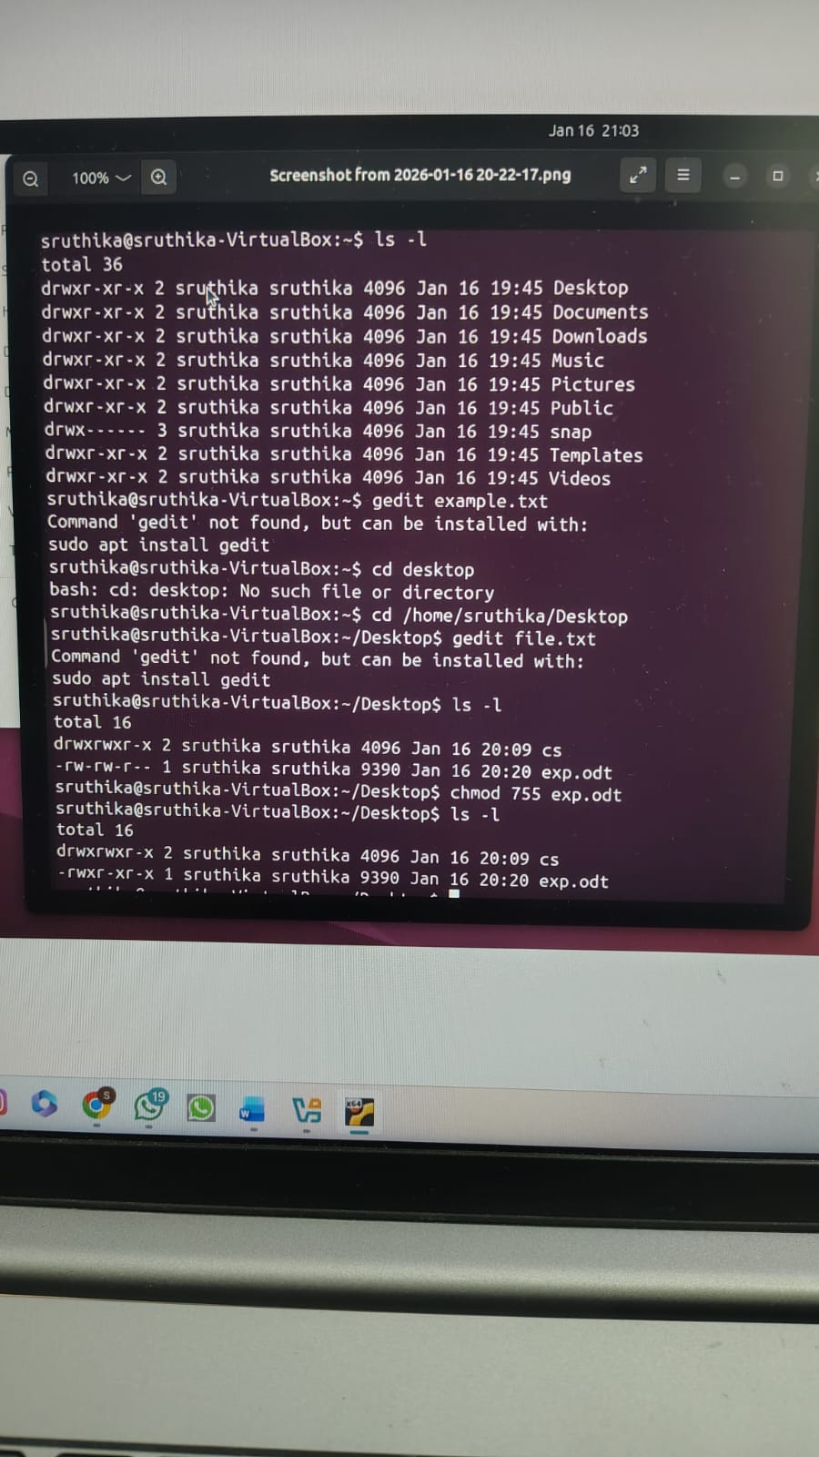

4. Administrator vs Standard User Privileges
Lear about them from chatgpt
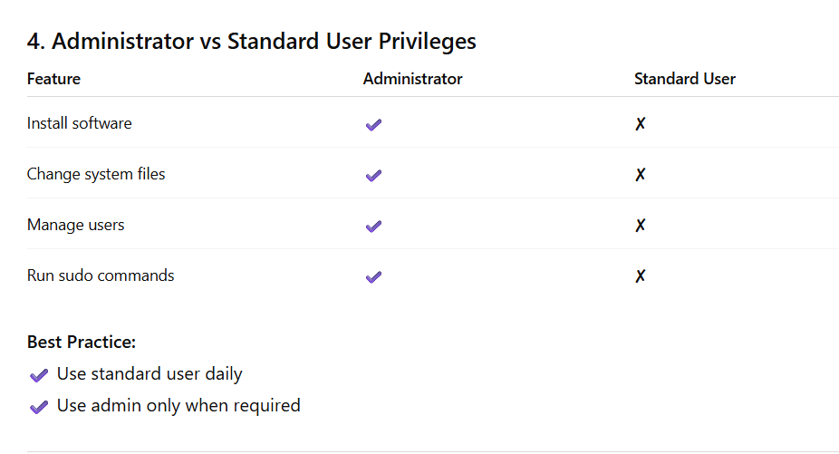

5. Enable Firewalls
Learned about firewalls and tried to run commands related to it
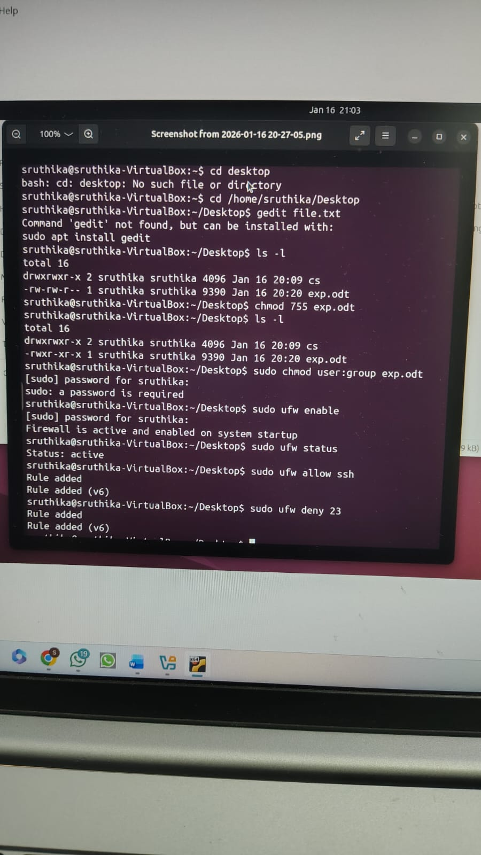
6. Identify Running Processes & Services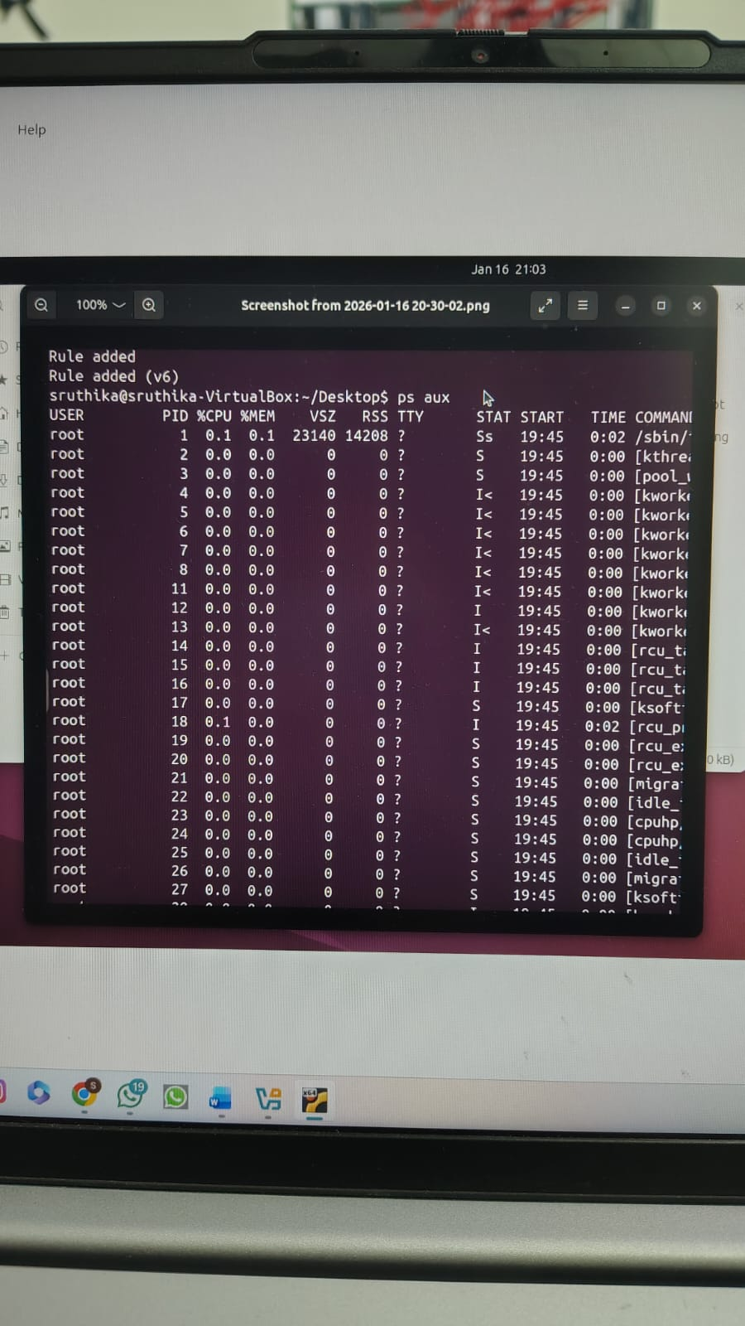

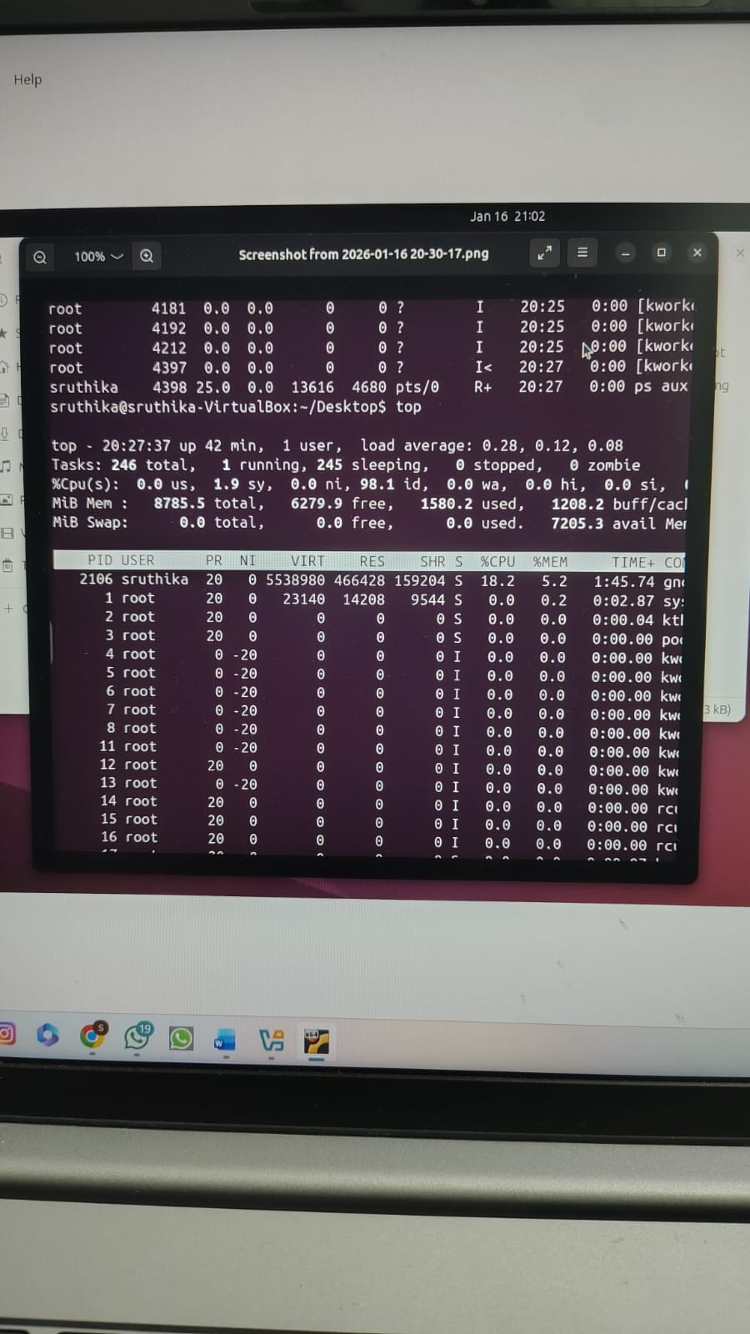
7. Disable Unnecessary Services
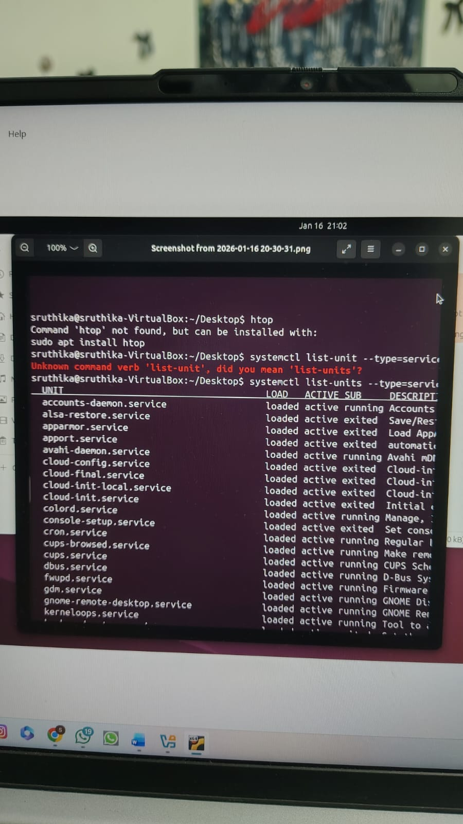

8. OS Hardening Best Practices
OS hardening means making the operating system more secure so that attackers cannot easily access or damage the system.
To keep a system safe:
Keep the OS updated to fix security problems.
Turn on the firewall to block unauthorized network access.
Use strong passwords so others cannot guess them.
Give users only necessary permissions (least privilege) to reduce misuse.
Disable services that are not needed to reduce security risks.
Monitor system logs to detect suspicious activities.
Use antivirus or Windows Defender to protect against malware.
Enable secure boot to prevent unauthorized software from loading during startup.
Encrypt the disk so data remains safe even if the device is stolen.
Take regular backups to recover data in case of failure or attack.

