TASK 8
DOCUMENTED ATTACK FLOW (Using SQLMap)
Target: http://testphp.vulnweb.com
Tool Used: SQLMap
Purpose: Identify and demonstrate SQL Injection vulnerability for educational testing

1. Target Identification
We chose the website testphp.vulnweb.com for testing because it is a publicly available site created specifically for learning web security vulnerabilities. Since it is intentionally vulnerable, it is safe to use for educational purposes.
2. Entry Point Identification
While browsing the site, we noticed that some pages were taking input directly from the URL. These inputs were being used to fetch data dynamically from the database. Any place where the user can control input like this can potentially be vulnerable to SQL Injection.
3. Identifying Injectable Parameters
The target URL containing parameters was provided to SQLMap for automated testing.
SQLMap analyzed all detected parameters and tested them for SQL Injection behavior.
One GET parameter showed abnormal database responses, indicating improper input handling.
The parameter was confirmed as injectable.

4. Vulnerability Confirmation Using SQLMap
SQLMap successfully confirmed the presence of SQL Injection vulnerability by:
Identifying database interaction
Detecting the database type
Verifying that SQL queries could be manipulated
This confirmed that user input was directly affecting SQL statements.

5. Database Enumeration
After confirming SQL Injection, SQLMap was used to enumerate the database names present on the server.
The attacker could view internal database names without authentication.
This exposed backend database structure information.
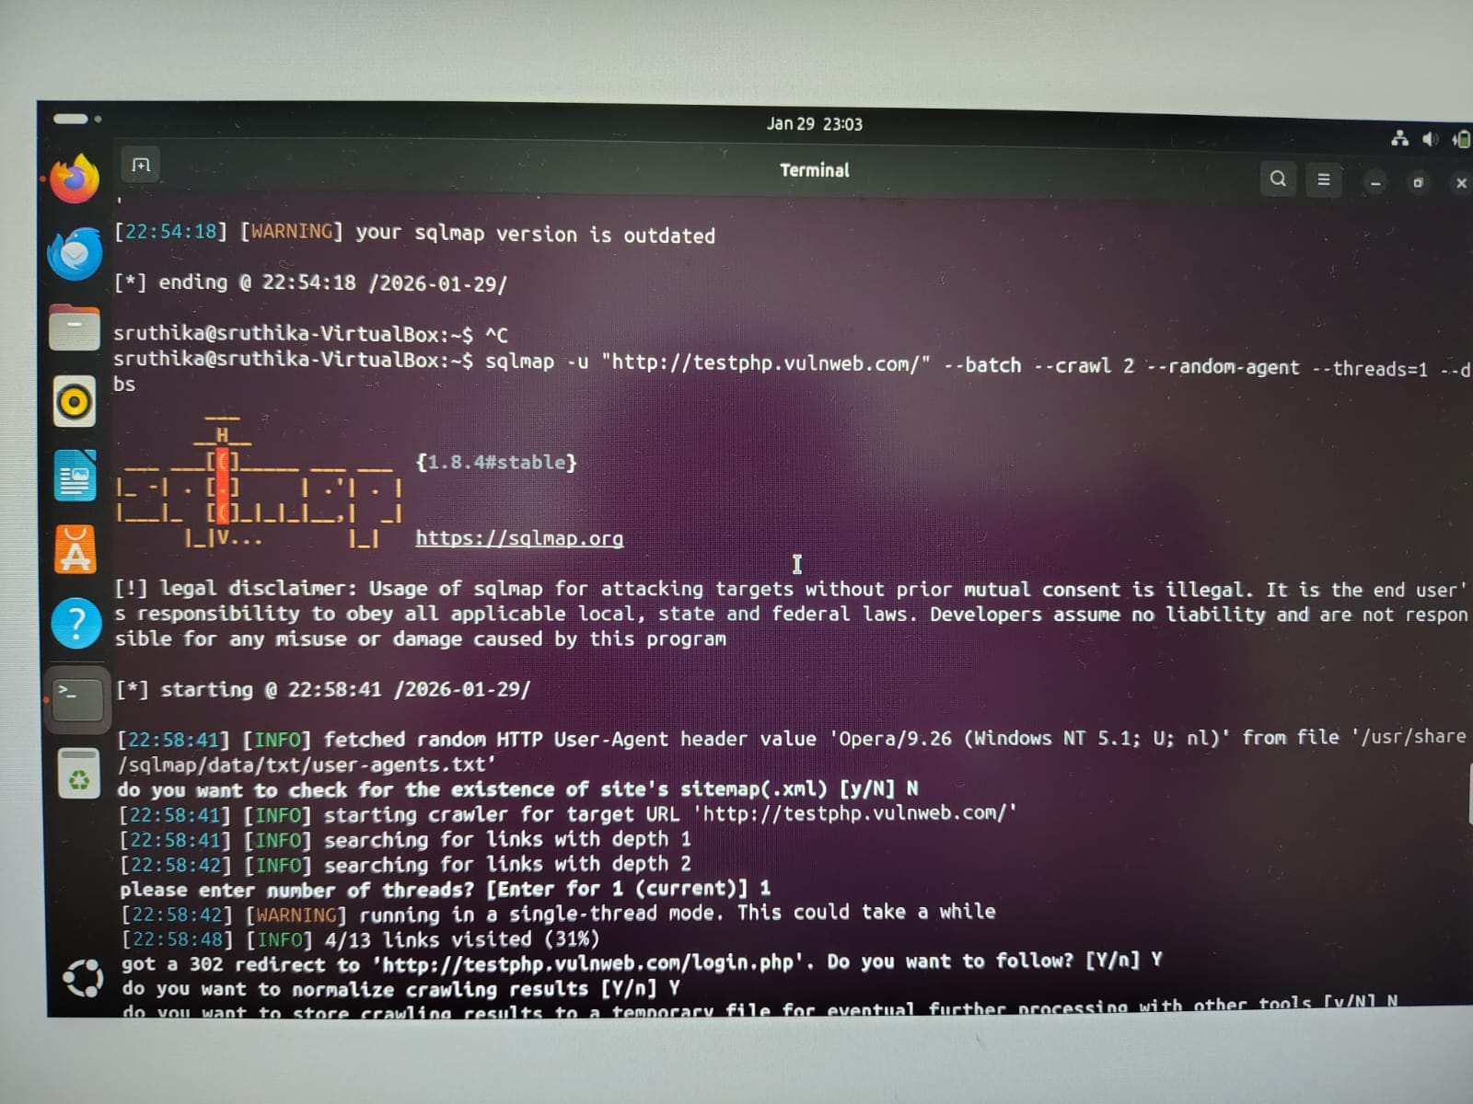

6. Table Enumeration
SQLMap was then used to enumerate tables within the identified database.
Several application-related and user-related tables were discovered.
This revealed how sensitive data was organized internally.
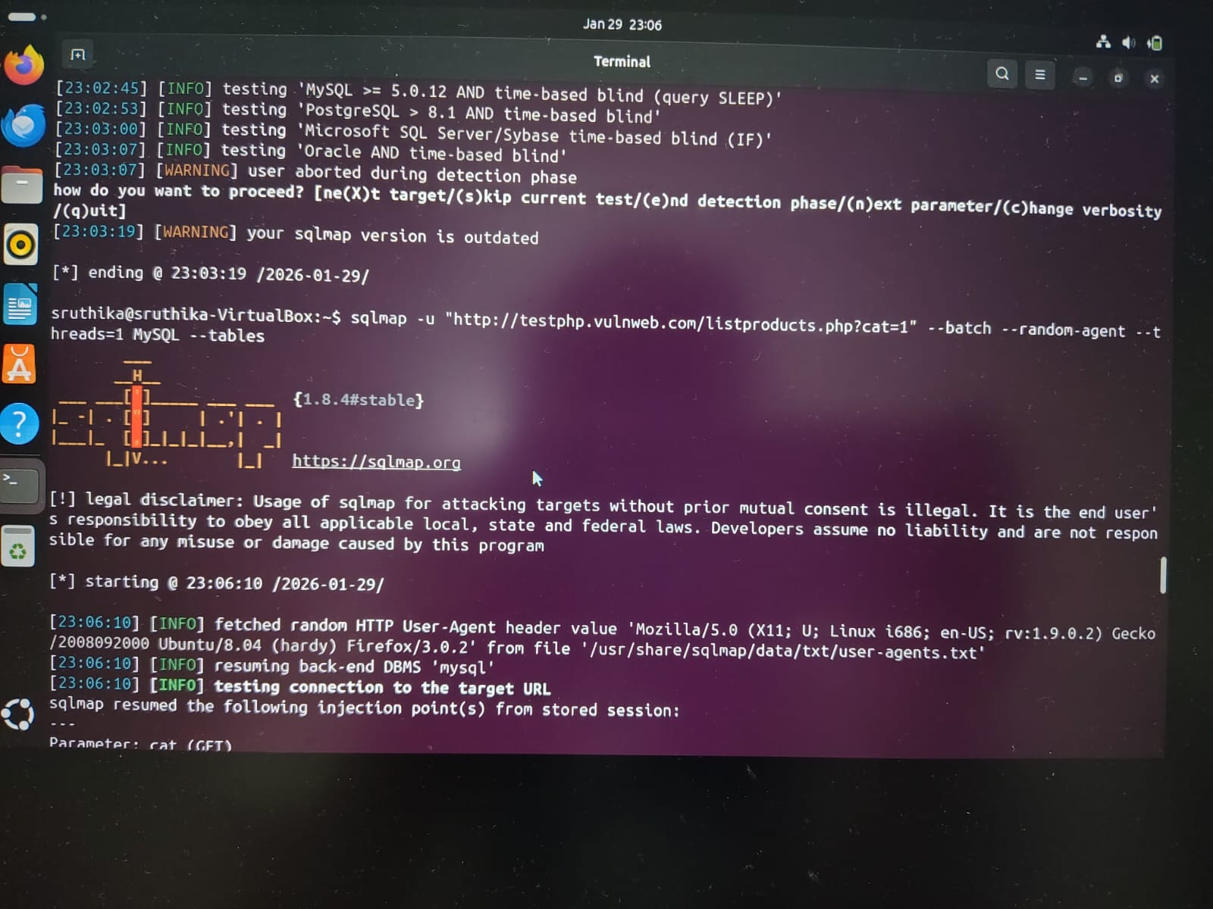
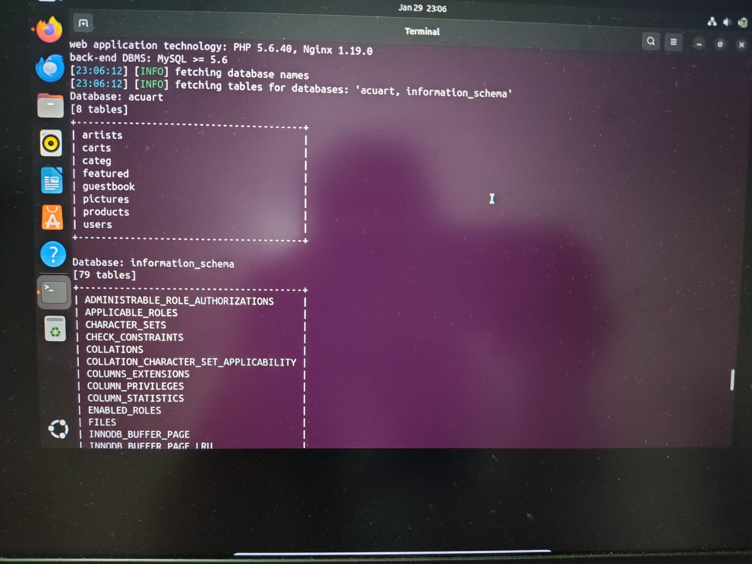

7. Data Extraction
SQLMap enabled extraction of data from selected tables.
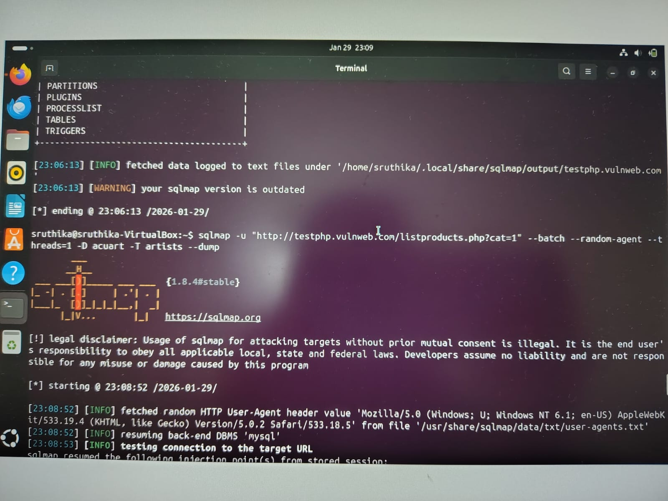
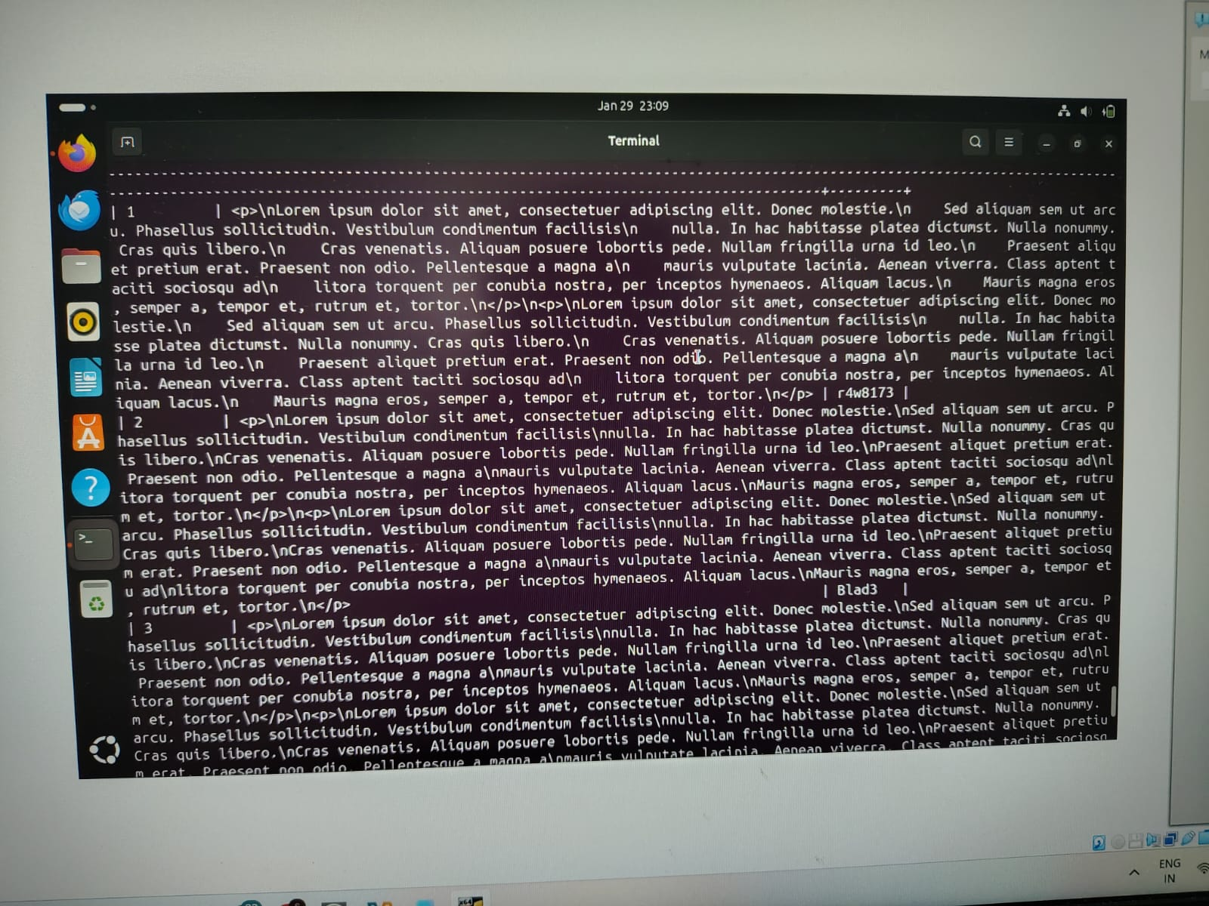
Impact:
Sensitive user information could be accessed by an unauthorized user.

8. Impact Analysis
The SQL Injection vulnerability allows an attacker to:
Read sensitive user data
Bypass authentication mechanisms
Modify or delete database records
Compromise data confidentiality and integrity
Severity: High

9. Documentation & Evidence
The following were documented:
Vulnerable URL and parameter
SQL Injection type identified by SQLMap
Databases and tables enumerated
Sample extracted data (masked)
Screenshots and logs as proof of exploitation
This documentation supports reproducibility and validation.

10. Suggested Fixes
To prevent SQL Injection:
Use prepared statements (parameterized queries)
Validate and sanitize all user inputs
Use ORM frameworks
Apply least-privilege access to database users
Disable detailed SQL error messages

