UML & PROTOTYPE DOCUMENTATION
Seat Selection & Layout Management System
Version 1.0
Purpose: This document contains the basic software diagrams and a prototype wireframe for the Seat Selection & Layout Management System. These artifacts can be uploaded to the GitHub repository as part of the version control exercise.
1. Use Case Diagram
Shows the interactions between the User, Administrator, and the major system functions.
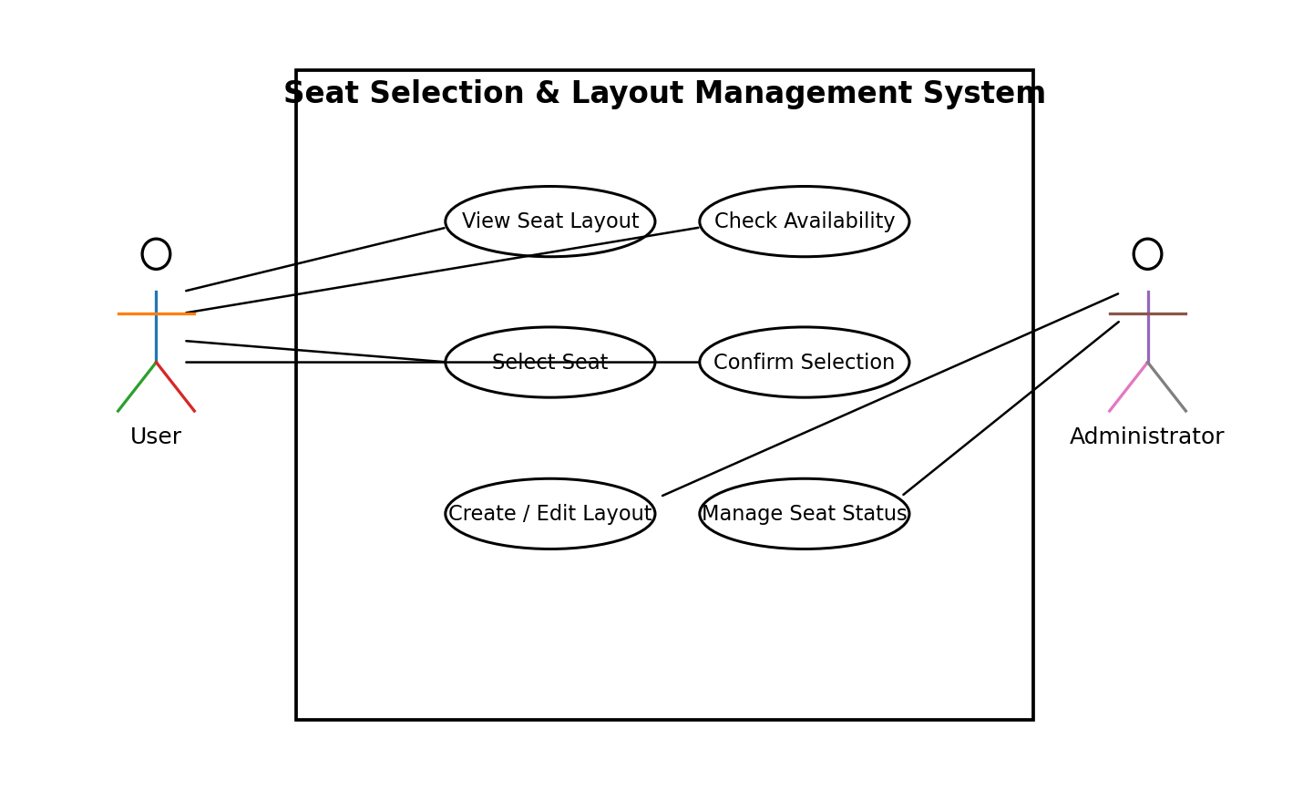

2. Class Diagram
Shows the main classes, their attributes, operations, and relationships.
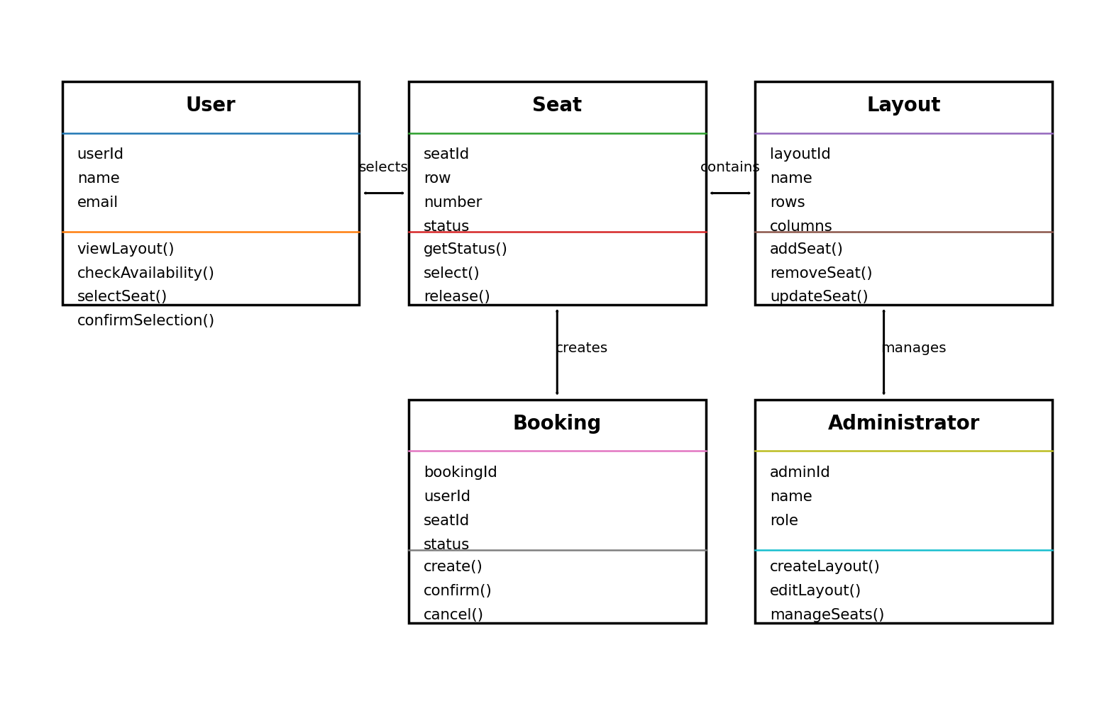

3. Sequence Diagram
Shows the sequence of interactions involved in viewing and selecting seats.
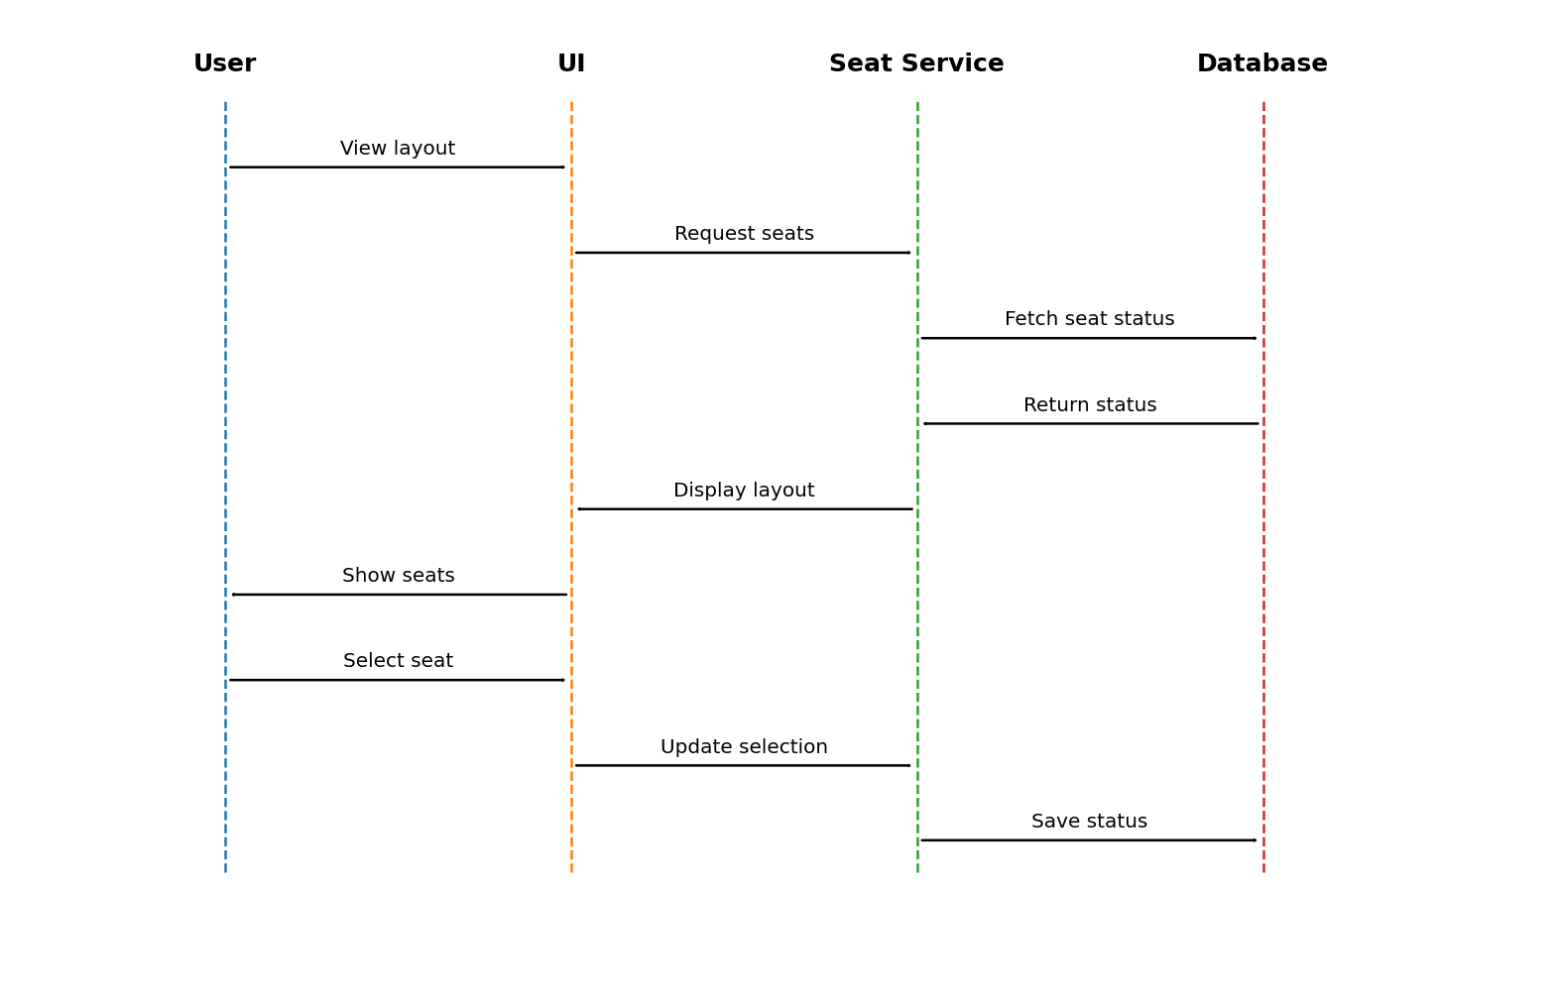

4. Activity Diagram
Shows the workflow from opening the layout to confirming a seat selection.
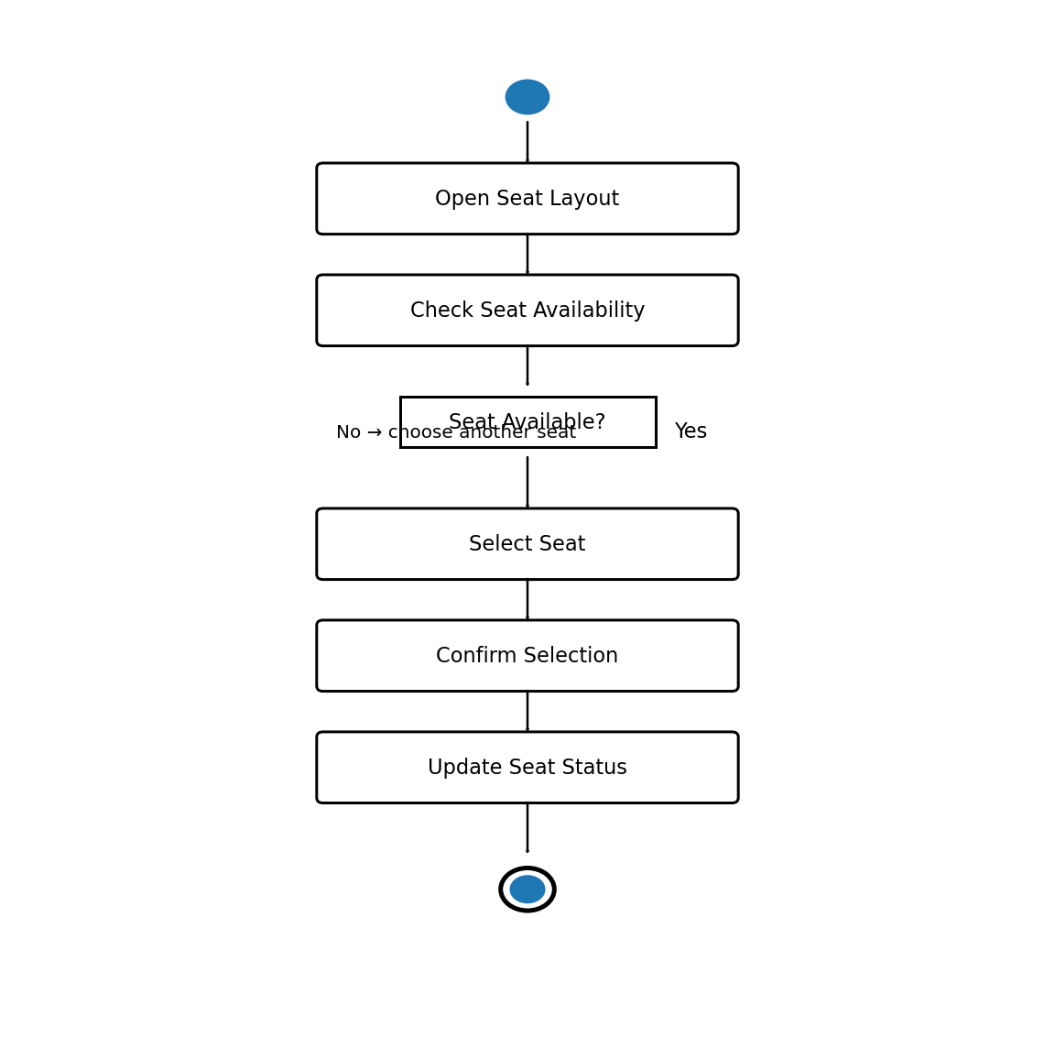

5. Prototype Wireframe
A simple interface prototype showing the seat grid, seat information, and confirmation action.
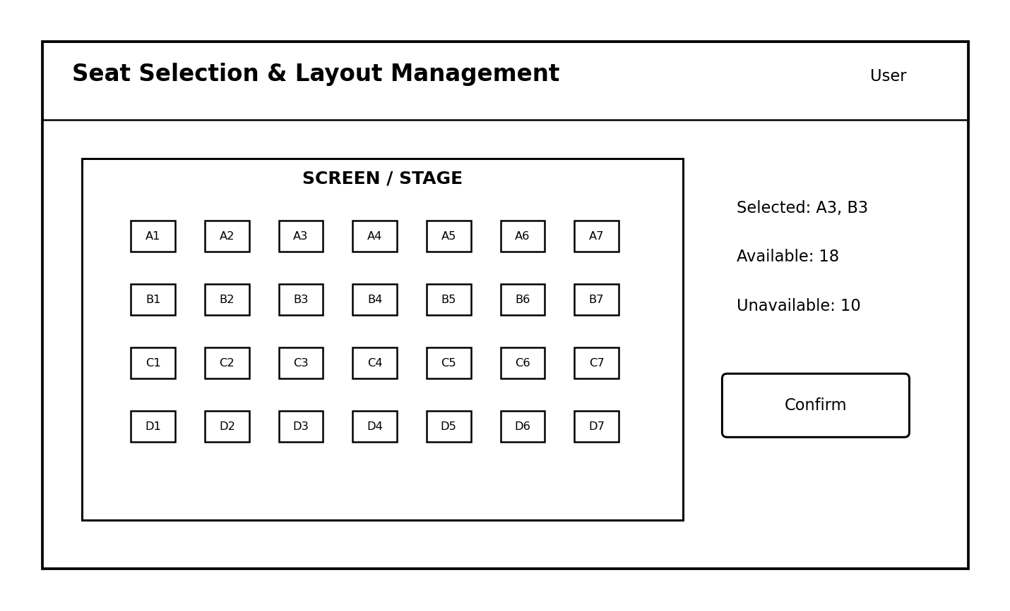

Conclusion
The diagrams and prototype provide a basic design reference for implementing the Seat Selection & Layout Management System. They can be refined further during development.

