**Topic : Library Management System**

You are going to build a project based on Library Management System. It keeps track of all information about books in the library, their cost, status and total number of books available in the library.  
  
Create a database named library and following TABLES in the database:   
  
1. Branch   
2. Employee   
3. Books  
4. Customer  
5. IssueStatus  
6. ReturnStatus   
  
Attributes for the tables:   
  
1. Branch

* Branch_no - Set as PRIMARY KEY
* Manager_Id
* Branch_address
* Contact_no

2. Employee

* Emp_Id – Set as PRIMARY KEY
* Emp_name
* Position
* Salary
* Branch_no - Set as FOREIGN KEY and it refer Branch_no in Branch table

3. Books

* ISBN - Set as PRIMARY KEY
* Book_title
* Category
* Rental_Price
* Status [Give yes if book available and no if book not available]
* Author
* Publisher

4. Customer

* Customer_Id - Set as PRIMARY KEY
* Customer_name
* Customer_address
* Reg_date

5. IssueStatus

* Issue_Id - Set as PRIMARY KEY
* Issued_cust – Set as FOREIGN KEY and it refer customer_id in CUSTOMER table  Issued_book_name
* Issue_date
* Isbn_book – Set as FOREIGN KEY and it should refer isbn in BOOKS table

6. ReturnStatus

* Return_Id - Set as PRIMARY KEY
* Return_cust
* Return_book_name
* Return_date
* Isbn_book2 - Set as FOREIGN KEY and it should refer isbn in BOOKS table

**Display all the tables and Write the queries for the following :**

create database Library;

use Library;

create table Branch(Branch_no int PRIMARY KEY,

Manager_Id int,

Branch_address varchar(30),

Contact_no bigint);

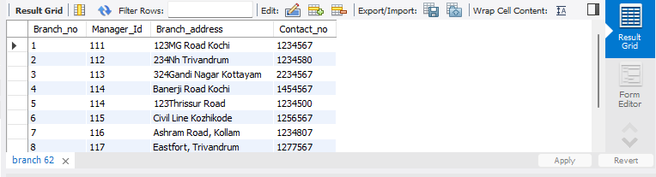

create table Employee(Emp_Id int PRIMARY KEY,

Emp_name varchar(20),

Position varchar(20),

Salary decimal(10,2),

Branch_no int,

foreign key (Branch_no) references Branch(Branch_no)

);

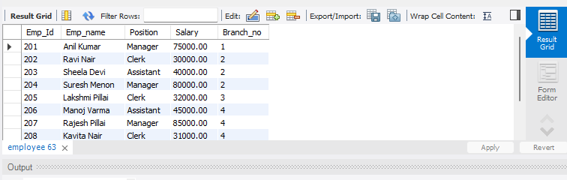

create table Books(ISBN int PRIMARY KEY,

Book_title varchar(50),

Category varchar(20),

Rental_Price float,

Status varchar(3) ,

Author varchar(30),

Publisher varchar(30));



create table Customer(Customer_Id int PRIMARY KEY,

Customer_name varchar(30),

Customer_address varchar(50),

Reg_date date);

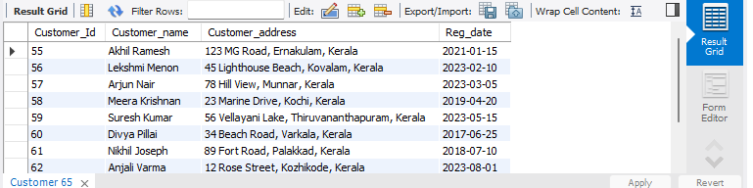

create table IssueStatus(Issue_Id int PRIMARY KEY ,

Issued_cust int,

Issued_book_name varchar(30),

Issue_date date,

Isbn_book int,

FOREIGN KEY(Issued_cust) references Customer (Customer_id),

FOREIGN KEY (Isbn_book) references books (ISBN));

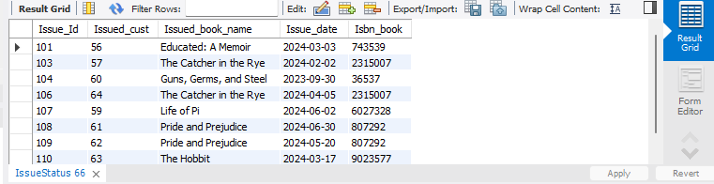

create table ReturnStatus(Return_Id int PRIMARY KEY,

Return_cust varchar(20),

Return_book_name varchar(30),

Return_date date,

Isbn_book2 int,

FOREIGN KEY (Isbn_book2) references books(isbn));



