# Real-Time Face Detection System

This real-time face detection system utilizes advanced machine learning techniques to accurately detect human faces in various scenarios.

Leveraging state-of-the-art algorithms, the system can swiftly identify and locate faces within digital images or video streams, enabling rapid processing and analysis of facial data.

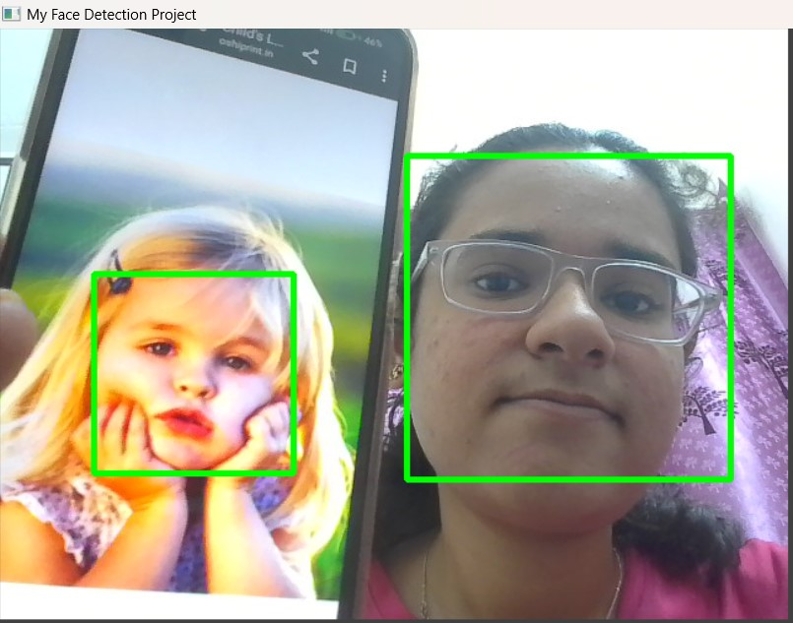

By employing deep learning models and cascaded functions, it can efficiently detect faces amidst varying backgrounds and lighting conditions.

The system's robustness is further enhanced through the use of descriptors like Local Binary Patterns (LBP) to extract facial features, reducing false detection rates and improving accuracy.

With applications ranging from security surveillance to human-computer interaction, this real-time face detection system exemplifies cutting-edge technology in the field of computer vision .

