WINTER SEMESTER 2018-19 (TD1)

SMART IRRIGATION SYSTEM

Submitted as part of the

Introduction to Innovative Projects ( PHY1999 ) Course

Winter Semester 2018-19

Slot – TD1

SRUTI VERMA (18BCE1005) | -
SANJANA VERNAKAR (18BEE1) | -
VIDUSHI SINHA (18BCE1147) | -
YASHVI (18BME1093)
 | -




VELLORE INSTITUTE OF TECHNOLOGY

CHENNAI CAMPUS

CHENNAI- 600127

WINTER SEMESTER 2018-19 (TD1)

SMART AGRICULTURE SYSTEM

SRUTI VERMA,SANJANA VERNAKAR,VIDUSHI SINHA AND YASHVI
VIT University Chennai Campus, Melakottaiyur, Chennai-600127, India

WINTER SEMESTER 2018-19 (TD1)

ABSTRACT

There is an urgent need for a system that makes the agricultural process easier and burden free from the farmer’s side. With the recent advancement of technology it has become necessary to increase the annual crop production output entirely agro-centric economy. The ability to conserve the natural resources as well as giving a splendid boost to the production of the crops is one of the main aims of incorporating such technology into the agricultural domain of the country to save farmers efforts and resources. Irrigation management is a complex decision making process to determine when and how much water to apply to a growing crop to meet specific management objectives. If the farmer is far from the agricultural land he will not be noticed of current conditions.

INTRODUCTION

WINTER SEMESTER 2018-19 (TD1)

Irrigation of plants is usually a very time- consuming activity, to be done in a reasonable amount of time; it requires a large amount of human resources. Traditionally all the steps were executed by humans. Nowadays some systems use technology to reduce the number or workers or the time required to water the plants. With such systems, the control is very limited, and many resources are still wasted. Water is one of these resources that are used excessively. Much irrigation is one method used to water the plant. This method represents massive losses since the amount of water given is in excess of the plant’s needs. The excess water is evacuated by the holes of the pots in greenhouses, or it percolates through the soil in the fields. The contemporary precipitation of water is that of a free renewable resource that can be used in abundance. It is therefore reasonable to assume that it will soon become a very expensive resource everywhere. In addition to the excess cost of water labour is becoming more and more expensive. As a result, if no effort is invested in optimising these resources, there will be more money involved in the same process. Technology is probably a solution to reduce costs and prevent loss of resource; this project can be a strong way to tackle such a situation.

Solar energy is the best way to use the enormous amount of sun’s energy.But manufacturing and efficiency of solar panels is a big problem which can be solved by pokeberries.

Soil content and amount of fertilizers needed has to be determined before growing the suitable crops.This can be achieved by IOT.

The Photo-electochemical cell increases efficiency of primitive solar cell by producing hydrogen parallel to the electricity generation . Except for silicon based electrode which is under long term exposure to water is affected by corrosion , Dye Sensitised Solar electrode is used with a corrosion resistant material (here aluminium ) .

WINTER SEMESTER 2018-19 (TD1)

EXISTING TECHNOLOGY
It is a simple project more useful in watering plants automatically without any human interference. We know that people do not pour the water on to the plants in their gardens when they go to vacation or often forget to water plants. As a result, there is a chance to get the plants damaged. This project is an excellent solution for such kind of problems. Many irrigation systems exits such as,

- Monitoring of rice crops using GPRS and wireless sensors for efficient use of water and Electricity.
- Wireless Sensor Based Remote Monitoring System for Agriculture Using ZigBee and GPS.
- Design of Embedded System for the Automation of Drip Irrigation.
- A Survey of Automated GSM Based Irrigation System.
- Wireless Sensor Networks Agriculture: For Potato Farming.
- Design and Implementation of GSM based Irrigation System Using ARM7.
- Automated Irrigation System Using a Wireless Sensor Network and GPRS Module.
- Automated Irrigation System Using Solar Power.
- Review for ARM based agriculture field monitoring system.
- Automatic Irrigation Control by using wireless sensor networks.
- Remote Sensing and Control of an Irrigation System Using a Distributed Wireless Sensor Network.

WINTER SEMESTER 2018-19 (TD1)

APPROACH
We have thought of designing a smart village irrigation system in which a farmer knows the estimated amount of water to be fed to a crop per unit area, he also knows in how much area has planted a certain crop. From this total amount of water needed by the crop in a certain time will be calculated, for example if a farmer plants wheat which requires 10L of water/sq. ft. in 50 sq. ft. of area the total amount of water needed will be calculated.

After the calculation of water needed irrigation system automatically start.

Since crop are very sensitive to weather condition, humidity water given by the system will be constantly monitored and be updated in the database. this will be achieved by SOIL HUMIDITY SENSOR.

SHS will detect the humidity and water level in the soil and will give direction to the irrigation system that if more water is needed or not.

WINTER SEMESTER 2018-19 (TD1)

HARDWARE REQUIREMENT

ARDUINO MICRO-CONTROLLER :

Arduino is an open-source prototyping platform based on easy-to-use hardware and software. Arduino boards are able to read inputs - light on a sensor, a finger on a button, or a Twitter message - and turn it into an output - activating a motor, turning on an LED, publishing something online. We can tell your board what to do by sending a set of instructions to the microcontroller on the board. To do so we use the Arduino programming language (based on wiring), and the Arduino Software (IDE), based on Processing. The Arduino Uno can be powered via the USB connection or with an external power supply. The power source is selected automatically. External (non-USB) power can come either from an AC-to-DC adapter (wall-wart) or battery. The adapter can be connected by plugging a 2.1mm center- positive plug into the board's power jack. Leads from a battery can be inserted in the Gnd and Vin pin headers of the POWER connector. The board can operate on an external supply of 6 to 20 volts. If supplied with less than 7V, however, the 5V pin may supply less than five volts and the board may be unstable. If using more than 12V, the voltage regulator may overheat and damage the board. The recommended range is 7 to 12 volts.

Summary
Microcontroller ATmega328
Operating Voltage 5V Input Voltage (recommended) 7-12V Input Voltage (limits) 6-20V
Digital I/O Pins 14 (6 provide PWM output)
Analog Input Pins 6
DC Current per I/O Pin 40 mA
DC Current for 3.3V Pin 50 mA
Flash Memory 32 KB (ATmega328) SRAM 2 KB (ATmega328)
EEPROM 1 KB (ATmega328)
Clock Speed 16 MHz

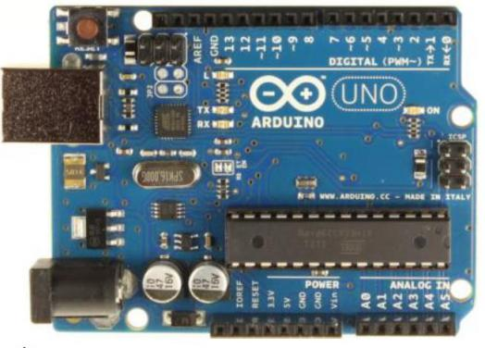

WINTER SEMESTER 2018-19 (TD1)

SOIL MOISTURE SENSOR

How the Soil Moisture Sensor Works
The Soil Moisture Sensor uses capacitance to measure dielectric permittivity of the surrounding medium. In soil, dielectric permittivity is a function of the water content. The sensor creates a voltage proportional to the dielectric permittivity, and therefore the water content of the soil.
The sensor averages the water content over the entire length of the sensor. There is a 2 cm zone of influence with respect to the flat surface of the sensor, but it has little or no sensitivity at the extreme edges. The figure above shows the electromagnetic field lines along a cross- section of the sensor, illustrating the 2 cm zone of influence.
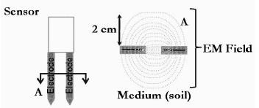

Summary
Range | 0 to 45%
Accuracy | ±4% typical
13-bit resolution (using SensorDAQ) | 0.05%
12-bit resolution | 0.1%
10-bit resolution (using CBL 2) | 0.4%
Power | 3 mA @ 5VDC
Operating temperature –40º C to +60º C
Dimensions 8.9 cm × 1.8 cm × 0.7 cm
Stored calibration slope 108%/volt
intercept –42%

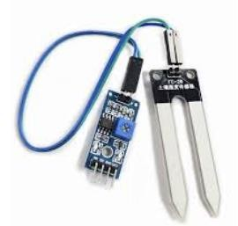

WINTER SEMESTER 2018-19 (TD1)

SERVO MOTOR
A servomotor is a rotary actuator or linear actuator that allows for precise control of angular or linear position, velocity and acceleration. It consists of a suitable motor coupled to a sensor for position feedback. It also requires a relatively sophisticated controller, often a dedicated module designed specifically for use with servomotors.

Servomotors are not a specific class of motor although the term servomotor is often used to refer to a motor suitable for use in a closed-loop control system.

Servomotors are used in applications such as robotics, CNC machinery or automated manufacturing. We are using to control the supply of water.

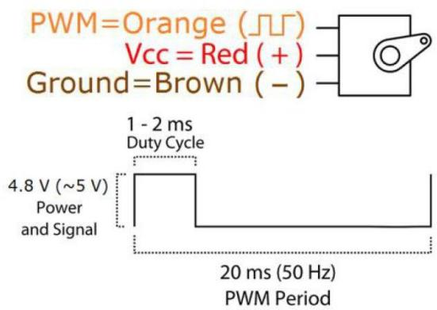
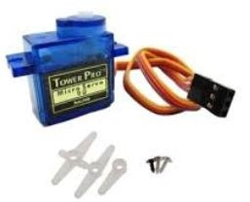

WINTER SEMESTER 2018-19 (TD1)

MOTOR DRIVER

A motor driver is a little current amplifier; the function of motor drivers is to take a low- current control signal and then turn it into a higher-current signal that can drive a motor.
Because of very low current requirement, these motors can easily operate with small batteries and solar panels. Quiet and smooth operation of this motor makes it a perfect choice for indoor and long hours of operation.

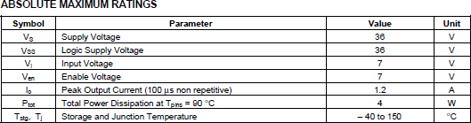

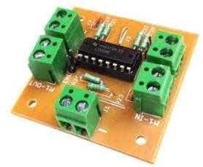

MAJOR SOFTWARE REQUIRED

ARDUINO SOFTWARE (IDE):

The open-source Arduino Software (IDE) makes it easy to write code and upload it to the board. It runs on Windows, Mac OS X, and Linux. The environment is written in Java and based on Processing and other open-source software. This software can be used with any Arduino board. For latest software refer to link. https://www.arduino.cc/en/Main/Software
- Arduino was born at the Ivrea Interaction Design Institute as an easy tool for fast prototyping, aimed at students with or without a background in electronics and programming.
- Arduino is an open-source prototyping platform based on easy-to-use hardware and software.
- Arduino boards are able to read inputs - light on a sensor, a finger on a button, or a message - and turn it into an output - activating a motor, turning on an LED, publishing something online and many more.
- You can tell your board what to do by sending a set of instructions to the microcontroller on the board.
- To do so you use the Arduino programming language (based on Wiring), and the Arduino Software (IDE), based on Processing.

IMAGES

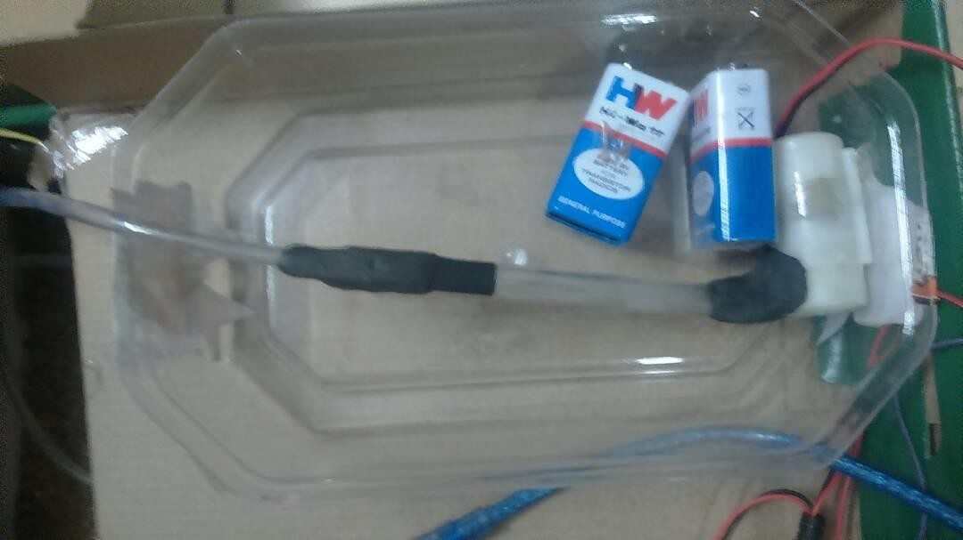
Water tank and 9V battery

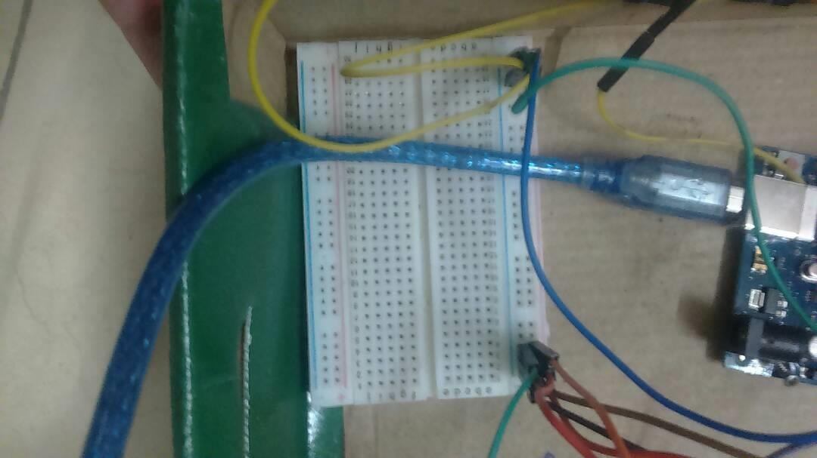

Breadboard

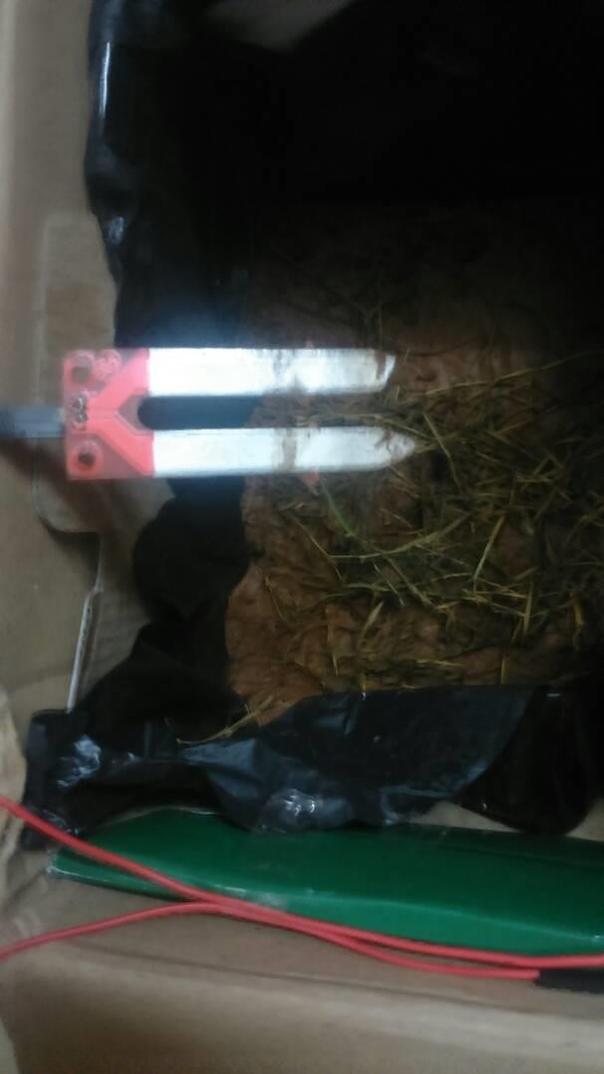

Soil Moisture Sensor

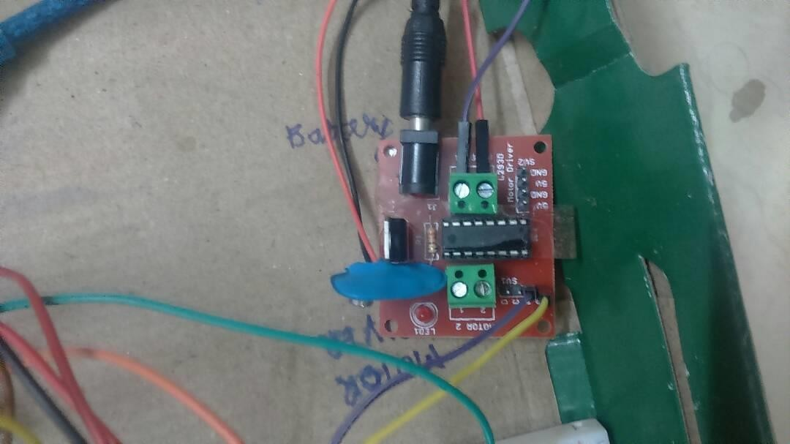

Motor Driver

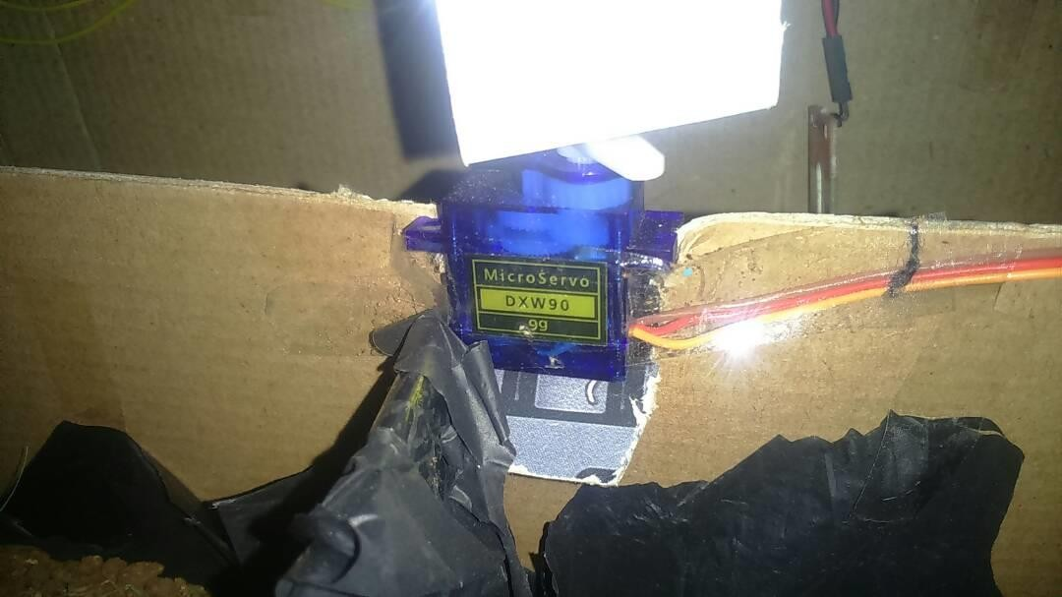

Servo Mortor for fixed motion

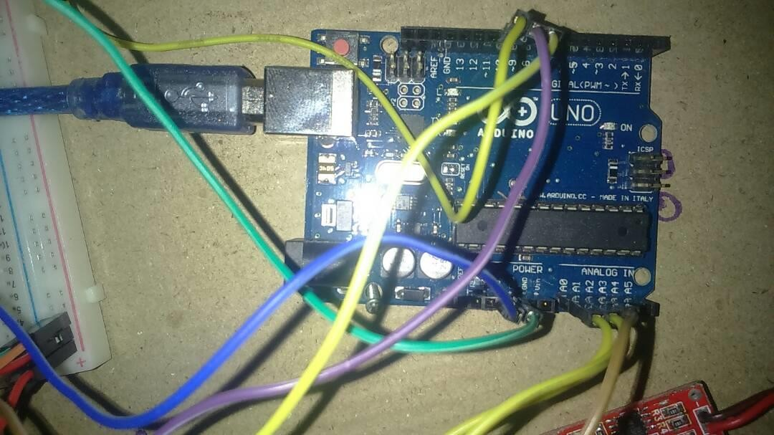

Arduino Uno Microcontroller

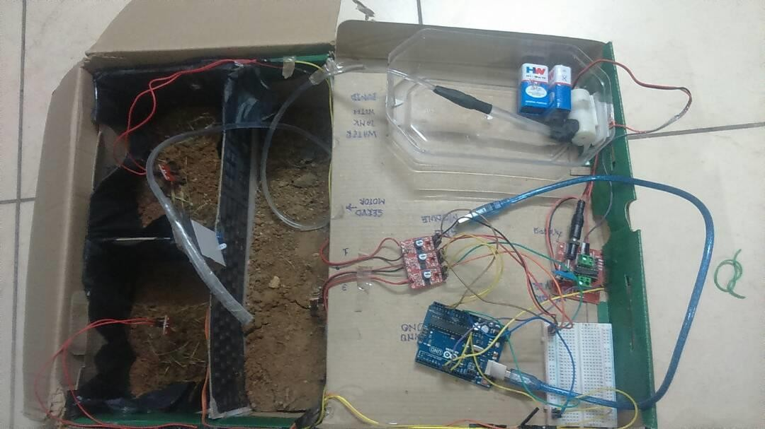

Full system

A Method to Reduce Water Evaporation from Soil Using the Absorbent Properties of Organic Wheat Straw

- Wheat straw also contains 35% polysaccharide. Therefore it is hypothesized that wheat straw, an inexpensive organic matter that farmers have easy access to, would allow plants to grow longer in low-water conditions.
- Effects of Water-Retaining Reagents on Soil Moisture
The effect of wheat straw on soil moisture was studied in three concentrations: 100 g, 150 g and 200 g, along with 150 g wood chip, dextrin and polymer. These results indicated that the three concentrations of wheat straw, 150 g wood chip, polymer and dextrin all had significantly greater soil moisture levels compared to the control after Day 10. Twenty-one days after the initial watering on Day 0, the soil moisture in the pots containing the wheat straw concentrations, wood chip and two positive controls (polymer and dextrin) remained at moisture levels of 3.8 to 4.8. These moisture levels are also plant growth friendly. This experiment also indicates that there was no significant difference between the wheat straw, wood chip and the two positive controls in soil water retention.

- By mixing 7.5% wheat straw into soil, water retention in soil could be enhanced by 10 to 15 days. If farmers can adapt this method into their growing of crops, we could save more money and water in the world.
- This research has indicated that wheat straw can significantly enhance soil water retention. Wheat straw can help to keep plants alive for three weeks without watering. Wheat straw can also help in the growth of these plants, making them healthier and stronger. Wheat straw is a great candidate for farmers to use when planting crops to save money and water.

WEED KILLING AI ROBOT

EcoRobotix has made a weed-killing robot . It's solar-powered and can kill weeds for 12 hours straight without an operator at the helm. Through artificial intelligence, cameras and two robotic arms, the table-looking robot sprays a dose of herbicide on weeds but not the crops. EcoRobotix uses 20 times less herbicide than traditional methods that spray entire fields.

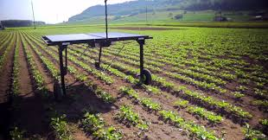

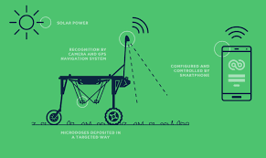

IOT
With the growing adoption of the Internet of Things (IoT), connected devices have penetrated every aspect of our life, from health and fitness, home automation, automotive and logistics, to smart cities and industrial IoT.
Although smart agriculture IoT, as well as industrial IoT in general, aren’t as popular as consumer connected devices; yet the market is still very dynamic. The adoption of IoT solutions for agriculture is constantly growing. Namely, BI Intelligence predicts that the number of agriculture IoT device installations will hit 75 million by 2020, growing 20% annually.
Data, tons of data, collected by smart agriculture sensors, e.g. weather conditions, soil quality, crop’s growth progress or cattle’s health. This data can be used to track the state of your business in general as well as staff performance, equipment efficiency, etc.

Better control over the internal processes and, as a result, lower production risks. The ability to foresee the output of your production allows you to plan for better product distribution. If you know exactly how much crops you are going to harvest, you can make sure your product won’t lie around unsold.

Cost management and waste reduction thanks to the increased control over the production. Being able to see any anomalies in the crop growth or livestock health, you will be able to mitigate the risks of losing your yield.

Increased business efficiency through process automation. By using smart devices, you can automate multiple processes across your production cycle, e.g. irrigation, fertilizing, or pest control.

Enhanced product quality and volumes. Achieve better control over the production process and maintain higher standards of crop quality and growth capacity through automation.

Monitoring of climate conditions
Probably the most popular smart agriculture gadgets are weather stations, combining various smart farming sensors. Located across the field, they collect

various data from the environment and send it to the cloud. The provided measurements can be used to map the climate conditions, choose the appropriate crops, and take the required measures to improve their capacity (i.e. precision farming).
Some examples of such agriculture IoT devices are allMETEO, Smart Elements, and Pycno.
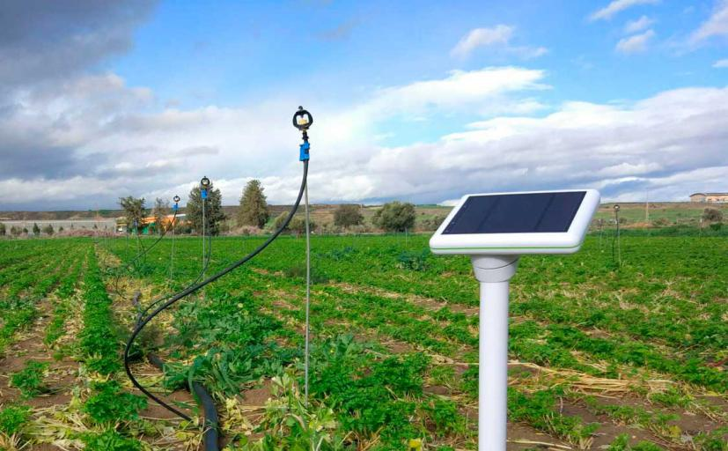
Crop management
One more type of IoT product in agriculture and another element of precision farming are crop management devices. Just like weather stations, they should be placed in the field to collect data specific to crop farming; from temperature and precipitation to leaf water potential and overall crop health.
Thus, you can monitor your crop growth and any anomalies to effectively prevent any diseases or infestations that can harm your yield. Arable and Semios can serve as good representations of how this use case can be applied in real life.
Cattle monitoring and management
Just like crop monitoring, there are IoT agriculture sensors that can be attached to the animals on a farm to monitor their health and log performance. This works similarly to IoT devices for petcare.

For example, SCR by Allflex and Cowlar use smart agriculture sensors (collar tags) to deliver temperature, health, activity, and nutrition insights on each individual cow as well as collective information about the herd.
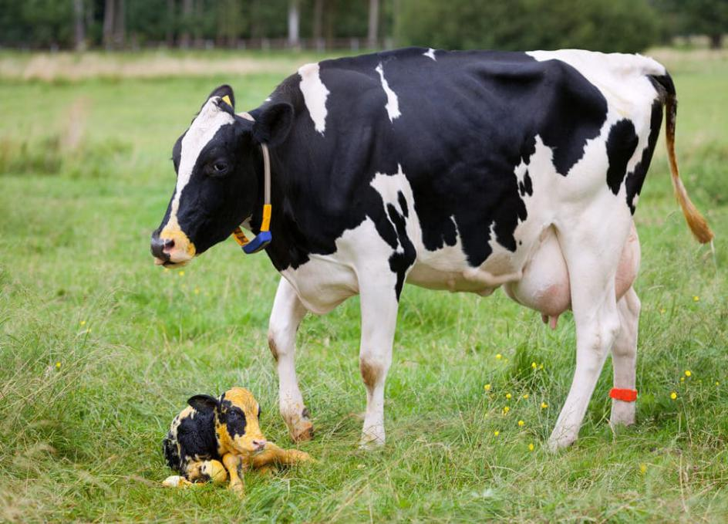

INNOVATIONS IN THE PROJECT

As there is possibility of the circuits of the smart irrigation system being spoilt by many factors such as rain or by animals. Also there maybe times where the water will be concentrated in a particular area or depth, the sensors might be respond to only that area whereas the surrounding areas may be left dried. For cases like these, we can put two rails around the field with two rollers installed in each rail. There rollers can be connected by 5 feet tall rods. The circuit is placed on the rod and the sensors are placed on another set of rods that are attached to the circuits as shown in the diagram below. By this method the problems stated above can be solved. Moreover, more area of land will be used for irrigation. The circuit can be covered the help of plastic covers.

POKEBERRIES

POKEBERRIES IS ACTUALLY A WEED. When the dye from pokeberries is spread over these cells, it acts as a light absorber, boosting the technology’s efficiency by about 7 percent. The dye helps the cell’s fibers capture more sunlight to convert into power.

PHOTO ELECTROCHEMICAL CELL

Photovoltaic action is conversion of light energy into electrical energy. Electrochemical cells are appliances in which materials undergo chemical reactions using the input electricity. In the PHOTO ELECTROCHEMICAL ACTION the electricity for electrochemical cells is provided by photovoltaic action of a solar cell and water is used as material which decomposes into Hydrogen gas(H₂) and Oxygen gas(O₂).
Sun is the ultimate source of energy for earth we have already devised devices for harnessing light and heat energy of sun’s
radiations inflicted on earth’s surface with very limited efficiency.
The Photo-Electrochemical Cell increases efficiency of primitive solar cells by producing Hydrogen parallel to the electricity generation.

INNOVATIVELY: Except for silicon based electrode which under long time exposure to water is affected by corrosion, Dye Sensitised Solar electrode is used with a corrosion resistant material(here aluminium).

DYE SENSITISED SOLAR ELECTRODE:
- The area to be coated by Titania coating is secured using masking tape on the aluminium base.
- Titania coating material is made by making a paste of Titania and Dil .Hydrochloric acid with a consistency like toothpaste.
- In the secured area the prepared paste is applied and spread firmly using a glass rod in one swift action for a smooth coating.
- The coated aluminium base is heated on a hot plate at 50 deg. for 2 minutes for solidification of paste.
- The masking tape securing the coated area is removed.
- Using a dropper a few drops of pigment is added to the coated part and is left undisturbed for 2-3 minutes.
- Excess pigment is rinsed off gently using water.

PHOTO-ELECTROCHEMICAL CELL:
- Aluminium base is coated with graphite using a pencil.
- The Dye Sensitised Solar Electrode is connected to the graphite coated aluminium base using wire.
- The whole setup is dipped in a 100 ml beaker containing water pivoted at the centre using a glass rod.
- The whole setup is put in sunlight to observe the characteristics of the Photo Electrochemical Cell.

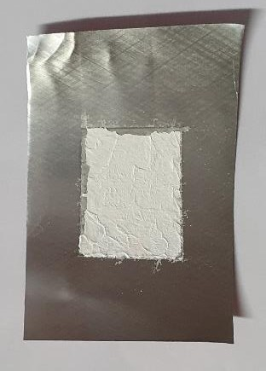
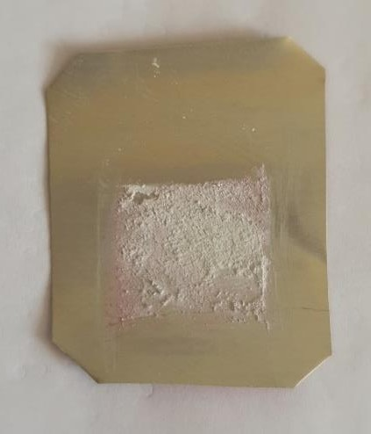
DSSE-WATER as SOLVENT DSSE-ACID as SOLVENT
(With Pigment) (Without Pigment)

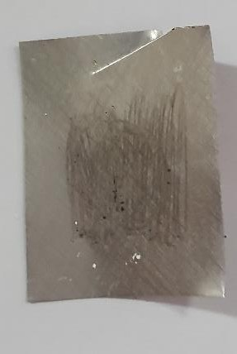
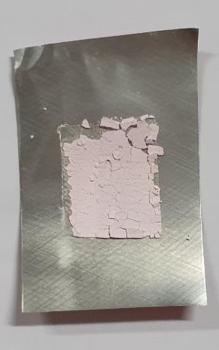
GRAPHITE COATED DSSE-ACID as SOLVENT
ELECTRODE (With Pigment )

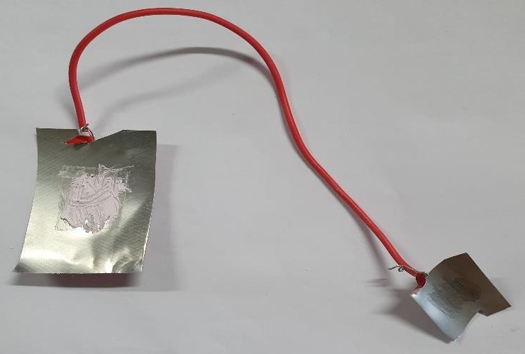

ELECTRODE HALF CIRCUIT OF PHOTO-ELECTROCHEMICAL CELL

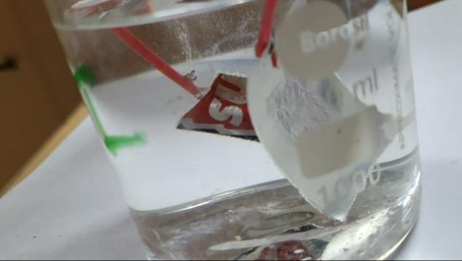
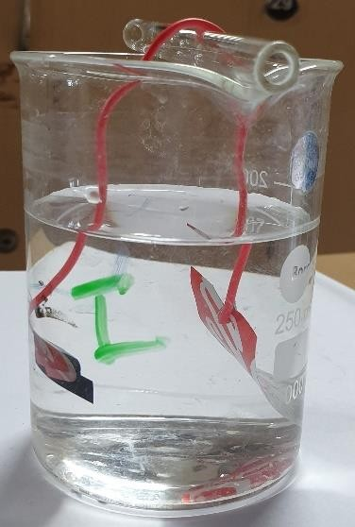
PHOTO-ELECTROCHEMICAL CELL
HYDROGEN AND OXYGEN EVOLUTION

WINTER SEMESTER 2018-19 (TD1)

ADVANTAGES

- Relatively simple to design and install.

- It is safest system and no manpower is required.

- The system helps to farmer or gardener to work when irrigation is taking place, as only the area between the plants are wet.

- Reduce soil erosion and nutrient leaching.

- The system need smaller water sources, as it consumes less than half of the water.

- Fertilizers can also be provided by using the system.

- PH content of the soil is maintained Through the suggestions which helps for healthy plant growth.

WINTER SEMESTER 2018-19 (TD1)

CONCLUSION

The primary applications for this project are for farmers and gardeners who do not have enough time to water their crops/plants. It also covers those farmers who are wasteful of water during irrigation.

As water supplies become scarce and polluted, there is a need to irrigate more efficiently in order to minimize water use and chemical leaching. Recent advances in soil water sensing make the commercial use of this technology possible to automate irrigation management for vegetable production. However, research indicates that different sensors types perform under all conditions with no negative impact on crop yields with reductions in water use range as high as 70% compared to traditional practices

WINTER SEMESTER 2016-17 (TAA1)

ACKNOWLEDGEMENTS

We would like take this opportunity to thank our faculty for his wholehearted guidance in making this project possible. Lastly, we would like to thank our parents for all their love and support and for providing all the necessary components required for this project.
We would also like to thank VIT University Chennai Campus for giving the opportunity to complete our project.

WINTER SEMESTER 2016-17 (TAA1)

REFERENCES

  - SMART IRRIGATION SYSTEM 1Gauri tope, 2A.S. Patel 1,2Department of E&TC M.S.S college of Engineering (Jalna) Email: 1gauritope0@gmail.com, 2atmeshpatel@gmail.com
  - SMART IRRIGATION SYSTEM USING RASPBERRY PI Bhagyashree K.Chate 1, Prof.J.G.Rana 2, 1 PG student, EC, JNEC, Maharashtra, India 2HOD, ETC, JNEC, Maharashtra, India
  - Smart Irrigation System S. Darshna1 , T.Sangavi2 , Sheena Mohan3 , A.Soundharya4 , Sukanya Desikan4 Department of Electronics and Communication, Amrita School of Engineering, India
  - Smart Irrigation System Using Internet of Things Babanna Kumbar, Basavaraj Galagi, Bheemashankar and Naveen Honnalli
  - SMART IRRIGATION SYSTEM THROUGH WIRELESS SENSOR NETWORKS G. Merlin Suba, Y M Jagadeesh, S Karthik and E Raj Sampath Department of EEE, Panimalar Engineering College, Chennai, India E-Mail: merlinsuba@rediffmail.com
  - IOT based Smart Irrigation System Srishti Rawal Department of Computer Science, VIT University
  - https://easternpeak.com/blog/iot-in-agriculture-5-technology-use-cases-for-smart-farming-and-4-challenges-to-consider/
  - Science daily

