CHAPTER NINE
Q.1. What is Web Mining?

Ans.
1. Web mining is mining of data related to the World Wide Web. This may be the data actually present in Web pages or data related to Web activity. Web data can be:
- Content of actual Web pages
- Intra page structure includes the HTML or XML node for the page.
- Inter page structure is the actual linkage structure between Web pages.
- Usage data that describe how Web pages are accessed by visitors.
- User profiles include demographic and registration information obtained about users.
Taxonomy of Web Mining:
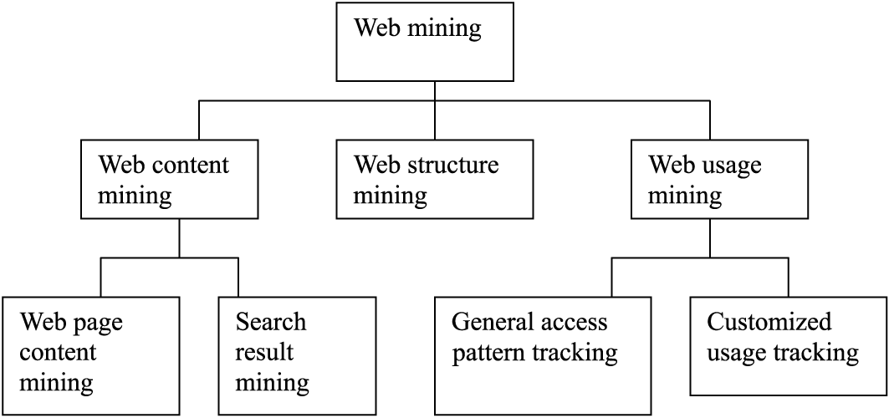
Figure: Web mining Taxonomy
2. Web content mining examines the content of Web pages as well as results of Web searching. The content includes text as well as graphics data. Web content mining is further divided into Web page content mining and search results mining.
3. Web page content mining is traditional searching of Web pages via content, while Search results mining is a further search of pages found from a previous search.
4. With Web structure mining, information is obtained from the actual organization of pages on the Web.
5. Web usage mining looks at the logs of Web access. General access pattern tracking is a type of usage mining that looks at a history of Web pages visited. This usage may be general or may be targeted to specific usage or users. Usage mining also involves mining of these sequential patterns.
6. Uses of Web Mining:
- Personalization for a user can be achieved by keeping track of previously accessed pages.
- Web usage patterns can be used to gather business intelligence to improve sales and advertisement.
- Collection of information can be done in new ways.
- Testing of relevance of content and web site architecture can be done.

Q.2. What is Web Content mining?

Ans.
1. Web content mining examines the content of Web pages as well as results of Web searching. The content includes text as well as graphics data. Web content mining is further divided into Web page content mining and search results mining.
2. Web page content mining is traditional searching of Web pages via content, while Search results mining is a further search of pages found from a previous search.
3. Web content mining can improve on traditional search engines through such techniques as concept hierarchies and synonyms, user profiles, and analyzing the links between pages.
4. Web content mining uses data mining techniques for efficiency, effectiveness and scalability.
5. Web content mining can be divided into:
- Agent-based approach
- Database based approach
Agent-based approach:
- They have software systems(agents) that perform the content mining.
- For example, search engines. Intelligent search agents use techniques like user profiles or knowledge concerning specific domains.
- Information filtering utilizes IR techniques, knowledge of the link structures to retrieve an categorize documents.
- Personalize Web agents use information about user preferences to direct their search.
Database-based Approach:
- It views the Web data as belonging to a database.
- There have been approaches that view the Web as a multilevel database, and there have been many query languages that target the Web.

6. Type of Text Mining:
- Basic content mining is a type of text mining.
- Text mining hierarchy
Simplest functions at the top and more complex functions at the bottom.
Many Web content mining activities have centre around techniques to summarize the information found.
Simple search engines retrieve relevant documents usually using a keyword-base retrieval technique similar to those found in traditional IR systems.

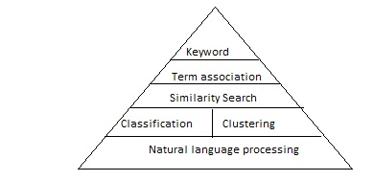
Figure shows the text mining hierarchy

Q.3. What is a Crawler?

Ans.
1. A robot(or spider or crawler) is a program that traverses the hypertext structure in the Web.
2. The page(or set of pages) that the crawler starts with are referred to as the seed URLs. By starting at one page, all links from it are recorded and saved in a queue. These new pages are in turn searched and their links are saved.
3. Types of Crawler:
- Periodic Crawler – may visit a certain number of pages and then stop, build an index, and replace the existing index.
- Incremental Crawler – selectively searches the Web and only updates the index incrementally as opposed to replacing it.
- Focused Crawler – visits pages related to the topics of interest.
- Context Focused Crawler (CFC) – performs crawling in two steps. In the first phase, context graphs and classifiers are constructed using a set of seed documents as a training set. In the second phase, crawling is performed using the classifiers to guide it. Also, context graphs are updated.

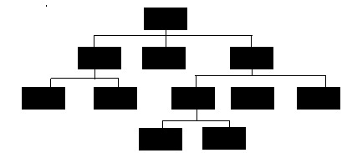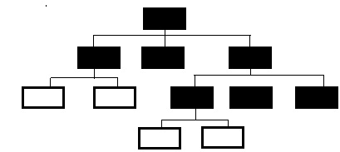
Figure: Regular Crawling and Focused Crawling

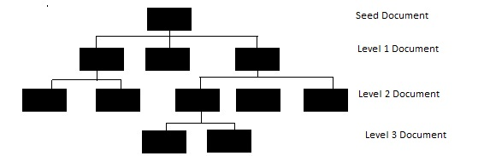

Figure for context graph

Q.4. What is a Harvest System?

Ans.
1. The Harvest system is based on the use of caching, indexing, and crawling. Harvest is actually a set of tools that facilitate gathering of information from diverse sources.
2. The Harvest design is centered around the use of gatherers and brokers.
3. A gatherer obtains information for indexing from an Internet service provider, while a broker provides the index and query interface. The relationship between brokers and gatherers can vary. Brokers may interface directly with gatherers or may go through other brokers to get to the gatherers.
4. Indices in Harvest are topic-specific, as are brokers.
5. Harvest gatherers use Essence system to assist in collecting data, Essence classifies documents by creating a semantic index.
6. Semantic indexing generates different types of information for different types of files. It then creates indices on this information.

Q.5. What is Virtual Web View?

Ans.
1. Multiple layered database (MLDB) is used to handle large amounts of unstructured data on the Web.
2. This database is massive and distributed. Each layer is more generalized than the layer beneath it.
3. The MLDB provides an abstracted and condensed view of a portion of the Web. A view of the MLDB, which is called a Virtual Web View (VWV) can be constructed.
4. Generalization tools are proposed, and concept hierarchies are used to assist in the generalization process for constructing the higher levels of the MLDB.
5. WebML, a web data mining query language is proposed to provide data mining operations on the MLDB. It is an extension of DMQL.

Q.6. What is Web Structure mining?

Ans.
1. With Web structure mining, information is obtained from the actual organization of pages on the Web.
2. It can be viewed as creating a model of the Web organization or a portion of it.
3. Uses:
- to classify Web pages
- to create similarity measures between documents.
4. Techniques of Web Structure Mining:
Page Rank and HITS Algorithm
5. Page Rank
- Was designed to increase the effectiveness and improve the efficiency of the search engines.
- It is used to measure the importance of a page and to prioritize the pages returned from a traditional search engine using keyword searching.
- Google uses this technique.
- The PageRank value for a page is calculated based on the number of pages that point to it.
- Given a page p, we use B_{p} to be the set of pages that point to p and F_{p} to be the set of links out of p. The PageRank of p is defined as:
PR(p)=cq∈B_{p} PR(q)/N(q)
0<c<1 , used for normalization
|N_{q}|=|F_{q}|
- Rank sink, is a problem with PageRank when a cyclic reference occurs.

6. Clever
- Clever is aimed at finding both authoritative pages and hubs.
- An authority is the ‘best source’ for the requested information and a hub is a page that contains links to authoritative pages.
- It identifies authoritative pages and hub pages by creating weights. A search can be viewed as having a goal of finding the best hubs and authorities.
- HITS algorithm:
Hyperlink-induced topic search(HITS) finds hubs an authoritative pages. The technique contains two components:
- Based on a given set of keywords(found in a query), a set of relevant pages is found.
- Hub an authority measures are associated with these pages. Pages with the highest values are returned.
- A search engine SE, is used to find a small set, root set (R), of pages P, which satisfy the given query, q. This set is then expanded into a larger set, base set (B), by adding pages linked either to or from R. This is used to induce a subgraph of the Web. This graph is the one that is actually examined to find the hubs and authorities.

HITS Algorithm
R=SE(W,q)
B=R ∪{pages that link to pages in R}
GB,L= Subgraph of W induced by B
GB, L'= Delete links in G within same site
Xp= ∑q where q,p L' Yq;Find authority weights
Yp= ∑q where p,q L' Xq;Find hub weights
A=p p has one of the highest Xp}
H=p p has one of the highest Yp}

Q.7. What is Web Usage Mining?

Ans.
1. Web usage mining performs mining on Web usage data, or Web logs. A Web log is a listing of page reference data. It is also called clickstream data because each entry corresponds to a mouse click.
2. When these logs are examined from a server perspective, mining uncovers information about the sites where the service resides an can help improve the design of the sites.
3. By evaluating a client’s sequence of clicks, information about a user (or a group of users) is detected. This could be used to perform pre-fetching and caching of pages.
4. Uses of Web usage Mining:
- Personalization for a user can be achieved by keeping track of previously accessed pages.
- By determining frequent access behavior for users, needed links can be identified to improve the performance.
- Identifying common access behaviors can help improve actual design of Web pages and make other modifications to the site.
- Patterns can be used to gather business intelligence to improve sales and advertisement.
5. Activities of Web usage Mining:
- Preprocessing activities center around reformatting the Web log data before processing.
- Pattern discovery activities form the major portion of the mining activities because these activities look to find hidden patterns within the log data.
- Pattern analysis is the process of looking at and interpreting the results of the discovery activities.
6. Preprocessing:
- It includes cleansing, user identification , session identification, path completion and formatting.
- Before processing the log, the data may be changed in several ways. For security or privacy reasons, the page addresses may be change into unique page identifications. This also will save storage space. Also, the data may be cleansed by removing irrelevant information.
- All pages visited from one source could be grouped by a server to understand the patterns of page references from each user.
- A common technique is for a server site to divide the log records into sessions. A session is a set of page references from one source site during one logical period. Login and logoff represents the logical start and end of the session.

7. Data Structures:
- Data Structures are used to keep track of patterns identified during the Web usage mining process.
- One of the basic data structure is trie. A trie is a rooted tree, where each path from the root to leaf represents a sequence. They are used to store strings for pattern-matching applications.
- The wastage of space in trie is solved by compressing nodes together when they have degrees of one. A compressed trie is called suffix tree.
Figure shows sample tries
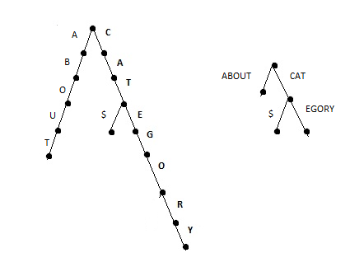
- With the help of suffix tree, it is efficient to find not only the subsequence in a sequence, but also to find the common subsequences among multiple sequences.

8. Pattern Discovery
- The most common data mining technique used on clickstream data is that of uncovering traversal pattern. A traversal pattern is a set of pages visited by a user in a session. Other types of patterns may be uncovered by Web usage mining.
- Different types of Traversal Patterns are:
- Association Rules
- Episodes
- Sequential patterns
- Forward sequences
- Maximal frequent sequences

9. Pattern Analysis:
- Pattern Analysis is the process of looking at and interpreting the results of discovery activities.
- Once the patterns are identified, they must be analyzed to determine how that information can be used. Some of the generated patterns may be deleted and determined not to be of interest.
- Web logs can identify patterns that are of interest because of their uniqueness or statistical properties. Each log is examined to find patterns based on any desired requirements. The patterns found across two logs are compared for similarity.

Q.8. Explain the Automatic Classification of Documents.

Ans.
1. In this each document is assigned a class label from a set of predefined topic categories.
2. For example, Yahoo!’s taxonomy and its associated documents can be used as training and test sets to derive a Web document classification scheme. This scheme may then be used to classify new Web documents.
3. Keyword-based document classification methods and keyword-based association analysis method can be used for Web document classification. Such a term-based classification scheme has shown good results in Web page classification.
4. A Web page may contain multiple themes, advertisement and navigation information. Therefore, block-based page content analysis may play an important role in construction of high-quality classification models.
5. Hyperlinks contain high-quality semantic clues to a page’s topic. It is beneficial to make good use of such semantic information in order to achieve even better accuracy than pure keyword-based classification. But, because the hyperlinks surrounding a document may be quite noisy, naïve use of terms in a document’s hyperlink neighborhood can even degrade accuracy. The use of block-based Web linkage analysis will reduce such noise and enhance the quality of Web document classification.
6. A Web information infrastructure that is expected to bring structure to the Web based on the semantic meaning of the contents of Web pages. Web document classification by Web mining will help in the automatic extraction of the semantic meaning of Web pages and build up ontology for the semantic Web. Conversely, the semantic Web, if successfully constructed, will greatly help automated Web document classification as well.

