IBM NAAN MUDHALVAN

APPLIED DATA SCIENCE

COVID-19 VACCINE ANALYSIS

PHASE – 4 PROJECT SUBMISSION

|  |  |
| --- | --- |
| DOMAIN | APPLIED DATA SCIENCE |
| PROJECT TOPIC | COVID-19 VACCINE ANALYSES |
| TEAM MEMBER  AND  REGISTER NUMBER | M.Vignesh(420421106045)  S.Sanjayharish(420421106034)  S.chitaardhan(420421106009)  k.Santhosh(420421106035) |

Dataset link: <https://www.kaggle.com/datasets/gpreda/covid-world-vaccination-progress>

Program:

STEP 1: Import the libraries.

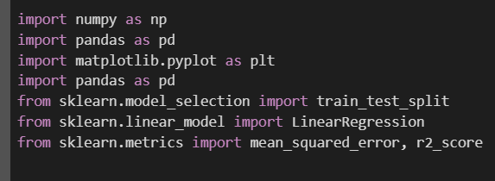

STEP 2: Load the datasets:

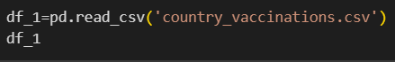

Output:

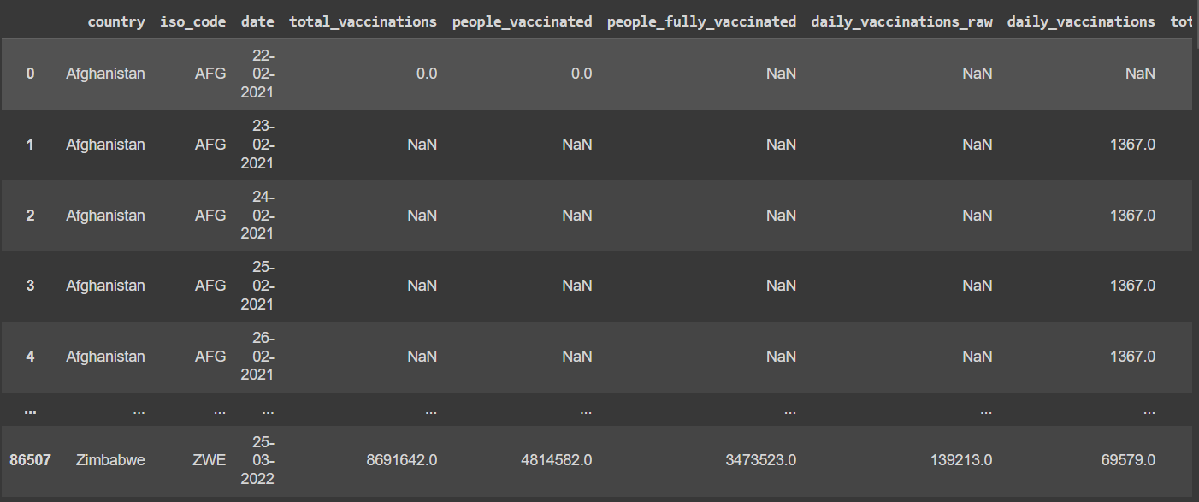

STEP 3: Describe the datasets.

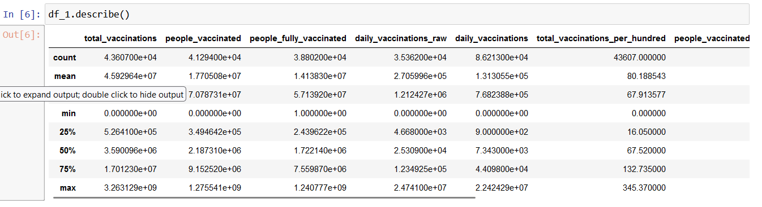

STEP 4: Data cleaning.

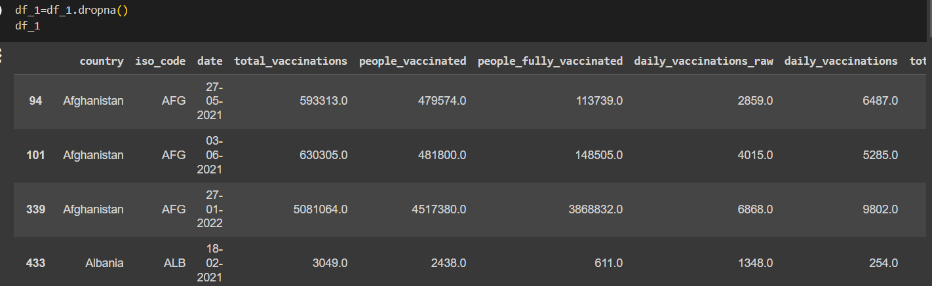

STEP 5: Data visualization.

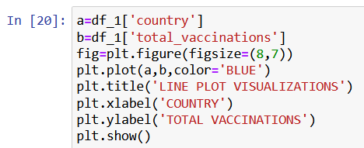

Output:

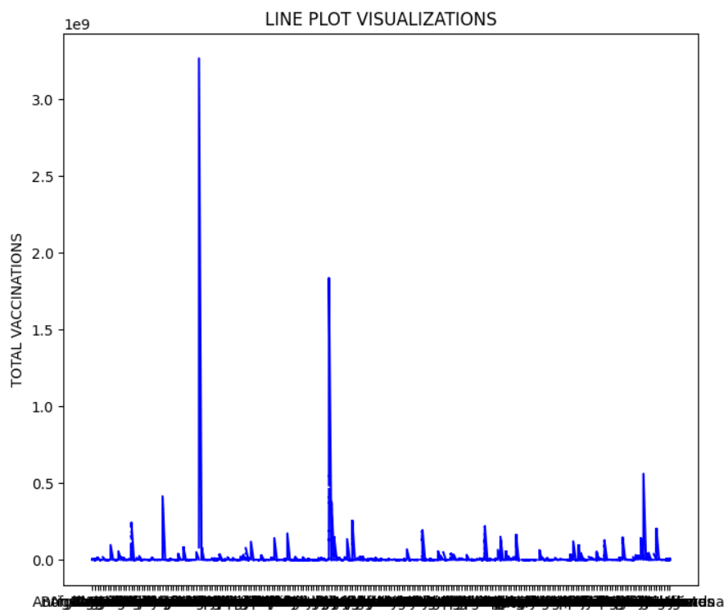

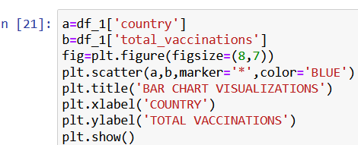

Output:

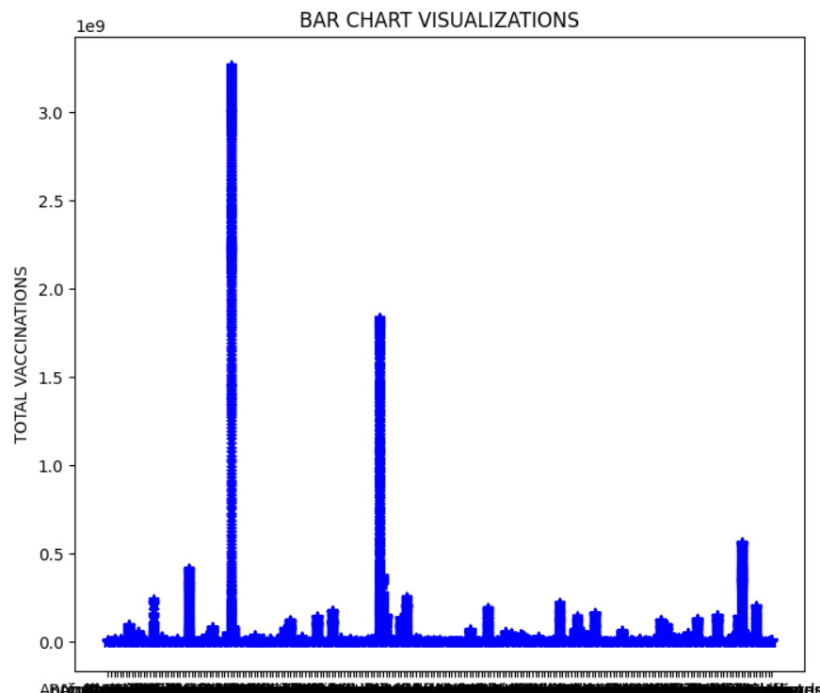

STEP 6: Training and evaluation of the datasets by linear regression models.

# Define features (X) and target (y)

X = df_1[['total_vaccinations', 'daily_vaccinations']]  # Specify the relevant features

y = df_1['daily_vaccinations_per_million']  # The target variable you want to predict

# Split the data into training and testing sets

X_train, X_test, y_train, y_test = train_test_split(X, y, test_size=0.2, random_state=42)

# Create a Linear Regression model

model = LinearRegression()

# Train the model on the training data

model.fit(X_train, y_train)

# Make predictions on the test data

y_pred = model.predict(X_test)

# Evaluate the model

mse = mean_squared_error(y_test, y_pred)

r2 = r2_score(y_test, y_pred)

print("Mean Squared Error:", mse)

print("R-squared (R2) Score:", r2)

# You can save the trained model for later use

# Example: save the model to a file

from joblib import dump

dump(model, 'covid_model.joblib')

output:

