Practicum Final Exam –Even Semester Year 2020/2021
Subject |  |  | COMP6048 - Data Structures |  |  | 
Class | : | BB03 / BB06 / BP01 / BV01 / PB01 |  | Start Date | : 19 June 2021
Lecturer | : | D4501 - Muhsin Shodiq, S.Kom., M.Sc.  D5025 - Yovita Tunardi, S.Kom., M.T.I  D5387 - Harvianto, S.Kom, M.T.I.  D6416 - Puti Andam Suri, S.Kom, M.TI  D6423 - Hidayaturrahman, S.Kom., M.T. |  | Start Time | : 09:20
Lecturer | : |  |  | End Date | : 19 June 2021
Lecturer | : |  |  | End Time | : 11:20

PERATURAN UJIAN:
Exam Regulations:
- Mahasiswa tidak diperbolehkan berdiskusi dan/atau bekerja sama dengan peserta ujian lainnya
Student is not allowed to discuss and/or work together with other exam participants
- Mahasiswa tidak diperbolehkan untuk membuka dan menyalin dari BUKU atau CATATAN, VIDEO dari pengajar (recording kelas, VBL, Youtube, dsb) dan REFERENSI lainnya
Student isn't allowed to open and copy from any resources such as notes, videos (class recording, VBL, Youtube, etc) and other references
- Mahasiswa tidak diperbolehkan membuka dan menyalin jawaban dari internet (google, stackoverflow, dsb)
Student isn't allowed to open and copy answer from the internet (google, stackoverflow, etc)
- Asisten BERHAK memberi nilai 0 (NOL) bagi peserta ujian yang melakukan segala bentuk kecurangan
Assistant is able to give 0 (ZERO) score for exam participant who does any cheating actions
- Kumpulkan jawaban tepat pada waktunya, apabila terlambat mengumpulkan maka jawaban tidak akan dikoreksi dan nilai mahasiswa adalah 0
Submit the answer on time, if not, then the answer will not be checked, and the students will receive 0 (ZERO)
- Bila Anda tidak membaca peraturan ini, maka Anda dianggap telah membaca dan menyetujuinya
If you have missed to read these regulations, so you are considered to have read and agreed on it

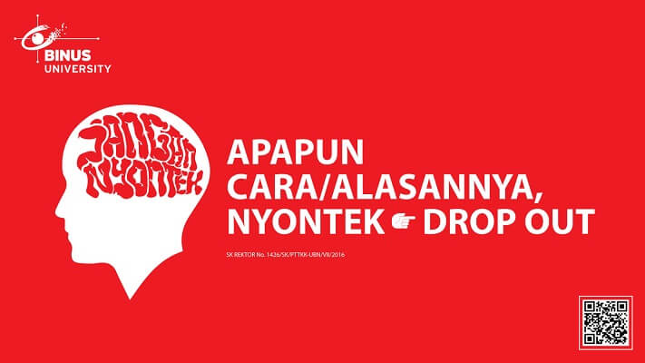

SOFTWARE YANG DIGUNAKAN:
Software will be used:
- Dev-C++ 5.11

FILE YANG DIKUMPULKAN:
File must be collected:
- [NIM].CPP

PERHATIAN!
Attention!
- Bagi yang mengerjakan tidak sesuai dengan soal, maka akan diberikan nilai NOL (0)
For those who do not work in accordance with the exam case will be marked as ZERO (0)
- Bagi yang mengerjakan tidak sesuai dengan software dan versi yang telah ditetapkan, maka akan tetap dikoreksi dengan software dan versi yang telah ditetapkan
For those who do not work in accordance with the software and specific version will be corrected by the predefined software and version
- Kompres semua jawaban yang akan diunggah. Pastikan format pengumpulan nama file dan ekstensi sesuai dengan format berikut: [NIM]-[NAMA].zip
Compress all file that will be uploaded. Make sure the format for collecting file name and extension according to the following format: [NIM]-[NAME].zip

Soal
Case

Mbek Farm
Mbek Farm is an application that will be developed to help Mr. Jack “Blue” Sky to manage his goat farm. You as a programmer is asked to help Mr. Jack to create an application that can help Mr. Jack to manage his goat farm. This application will be developed using AVL Tree. The descriptions of the program are:
- The program consists of 5 menus:
1. Insert New goat
2. Remove a goat
3. See all goat
4. Remove all goat
5. Exit
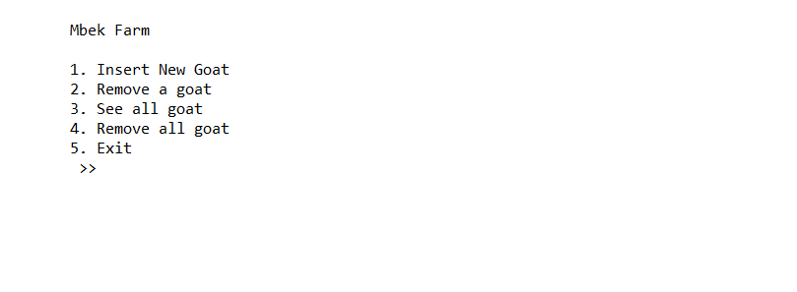
Figure 1. Main Menu
- If user chooses Insert New Goat (Menu 1):
  - Ask user to input goat’s id. Validate the id must consist of 5 digit number and must be unique
  - Ask user to input goat’s name. Validate that the name must be more than or equals two characters
  - Ask user to input goat’s color. Validate that the input must be either “white”, “black”, or “brown” (case insensitive)
  - Input the goat’s weight. Validate the weight must be between 2 and 150 inclusively
  - Input goat’s age in month count. Validate the month must be between 0 and 60 inclusively
  - Before inserting the data into the AVL Tree, ask user for confirmation and show the goat’s name. if user input “Y” then insert the goat to the AVL Tree and shows a success message. Otherwise, redirect back to the main menu
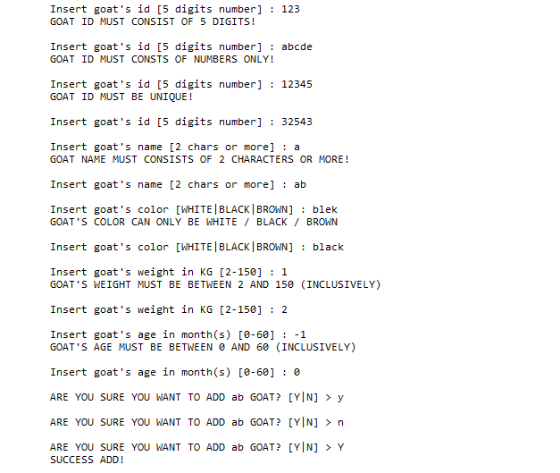
Figure 2. Insert goat menu
- If user chooses Remove a goat (Menu 2):
  - If the user does not have any goat, show a message “You don’t have any goat !”
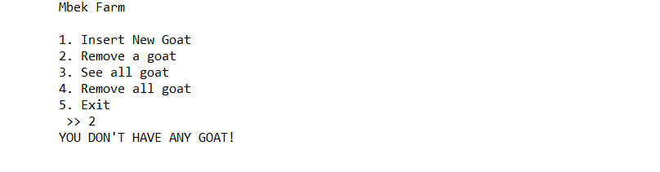
Figure 3. No goat message
  - Otherwise, ask user to input goat’s id
    - Validate if the inputted id does not exist, then show a message “ID is invalid”
    - Validate so the user cannot remove a goat which name starts with “my” (case sensitive)
  - If the inputted id is valid, then delete the goat’s data from the AVL Tree
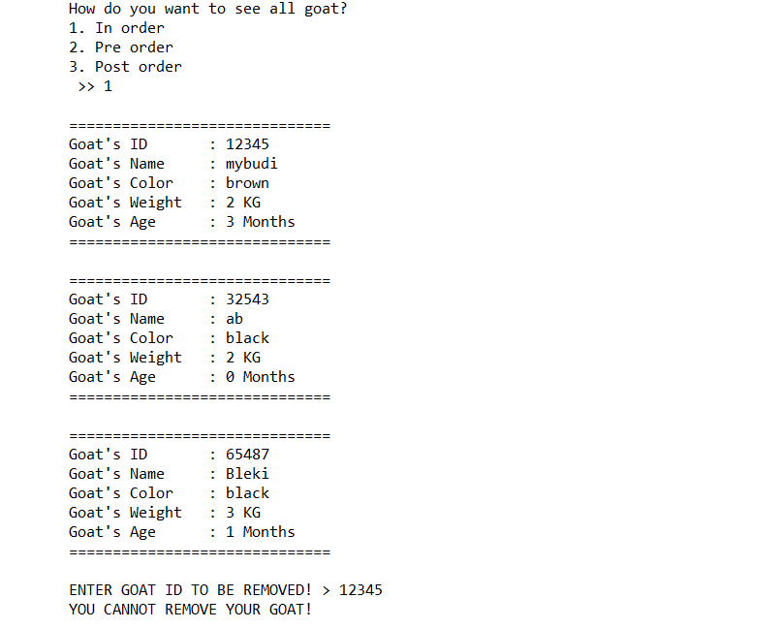
Figure 4. Unable to remove goat with prefix “my”
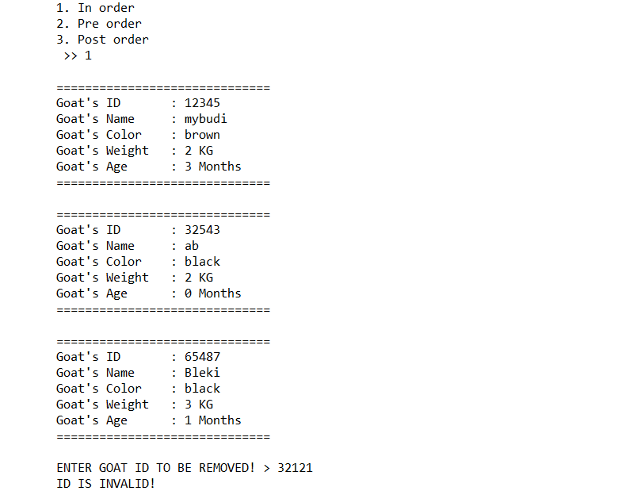
Figure 5. Invalid ID
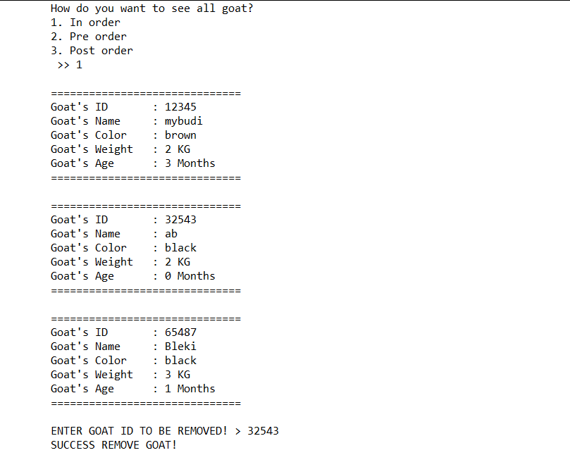
Figure 6. Success remove goat
- If user chooses See all goat (Menu 3):
  - If the user does not have any goat, show a message “You don’t have any goat!”
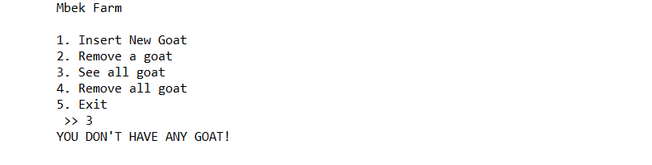
Figure 7. No goat message
  - Otherwise, then ask user how he wants to display the goat’s data
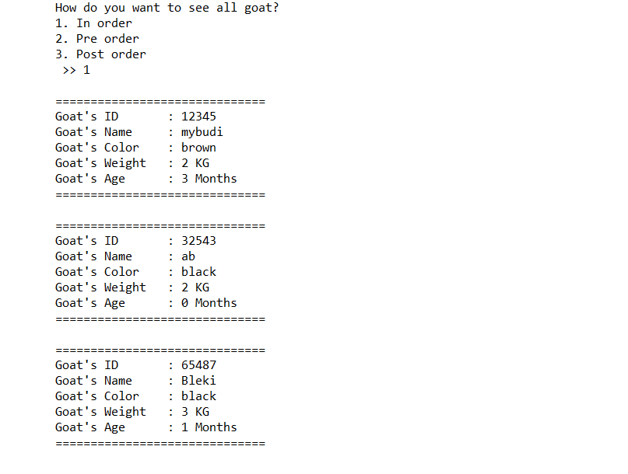
Figure 8. Ask user for display option
Figure 9. See goat in in-order
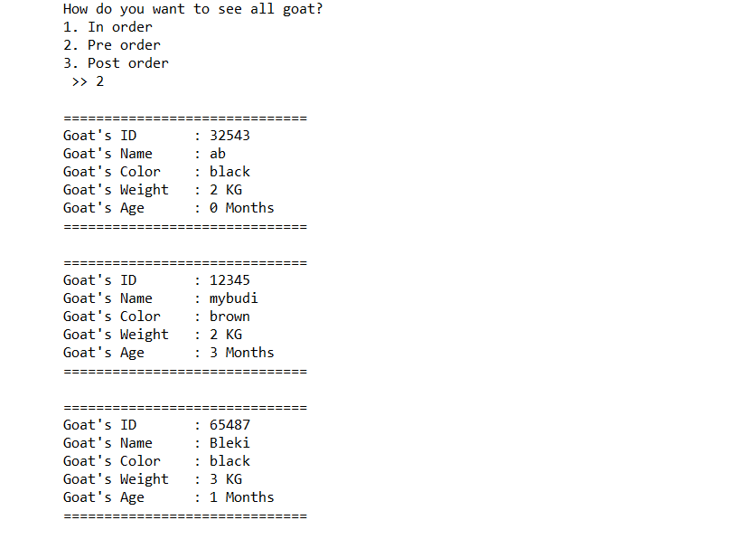
Figure 10. Display goat in pre-order
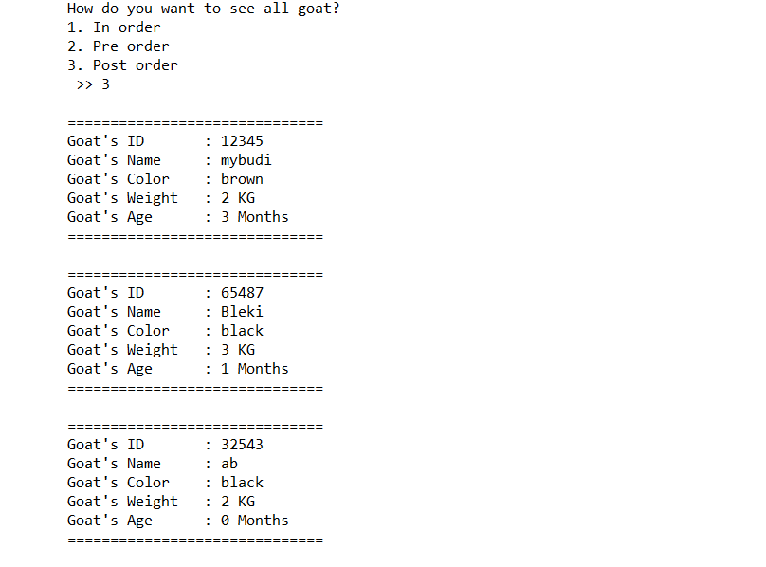
Figure 11. Display goat in post-order
- If user chooses Remove All (Menu 4):
  - If the user does not have any goat then show a message “You don’t have any goat!”
  - Otherwise, before removing all the data, ask user for confirmation. Validate the input must be either “Y” or “N” (case sensitive)
  - If user choose “Y” then remove all the data from AVL Tree or else redirect back to main menu
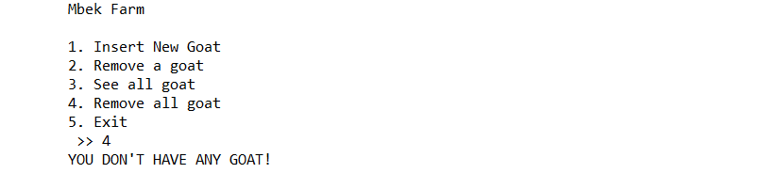
Figure 12. No goat message
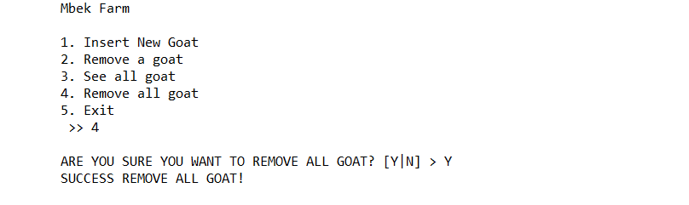
Figure 13. Remove all goat with confirmation
- If user chooses Exit (Menu 5), close the program

Please run the EXE file to see the sample program

