**ASSESSMENT FORM**

**Course: ISYS6169 Database Systems**

**Method of Assessment: Performance Task**

**Semester/Academic Year :** 3/2021-2022

**Name of Lecturer : HARKAT CHRISTIAN ZAMASI, S.Kom., M.M.S.I**

**Date : 09 Januari 2022**

**Class : LP01-LEC**

**Topic : Entity Relationship Modeling, SQL Data Definition (Table, Index), SQL Data Manipulation (Basic), SQL Data Definition (View), SQL Data Manipulation (Advanced)**

|  |  |
| --- | --- |
| **Group Members :** | 1. Andre Budiman (2440050344)  2. Farhan Izzahturrahman Andiejanto (2440049020)  3. Ravino Elang Mahardika (2440050703)  4. Rachmad Darmawan (2440045086)  5. Cirilus Davin Rahadyan Mananda (2440050691) |

**Student Outcomes:**

**SO 1 - Able to create software application design with the implementation of database system principal design to solve structured and semi-structured data;**

**L.Obj 1.1 - Able to identify the structured and semi-structured problems in order to formulate the best solutions;**

**L.Obj 1.2 - Able to design database with the application of database system design principal;**

**L.Obj 1.3 - Able to create software application design with the database system;**

CONCEPTUAL ERD

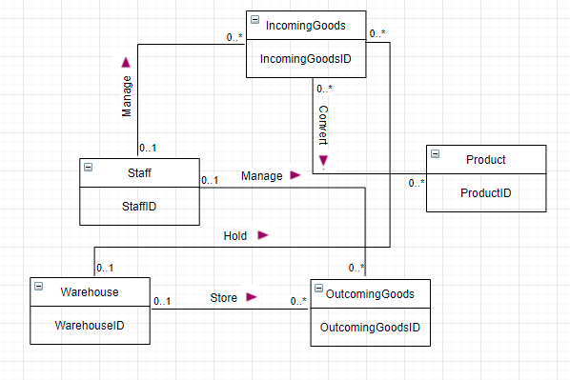

LOGICAL ERD

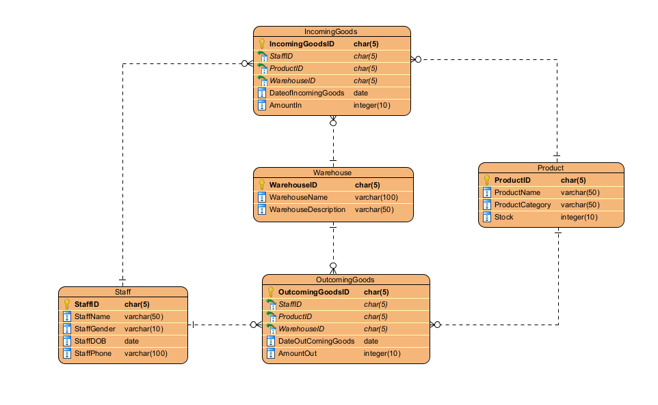

Conceptual Process

<https://docs.google.com/spreadsheets/d/1kEme9YZF7j7AUPBGFWMYjK1p_hCajKZIVZsBBHsC5ko/edit?usp=sharing>

Normalization Process

<https://docs.google.com/spreadsheets/d/1bS2ck76sZ2xRqcM3tjbeZx4jWkurDhNa6lI0F5HxbPM/edit?usp=sharing>

DDL

CREATE DATABASE DataGudang

USE DataGudang

CREATE TABLE Staff(

StaffID CHAR(5) NOT NULL PRIMARY KEY CHECK(StaffID LIKE 'ST[0-9][0-9][0-9]'),

StaffName VARCHAR(50) NOT NULL,

StaffGender VARCHAR(10) NOT NULL CHECK(StaffGender like 'Male' OR StaffGender like 'Female'),

StaffDOB DATE NOT NULL,

StaffPhone VARCHAR(100) NOT NULL CHECK(StaffPhone like '+62%')

)

CREATE TABLE Product(

ProductID CHAR(5) NOT NULL PRIMARY KEY CHECK(ProductID LIKE 'PT[0-9][0-9][0-9]'),

ProductName VARCHAR(50) NOT NULL,

ProductCategory VARCHAR(50) NOT NULL CHECK(ProductCategory LIKE 'Shopping' or ProductCategory LIKE 'Industry'),

Stock INT NOT NULL

)

CREATE TABLE IncomingGoods(

IncomingGoodsID CHAR(5) NOT NULL PRIMARY KEY CHECK(IncomingGoodsID LIKE 'IG[0-9][0-9][0-9]'),

StaffID CHAR(5) FOREIGN KEY REFERENCES Staff(StaffID) ON UPDATE CASCADE ON DELETE CASCADE NOT NULL,

ProductID CHAR(5) FOREIGN KEY REFERENCES Product(ProductID) ON UPDATE CASCADE ON DELETE CASCADE NOT NULL,

WarehouseID CHAR(5) FOREIGN KEY REFERENCES Warehouse(WarehouseID) ON UPDATE CASCADE ON DELETE CASCADE NOT NULL,

DateofIncomingGoods DATE NOT NULL,

AmountIn INT NOT NULL

)

CREATE TABLE OutcomingGoods(

OutcomingGoodsID CHAR(5) NOT NULL PRIMARY KEY CHECK(OutcomingGoodsiD LIKE 'OG[0-9][0-9][0-9]'),

StaffID CHAR(5) FOREIGN KEY REFERENCES Staff(StaffID) ON UPDATE CASCADE ON DELETE CASCADE NOT NULL,

ProductID CHAR(5) FOREIGN KEY REFERENCES Product(ProductID) ON UPDATE CASCADE ON DELETE CASCADE NOT NULL,

WarehouseID CHAR(5) FOREIGN KEY REFERENCES Warehouse(WarehouseID) ON UPDATE CASCADE ON DELETE CASCADE NOT NULL,

DateOutComingGoods DATE NOT NULL,

AmountOut INT NOT NULL

)

CREATE TABLE Warehouse(

WarehouseID CHAR(5) NOT NULL PRIMARY KEY CHECK(WarehouseID like 'WA[0-9][0-9][0-9]'),

WarehouseName VARCHAR(100) NOT NULL,

WarehouseDescription VARCHAR(50) NOT NULL CHECK(WarehouseDescription LIKE 'Penyimpanan Makanan' OR WarehouseDescription LIKE 'Penyimpanan Minuman' OR WarehouseDescription LIKE 'Penyimpanan Alat Tulis' OR WarehouseDescription LIKE 'Penyimpanan Barang Bekas')

)

INSERT DATA

INSERT INTO Staff VALUES

('ST001','Andre Budiman','Male','2002-10-29','+628128566376'),

('ST002','Sandra Charls','Female','2002-04-19','+6281298224525'),

('ST003','Alex Tom','Male','2002-12-15','+6281287221857'),

('ST004','Dewi Putri','Female','2002-08-05','+6281297662984')

INSERT INTO Product VALUES

('PT001','Fiesta','Shopping','200'),

('PT002','Chitato','Shopping','180'),

('PT003','Pensil','Industry','350'),

('PT004','Penghapus','Industry','300')

INSERT INTO IncomingGoods VALUES

('IG001','ST001','PT001','WA001','2020-07-17','199'),

('IG002','ST002','PT002','WA002','2019-08-15','244'),

('IG003','ST003','PT003','WA003','2020-12-21','95'),

('IG004','ST004','PT004','WA004','2020-03-11','120')

INSERT INTO OutcomingGoods VALUES

('OG001','ST001','PT001','WA001','2021-04-27','129'),

('OG002','ST002','PT002','WA002','2020-04-25','153'),

('OG003','ST003','PT003','WA003','2021-07-11','73'),

('OG004','ST004','PT004','WA004','2021-05-01','67')

INSERT INTO Warehouse VALUES

('WA001','Warehouse Cipinang','Penyimpanan Makanan'),

('WA002','Warehouse Jakarta','Penyimpanan Makanan'),

('WA003','Warehouse Tangerang','Penyimpanan Alat Tulis'),

('WA004','Warehouse Bekasi','Penyimpanan Alat Tulis')

CREATE VIEW

-- Create View to display all Staff attribute

GO

CREATE VIEW DisplayStaff

AS

SELECT

*

FROM Staff

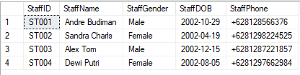

--Create View to display staff(StaffID, StaffName) who handle incomingGoods amount more than 100

GO

CREATE VIEW AmountIn

AS

SELECT

s.StaffID,

StaffName

FROM Staff s

JOIN IncomingGoods ig ON ig.StaffID = s.StaffID

WHERE AmountIn > 100

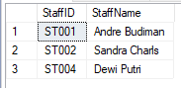

--Create View to display Product(ProductID, ProductName) that out in 2021

GO

CREATE VIEW displayProduct

AS

select

og.ProductID,

ProductName

from Product p

join OutcomingGoods og on og.ProductID = p.ProductID

where year(DateOutComingGoods) LIKE '2021'

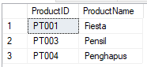

--Create View to display Staff(StaffID, StaffName) who handle incoming in 2019

GO

CREATE VIEW displayStaff2019

AS

SELECT

s.StaffID,

StaffName

FROM Staff s

join IncomingGoods ig on ig.StaffID = s.StaffID

WHERE YEAR(DateofIncomingGoods) LIKE '2019'



--Create View to display warehouse(WarehouseID, WarehouseName) yang menyimpan makanan

GO

CREATE VIEW displayWarehouse

AS

SELECT

WarehouseID,

WarehouseName

FROM Warehouse w

WHERE WarehouseDescription LIKE 'Penyimpanan Makanan'

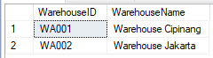

--Create View to display productname yang memiliki amountin lebih besar daripada average semua amount in

GO

CREATE VIEW displayproductname

as

select

ProductName

from IncomingGoods ig

join Product p on p.ProductID = ig.ProductID,

(

select

avg(AmountIn) [Average]

from IncomingGoods ig

)as alias

where AmountIn > alias.Average

