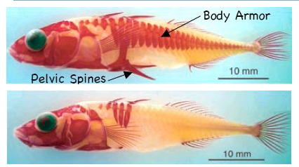
Epinoche lacustre
Epinoche marine

