ELECTRONIC MEDICAL RECORDS SYSTEM
Database Management System Project Report
Hospital Setting
Database Management Systems Course
SSEGIRINYA SIMON (GROUP 10)
2025/BCS/215/PS

1. Database Selection

1a. Area of Interest
The area of interest selected for this project is the Healthcare and Hospital Management sector. Hospitals generate and rely on enormous volumes of data daily, ranging from patient demographics and clinical notes to lab results and billing records. Effective database management in this sector directly impacts the quality of patient care, operational efficiency, and regulatory compliance.

1b. Possible Database Systems in the Hospital Setting
The following are database systems that are applicable within a hospital environment:

# | Database System | Description
1 | Electronic Medical Records (EMR) System | Centralizes patient health information including diagnoses, treatments, prescriptions, and lab results for use within a single hospital.
2 | Hospital Billing and Financial Management System | Manages patient invoices, insurance claims, payment processing, and financial reporting for the hospital.
3 | Pharmacy Management System | Tracks medication inventory, dispensing records, supplier orders, and prescription fulfillment within the hospital pharmacy.
4 | Appointment Scheduling System | Manages patient bookings, doctor availability, consultation queues, and appointment reminders.
5 | Blood Bank Management System | Tracks blood donations, blood type inventory, cross-matching, and transfusion records.
6 | Human Resources and Payroll System | Manages staff records, work schedules, leave management, and salary processing for hospital employees.
7 | Laboratory Information System (LIS) | Dedicated system for managing lab test orders, sample tracking, results entry, and reporting.

1c. Reason for Choosing the Electronic Medical Records System
The Electronic Medical Records (EMR) System was selected for the following reasons:

- Central importance: The EMR is the backbone of all hospital operations. Every other system — billing, pharmacy, lab, scheduling — depends on or feeds into patient medical records. This makes it the most critical and comprehensive database to model.
- Rich relational structure: The EMR naturally involves many entities (patients, doctors, nurses, wards, prescriptions, lab tests, admissions) with complex relationships, making it ideal for demonstrating advanced database design concepts including one-to-many and many-to-many relationships.
- Real-world relevance: EMR adoption is a global healthcare priority. Studying this system provides practical knowledge that is directly applicable in real hospital environments and health IT careers.
- Data diversity: The system handles a wide variety of data types — dates, enumerations, text, numeric values — which makes it an excellent candidate for exploring SQL data types, constraints, and queries.
- Demonstrable impact: The business case for an EMR is strong and easy to quantify in terms of cost savings, error reduction, and care quality improvement, making the business case section substantive and convincing.

1d. Comparable Real-World System: OpenMRS
In developing this project, insight was drawn from OpenMRS (Open Medical Record System), a widely used open-source EMR platform deployed in hospitals and clinics across over 40 countries, particularly in low- and middle-income settings in Africa, Asia, and Latin America.

About OpenMRS
OpenMRS was founded in 2004 as a collaboration between Regenstrief Institute and Partners in Health. It is designed to be flexible and configurable to suit different healthcare contexts. It is actively used in countries including Kenya, Rwanda, Uganda, South Africa, Haiti, and India.

Key Lessons Learned from OpenMRS
- Patient-centric design: OpenMRS organizes all data around a central Patient record. Every encounter, observation, diagnosis, and prescription is linked back to a single patient identifier. This informed the design decision to make patient_id the central foreign key referenced across all tables in our EMR schema.
- Concept-based data model: OpenMRS uses a flexible concept dictionary to store observations, allowing the system to represent any clinical measurement without changing the database schema. While our system uses fixed columns for simplicity, this highlighted the importance of designing for extensibility.
- Role-based access control: OpenMRS assigns different permissions to doctors, nurses, administrators, and data clerks. This directly informed our User Interface dialogue structure, where each user group accesses only the modules relevant to their role.
- Encounter and visit tracking: OpenMRS distinguishes between a Visit (a period of care) and an Encounter (a specific interaction during a visit). This influenced our decision to maintain both an Appointments table and a Medical Records table as separate but linked entities.
- Importance of audit trails: OpenMRS logs who created or modified every record and when. While our implementation does not include audit columns for simplicity, this is noted as a future enhancement in our system limitations section.

2. Executive Summary
This report presents the design and implementation of an Electronic Medical Records (EMR) Database Management System for a hospital setting. The system is built on MySQL and provides a centralized, structured platform for managing all patient health information within a hospital environment.
The EMR system replaces traditional paper-based record keeping with a digital database that supports patient registration, appointment scheduling, medical record management, prescription tracking, laboratory test management, and ward admission control. The system serves multiple user groups including doctors, nurses, receptionists, lab technicians, pharmacists, and hospital administrators.
The database consists of nine interrelated tables: Patients, Doctors, Nurses, Wards, Appointments, Medical Records, Prescriptions, Lab Tests, and Admissions. The logical and physical designs were developed following standard database design principles including entity-relationship modeling and normalization. The system was fully implemented in MySQL with sample data and ten functional queries demonstrating its operational capabilities.
The business case analysis demonstrates that the EMR system is economically feasible, with estimated costs of $11,500 to $33,000 and a projected return on investment within 12 to 18 months through improved efficiency, reduced paper costs, and fewer medical errors.

3. Business Case

2a. Application Domain
The EMR system supports the digitization and management of patient health information within a hospital setting. It replaces paper-based records with a centralized, structured database that supports the following tasks and operations:
- Patient registration and demographic management
- Recording diagnoses, treatments, and clinical notes
- Scheduling and tracking patient appointments
- Managing prescriptions and medication history
- Ordering and retrieving laboratory test results
- Managing ward admissions and patient discharges

The system serves the following user groups:

User Group | Role in the System
Doctors | Record diagnoses, prescribe medication, order lab tests
Nurses | Update patient vitals, manage ward admissions
Lab Technicians | Enter and retrieve test results
Pharmacists | View and dispense prescriptions
Receptionists | Register patients, schedule appointments
Administrators | Generate reports, monitor hospital performance

2b. Analysis of Benefits
Tangible Benefits
- Elimination of paper record costs including printing, storage, and retrieval
- Faster patient processing resulting in reduced wait times at registration and consultation
- Reduced medication errors through digitized prescription tracking
- Faster billing and insurance claim processing
- Reduced duplicate lab tests due to accessible shared patient records
Intangible Benefits
- Improved quality of care: doctors can access complete patient history instantly
- Better coordination between departments such as lab, pharmacy, and wards
- Enhanced patient privacy and data security compared to physical files
- Improved regulatory compliance with health data standards
- Greater patient trust and overall satisfaction with hospital services

2c. Analysis of Costs
Cost Item | Estimated Cost (USD)
Database server hardware | $3,000 – $8,000
Software licenses (MySQL, OS) | $500 – $2,000/year
System development & setup | $5,000 – $15,000
Staff training | $1,000 – $3,000
Network infrastructure | $2,000 – $5,000
Total Estimated Cost | $11,500 – $33,000

Intangible Costs
- Resistance to change from staff accustomed to paper-based workflows
- Temporary productivity loss during system transition and training period
- Risk of workflow disruption during data migration from paper to digital records

Cost/Benefit Verdict: The system becomes economically feasible within 12 to 18 months, as reduced paper costs, improved efficiency, and fewer medical errors generate savings that outweigh the initial investment.

2d. User Issues
Skills Required
- Basic computer literacy required for all users
- SQL and database knowledge required for IT and administrative staff only
- Familiarity with medical coding standards (e.g., ICD-10) required for clinical staff
Adoption Effort
- Clinical staff (doctors and nurses) require 1 to 2 weeks of hands-on training
- Reception and administrative staff require 3 to 5 days of training
- A phased rollout department by department is recommended to minimize disruption
- A dedicated IT support desk should be available during the first 3 months post-launch

2e. Risk Assessment
Risk | Type | Likelihood | Impact | Mitigation
Unauthorized access to patient records | Security | Medium | High | Role-based access control, password policies
System downtime during emergencies | Technical | Low | High | Backup servers, offline contingency records
Data loss or corruption | Technical | Low | High | Regular automated backups
Staff resistance / low adoption | Organizational | Medium | Medium | Training and change management program
Incomplete migration from paper records | Organizational | High | Medium | Supervised data entry team during transition
Regulatory non-compliance | Legal | Low | High | Align system with HIPAA and local health data laws

2f. System Limitations
- No real-time medical device integration: the system does not directly pull data from diagnostic equipment; values must be entered manually.
- Single-hospital scope: the system is designed for one hospital and does not support inter-hospital record sharing.
- No clinical decision support: the system stores and retrieves records but does not provide AI-based diagnostic suggestions or drug interaction alerts.
- Internet dependency: the system requires network connectivity; full offline access is not supported.
- No mobile application: access is limited to desktop terminals within the hospital.
- Language support: the system is designed for English only; multilingual support is not included in this version.

4. Database Design

3a & 3b. Entities and Attributes
Entity | Attributes
Patient | patient_id (PK), first_name, last_name, dob, gender, blood_type, phone, address
Doctor | doctor_id (PK), first_name, last_name, specialization, department, phone
Nurse | nurse_id (PK), first_name, last_name, department, phone, ward_id (FK)
Ward | ward_id (PK), ward_name, capacity, floor_number
Appointment | appointment_id (PK), patient_id (FK), doctor_id (FK), appointment_date, reason, status
Medical_Record | record_id (PK), patient_id (FK), doctor_id (FK), diagnosis, treatment, record_date
Prescription | prescription_id (PK), record_id (FK), patient_id (FK), medication, dosage, duration
Lab_Test | test_id (PK), patient_id (FK), doctor_id (FK), test_name, result, test_date
Admission | admission_id (PK), patient_id (FK), ward_id (FK), admit_date, discharge_date

3c & 3d. Entity Relationships with Multiplicities
Relationship | Entities | Multiplicity | Description
has | Patient — Appointment | 1 to Many | One patient can have many appointments
conducts | Doctor — Appointment | 1 to Many | One doctor handles many appointments
generates | Appointment — Medical Record | 1 to 1 | Each appointment produces one medical record
creates | Doctor — Medical Record | 1 to Many | A doctor can create many medical records
contains | Medical Record — Prescription | 1 to Many | One record can have multiple prescriptions
orders | Doctor — Lab Test | 1 to Many | A doctor can order many lab tests
undergoes | Patient — Lab Test | 1 to Many | A patient can undergo many lab tests
assigned_to | Patient — Admission | 1 to Many | A patient can have multiple admissions
accommodates | Ward — Admission | 1 to Many | One ward accommodates many admissions
monitors | Nurse — Ward | Many to 1 | Many nurses monitor one ward

3e. Entity Relationship Diagram (ERD)

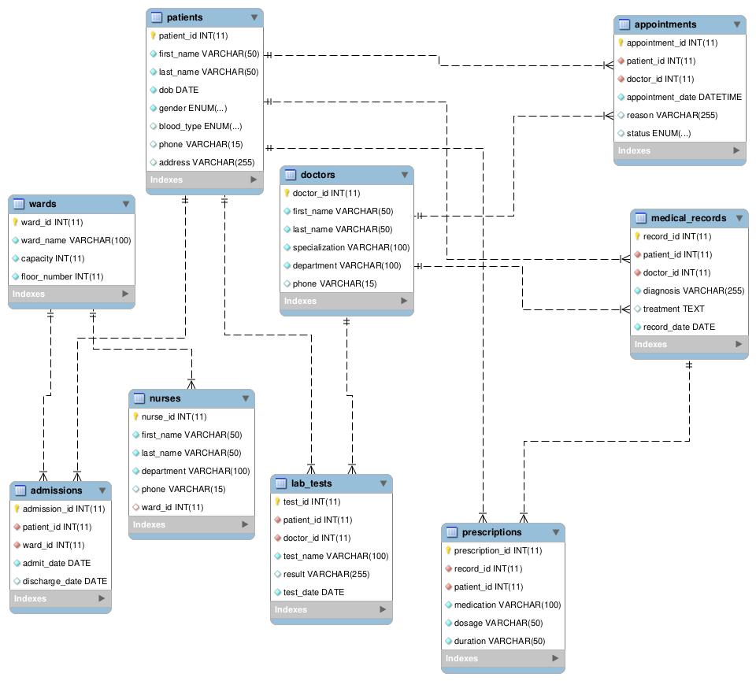

3f. User Interface — Dialogue Structure
The system uses a role-based menu structure. Each user group accesses only the modules relevant to their responsibilities:

MAIN LOGIN SCREEN
├── Doctor Portal
│ ├── View My Appointments
│ ├── Create / Update Medical Record
│ ├── Write Prescription
│ └── Order Lab Test
├── Nurse Portal
│ ├── View Ward Admissions
│ ├── Update Patient Vitals
│ └── Manage Admissions / Discharges
├── Receptionist Portal
│ ├── Register New Patient
│ ├── Schedule Appointment
│ └── Search Patient Records
├── Lab Technician Portal
│ ├── View Pending Lab Tests
│ └── Enter Test Results
└── Admin Portal
├── Generate Reports
├── Manage Staff Accounts
└── View System Statistics

3g. Physical Design — Database Schema
The physical schema consists of nine tables with primary and foreign key relationships enforced at the database level. The schema was implemented in MySQL as described in Section 4.

Table | Primary Key | Foreign Keys | Linked To
patients | patient_id | — | —
doctors | doctor_id | — | —
wards | ward_id | — | —
nurses | nurse_id | ward_id | wards
appointments | appointment_id | patient_id, doctor_id | patients, doctors
medical_records | record_id | patient_id, doctor_id | patients, doctors
prescriptions | prescription_id | record_id, patient_id | medical_records, patients
lab_tests | test_id | patient_id, doctor_id | patients, doctors
admissions | admission_id | patient_id, ward_id | patients, wards

3h. Key Queries and Reports
Output / Report | Query Type | Business Need
Patient full medical history | Multi-table JOIN | Doctors reviewing prior diagnoses
Doctor appointment load | GROUP BY + COUNT | Admin monitoring workload balance
Active prescriptions per patient | 3-table JOIN | Pharmacy dispensing medication
Current ward occupancy | JOIN + NULL check | Nurses managing bed availability
Top 10 diagnoses | GROUP BY + ORDER BY | Admin tracking disease trends
Monthly appointment report | DATE_FORMAT + COUNT | Hospital performance reporting

5. Implementation

4a. CREATE TABLE Statements
The following SQL statements were used to create the EMR database and its nine tables in MySQL:

CREATE DATABASE IF NOT EXISTS Electronic_Medical_Records;
USE Electronic_Medical_Records;

-- 1. PATIENTS
CREATE TABLE patients (
patient_id INT AUTO_INCREMENT PRIMARY KEY,
first_name VARCHAR(50) NOT NULL,
last_name VARCHAR(50) NOT NULL,
dob DATE NOT NULL,
gender ENUM('Male','Female','Other') NOT NULL,
blood_type ENUM('A+','A-','B+','B-','AB+','AB-','O+','O-'),
phone VARCHAR(15),
address VARCHAR(255)
);

-- 2. DOCTORS
CREATE TABLE doctors (
doctor_id INT AUTO_INCREMENT PRIMARY KEY,
first_name VARCHAR(50) NOT NULL,
last_name VARCHAR(50) NOT NULL,
specialization VARCHAR(100) NOT NULL,
department VARCHAR(100) NOT NULL,
phone VARCHAR(15)
);

-- 3. WARDS
CREATE TABLE wards (
ward_id INT AUTO_INCREMENT PRIMARY KEY,
ward_name VARCHAR(100) NOT NULL,
capacity INT NOT NULL,
floor_number INT NOT NULL
);

-- 4. NURSES
CREATE TABLE nurses (
nurse_id INT AUTO_INCREMENT PRIMARY KEY,
first_name VARCHAR(50) NOT NULL,
last_name VARCHAR(50) NOT NULL,
department VARCHAR(100) NOT NULL,
phone VARCHAR(15),
ward_id INT,
FOREIGN KEY (ward_id) REFERENCES wards(ward_id)
);

-- 5. APPOINTMENTS
CREATE TABLE appointments (
appointment_id INT AUTO_INCREMENT PRIMARY KEY,
patient_id INT NOT NULL,
doctor_id INT NOT NULL,
appointment_date DATETIME NOT NULL,
reason VARCHAR(255),
status ENUM('Scheduled','Completed','Cancelled') DEFAULT 'Scheduled',
FOREIGN KEY (patient_id) REFERENCES patients(patient_id),
FOREIGN KEY (doctor_id) REFERENCES doctors(doctor_id)
);

-- 6. MEDICAL RECORDS
CREATE TABLE medical_records (
record_id INT AUTO_INCREMENT PRIMARY KEY,
patient_id INT NOT NULL,
doctor_id INT NOT NULL,
diagnosis VARCHAR(255) NOT NULL,
treatment TEXT,
record_date DATE NOT NULL,
FOREIGN KEY (patient_id) REFERENCES patients(patient_id),
FOREIGN KEY (doctor_id) REFERENCES doctors(doctor_id)
);

-- 7. PRESCRIPTIONS
CREATE TABLE prescriptions (
prescription_id INT AUTO_INCREMENT PRIMARY KEY,
record_id INT NOT NULL,
patient_id INT NOT NULL,
medication VARCHAR(100) NOT NULL,
dosage VARCHAR(50) NOT NULL,
duration VARCHAR(50) NOT NULL,
FOREIGN KEY (record_id) REFERENCES medical_records(record_id),
FOREIGN KEY (patient_id) REFERENCES patients(patient_id)
);

-- 8. LAB TESTS
CREATE TABLE lab_tests (
test_id INT AUTO_INCREMENT PRIMARY KEY,
patient_id INT NOT NULL,
doctor_id INT NOT NULL,
test_name VARCHAR(100) NOT NULL,
result VARCHAR(255),
test_date DATE NOT NULL,
FOREIGN KEY (patient_id) REFERENCES patients(patient_id),
FOREIGN KEY (doctor_id) REFERENCES doctors(doctor_id)
);

-- 9. ADMISSIONS
CREATE TABLE admissions (
admission_id INT AUTO_INCREMENT PRIMARY KEY,
patient_id INT NOT NULL,
ward_id INT NOT NULL,
admit_date DATE NOT NULL,
discharge_date DATE,
FOREIGN KEY (patient_id) REFERENCES patients(patient_id),
FOREIGN KEY (ward_id) REFERENCES wards(ward_id)
);

4b. Sample Data Inserts
Sample data was inserted into all nine tables to enable testing and demonstration of the system.
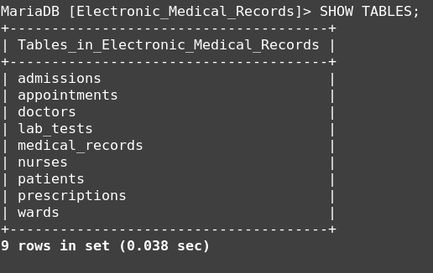

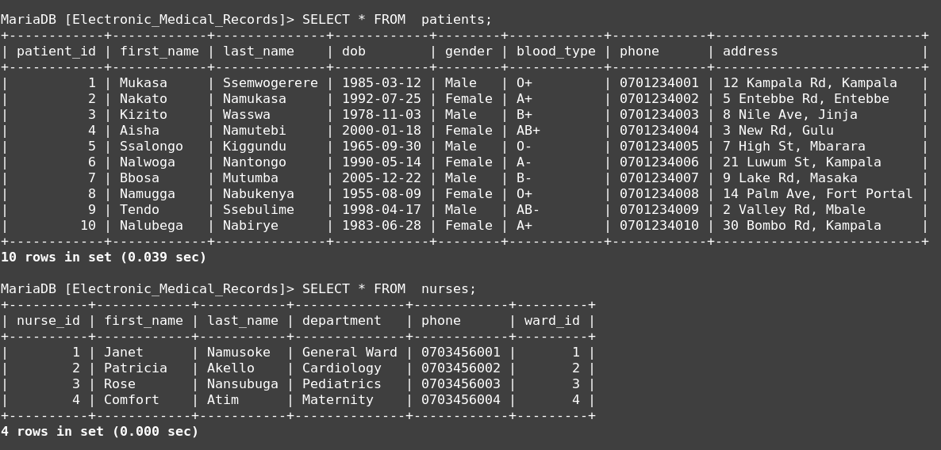

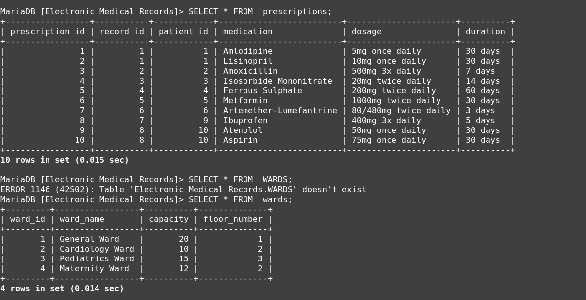
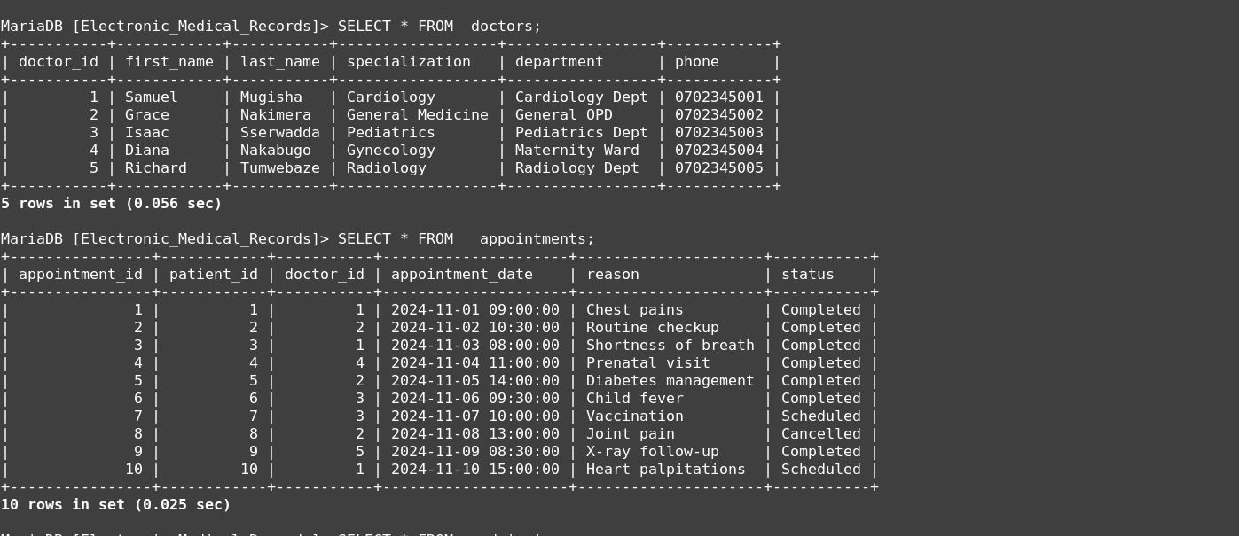

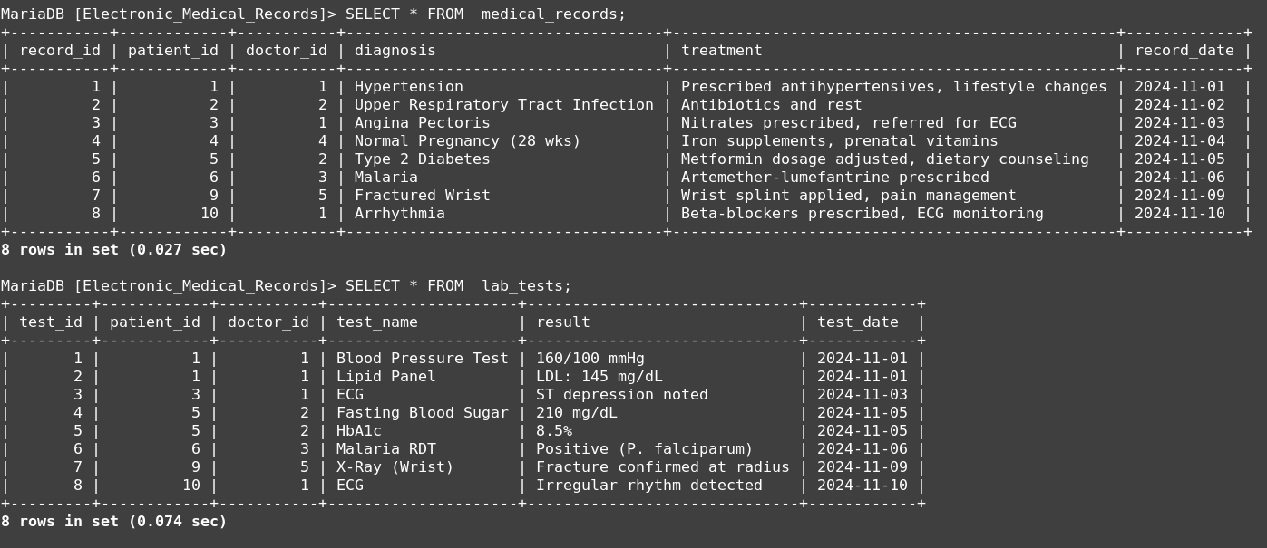

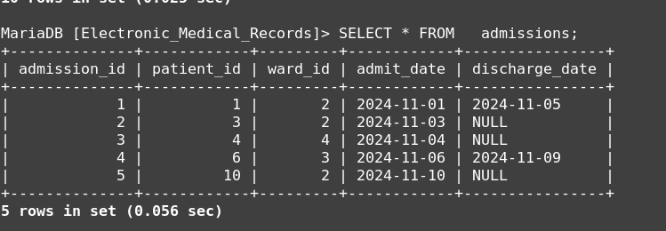

6. Sample Queries and Results
The following ten queries demonstrate the operational capabilities of the EMR system. Each query addresses a real-world information need identified in the business case.

Query 1: List All Patients
Purpose: Basic retrieval of all registered patients for administrative reference.
SELECT patient_id, CONCAT(first_name, ' ', last_name) AS full_name,
dob, gender, blood_type, phone
FROM patients
ORDER BY last_name ASC;

patient_id | full_name | dob | gender | blood_type
5 | Mutumba Disan | 1965-09-30 | Male | O-
1 | Katende Jonas | 1985-03-12 | Male | O+
2 | Ayebare Annet | 1992-07-25 | Female | A+
4 | Sanyu Flavia | 2000-01-18 | Female | AB+
3 | Nduggwa Amos | 1978-11-03 | Male | B+

Query 2: Appointments for a Specific Doctor
Purpose: Helps a doctor review their scheduled and completed appointments.
SELECT a.appointment_id,
CONCAT(p.first_name, ' ', p.last_name) AS patient_name,
a.appointment_date, a.reason, a.status
FROM appointments a
JOIN patients p ON a.patient_id = p.patient_id
JOIN doctors d ON a.doctor_id = d.doctor_id
WHERE d.last_name = 'Amos'
ORDER BY a.appointment_date DESC;

Query 3: Patient Load per Doctor
Purpose: Hospital management monitors doctor workload for staffing decisions.
SELECT CONCAT(d.first_name, ' ', d.last_name) AS doctor_name,
d.specialization,
COUNT(DISTINCT a.patient_id) AS total_patients
FROM doctors d
JOIN appointments a ON d.doctor_id = a.doctor_id
GROUP BY d.doctor_id
ORDER BY total_patients DESC;

doctor_name | specialization | total_patients
Samuel Ssekasi | Cardiology | 3
Grace Arinda | General Medicine | 3
Isaac Kakande | Pediatrics | 2
Diana Nalubega | Gynecology | 1
Richard Kaweesi | Radiology | 1

Query 4: Full Medical History for a Patient
Purpose: A doctor retrieves a complete clinical history before a consultation.
SELECT mr.record_date, mr.diagnosis, mr.treatment,
CONCAT(d.first_name, ' ', d.last_name) AS attending_doctor,
d.specialization
FROM medical_records mr
JOIN doctors d ON mr.doctor_id = d.doctor_id
WHERE mr.patient_id = 1
ORDER BY mr.record_date DESC;

Query 5: Active Prescriptions for a Patient
Purpose: Pharmacy verifies what medications a patient is currently on before dispensing.
SELECT p.medication, p.dosage, p.duration,
mr.diagnosis, mr.record_date
FROM prescriptions p
JOIN medical_records mr ON p.record_id = mr.record_id
WHERE p.patient_id = 1;

medication | dosage | duration | diagnosis
Amlodipine | 5mg once daily | 30 days | Hypertension
Lisinopril | 10mg once daily | 30 days | Hypertension

Query 6: Current Ward Occupancy
Purpose: Nurses check who is currently admitted in a ward (no discharge date).
SELECT CONCAT(p.first_name, ' ', p.last_name) AS patient_name,
a.admit_date, w.ward_name
FROM admissions a
JOIN patients p ON a.patient_id = p.patient_id
JOIN wards w ON a.ward_id = w.ward_id
WHERE a.discharge_date IS NULL;

patient_name | admit_date | ward_name
Kofi Boateng | 2024-11-03 | Cardiology Ward
Ama Owusu | 2024-11-04 | Maternity Ward
Adwoa Tetteh | 2024-11-10 | Cardiology Ward

Query 7: Lab Tests for a Patient
Purpose: Doctor or lab technician reviews all tests ordered for a patient.
SELECT lt.test_name, lt.result, lt.test_date,
CONCAT(d.first_name, ' ', d.last_name) AS ordered_by
FROM lab_tests lt
JOIN doctors d ON lt.doctor_id = d.doctor_id
WHERE lt.patient_id = 1
ORDER BY lt.test_date DESC;

test_name | result | test_date | ordered_by
Blood Pressure Test | 160/100 mmHg | 2024-11-01 | Samuel Mensah
Lipid Panel | LDL: 145 mg/dL | 2024-11-01 | Samuel Mensah

Query 8: Most Common Diagnoses
Purpose: Hospital administration tracks disease trends for planning and resource allocation.
SELECT diagnosis, COUNT(*) AS diagnosis_count
FROM medical_records
GROUP BY diagnosis
ORDER BY diagnosis_count DESC
LIMIT 10;

Query 9: Patients with No Lab Tests
Purpose: Flags patients who may need routine health screening.
SELECT patient_id, CONCAT(first_name, ' ', last_name) AS full_name
FROM patients
WHERE patient_id NOT IN (
SELECT DISTINCT patient_id FROM lab_tests
);

Query 10: Monthly Appointment Report
Purpose: Monthly performance reporting for hospital management and administration.
SELECT DATE_FORMAT(appointment_date, '%Y-%m') AS month,
COUNT(*) AS total_appointments,
SUM(CASE WHEN status = 'Completed' THEN 1 ELSE 0 END) AS completed,
SUM(CASE WHEN status = 'Cancelled' THEN 1 ELSE 0 END) AS cancelled
FROM appointments
GROUP BY month
ORDER BY month ASC;

month | total_appointments | completed | cancelled
2024-11 | 10 | 7 | 1

7. Bibliography
1. Connolly, T. & Begg, C. (2015). Database Systems: A Practical Approach to Design, Implementation, and Management (6th ed.). Pearson.
2. Silberschatz, A., Korth, H. F., & Sudarshan, S. (2019). Database System Concepts (7th ed.). McGraw-Hill.
3. MySQL Documentation. (2024). MySQL 8.0 Reference Manual. Oracle Corporation. Retrieved from https://dev.mysql.com/doc/
4. World Health Organization. (2006). Electronic Health Records: Manual for Developing Countries. WHO Press.
5. HealthIT.gov. (2023). What is an Electronic Health Record (EHR)? Office of the National Coordinator for Health Information Technology. Retrieved from https://www.healthit.gov

