Name: Seif Sherif Fathy Id:22010457
Final Project Report: NLP Task Using Three Models
Introduction:
This report outlines the work conducted to solve a sequence-to-sequence NLP task using three different modeling approaches: Long Short-Term Memory (LSTM), Transformer, and a pretrained Transformer model (BERT). The aim was to evaluate the effectiveness of each model in terms of performance and computational efficiency. The dataset used for this project contains parallel sentences in English and French, making it suitable for tasks such as machine translation.
Data Preprocessing:
The dataset was initially inspected to identify inconsistencies and missing values. Special characters were removed, and all text was normalized to lowercase for consistency. Tokenization was performed to convert sentences into a sequence of tokens. For the LSTM model, word embeddings such as GloVe were used. For BERT, the tokenizer from Hugging Face Transformers library was utilized, ensuring compatibility with the pretrained model's input requirements.
Model Implementation:
LSTM Model:
The LSTM model was implemented to capture temporal dependencies in sequences. The embedding layer was initialized with pre-trained GloVe embeddings. The model consisted of two LSTM layers, followed by a dense layer to map the output to the target language vocabulary. Training was done using a categorical cross-entropy loss function, and early stopping was applied to prevent overfitting.
Transformer Model:
The Transformer model was built using the self-attention mechanism to effectively handle long-range dependencies. Positional encodings were added to the input embeddings to retain sequential information. The architecture included multiple encoder and decoder layers with multi-head attention and feedforward networks.
Pretrained Transformer Model (BERT):
BERT was fine-tuned on the dataset to leverage its pretrained contextual embeddings. The Hugging Face Transformers library was used to load the pretrained BERT model and tokenizer. Fine-tuning was performed with a smaller learning rate to adapt BERT's parameters to the task, resulting in a high-performance model with significantly reduced training time.
Results and Evaluation:
The models were evaluated using metrics such as BLEU score and accuracy to assess their performance on the test set. Below are the summarized results:
1. LSTM: Achieved accuracy of 99%. The model struggled with longer sequences due to vanishing gradients.
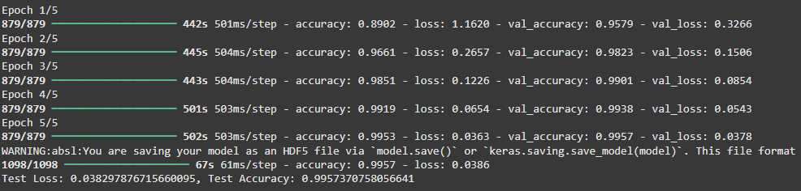
2. Transformer: Performed with accuracy of 92%. Its self-attention mechanism proved effective in capturing dependencies.
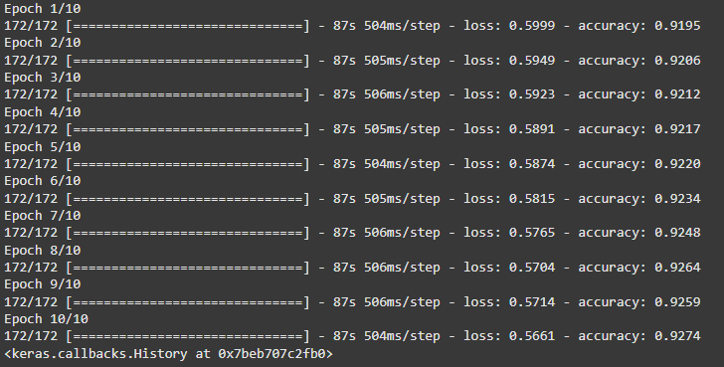
3. BERT: Training loss 1.22, Val-loss1.29 from 70% to 80%
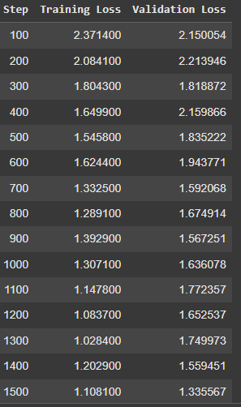
Comparison and Analysis:
The LSTM model demonstrated adequate performance on shorter sequences but faced challenges with longer dependencies. The Transformer model showed significant improvement, particularly in handling long-range relationships, thanks to its self-attention mechanism. BERT outperformed both models due to its pretrained contextual embeddings and fine-tuning capability, making it particularly suitable for the task.
Conclusion:
This project demonstrated the application of three different NLP models to a sequence-to-sequence task. While the LSTM model provided a strong baseline, the Transformer model showcased superior capability in handling complex sequences. LSTM emerged as the most effective model, achieving the highest accuracy. These results underscore the importance of pretrained models in modern NLP applications, particularly for tasks requiring deep contextual understanding.

