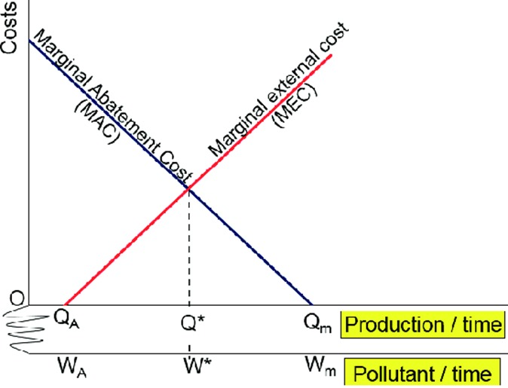

The diagram presents a standard economic model used to determine the socially optimal level of pollution through the interaction of two key cost curves: the Marginal Abatement Cost (MAC) and the Marginal External Cost (MEC). The vertical axis measures costs in monetary terms, while the horizontal axis represents either the quantity of pollution emitted over time or the level of production associated with that pollution.

The Marginal Abatement Cost (MAC) curve, shown in blue, slopes downward. This reflects the economic principle that it is relatively inexpensive to reduce the first few units of pollution, but the cost of abatement increases as emissions approach zero. For example, simple measures like covering manure or recycling waste water might be cheap, but installing advanced filtration systems becomes increasingly costly. Therefore, as a firm like Ssembatya Poultry Farm reduces its emissions, the cost of abating each additional unit of pollution becomes higher.

In contrast, the Marginal External Cost (MEC) curve, shown in red, slopes upward. This curve represents the increasing harm to society from each additional unit of pollution. As emissions rise, the social damage caused such as health complications among residents, environmental degradation, or reduced property values, increases as well. The curve captures the idea that initial pollution may have tolerable effects, but excessive emissions impose much greater marginal damage.

The optimal level of pollution is found at the point where the MAC and MEC curves intersect, denoted as W* (on the pollutant/time axis) or Q* (on the production/time axis). At this intersection, the cost of reducing one more unit of pollution (MAC) equals the external damage caused by that unit (MEC). This is known as the socially efficient level of pollution. Emitting beyond this point (e.g., up to Wₘ or Qₘ) leads to excessive pollution, where the external costs outweigh the savings from not abating. Conversely, reducing pollution below W* is inefficient because the cost of abatement would exceed the social benefit of cleaner air.

To move firms toward this optimal pollution level, governments can intervene using environmental policies. For instance, pollution standards can directly limit emissions to W*, or emissions taxes can be set equal to the MEC at W*, internalizing the externality. Tradable emission permits are another tool, capping emissions at W* and allowing firms to trade allowances, achieving cost-effective pollution control across the industry.

This framework is crucial in helping regulatory bodies like NEMA assess and control the environmental impacts of businesses such as Ssembatya Poultry Farm, ensuring that economic activity does not come at the expense of public health and environmental sustainability.

**Policies**



To correct this inefficiency, the government can impose a pollution penalty (P*), shown as the horizontal dashed line intersecting the vertical axis at P*. This penalty is designed to internalize the external cost by making firms pay for the damage they cause. If the penalty is set at the correct level (equal to MEC at Q*), it will align private decision-making with social efficiency. In other words, producers will limit their output to Q*, where their net private benefit is just equal to the social cost they impose, thereby restoring allocative efficiency.

The point S on the graph shows the regulated level of production (Qα or Wα), which could be the outcome of a command-and-control approach where the government sets a fixed cap. However, without pricing externalities (like through taxes or permits), such regulation may not be cost-effective unless well-calibrated.