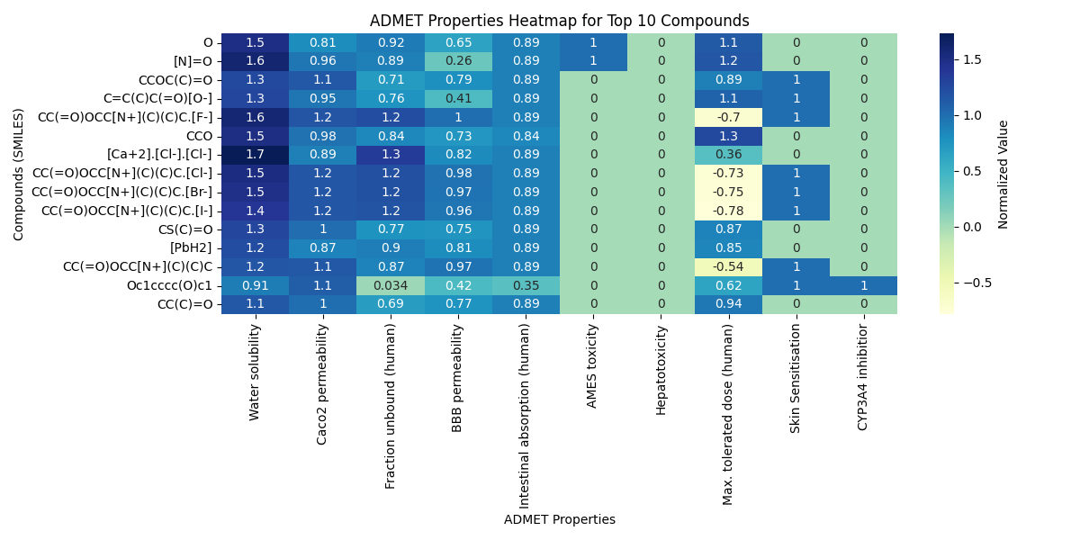

Figure 1: The heat map for the best 15 compounds.