Systems-Level Design of a Multi-Epitope Immunotherapeutic Construct Targeting EBV-Associated Oncogenesis

Ssemuyiga Charles^{1,2*}, and Naddamba Assumpta²

¹PharmaQsar Bioinformatics Firm, Kampala, Uganda. ²Department of Microbiology, Kampala International University, School of Natural and Applied Sciences (SONAS), Kansanga, Kampala, Uganda.

Correspondence.
(charles.ssemuyiga@kiu.ac.ug)

Table S1: Summary of the roles of different EBV proteins in different cancers.
Cancer Type | EBV Association | Dominant EBV Latent Proteins | Mechanistic Role of EBV | Major Oncogenic Pathways | Latency Program | Key References
Nasopharyngeal Carcinoma (NPC) | ~100% in endemic regions | LMP1, LMP2A, EBNA1, BART miRNAs | LMP1 constitutively activates CD40 signaling; LMP2A mimics BCR; BART miRNAs suppress apoptosis and immune recognition | NF-κB, PI3K/AKT, JAK/STAT, EMT, p53 suppression | Latency II | ^{1,2}
Hodgkin Lymphoma (HL) | 40–50% (higher in developing regions) | LMP1, LMP2A, EBNA1 | LMP1 substitutes CD40 signaling; LMP2A replaces BCR signaling; supports Reed–Sternberg cell survival | NF-κB, JAK/STAT, immune evasion | Latency II | ³
Endemic Burkitt Lymphoma (BL) | ~95% (endemic); ~15–30% sporadic | EBNA1, EBERs, BART miRNAs | MYC translocation; EBNA1 maintains episome; limited immune visibility | MYC activation, apoptosis resistance | Latency I | ⁴
EBV-Associated Gastric Carcinoma (EBVaGC) | ~9% globally | EBNA1, LMP2A, BART miRNAs | Epigenetic reprogramming; CpG island hypermethylation; immune checkpoint upregulation | DNA methylation, PI3K/AKT, PD-L1 upregulation | Latency I or II | ^{5,6}
Extranodal NK/T-Cell Lymphoma | ~100% | LMP1, LMP2A | LMP1 drives NF-κB; promotes proliferation and immune escape | NF-κB, JAK/STAT, apoptosis suppression | Latency II | ⁷
Post-Transplant Lymphoproliferative Disorder (PTLD) | >90% (early PTLD) | EBNA2, LMP1, LMP2A, EBNA3s | EBNA2 transactivates host oncogenes; LMP1 survival signaling | NF-κB, JAK/STAT, B-cell activation | Latency III | ⁸
EBV-positive Diffuse Large B-Cell Lymphoma (DLBCL) | Subset (~10%) | LMP1, EBNA1 | Survival signaling; immune evasion | NF-κB, BCR signaling | Latency II/III | ⁹
Primary Effusion Lymphoma (PEL) | EBV co-infection common (~70%), HHV-8 required | EBNA1, LMP1 (variable) | Cooperative oncogenesis with KSHV; anti-apoptotic signaling | NF-κB, PI3K/AKT | Latency I/II | ¹⁰
Plasmablastic Lymphoma (PBL) | 70–80% (HIV-associated) | EBNA1, LMP1 (variable) | Supports MYC-driven proliferation | MYC activation, NF-κB | Latency I/II | ¹¹
Systemic EBV-positive T/NK-cell lymphoproliferative disorders | Rare; geographic clustering | EBNA1, LMP1 (variable), EBERs | Clonal proliferation of EBV-infected T/NK cells; immune dysregulation | NF-κB, JAK/STAT (Variable) | Often Latency II | ¹²

Table S2: The role of different proteins in immune modulation if any, and the latency stage it works in.
EBV Gene/Product | Immune Function | Immune Pathway Targeted | Cell Type Affected | Molecular Mechanism | Latency Stage | Key Reference
BCRF1 (vIL-10) | Suppresses antiviral immune responses | Th1 cytokine signaling, NK activity | B cells, macrophages, T cells | Viral IL-10 homolog inhibits IFN-γ and IL-12 production | Lytic | ¹³
BNLF2a | Inhibits antigen presentation | MHC class I processing | B cells | Blocks TAP peptide transporter | Latency III | ¹⁴
BILF1 | Downregulates HLA class I | Antigen presentation | B cells | Induces lysosomal degradation of HLA-A and HLA-B | Lytic | ¹⁵
BZLF2 (gp42) | Blocks CD4⁺ T cell recognition | MHC class II presentation | B cells, APCs | Interferes with TCR–MHC II interaction | Lytic | ¹⁶
BGLF5 | Host shutoff; inhibits IFN signaling | mRNA stability, TLR9 sensing | DCs, epithelial cells | Viral RNase degrades host mRNAs and TLR9 | Lytic | ¹⁷
BGLF2 | Inhibits type I interferon signaling | JAK/STAT pathway | Multiple immune cells | Interacts with Tyk2, suppresses STAT1 activation | Lytic | ¹⁸
BORF2 | Antagonizes intrinsic immunity | APOBEC3B antiviral restriction | Infected cells | Relocalizes APOBEC3B from nucleus | Lytic | ¹⁹
BRLF1 (Rta) | Suppresses innate signaling | TLR/NF-κB pathways | Monocytes, DCs | Disrupts MyD88/TRAF6 signaling | Lytic | ²⁰
EBNA1 | Evades CD8⁺ T cell recognition | Proteasomal processing, NK activation | B cells | Gly-Ala repeat blocks proteasomal degradation; downregulates NKG2D ligands | Latency I/II/III | ^{21,22}
LMP1 | Alters innate immune sensing | TLR9, NF-κB signaling | B cells | Constitutive CD40 signaling represses TLR9 transcription | Latency II/III | ²³
LMP2A | Suppresses IFN signaling | IFN receptor signaling | B cells | Promotes degradation of IFN receptors; mimics BCR | Latency II/III | ²⁴
EBER1/2 | Modulates cytokine production | TLR3, RIG-I signaling | DCs, monocytes | Activates TLR3 and induces IL-10 and IFN | Latency I/II/III | ²⁵
miR-BART6-3p | Suppresses antiviral sensing | RIG-I pathway | Epithelial & B cells | Targets DDX58 (RIG-I) mRNA | Latency | ²⁶
miR-BART15 | Inhibits inflammasome | NLRP3 inflammasome | Monocytes, macrophages | Targets NLRP3 mRNA | Latency | ²⁷

Table S3: The list of the top 10 epitopes predicted for MHC Class I and MHC Class II, based on rank values (where lower rank indicates better binding affinity)
MHC I TOP 10 EPITOPES
Peptide | Rank | Score | Protein
GTYKRVTEK | 0.01 | 0.89547 | GP350
DPYQVPFV | 0.01 | 0.933071 | BZLF1
AYQAYAAPQLF | 0.01 | 0.932468 | BZLF1
ATVKGMQSY | 0.01 | 0.864779 | GP350
IALYLQQNW | 0.01 | 0.989273 | LMP2 (Type 1)
HTFQVPQNY | 0.01 | 0.936329 | LMP1 (Type 1)
MTNTLLSAW | 0.01 | 0.990361 | LMP2 (Type 2)
TYGPVFMSL | 0.01 | 0.977763 | LMP2 (Type 2)
TEWGSGNRTY | 0.01 | 0.974501 | LMP2 (Type 2)
RVAAAAITW | 0.01 | 0.978999 | LMP1 (Type 1)
MHC II TOP 10 EPITOPES
Peptide | Rank | Score | Protein
PPMVEGAAAEGDDGD | 0.01 | 0.0642 | EBNA1 (Type 1)
SDREVRGSALYEAST | 0.01 | 0.8806 | gH
TSSFVTNTTVGIELP | 0.01 | 0.9503 | gB
ELEIKRYKNRVASRK | 0.01 | 0.9726 | BZLF1
GTLNNPATVQIQFAY | 0.03 | 0.8616 | gB
SSIYGKAVAAKRLGD | 0.03 | 0.8942 | gB
NYKIVDYDNRGTNPQ | 0.03 | 0.9581 | gB
GNEIHVYNDYHHFKT | 0.04 | 0.0971 | gB
PAPENAYQAYAAPQL | 0.04 | 0.4262 | BZLF1
VYNDYHHFKTIELDG | 0.05 | 0.4073 | gB

Table S4: The top 10 epitopes based on MHC I immunogenicity scores are summarized below.
Rank | Peptide | Immunogenicity Score
1 | VTVTAFWAW | 0.41056
2 | YTIPWTELM | 0.36230
3 | NVFDLEGIFR | 0.35964
4 | GTDNEIFLTK | 0.35131
5 | ESLWVGVYR | 0.32407
6 | ALAEPVDIPAV | 0.30323
7 | IFLIGFALF | 0.30006
8 | VEIPEFPFY | 0.29878
9 | KLPHWTPTL | 0.29451
10 | SLEREDRDAW | 0.29398

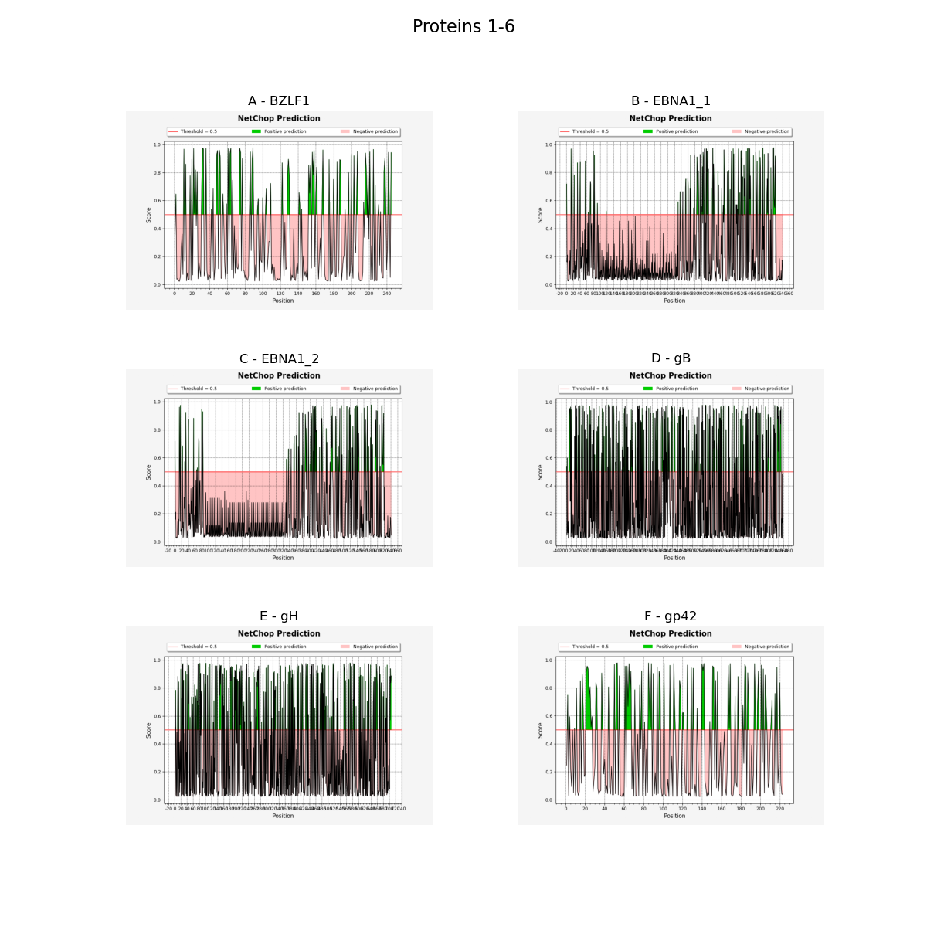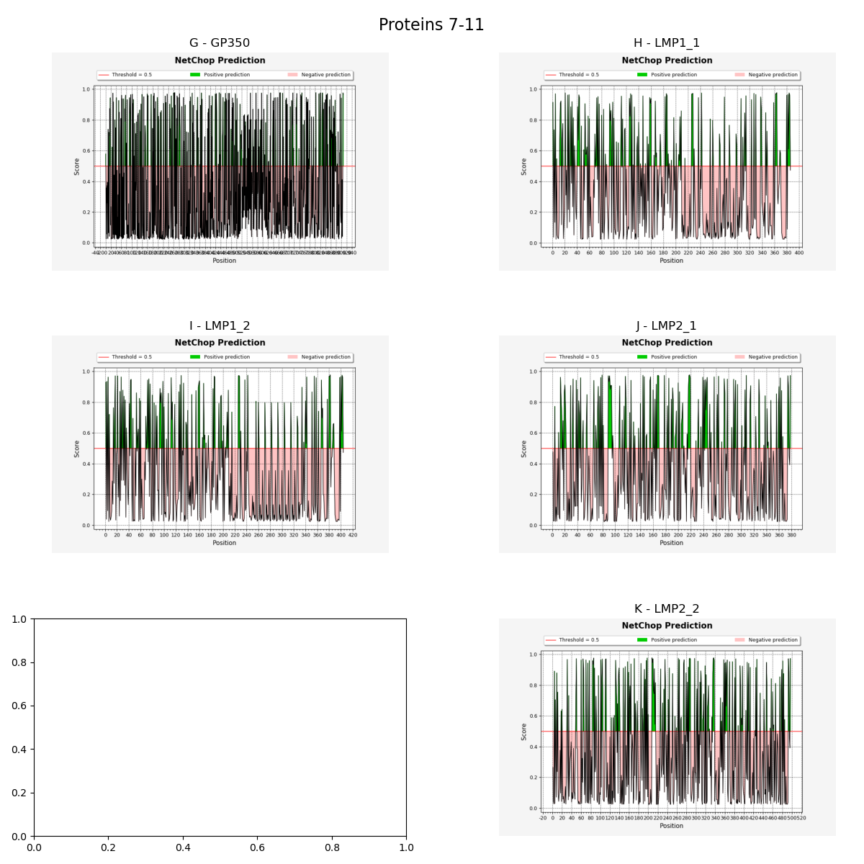
Figure S1: Cleavage prediction results. Each figure shows the NetChop prediction score vs. residue position, where green represents positive predictions, and red represents negative predictions. These figures provide a clear overview of where cleavage sites are likely to occur in the protein sequences.

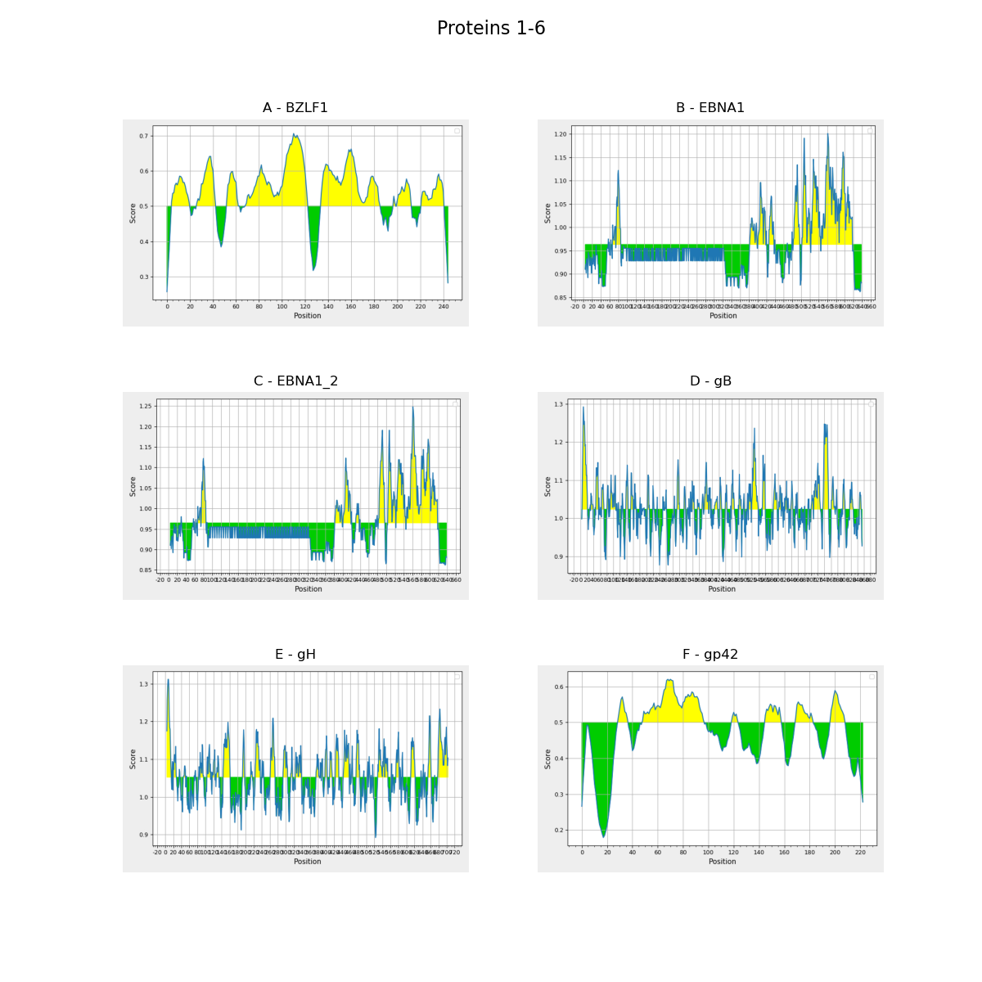

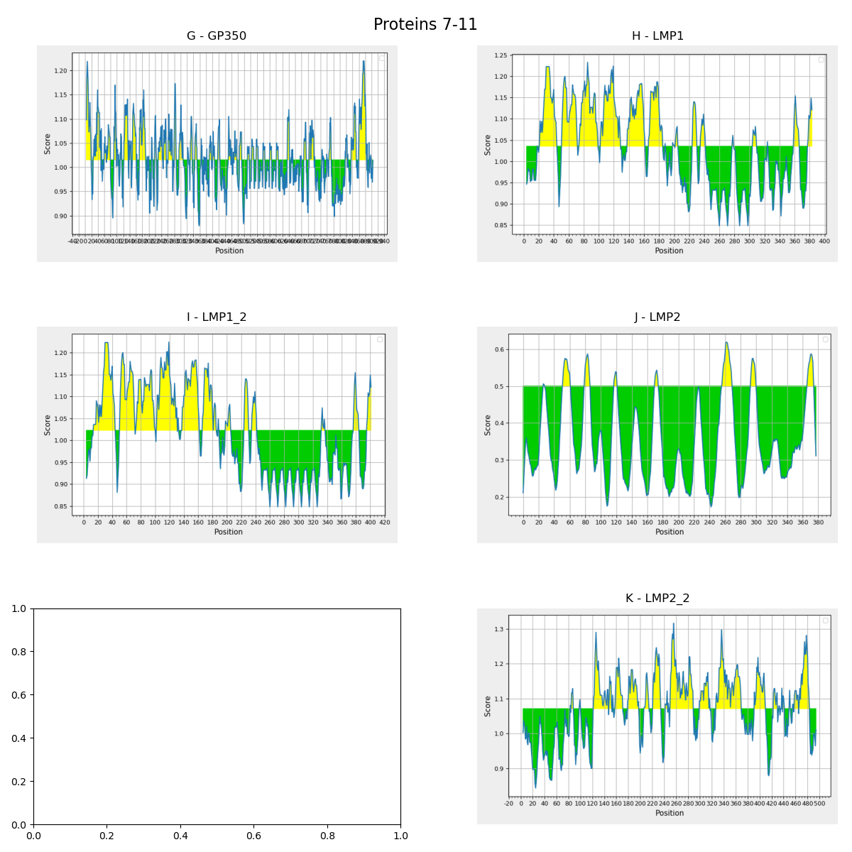

Figure S2: Residue-wise linear B-cell epitope prediction profiles for EBV proteins analyzed using BepiPred-2.0 (BZLF1 and gp42) and the Kolaskar–Tongaonkar antigenicity method (remaining proteins). Yellow regions indicate residues exceeding method-specific antigenicity thresholds, while green regions represent sub-threshold scores.

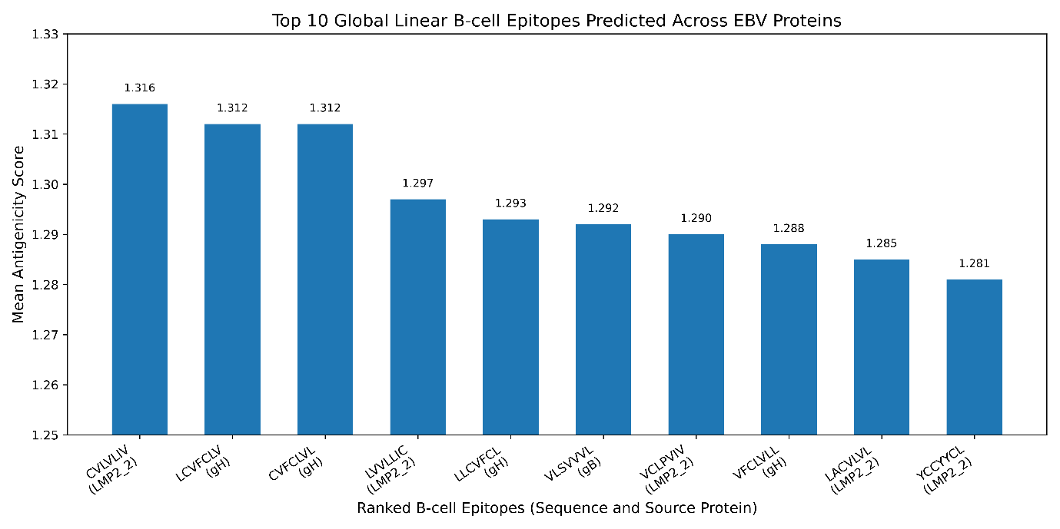

Figure S3: Top 10 global linear B-cell epitopes predicted across EBV proteins.

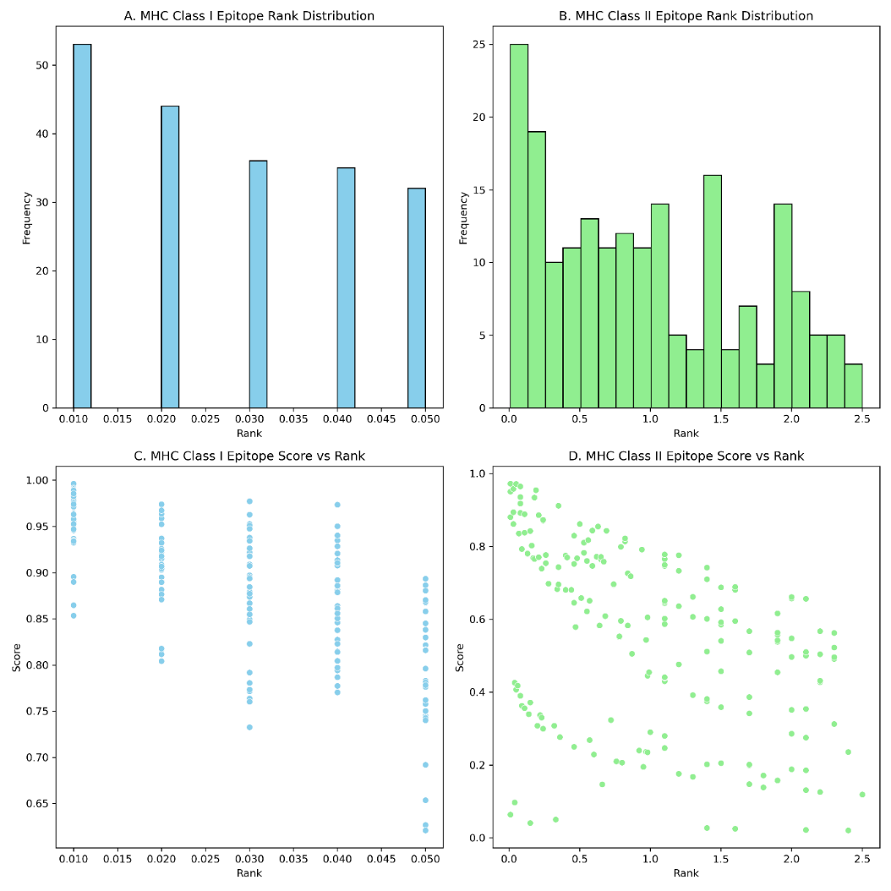
Figure S4: Summary of epitope features.

Table S5: Summary of stereochemical and geometric quality metrics for the 16 multi-epitope Construct constructs assessed before and after Rosetta-based structural refinement.
 | Before |  |  |  |  |  |  | After
Construct | Ramachandran Outliers | Ramachandran Favored | Rotamer Outliers | Clashscore | RMS Bonds | RMS Angles | MolProbity Score | Ramachandran Outliers | Ramachandran Favored | Rotamer Outliers | Clashscore | RMS Bonds | RMS Angles | MolProbity Score
Construct_10 | 39.17 | 33.44 | 10.4 | 13.77 | 0.0208 | 6.13 | 3.47 | 1.91 | 90.76 | 1.16 | 6.01 | 0.0302 | 6.33 | 1.90
Construct_11 | 42.32 | 26.59 | 13.29 | 27.69 | 0.0237 | 6.90 | 3.85 | 2.25 | 89.14 | 2.80 | 13.71 | 0.0353 | 6.65 | 2.56
Construct_12 | 38.98 | 31.36 | 13.04 | 24.79 | 0.0210 | 5.84 | 3.79 | 1.69 | 91.53 | 0.87 | 3.74 | 0.0318 | 6.17 | 1.67
Construct_13 | 6.85 | 85.89 | 10.26 | 27.60 | 0.0269 | 3.18 | 3.34 | 0.40 | 94.35 | 0.00 | 0.86 | 0.0237 | 3.02 | 1.15
Construct_14 | 7.11 | 85.38 | 13.46 | 24.09 | 0.0255 | 3.14 | 3.38 | 0.40 | 96.44 | 0.00 | 4.26 | 0.0254 | 3.93 | 1.44
Construct_15 | 13.89 | 74.07 | 19.80 | 39.06 | 0.0282 | 4.30 | 3.86 | 0.62 | 92.90 | 0.50 | 3.99 | 0.0191 | 4.00 | 1.64
Construct_16 | 20.74 | 66.25 | 19.31 | 34.02 | 0.0256 | 4.94 | 3.86 | 0.62 | 89.78 | 0.00 | 4.89 | 0.0177 | 4.63 | 1.81
Construct_1 | 44.81 | 26.95 | 9.09 | 14.94 | 0.0219 | 6.59 | 3.48 | 0.97 | 90.26 | 0.61 | 3.93 | 0.0279 | 6.15 | 1.72
Construct_2 | 38.96 | 30.19 | 8.98 | 13.17 | 0.0274 | 5.71 | 3.41 | 2.27 | 87.01 | 0.00 | 2.84 | 0.0242 | 5.67 | 1.69
Construct_3 | 43.18 | 27.27 | 8.38 | 12.16 | 0.0275 | 5.89 | 3.37 | 2.27 | 88.64 | 0.00 | 4.14 | 0.0253 | 5.88 | 1.78
Construct_4 | 43.18 | 31.17 | 10.84 | 10.35 | 0.0262 | 6.03 | 3.38 | 1.62 | 87.34 | 0.60 | 5.17 | 0.0231 | 5.90 | 1.89
Construct_5 | 41.88 | 28.90 | 9.52 | 17.86 | 0.0267 | 5.97 | 3.56 | 2.92 | 84.74 | 2.38 | 6.73 | 0.0247 | 5.87 | 2.32
Construct_6 | 41.88 | 28.90 | 9.52 | 17.86 | 0.0267 | 5.97 | 3.56 | 1.30 | 84.42 | 2.38 | 6.73 | 0.0247 | 5.86 | 2.33
Construct_7 | 41.88 | 34.42 | 6.71 | 19.39 | 0.0310 | 6.26 | 3.45 | 2.92 | 88.31 | 0.61 | 5.76 | 0.0329 | 6.34 | 1.91
Construct_8 | 40.26 | 26.95 | 10.24 | 19.22 | 0.0326 | 6.60 | 3.62 | 2.60 | 83.77 | 2.41 | 13.50 | 0.0315 | 6.51 | 2.61
Construct_9 | 38.54 | 38.54 | 8.62 | 11.61 | 0.0240 | 5.68 | 3.32 | 1.91 | 86.94 | 0.00 | 3.46 | 0.0229 | 5.66 | 1.76

Table S6: The Vaxign2 results of the Construct constructs before and after incorporation of signal peptide.
Construct ID | Without Signal Peptide |  |  |  | With Signal Peptide
 | Vaxign-ML Score | Localization (Prob.) | Adhesin Prob. | TM Helices | Vaxign-ML Score | Localization (Prob.) | Adhesin Prob. | TM Helices
Construct1 | 90.9 | Unknown (0.20) | 0.563 | 0 | 90.9 | Cytoplasmic Membrane (0.95) | 0.555 | 1
Construct2 | 90.8 | Unknown (0.20) | 0.561 | 0 | 90.9 | Cytoplasmic Membrane (0.95) | 0.661 | 1
Construct3 | 90.3 | Unknown (0.20) | 0.696 | 0 | 90.9 | Cytoplasmic Membrane (0.95) | 0.751 | 1
Construct4 | 90.9 | Unknown (0.20) | 0.564 | 0 | 90.9 | Cytoplasmic Membrane (0.95) | 0.573 | 1
Construct5 | 90.6 | Unknown (0.20) | 0.574 | 0 | 90.9 | Cytoplasmic Membrane (0.95) | 0.593 | 1
Construct6 | 90.8 | Unknown (0.20) | 0.574 | 0 | 90.9 | Cytoplasmic Membrane (0.95) | 0.593 | 1
Construct7 | 90.9 | Unknown (0.20) | 0.565 | 0 | 90.9 | Cytoplasmic Membrane (0.95) | 0.589 | 1
Construct8 | 90.9 | Unknown (0.20) | 0.508 | 0 | 90.9 | Cytoplasmic Membrane (0.95) | 0.549 | 1
Construct9 | 90.9 | Unknown (0.20) | 0.595 | 0 | 90.9 | Cytoplasmic Membrane (0.95) | 0.608 | 1
Construct10 | 90.9 | Unknown (0.20) | 0.576 | 0 | 90.9 | Cytoplasmic Membrane (0.95) | 0.585 | 1
Construct11 | 90.5 | Unknown (0.20) | 0.563 | 0 | 90.5 | Cytoplasmic Membrane (0.95) | 0.589 | 1
Construct12 | 90.6 | Unknown (0.20) | 0.678 | 0 | 90.5 | Cytoplasmic Membrane (0.95) | 0.650 | 1
Construct13 | 90.9 | Periplasmic (0.98) | 0.738 | 0 | 88.2 | Periplasmic (0.84) | 0.715 | 1
Construct14 | 90.9 | Periplasmic (0.98) | 0.682 | 0 | 88.8 | Periplasmic (0.84) | 0.647 | 1
Construct15 | 90.9 | Periplasmic (0.98) | 0.658 | 2 | 90.9 | Cytoplasmic Membrane (0.95) | 0.600 | 3
Construct16 | 90.9 | Unknown (0.25) | 0.682 | 2 | 90.9 | Cytoplasmic Membrane (0.95) | 0.617 | 3

Table S7: Vaxijen results of antigenicity. PA=Probable Antigen, PNA=Probable Non-Antigen.
 | No Adjuvant |  |  |  | With Adjuvant
Construct ID | Tumor Score | Tumor Prediction | Virus Score | Virus Prediction | Tumor Score | Tumor Prediction | Virus Score | Virus Prediction
1 | 0.7822 | PA | 0.3441 | PNA | 0.8037 | PA | 0.3469 | PNA
2 | 0.7622 | PA | 0.4322 | PA | 0.7626 | PA | 0.4279 | PA
3 | 0.7660 | PA | 0.4251 | PA | 0.7663 | PA | 0.4211 | PA
4 | 0.7606 | PA | 0.4225 | PA | 0.7692 | PA | 0.4212 | PA
5 | 0.7836 | PA | 0.4117 | PA | 0.7914 | PA | 0.4108 | PA
6 | 0.7836 | PA | 0.4117 | PA | 0.7914 | PA | 0.4108 | PA
7 | 0.7720 | PA | 0.4447 | PA | 0.7801 | PA | 0.4427 | PA
8 | 0.8457 | PA | 0.4372 | PA | 0.8515 | PA | 0.4354 | PA
9 | 0.8060 | PA | 0.4790 | PA | 0.7898 | PA | 0.4817 | PA
10 | 0.7808 | PA | 0.4073 | PA | 0.7574 | PA | 0.4058 | PA
11 | 0.8657 | PA | 0.3630 | PNA | 0.8372 | PA | 0.3750 | PNA
12 | 1.0488 | PA | 0.4749 | PA | 0.9997 | PA | 0.4686 | PA
13 | 0.5243 | PA | 0.5235 | PA | 0.5261 | PA | 0.5234 | PA
14 | 0.5369 | PA | 0.5215 | PA | 0.5126 | PA | 0.5190 | PA
15 | 0.4826 | PNA | 0.4272 | PA | 0.4605 | PNA | 0.4304 | PA
16 | 0.4759 | PNA | 0.4288 | PA | 0.4578 | PNA | 0.4279 | PA

Table S8: Integrated allergenicity, toxicity, solubility, and aggregation propensity assessment of the designed multi-epitope Construct constructs. Allergenicity was evaluated using AllerCatPro 2.0 and AllergenFP v1.0, toxicity using ToxinPred2.0, solubility using Protein-Sol, and aggregation propensity using AGGRESCAN. a3v, AGGRESCAN sequence aggregation score; NHS, number of aggregation hot spots; NHSA, normalized hot spot area; pI, theoretical isoelectric point. Asterisks (*) indicate constructs for which Protein-Sol detected putative transmembrane regions, and the corresponding solubility predictions should therefore be interpreted with caution.
Construct | AllerCatPro | AllergenFP | Tanimoto | Hybrid Score | ML score | Toxicity | Protein-Sol | pI | a3v | NHS | NHSA
Construct1 | No evidence | Non-Allergen | 0.689 | 0.19 | 0.19 | Non-Toxin | 0.522 | 9.17 | -0.326 | 3 | 0.968
Construct2 | No evidence | Non-Allergen | 0.697 | 0.13 | 0.13 | Non-Toxin | 0.527 | 10.01 | -0.318 | 3 | 0.968
Construct3 | No evidence | Non-Allergen | 0.689 | 0.13 | 0.13 | Non-Toxin | 0.590 | 10.57 | -0.295 | 3 | 0.968
Construct4 | No evidence | Non-Allergen | 0.674 | 0.19 | 0.19 | Non-Toxin | 0.529 | 10.01 | -0.301 | 4 | 1.290
Construct5 | No evidence | Non-Allergen | 0.697 | 0.13 | 0.13 | Non-Toxin | 0.562 | 10.25 | -0.307 | 3 | 0.968
Construct6 | No evidence | Non-Allergen | 0.697 | 0.13 | 0.13 | Non-Toxin | 0.562 | 10.25 | -0.307 | 3 | 0.968
Construct7 | No evidence | Non-Allergen | 0.674 | 0.17 | 0.17 | Non-Toxin | 0.516 | 9.20 | -0.308 | 3 | 0.968
Construct8 | No evidence | Non-Allergen | 0.667 | 0.17 | 0.17 | Non-Toxin | 0.590 | 10.61 | -0.327 | 3 | 0.968
Construct9 | No evidence | Non-Allergen | 0.752 | 0.13 | 0.13 | Non-Toxin | 0.634 | 10.81 | -0.295 | 4 | 1.266
Construct10 | No evidence | Non-Allergen | 0.689 | 0.15 | 0.15 | Non-Toxin | 0.518 | 9.99 | -0.279 | 6 | 1.899
Construct11 | No evidence | Non-Allergen | 0.674 | 0.30 | 0.30 | Non-Toxin | 0.700 | 11.56 | -0.310 | 4 | 1.487
Construct12 | No evidence | Non-Allergen | 0.616 | 0.20 | 0.20 | Non-Toxin | 0.727 | 11.41 | -0.298 | 4 | 1.681
Construct13 | No evidence | Non-Allergen | 0.773 | 0.23 | 0.23 | Non-Toxin | 0.531* | 9.63 | -0.003 | 9 | 3.600
Construct14 | No evidence | Non-Allergen | 0.790 | 0.22 | 0.22 | Non-Toxin | 0.534 | 9.63 | -0.004 | 10 | 3.922
Construct15 | No evidence | Allergen | 0.682 | 0.32 | 0.32 | Non-Toxin | 0.563* | 4.18 | 0.039 | 13 | 3.988
Construct16 | No evidence | Allergen | 0.678 | 0.32 | 0.32 | Non-Toxin | 0.564* | 4.18 | 0.039 | 11 | 3.385

Table S9: Summary of post-construction junction epitope analysis across final Construct constructs.
protein | Intended | Redundant Intended | Junction-derived | Linker-only | Novel | junction_burden
Construct1 | 101 | 1822 | 0 | 0 | 0 | 0
Construct2 | 75 | 1881 | 0 | 0 | 0 | 0
Construct3 | 62 | 1577 | 0 | 0 | 0 | 0
Construct4 | 52 | 1394 | 0 | 0 | 0 | 0
Construct5 | 67 | 1473 | 0 | 0 | 0 | 0
Construct6 | 68 | 1504 | 0 | 0 | 0 | 0
Construct7 | 113 | 1919 | 0 | 0 | 0 | 0
Construct8 | 139 | 1891 | 0 | 0 | 0 | 0
Construct9 | 77 | 1847 | 0 | 0 | 0 | 0
Construct10 | 77 | 1846 | 0 | 0 | 0 | 0
Construct11 | 74 | 1849 | 0 | 0 | 0 | 0
Construct12 | 73 | 1850 | 0 | 0 | 0 | 0
Construct13 | 73 | 1850 | 0 | 0 | 0 | 0
Construct14 | 75 | 1848 | 0 | 0 | 0 | 0
Construct15 | 75 | 1881 | 0 | 0 | 0 | 0
Construct16 | 88 | 304 | 0 | 0 | 0 | 0

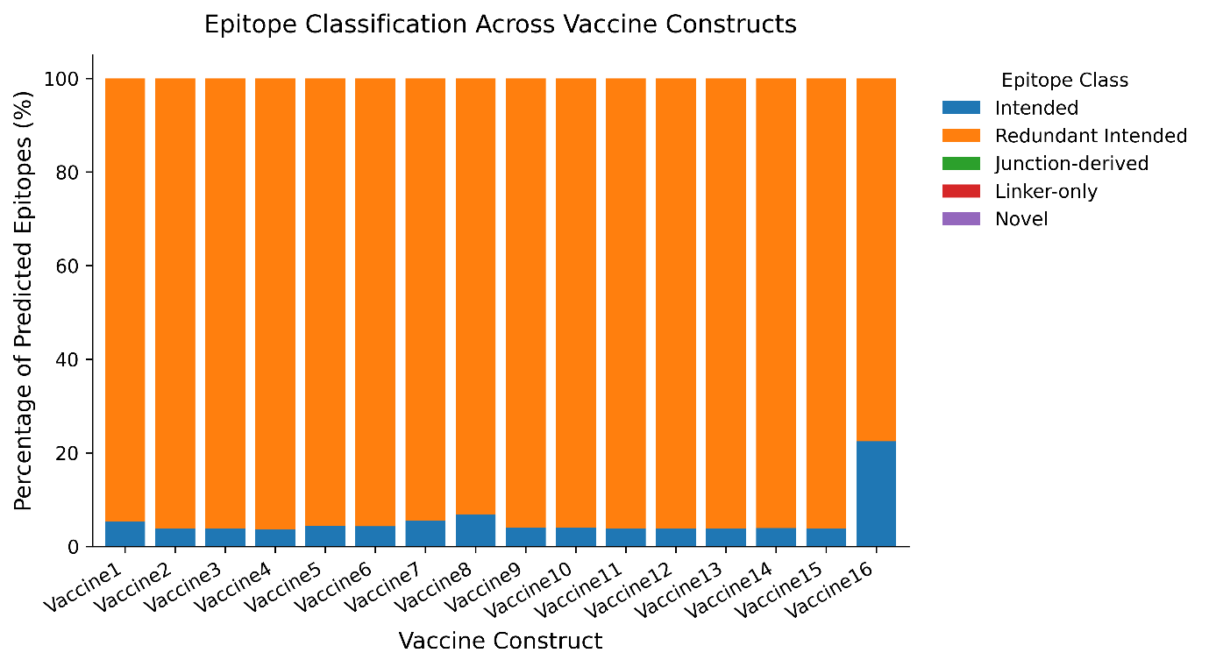
Figure S5: Junction epitope burden across final multi-epitope Construct constructs.
Table S10: The results summary of the immune simulation for the best 10 constructs.
Rank | Construct ID | Innate Activation (Danger Signal) | Humoral Response (IgG1/IgG2) | Th1 Cytokine Profile | Epitope Quality | Overall Immunogenic Interpretation
1 | Construct4 | Highest peak (>1.1 RU); rapid macrophage presentation | Strong IgM peak; robust IgG1 switching; longest IgG2 persistence | Highest IFN-γ and IL-2; delayed IL-10 regulation | Dominant 53-residue high-propensity epitope block | Top-ranked construct with strongest magnitude, durability, and memory recall
2 | Construct7 | Strong innate alert; fast antigen processing | High IgM; sustained IgG1/IgG2 switching | Strong Th1 bias; balanced regulation | Dense epitope hotspots | Highly immunogenic with balanced humoral and cellular responses
3 | Construct10 | High innate activation; stable antigen presentation | Efficient IgG class switching; durable IgG2 tail | Strong IFN-γ and IL-2 peaks | Multiple extended epitope regions | Robust single-dose and booster recall performer
4 | Construct15 | Moderate–high innate peak | Strong IgM and IgG switching | Solid Th1 cytokine induction | Good epitope accessibility | Reliable adaptive immunity with moderate durability
5 | Construct8 | Moderate innate response | Effective IgG1/IgG2 switching | Sustained IL-2; moderate IFN-γ | Short but valid epitopes | Consistent immune activation with acceptable balance
6 | Construct14 | Moderate innate alert; slower processing | Moderate IgG persistence | Stable Th1 profile | Valid epitopes with mixed binding | Functional but lower peak magnitude
7 | Construct5 | Moderate innate activation | Effective switching; earlier contraction | Early IL-10 regulation | Distinct 22-aa epitope | Good specificity but limited durability
8 | Construct6 | Moderate innate response | Moderate IgG1 peak; weak IgG2 tail | Controlled Th1 bias | Distinct 22-aa epitope | Specific but reduced long-term persistence
9 | Construct16 | Lower innate peak | Stable but modest humoral response | Acceptable cytokine balance | Confirmed epitope exposure | Functional priming with lower amplitude
10 | Construct12 | Slow and weak innate activation | Limited IgG durability | Moderate IFN-γ; mixed binding signals | Inconsistent epitope binding | Lowest among top ten but retains immune priming capacity
11 | Negative | Slower and weaker | Very limited | Weak | Inconsistent | Lowest among all

Table S11: Scores derived from relative peak magnitude, persistence, and kinetic quality across immune dimensions.
Rank | Construct | Innate Activation | Humoral Response | Cellular Immunity | Epitope Quality | Immune Durability | Total
1 | Construct 4 | 5 | 5 | 5 | 5 | 5 | 25
2 | Construct 7 | 5 | 4 | 5 | 5 | 5 | 24
3 | Construct 10 | 4 | 5 | 5 | 5 | 4 | 23
4 | Construct 15 | 4 | 4 | 4 | 4 | 4 | 20
5 | Construct 8 | 3 | 4 | 4 | 3 | 4 | 18
6 | Construct 14 | 3 | 4 | 4 | 3 | 3 | 17
7 | Construct 5 | 3 | 4 | 3 | 3 | 3 | 16
8 | Construct 16 | 3 | 3 | 3 | 3 | 3 | 15
9 | Construct 1 | 3 | 3 | 3 | 2 | 3 | 14
10 | Construct 12 | 2 | 2 | 3 | 2 | 2 | 11
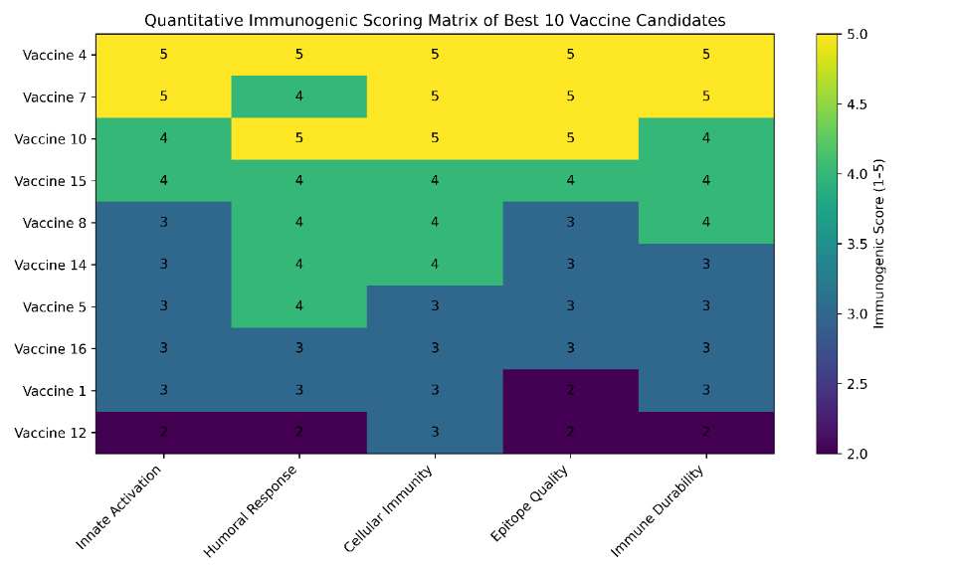
Figure S6: Ranking of 10 Construct constructs based on immune activation, humoral response, cellular immunity, epitope quality, and immune durability. This comprehensive evaluation highlights the top candidates with the most robust immune profiles.

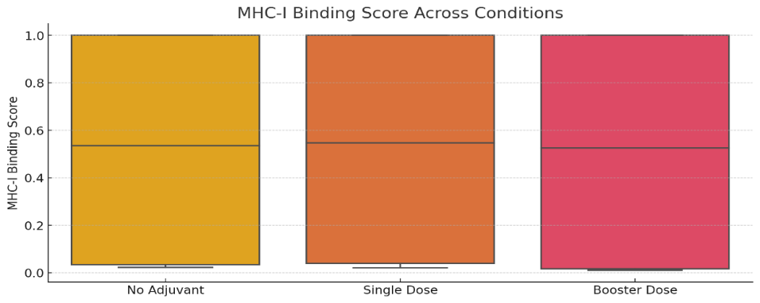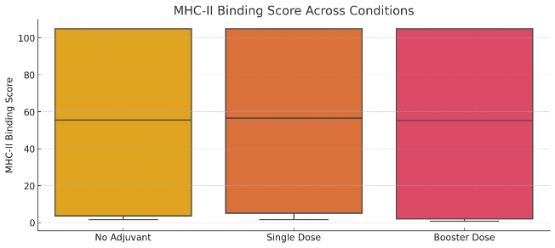
Figure S7: Immune modulation analysis for MHC binding scores under different adjuvant and dosing conditions.

Table S12: Extended analysis of immune modulation in adjuvanted Construct constructs, showing enhanced MHC-I binding following booster doses. Statistical significance was noted in MHC-I but not in MHC-II binding across dosing conditions.
Comparison | t-test p-value | Wilcoxon p-value
MHC-I No Adjuvant vs. Single Dose | 0.1911 | 0.1441
MHC-I No Adjuvant vs. Booster Dose | 0.0374 | 0.0679
MHC-I Single Dose vs. Booster Dose | 0.0628 | 0.0679
MHC-II No Adjuvant vs. Single Dose | 0.0870 | 0.0679
MHC-II No Adjuvant vs. Booster Dose | 0.0614 | 0.0679
MHC-II Single Dose vs. Booster Dose | 0.0542 | 0.0679

Table S13: Correlation Analysis Between MHC-I and MHC-II Binding.
Condition | Pearson Correlation (MHC-I vs. MHC-II)
No Adjuvant | 0.882 (Strong positive correlation)
Single Dose | 0.915 (Stronger correlation)
Booster Dose | 0.879 (Slightly weaker than single dose)

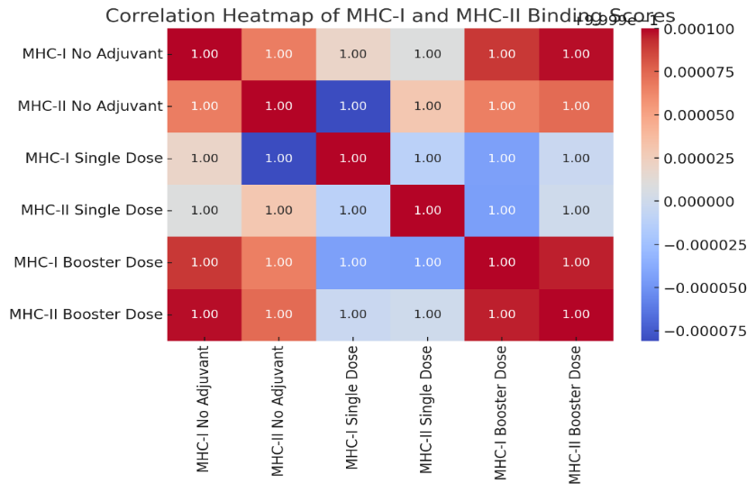
Figure S8: Pearson correlation analysis of MHC-I and MHC-II binding scores across experimental conditions. Strong positive correlation observed, especially under single-dose adjuvant conditions.
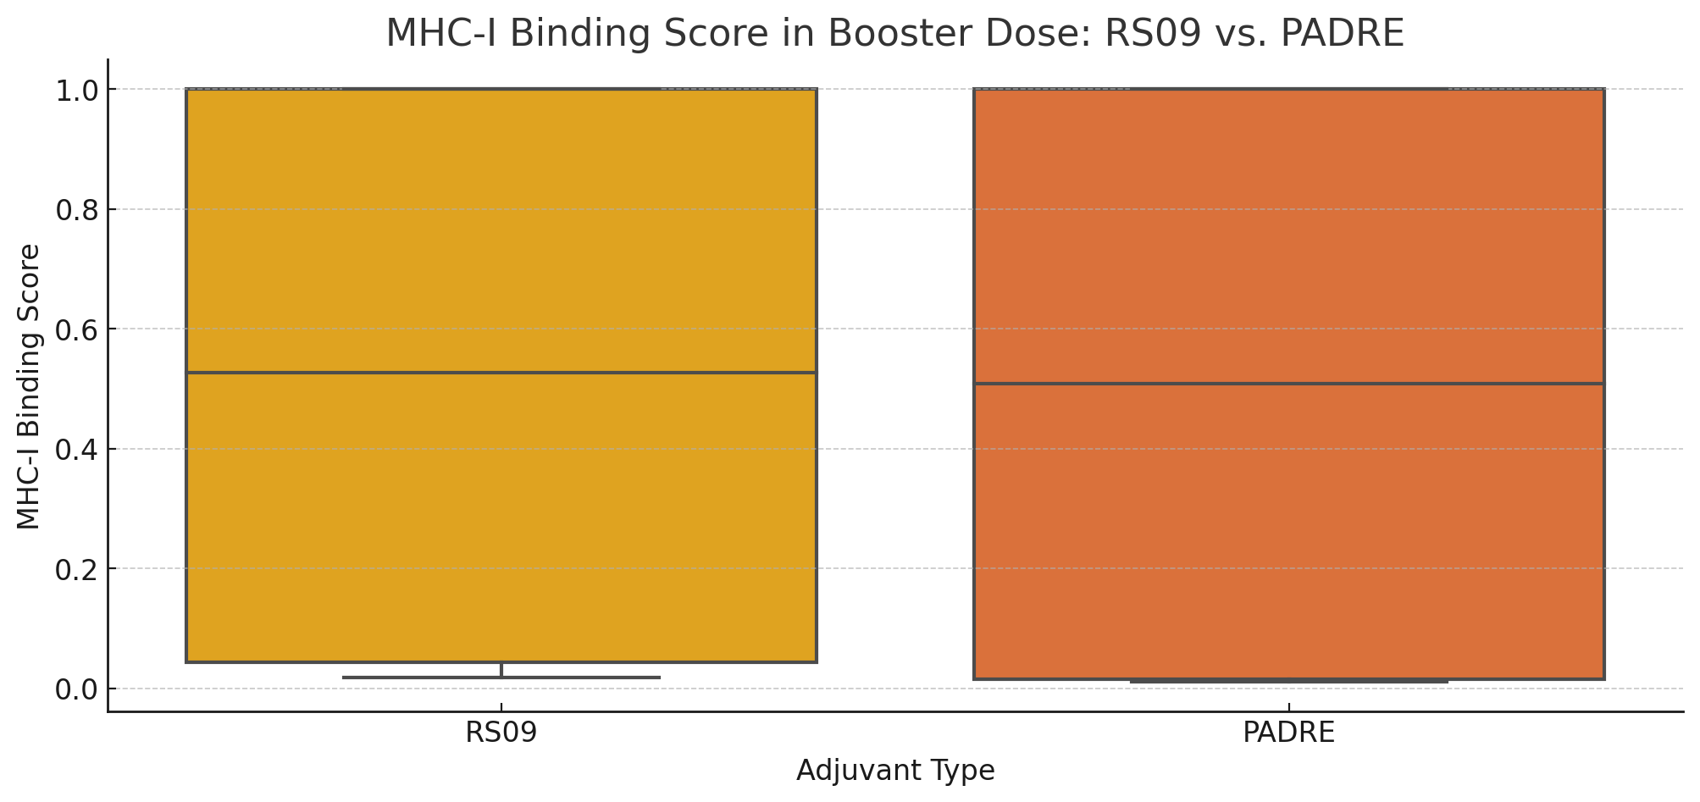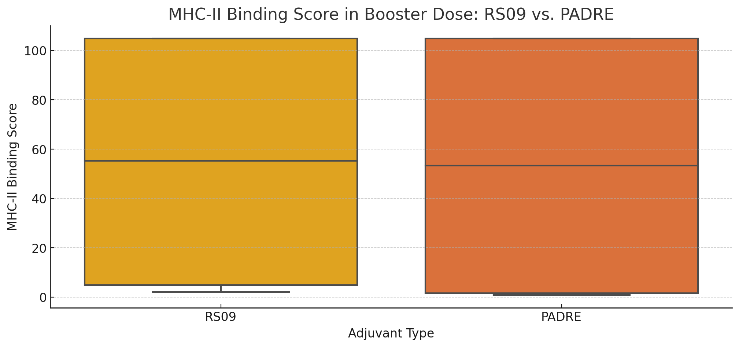
Figure S9: Comparison of RS09 and PADRE adjuvants across single-dose and booster-dose conditions, showing no significant differences in MHC-I and MHC-II binding scores. Both adjuvants demonstrated comparable immunostimulatory performance
Table S14: Comparison of RS09 and PADRE adjuvants in booster doses, with no significant differences in MHC-I or MHC-II binding scores. This highlights the robustness of the Construct design to adjuvant selection.
Comparison | t-test p-value | Wilcoxon p-value
MHC-I RS09 vs. PADRE (Booster) | 0.9809 | 0.5929
MHC-II RS09 vs. PADRE (Booster) | 0.9779 | 0.5929
MHC-I RS09 vs. PADRE (Single Dose) | 0.9653 | 0.5929
MHC-II RS09 vs. PADRE (Single Dose) | 0.9679 | 0.5929

Table S15: Statistical comparison of T-cell activation between different dosing conditions, showing significantly enhanced activation in booster-dose groups compared to single-dose or no-adjuvant conditions.
Comparison | t-test p-value | Wilcoxon p-value
T-Cell Activation No Adjuvant vs. Single Dose | 0.0796 | 0.0833
T-Cell Activation No Adjuvant vs. Booster Dose | 0.0411 | 0.0588
T-Cell Activation Single Dose vs. Booster Dose | 0.0331 | 0.0455

Table S16: Docking scores of Construct constructs against four immune-relevant receptors, showing adjuvanted vs non-adjuvanted configurations.
Receptor | Construct | Adjuvant_score | Nonadjuvant_score
8WTA | Construct15 | -1613.45 | -1483.71
8WTA | Construct14 | -1477.2 | -1337.16
8WTA | Construct16 | -1437.75 | -1433.14
8WTA | Construct13 | -1409.85 | -1378.85
8WTA | Construct4 | -1283.26 | -1276.44
8WTA | Construct8 | -1274.51 | -1220.27
8WTA | Construct3 | -1273.16 | -1273.45
8WTA | Construct10 | -1272.34 | -1254.72
8WTA | Construct2 | -1259.65 | -1275.42
8WTA | Construct7 | -1243.02 | -1208.53
8WTA | Construct9 | -1241.47 | -1242.85
8WTA | Construct6 | -1236.46 | -1238.12
8WTA | Construct5 | -1216.5 | -1264.4
8WTA | Construct1 | -1216.04 | -1247.04
8WTA | Construct12 | -1207.21 | -1215.82
7M8S | Construct15 | -1184.55 | -1060.86
4ZQK | Construct15 | -1094.43 | -962.021
7M8S | Construct14 | -1060.86 | -915.42
7M8S | Construct16 | -1014.92 | -1016.88
7M8S | Construct13 | -1006.56 | -968.613
1KCG | Construct15 | -1003.9 | -868.7
4ZQK | Construct14 | -968.879 | -817.903
4ZQK | Construct16 | -913.986 | -923.815
4ZQK | Construct13 | -899.199 | -865.314
7M8S | Construct4 | -885.653 | -855.431
1KCG | Construct14 | -875.7 | -732.649
7M8S | Construct3 | -875.667 | -874.899
7M8S | Construct10 | -866.125 | -852.811
7M8S | Construct8 | -866.006 | -813.457
7M8S | Construct2 | -847.916 | -868.261
7M8S | Construct7 | -845.099 | -811.004
7M8S | Construct6 | -838.334 | -830.231
7M8S | Construct9 | -834.301 | -845.502
1KCG | Construct16 | -827.638 | -849.443
7M8S | Construct11 | -827.329 | -797.873
7M8S | Construct5 | -818.732 | -852.723
1KCG | Construct13 | -812.274 | -779.385
7M8S | Construct1 | -809.632 | -844.339
7M8S | Construct12 | -805.146 | -802.321
4ZQK | Construct4 | -786.435 | -765.155
4ZQK | Construct3 | -779.125 | -770.672
4ZQK | Construct2 | -767.307 | -771.716
4ZQK | Construct8 | -762.979 | -712.507
4ZQK | Construct10 | -761.152 | -755.459
4ZQK | Construct7 | -745.268 | -714.968
4ZQK | Construct6 | -742.697 | -739.906
4ZQK | Construct9 | -734.841 | -749.971
4ZQK | Construct11 | -730.452 | -703.447
4ZQK | Construct5 | -720.485 | -754.535
4ZQK | Construct1 | -711.779 | -747.419
4ZQK | Construct12 | -706.383 | -701.469
1KCG | Construct3 | -698.051 | -691.232
1KCG | Construct4 | -695.245 | -684.359
1KCG | Construct10 | -684.267 | -669.171
1KCG | Construct8 | -679.817 | -627.14
1KCG | Construct2 | -670.656 | -681.411
1KCG | Construct7 | -656.427 | -625.886
1KCG | Construct6 | -654.573 | -646.014
1KCG | Construct9 | -654.546 | -655.426
1KCG | Construct11 | -643.19 | -612.036
1KCG | Construct5 | -633.305 | -665.884
1KCG | Construct1 | -631.003 | -655.106
1KCG | Construct12 | -614.053 | -616.043

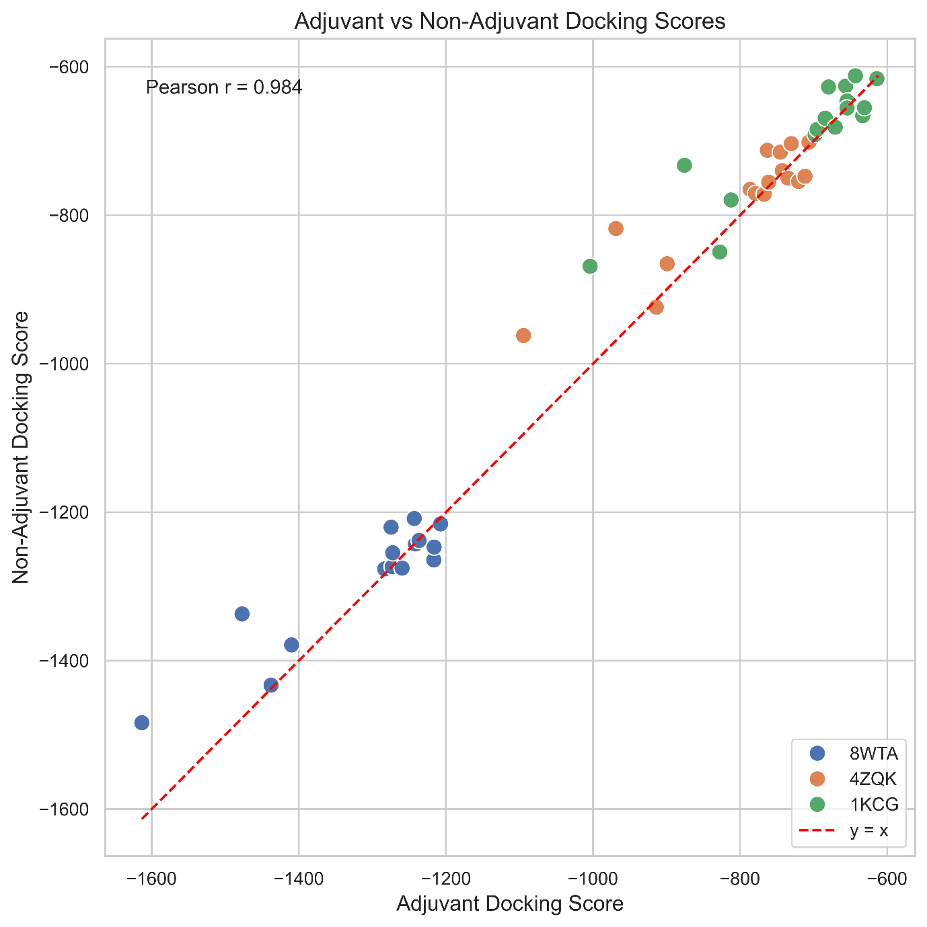
Figure S10: Comparison of Adjuvanted to Non-Adjuvanted Binding Affinities Across Receptors.
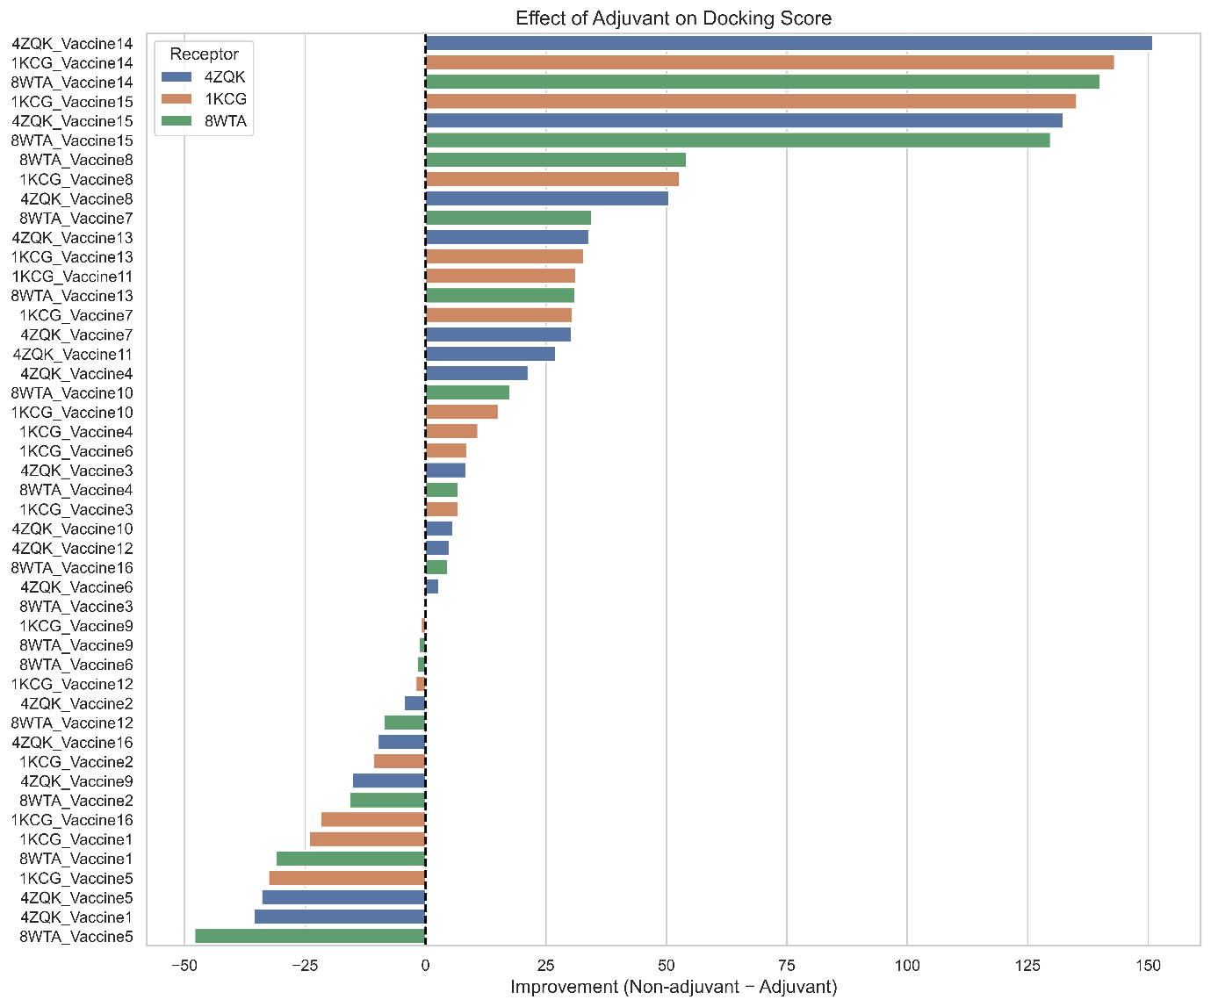
Figure S11: Effect of adjuvants on docking scores obtained as a difference between adjuvant and adjuvant scores.
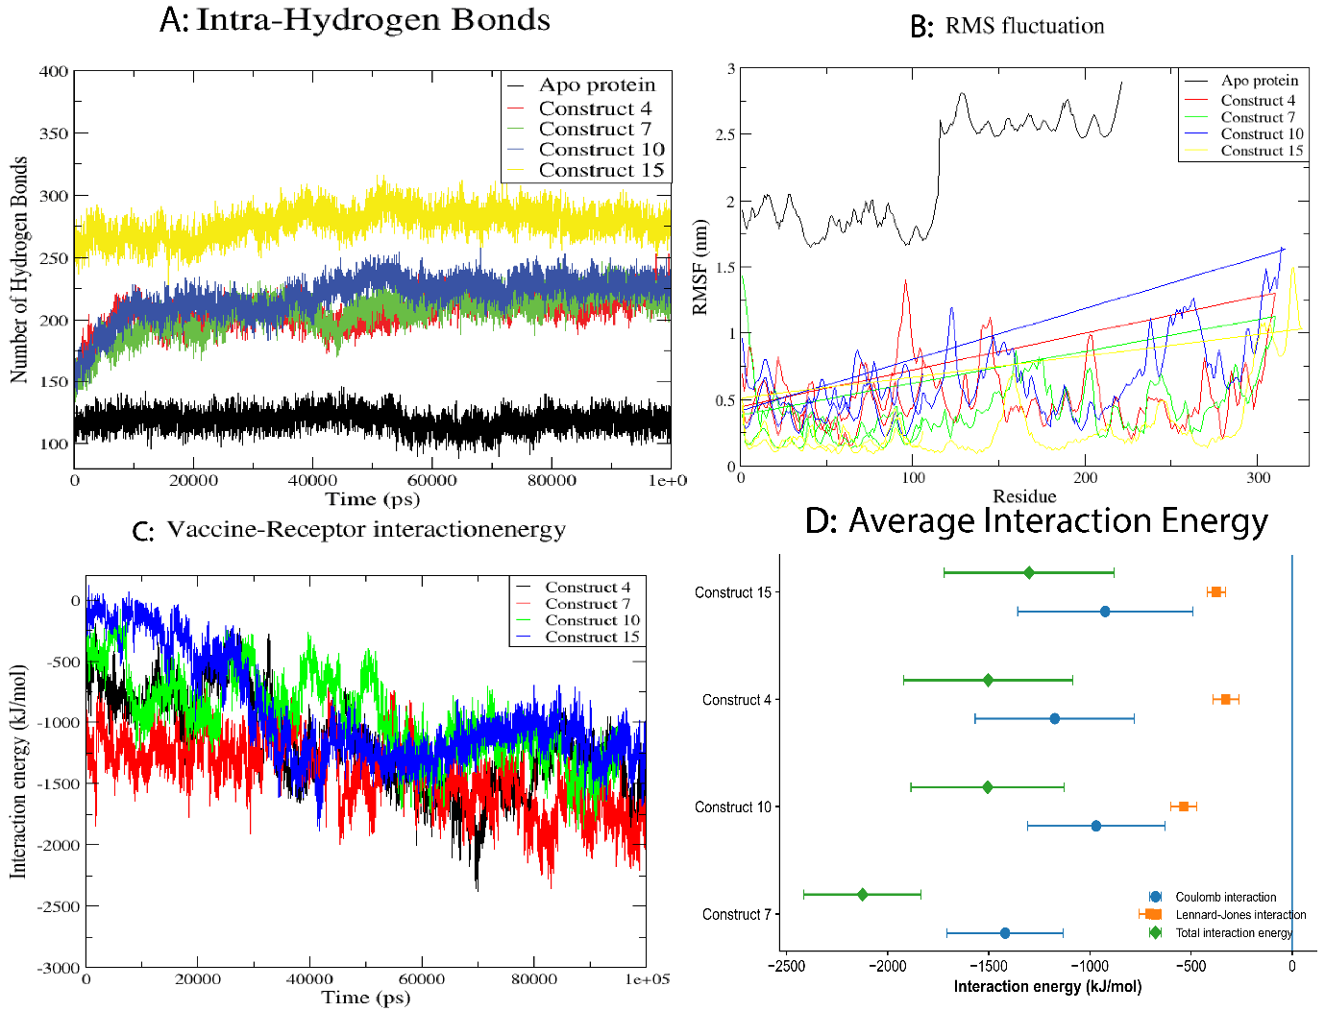
Figure S12: Compactness and internal stabilization metrics of Construct–PD-1 complexes. (A) RMSF profiles indicating residue-level flexibility. (B) Total intra-complex hydrogen bonds across simulation time, reflecting internal structural stabilization.
Figure 13: Time evolution of interaction energies during molecular dynamics simulations.
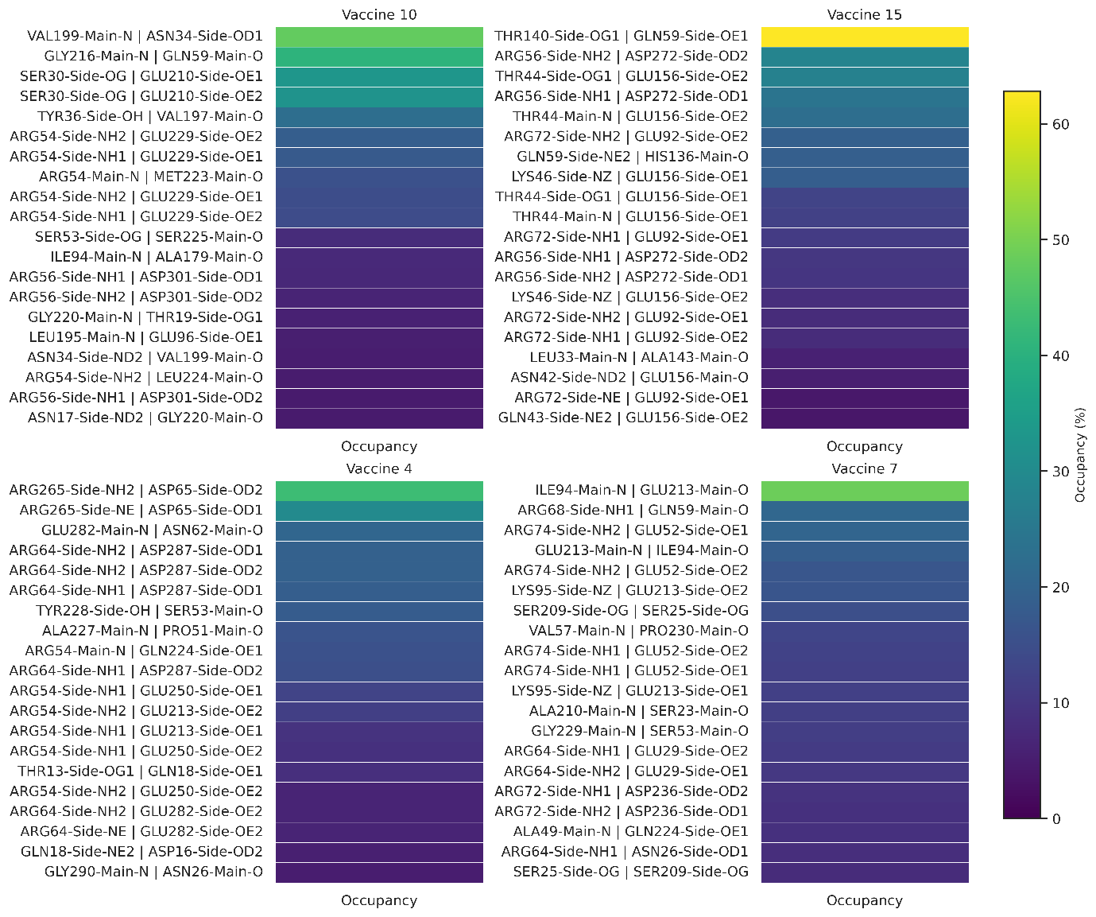
Figure S14: Hydrogen bond occupancy maps of Construct-PD-1 complexes over 100-ns molecular dynamics simulations. Heatmaps display the percentage occupancy of specific donor-acceptor hydrogen bond interactions across the trajectory for Constructs 4, 7, 10, and 15. Warmer colors indicate higher interaction persistence.

Exploratory structural analyses

S2 Structure-Based Assessment of Surface-Accessible Regions
B-cell epitope profiling was performed to evaluate the Construct's potential to elicit humoral immune responses. 3D structures were analyzed using structure-based epitope prediction tools implemented in the IEDB Analysis Resource, namely DiscoTope v1.1 ^{28,29} and ElliPro ³⁰. DiscoTope v1.1 was employed to predict discontinuous (conformational) B-cell epitopes at the residue level. For each Construct construct, the corresponding PDB structure was uploaded and analyzed as a single protein chain using the default threshold score of −7.7, corresponding to ~75% specificity and 47% sensitivity ^{28,29}. DiscoTope integrates residue contact numbers, amino-acid epitope propensity scores, and 3D proximity to calculate a composite DiscoTope score for each residue. Residues with DiscoTope scores above the threshold were classified as positive conformational B-cell epitope residues, while residues below the threshold were considered non-epitopic. To complement DiscoTope predictions, ElliPro was used to identify both linear and discontinuous B-cell epitopes based on structural protrusion. It approximates the protein structure using a series of ellipsoids and assigns a Protrusion Index (PI) to each residue, reflecting its degree of solvent exposure. Predicted epitopes were scored using the average PI of their constituent residues, with higher scores indicating increased likelihood of antibody accessibility.

S3 Structure-Based Prediction of Conformational B-Cell Epitopes
DiscoTope and ElliPro analyses were performed on the refined structural models to identify surface-accessible regions and assess the distribution of residues predicted to be exposed within the modeled Construct conformations. Given that the Construct constructs consist of linked epitope assemblies rather than native viral protein domains, these analyses were not intended to identify authentic EBV conformational epitopes. Instead, they were used as structural descriptors of residue accessibility within the predicted Construct models (Figure S5). All constructs exhibited alternating regions of epitope-positive and epitope-negative residues, reflecting variability in surface accessibility and structural organization. Constructs 1-6 displayed prominent epitope-rich regions primarily within the N-terminal and central segments. Notably, Construct 1 exhibited a sustained cluster of residues exceeding the −7.7 threshold between positions ~30-90, indicating a contiguous surface-exposed region with high epitope propensity. Similar patterns were observed in Constructs 2 and 3, albeit with greater score fluctuation, suggesting more heterogeneous surface exposure. In contrast, Constructs 4-6 showed pronounced troughs below the threshold within central regions, consistent with increased contact density and reduced accessibility, although multiple discrete epitope-positive segments were retained, particularly toward terminal regions.
Constructs 7–12 demonstrated more balanced epitope distributions, characterized by frequent transitions between epitope-positive and epitope-negative residues. Construct 8 exhibited one of the most extensive epitope clusters, with prolonged regions above the threshold, indicative of a highly accessible surface topology. Constructs 9 and 10 displayed narrower yet well-defined epitope-positive peaks, consistent with localized conformational epitope hotspots. In contrast, Constructs 13-16 exhibited extended stretches of residues below the threshold, particularly within central regions, suggesting more compact or buried structural domains. Nevertheless, distinct epitope-positive regions were consistently identified near the C-termini of Constructs 15 and 16, indicating localized surface accessibility despite overall structural compactness. Residues predicted as conformational epitopes consistently combined higher propensity scores with lower contact numbers, confirming both compositional favorability and structural accessibility. Several residues with elevated propensity scores remained below the DiscoTope threshold due to high contact density, underscoring the importance of three-dimensional context in epitope prediction (top 10 residues summarized in Table S6).
ElliPro analysis identified multiple linear and discontinuous B-cell epitopes across all constructs. Linear epitopes were typically short and localized within surface-exposed loops, whereas discontinuous epitopes comprised spatially proximal residues derived from non-contiguous sequence regions. Constructs exhibiting extended epitope-positive regions in DiscoTope analysis-particularly Constructs 1, 2, 8, and 10-also yielded higher-scoring ElliPro epitopes with elevated protrusion index (PI) values, consistent with enhanced solvent accessibility. Conversely, Constructs 13-16 produced fewer high-PI ElliPro epitopes, reflecting their more compact structural profiles, although discrete protruding regions were still identified (top 10 epitopes summarized in Table S7).

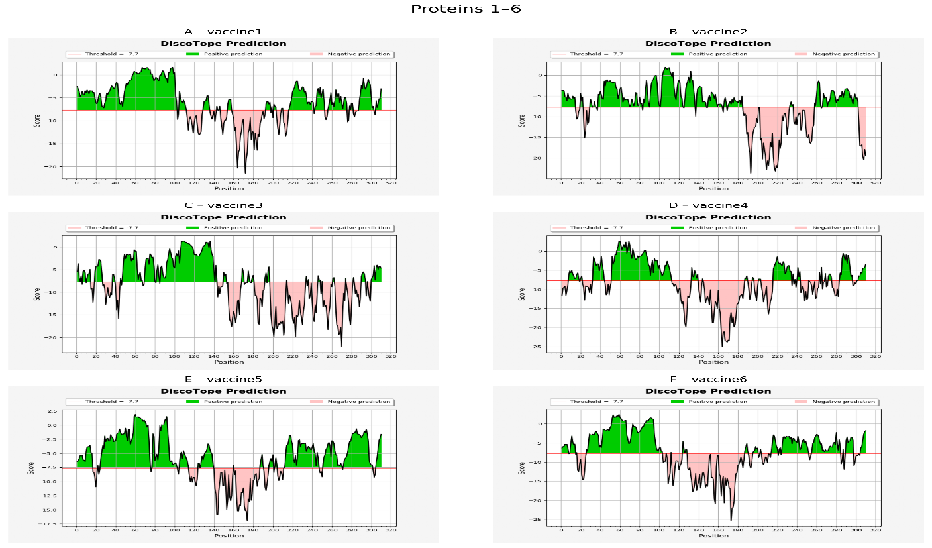

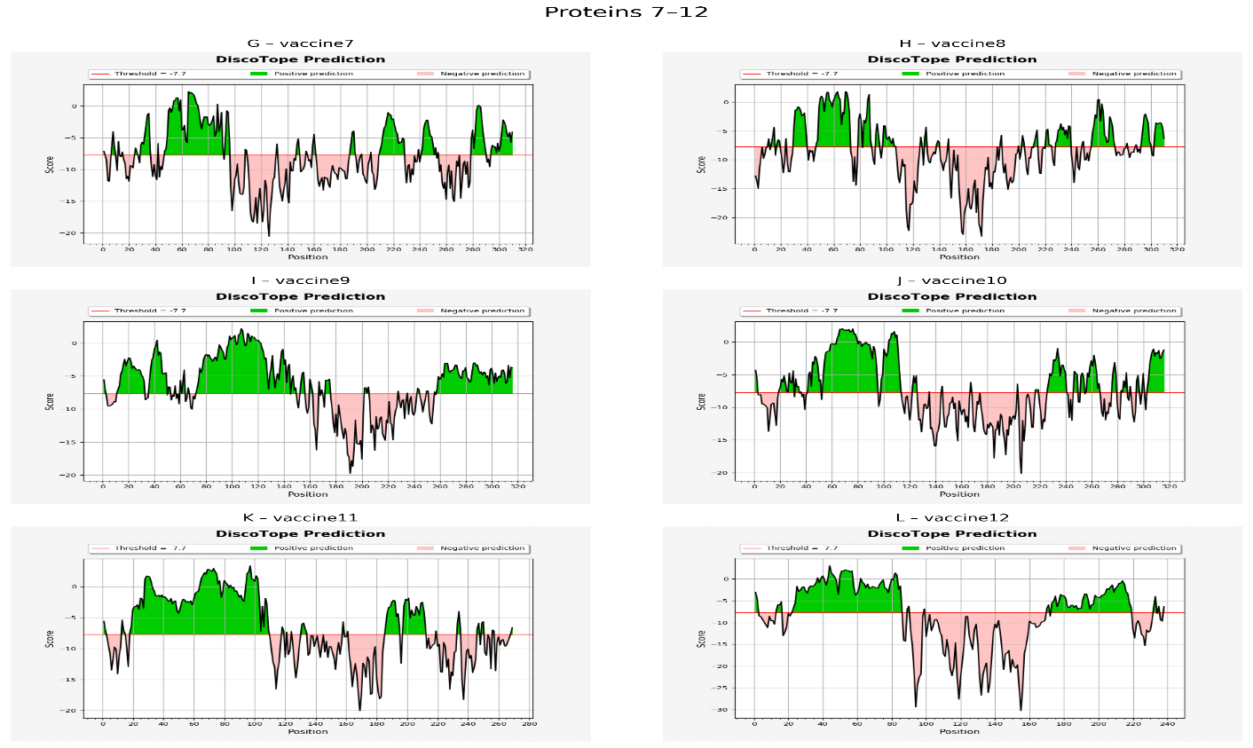

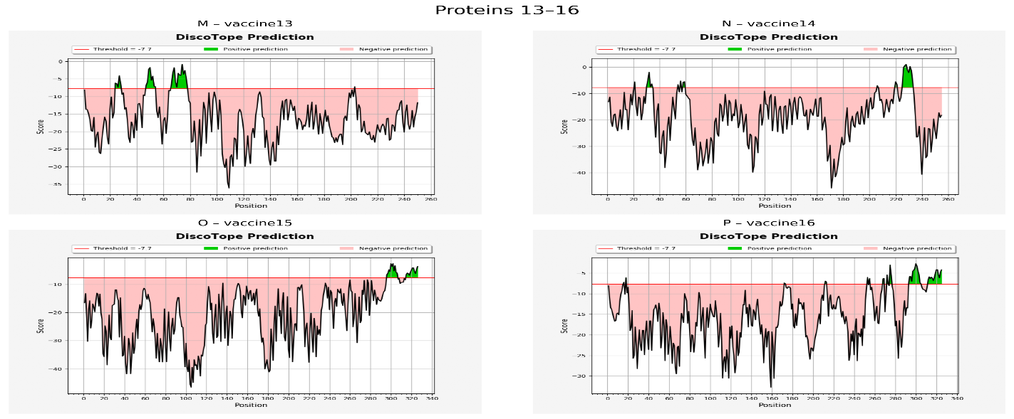

Figure S6: The results of DiscoTope prediction for All constructs.
Table S7: Top Construct constructs ranked by DiscoTope conformational B-cell epitope scores
Rank | Construct ID | Mean DiscoTope Score | Max DiscoTope Score | Mean Propensity Score | Structural Epitope Coverage | Interpretation
1 | Construct6 | High | Very high | High | Broad | Strong, surface-exposed conformational epitopes
2 | Construct5 | High | High | High | Broad | Stable epitope clusters above threshold
3 | Construct3 | Moderate–High | High | Moderate | Broad | Balanced surface exposure
4 | Construct2 | Moderate–High | Moderate | Moderate | Moderate | Consistent epitope regions
5 | Construct1 | Moderate | Moderate | Moderate | Moderate | Localized epitope peaks
6 | Construct8 | Moderate | Moderate | Moderate | Moderate | Good surface distribution
7 | Construct4 | Moderate | Moderate | Lower | Moderate | Mixed positive/negative regions
8 | Construct7 | Lower–Moderate | Moderate | Lower | Limited | Sparse conformational epitopes
9 | Construct10 | Lower | Moderate | Lower | Limited | Isolated surface residues
10 | Construct9 | Lower | Lower | Lower | Limited | Weak conformational signal

Table S8: Top Construct constructs ranked by ElliPro protrusion index
Rank | Construct ID | Highest PI Score | Number of Linear Epitopes | Number of Discontinuous Epitopes | Epitope Type Dominance | Interpretation
1 | Construct6 | ≥0.90 | Multiple | Multiple | Discontinuous | Highly protruding, antibody-accessible
2 | Construct5 | ≥0.88 | Multiple | Multiple | Discontinuous | Strong structural exposure
3 | Construct3 | ≥0.85 | Moderate | Multiple | Mixed | Balanced linear & conformational
4 | Construct2 | ≥0.83 | Moderate | Moderate | Mixed | Surface-accessible regions
5 | Construct1 | ≥0.80 | Moderate | Few | Linear | Accessible but localized
6 | Construct8 | ≥0.78 | Few | Few | Linear | Moderate exposure
7 | Construct4 | ≥0.75 | Few | Few | Linear | Limited protrusion
8 | Construct7 | ≥0.73 | Few | Rare | Linear | Weak structural epitopes
9 | Construct10 | ≥0.70 | Few | Rare | Linear | Minimal exposure
10 | Construct9 | ≥0.68 | Few | Rare | Linear | Poor epitope protrusion

References
1. Young, L. S., & Dawson, C. W. (2014). Epstein-Barr virus and nasopharyngeal carcinoma. Chinese Journal of Cancer, 33(12), 581. https://doi.org/10.5732/cjc.014.10197
2. Tsao, S. W., Tsang, C. M., & Lo, K. W. (2017). Epstein-barr virus infection and nasopharyngeal carcinoma. Philosophical Transactions of the Royal Society B: Biological Sciences, 372(1732). https://doi.org/10.1098/rstb.2016.0270
3. Küppers, R. (2008). The biology of Hodgkin’s lymphoma. Nature Reviews Cancer 2009 9:1, 9(1), 15–27. https://doi.org/10.1038/nrc2542
4. Thorley-Lawson, D. A. (2015). EBV Persistence—Introducing the Virus. Epstein Barr Virus, 1, 151–209. https://doi.org/10.1007/978-3-319-22822-8_8
5. Giordano, T. J. (2014). The Cancer Genome Atlas Research Network: A Sight to Behold. Endocrine Pathology 2014 25:4, 25(4), 362–365. https://doi.org/10.1007/s12022-014-9345-4
6. Bass, A. J., Thorsson, V., Shmulevich, I., Reynolds, S. M., Miller, M., Bernard, B., Hinoue, T., Laird, P. W., Curtis, C., Shen, H., Weisenberger, D. J., Schultz, N., Shen, R., Weinhold, N., Kelsen, D. P., Bowlby, R., Chu, A., Kasaian, K., Mungall, A. J., … Liu, J. (2014). Comprehensive molecular characterization of gastric adenocarcinoma. Nature 2014 513:7517, 513(7517), 202–209. https://doi.org/10.1038/nature13480
7. Tse, E., & Kwong, Y. L. (2017). The diagnosis and management of NK/T-cell lymphomas. Journal of Hematology & Oncology 2017 10:1, 10(1), 85-. https://doi.org/10.1186/s13045-017-0452-9
8. Allen, U. D., & Preiksaitis, J. K. (2019). Post-transplant lymphoproliferative disorders, Epstein-Barr virus infection, and disease in solid organ transplantation: Guidelines from the American Society of Transplantation Infectious Diseases Community of Practice. Clinical Transplantation, 33(9), e13652. https://doi.org/10.1111/ctr.13652
9. Ok, C. Y., Ye, Q., Li, L., Manyam, G. C., Deng, L., Goswami, R. R., Wang, X., Montes-Moreno, S., Visco, C., Tzankov, A., Dybkaer, K., Zhang, L., Abramson, J., Sohani, A. R., Chiu, A., Orazi, A., Zu, Y., Bhagat, G., Richards, K. L., … Young, K. H. (2015). Age cutoff for Epstein-Barr virus-positive diffuse large B-cell lymphoma–is it necessary? Oncotarget, 6(16), 13933. https://doi.org/10.18632/oncotarget.4324
10. Pekkonen, P., Järviluoma, A., Zinovkina, N., Cvrljevic, A., Prakash, S., Westermarck, J., Evan, G., Cesarman, E., Verschuren, E. W., & Ojala, P. (2014). KSHV viral cyclin interferes with T-cell development and induces lymphoma through Cdk6 and notch activation in vivo. Cell Cycle, 13(23), 3670–3684. https://doi.org/10.4161/15384101.2014.964118
11. Castillo, J. J., Bibas, M., & Miranda, R. N. (2015). The biology and treatment of plasmablastic lymphoma. Blood, 125(15), 2323–2330. https://doi.org/10.1182/blood-2014-10-567479
12. Kimura, H., Ito, Y., Kawabe, S., Gotoh, K., Takahashi, Y., Kojima, S., Naoe, T., Esaki, S., Kikuta, A., Sawada, A., Kawa, K., Ohshima, K., & Nakamura, S. (2012). EBV-associated T/NK–cell lymphoproliferative diseases in nonimmunocompromised hosts: prospective analysis of 108 cases. Blood, 119(3), 673–686. https://doi.org/10.1182/blood-2011-10-381921
13. Moore, K. W., Vieira, P., Fiorentino, D. F., Trounstine, M. L., Khan, T. A., & Mosmann, T. R. (1990). Homology of cytokine synthesis inhibitory factor (IL-10) to the Epstein-Barr virus gene BCRFI. Science, 248(4960), 1230–1234. https://doi.org/10.1126/science.2161559
14. Ressing, M. E., Horst, D., Griffin, B. D., Tellam, J., Zuo, J., Khanna, R., Rowe, M., & Wiertz, E. J. H. J. (2008). Epstein-Barr virus evasion of CD8+ and CD4+ T cell immunity via concerted actions of multiple gene products. Seminars in Cancer Biology, 18(6), 397–408. https://doi.org/10.1016/j.semcancer.2008.10.008
15. Zuo, J., & Jin, D.-Y. (2025). Immune Evasion by Epstein–Barr Virus. 1–39. https://doi.org/10.1007/82_2025_311
16. Ressing, M. E., van Leeuwen, D., Verreck, F. A. W., Keating, S., Gomez, R., Franken, K. L. M. C., Ottenhoff, T. H. M., Spriggs, M., Schumacher, T. N., Hutt-Fletcher, L. M., Rowe, M., & Wiertz, E. J. H. J. (2005). Epstein-Barr Virus gp42 Is Posttranslationally Modified To Produce Soluble gp42 That Mediates HLA Class II Immune Evasion. Journal of Virology, 79(2), 841–852. https://doi.org/10.1128/jvi.79.2.841-852.2005
17. Feederle, R., Bannert, H., Lips, H., Müller-Lantzsch, N., & Delecluse, H.-J. (2009). The Epstein-Barr Virus Alkaline Exonuclease BGLF5 Serves Pleiotropic Functions in Virus Replication. Journal of Virology, 83(10), 4952–4962. https://doi.org/10.1128/jvi.00170-09
18. Liu, X., Sadaoka, T., Krogmann, T., & Cohen, J. I. (2020). Epstein-Barr Virus (EBV) Tegument Protein BGLF2 Suppresses Type I Interferon Signaling To Promote EBV Reactivation. Journal of Virology, 94(11). https://doi.org/10.1128/jvi.00258-20
19. Cheng, A. Z., Yockteng-Melgar, J., Jarvis, M. C., Malik-Soni, N., Borozan, I., Carpenter, M. A., McCann, J. L., Ebrahimi, D., Shaban, N. M., Marcon, E., Greenblatt, J., Brown, W. L., Frappier, L., & Harris, R. S. (2018). Epstein–Barr virus BORF2 inhibits cellular APOBEC3B to preserve viral genome integrity. Nature Microbiology 2018 4:1, 4(1), 78–88. https://doi.org/10.1038/s41564-018-0284-6
20. Chen, Y. L., Chen, Y. J., Tsai, W. H., Ko, Y. C., Chen, J. Y., & Lin, S. F. (2009). The Epstein-Barr virus replication and transcription activator, Rta/BRLF1, induces cellular senescence in epithelial cells. Cell Cycle, 8(1), 58–65. https://doi.org/10.4161/cc.8.1.7411
21. Nikiforow, S., Bottomly, K., Miller, G., & Münz, C. (2003). Cytolytic CD4 + -T-Cell Clones Reactive to EBNA1 Inhibit Epstein-Barr Virus-Induced B-Cell Proliferation . Journal of Virology, 77(22), 12088–12104. https://doi.org/10.1128/jvi.77.22.12088-12104.2003
22. Smith, D. W., Chakravorty, A., Hayes, M., Hammerschmidt, W., & Sugden, B. (2021). The Epstein-Barr Virus Oncogene EBNA1 Suppresses Natural Killer Cell Responses and Apoptosis Early after Infection of Peripheral B Cells. MBio, 12(6). https://doi.org/10.1128/mBio.02243-21
23. Fathallah, I., Parroche, P., Gruffat, H., Zannetti, C., Johansson, H., Yue, J., Manet, E., Tommasino, M., Sylla, B. S., & Hasan, U. A. (2010). EBV Latent Membrane Protein 1 Is a Negative Regulator of TLR9. The Journal of Immunology, 185(11), 6439–6447. https://doi.org/10.4049/jimmunol.0903459
24. Guasparri, L., Bubman, D., & Cesarman, E. (2008). EBV LMP2A affects LMP1-mediated NF-κB signaling and survival of lymphoma cells by regulating TRAF2 expression. Blood, 111(7), 3813–3820. https://doi.org/10.1182/blood-2007-03-080309
25. Swaminathan, S., Huneycu1t, B. S., Reiss, C. S., & Kieff, E. (1992). Epstein-Barr virus-encoded small RNAs (EBERs) do not modulate interferon effects in infected lymphocytes. Journal of Virology, 66(8), 5133–5136. https://doi.org/10.1128/jvi.66.8.5133-5136.1992
26. Lu, Y., Qin, Z., Wang, J., Zheng, X., Lu, J., Zhang, X., Wei, L., Peng, Q., Zheng, Y., Ou, C., Ye, Q., Xiong, W., Li, G., Fu, Y., Yan, Q., & Ma, J. (2017). Epstein-Barr Virus miR-BART6-3p Inhibits the RIG-I Pathway. Journal of Innate Immunity, 9(6), 574–586. https://doi.org/10.1159/000479749
27. Choi, H., & Lee, S. K. (2016). TAX1BP1 downregulation by EBV-miR-BART15-3p enhances chemosensitivity of gastric cancer cells to 5-FU. Archives of Virology 2016 162:2, 162(2), 369–377. https://doi.org/10.1007/s00705-016-3109-z
28. Haste Andersen, P., Nielsen, M., & Lund, O. (2006). Prediction of residues in discontinuous B-cell epitopes using protein 3D structures. Protein Science : A Publication of the Protein Society, 15(11), 2558–2567. https://doi.org/10.1110/PS.062405906
29. Kringelum, J. V., Lundegaard, C., Lund, O., & Nielsen, M. (2012). Reliable B cell epitope predictions: impacts of method development and improved benchmarking. PLoS Computational Biology, 8(12). https://doi.org/10.1371/JOURNAL.PCBI.1002829
30. Ponomarenko, J., Bui, H. H., Li, W., Fusseder, N., Bourne, P. E., Sette, A., & Peters, B. (2008). ElliPro: a new structure-based tool for the prediction of antibody epitopes. BMC Bioinformatics, 9. https://doi.org/10.1186/1471-2105-9-514

