WATER QUALITY ANLYSIS

TEAM LEADER: SURENTHER S (310121104104)

TEAM MEMBERS: SHARATH P (310121104097)

RANJITH KUMAR V (310121104082)

INTRODUCTION

Introduction for water quality analysis

Water quality analysis is the process of evaluating the physical, chemical, and biological characteristics of water to determine its suitability for various purposes, such as drinking, recreational, industrial, or ecological. It involves the measurement and assessment of parameters like pH, temperature, turbidity, dissolved oxygen, nutrients, heavy metals, bacteria, and more. This analysis helps ensure water safety, environmental protection, and compliance with regulatory standards. Water quality testing is crucial for maintaining public health and safeguarding aquatic ecosystems.

DATA PREPROCESSING

Data preprocessing is a fundamental step in the data analysis pipeline. It involves cleaning and transforming raw data into a format suitable for analysis. The process typically includes tasks like handling missing values, removing duplicates, scaling and normalizing data, encoding categorical variables, and feature selection or extraction. Data preprocessing aims to enhance the quality of data, reduce noise, and make it compatible with machine learning algorithms or statistical analysis. Effective data preprocessing is critical for obtaining meaningful insights and building accurate predictive models.

DATA SAVING

Data saving involves storing and managing datasets that are used for training, testing, and validating machine learning models. This process includes collecting, preprocessing, and archiving data in a structured format. Common data-saving formats for machine learning include CSV, JSON, or specialized formats like HDF5. Proper data saving is crucial for reproducibility, as it allows researchers and practitioners to access the same data for model development and evaluation. Additionally, version control systems may be used to track changes to datasets, ensuring that data remains consistent and traceable throughout the machine learning project.

DATA COLLECTION

Data collection is a crucial phase in machine learning that involves gathering the necessary information or datasets to train, test, and validate machine learning models. Here are some key points about data collection in machine learning:

1. Data Sources: Data can be collected from various sources, such as databases, APIs, sensors, web scraping, surveys, or existing datasets. The choice of data source depends on the specific problem and the type of data required.

2. Data Quality: Ensuring data quality is essential. This includes addressing issues like missing values, outliers, noise, and data inconsistencies. High-quality data is vital for training accurate and reliable models.

3. Data Annotation: In some cases, data may need to be manually annotated or labeled. This is common in supervised learning, where data points are assigned labels or categories.

4. Data Privacy and Ethics: Data collection should adhere to ethical standards and data privacy regulations. It's important to obtain consent and protect sensitive information when collecting data from individuals.

5. Data Volume: The amount of data needed depends on the complexity of the problem and the type of machine learning algorithm. More complex models often require larger datasets.

6. Data Splitting: Data is typically divided into training, validation, and testing sets. This splitting allows for model training, hyperparameter tuning, and evaluation on unseen data.

7. Data Versioning: Keeping track of different versions of the dataset is important for reproducibility. Version control systems can help manage data changes.

8. Bias and Fairness: Care should be taken to address bias in the collected data, as biased data can lead to biased machine learning models. Efforts should be made to ensure fairness and inclusivity in data collection.

9. Data Storage: Data should be stored in a secure and organized manner, making it easily accessible for model development and analysis.

Data collection is a critical step that lays the foundation for the success of a machine learning project. The quality and relevance of the data gathered significantly impact the performance and generalizability of the resulting models.

DATA VISUALISATION

Data visualization plays a critical role in machine learning for water quality analysis. Here's how it is used in this specific context:

1. *Exploratory Data Analysis (EDA) :*Data visualization is employed to explore and understand water quality datasets. Visualizations like scatter plots, line charts, and histograms help identify patterns, outliers, and correlations among different water quality parameters.

2. *Temporal Trends:* Time series data visualization is crucial for tracking how water quality parameters change over time. This can reveal seasonal variations and long-term trends.

3. *Spatial Analysis:* Geospatial visualizations, such as maps and heatmaps, are useful for analyzing how water quality varies across different locations, which can be vital for environmental monitoring.

4. *Feature Engineering:* Data visualizations help in selecting relevant features (water quality parameters) for machine learning models. Feature importance can be assessed through techniques like feature ranking plots.

5. *Model Evaluation:* Visualizations are used to assess the performance of machine learning models. ROC curves, confusion matrices, and precision-recall curves are common for evaluating models in water quality analysis.

6. *Predictive Modeling:* Visualizations can aid in understanding the output of machine learning models. For example, you can create visualizations to compare predicted vs. actual water quality values.

7. *Anomaly Detection:* Visualizations are effective for identifying anomalies or outliers in water quality data, which may indicate pollution events or abnormal conditions.

8. *Data Communication:* Visualizations are essential for communicating the results of water quality analysis to stakeholders, such as regulatory agencies, the public, or water treatment facilities.

9. *Real-time Monitoring:* Real-time visualizations are valuable for continuous monitoring of water quality, allowing immediate responses to changes or emergencies.

In the context of water quality analysis, effective data visualization enhances the understanding of complex datasets, aids in model development, and facilitates informed decision-making for water resource management and environmental protection

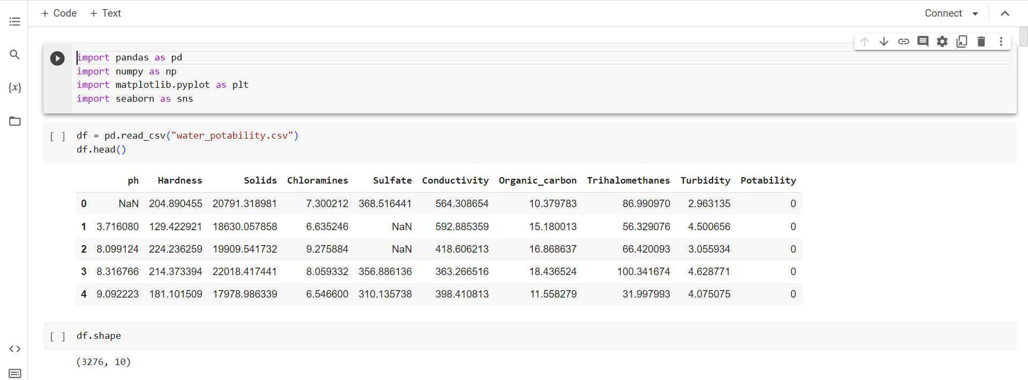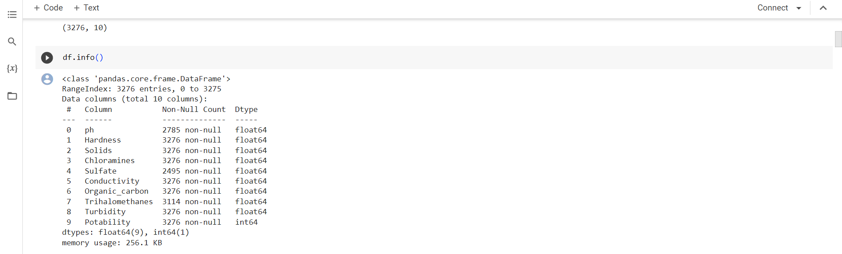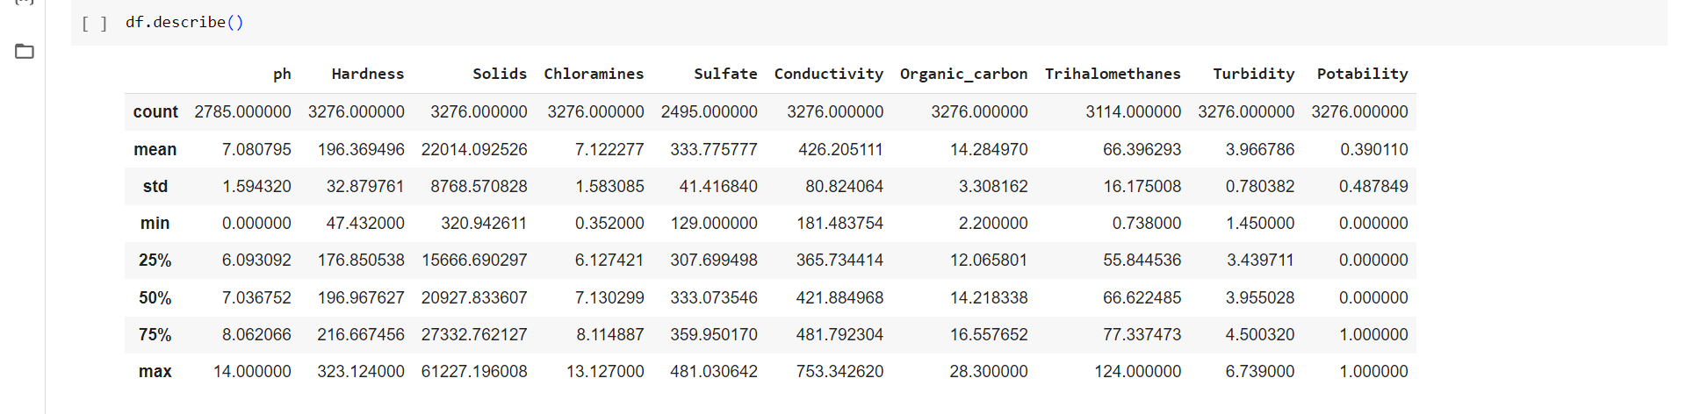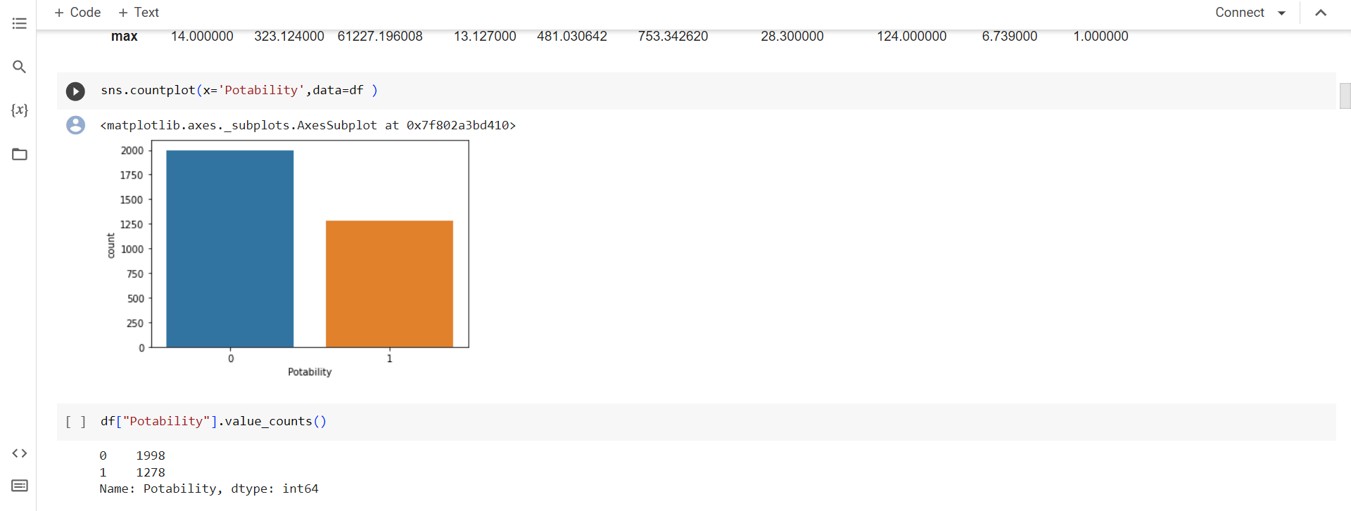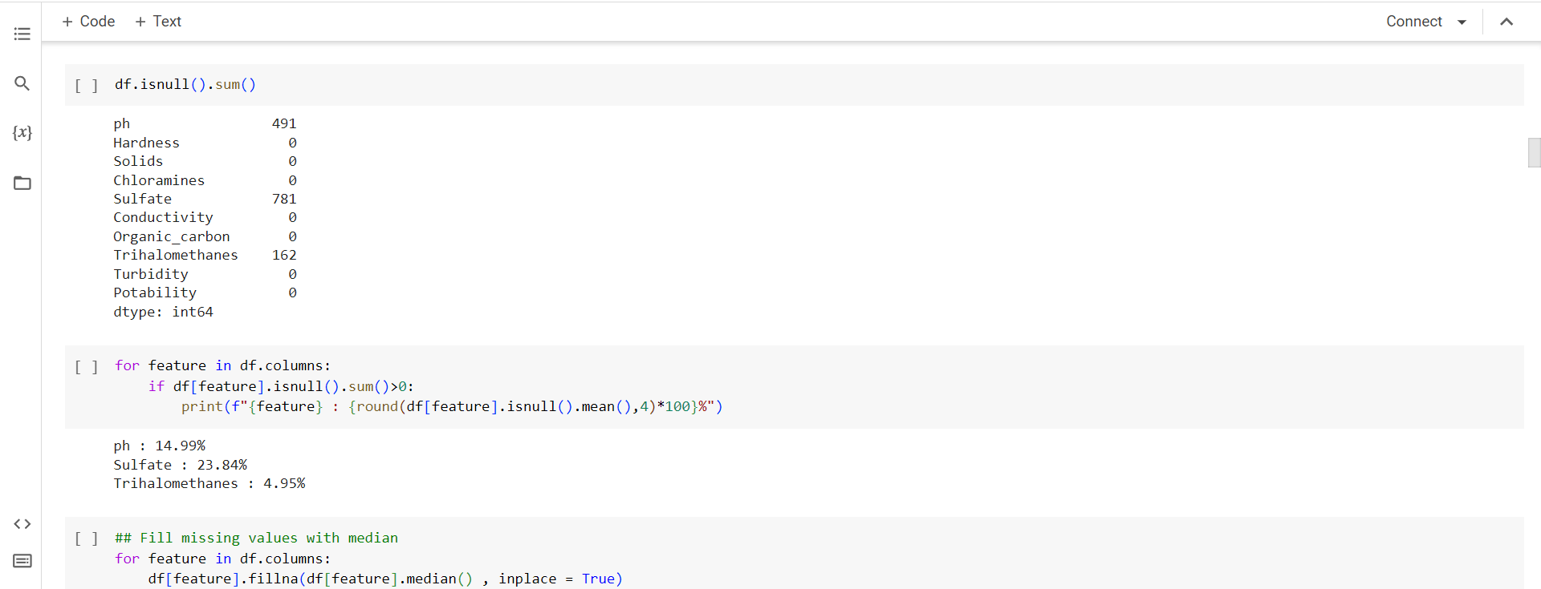

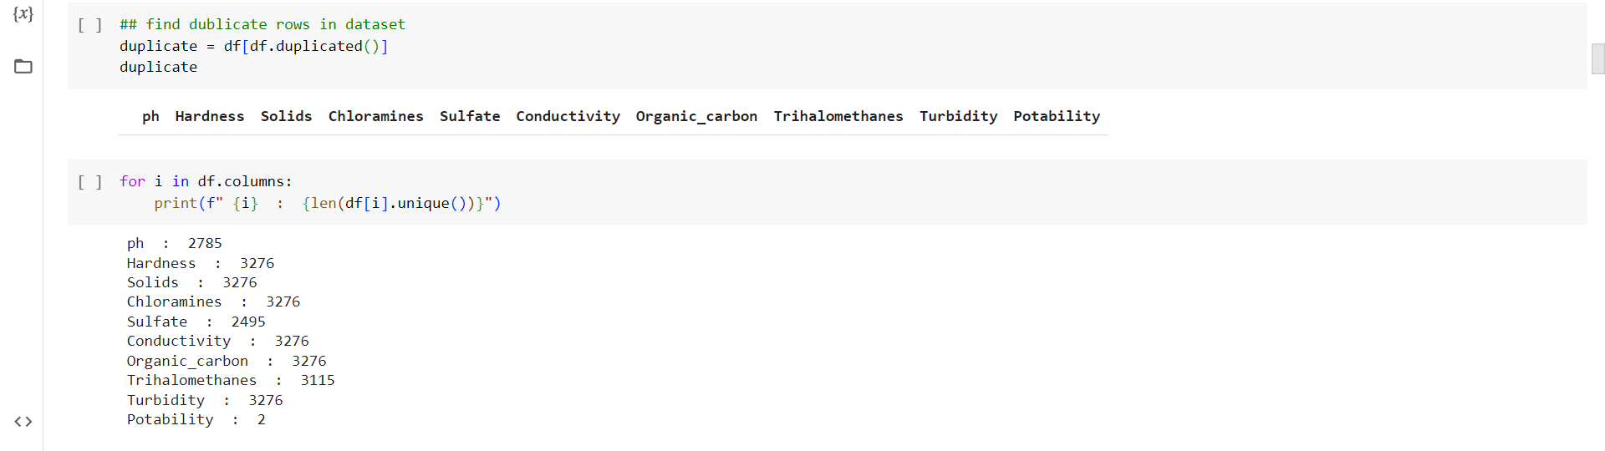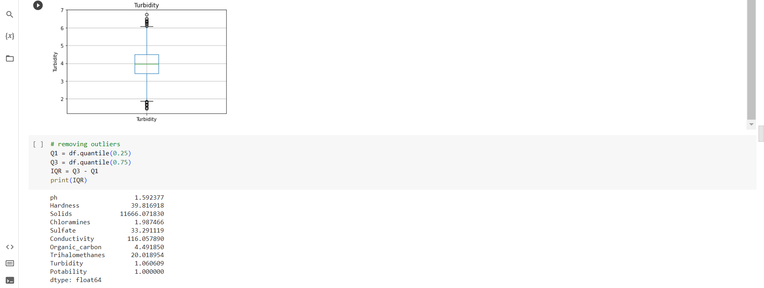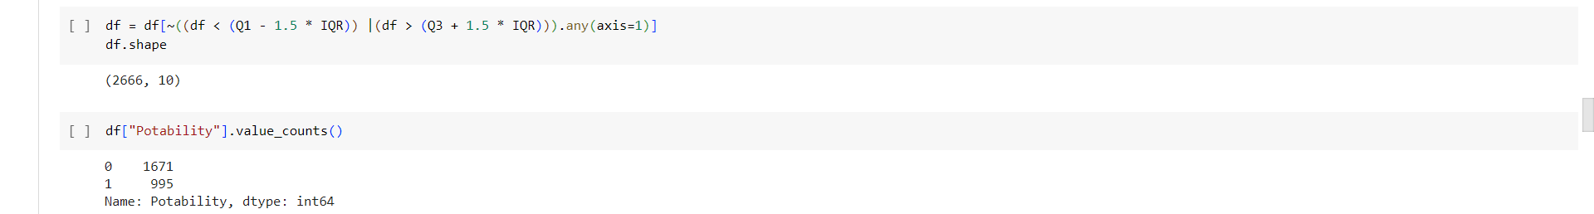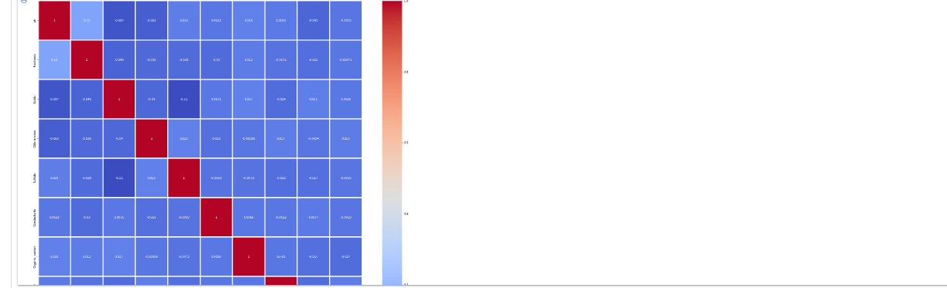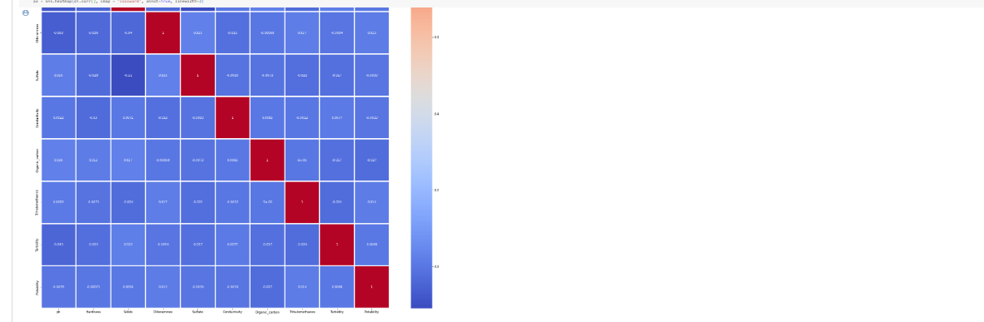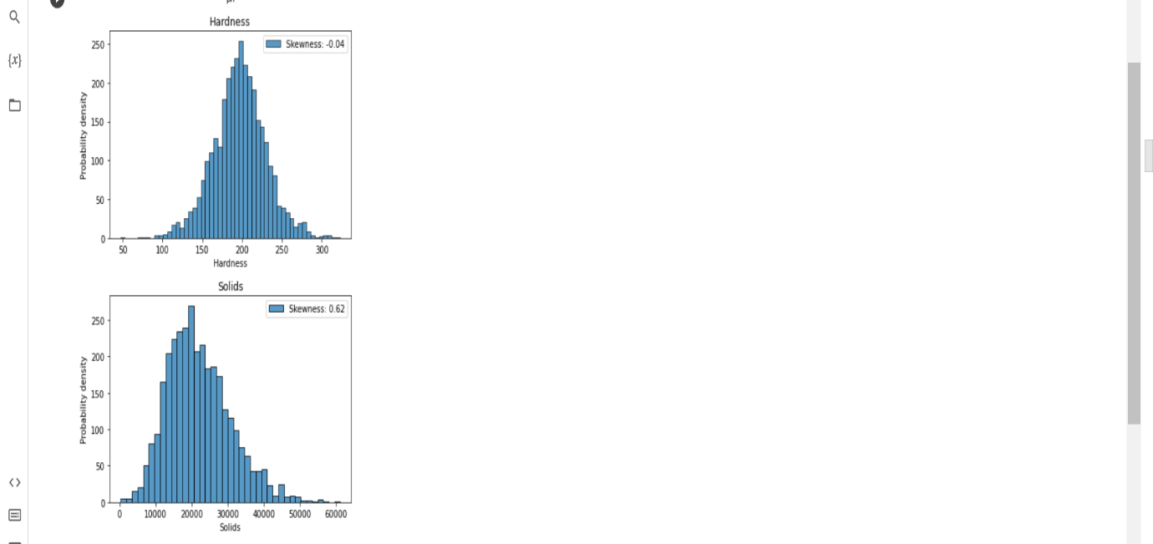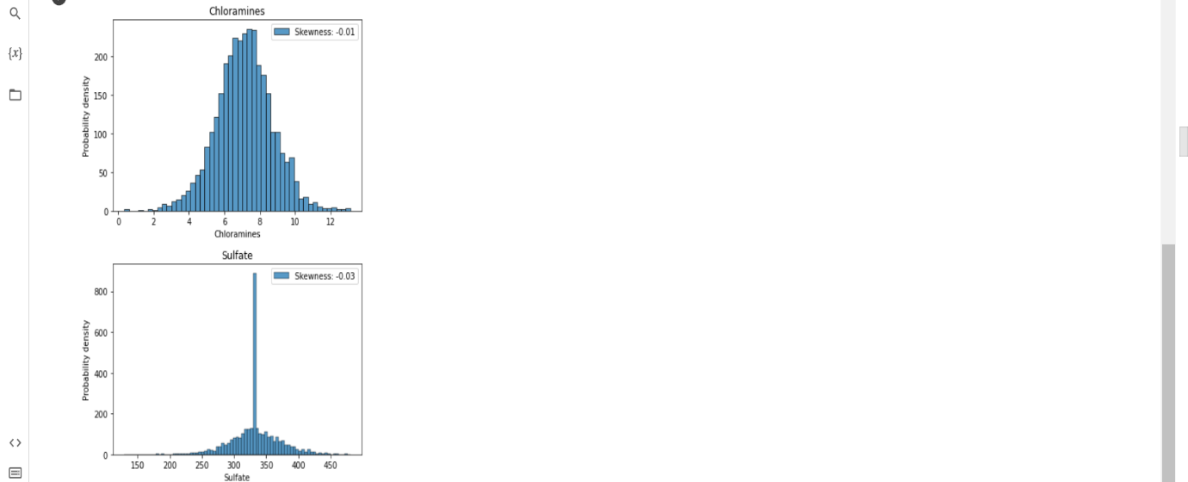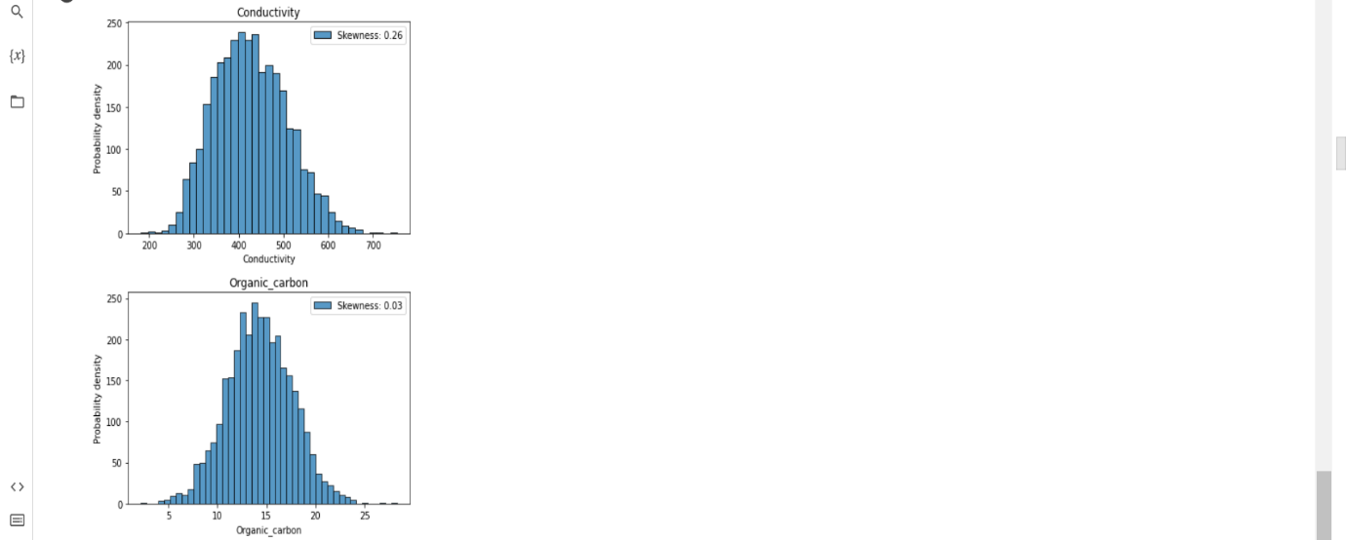

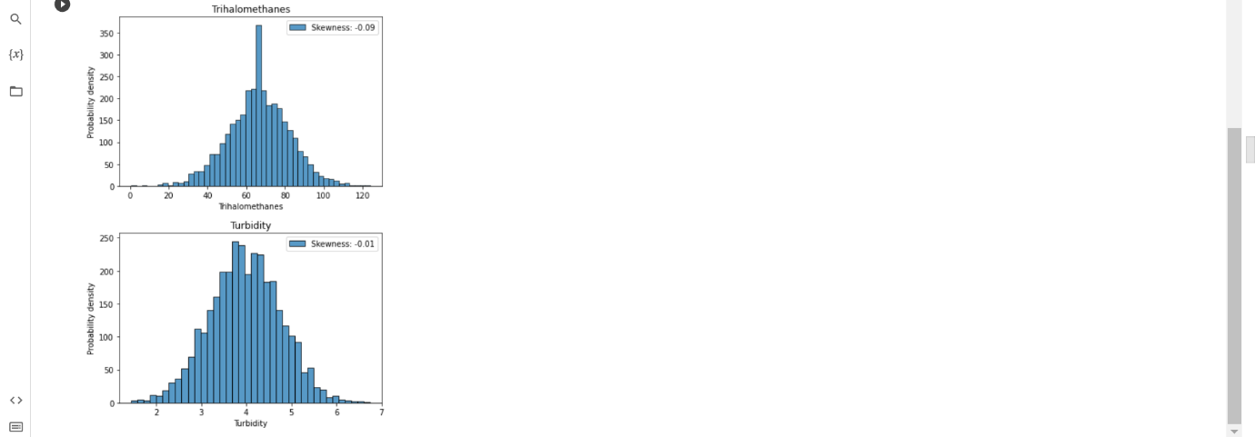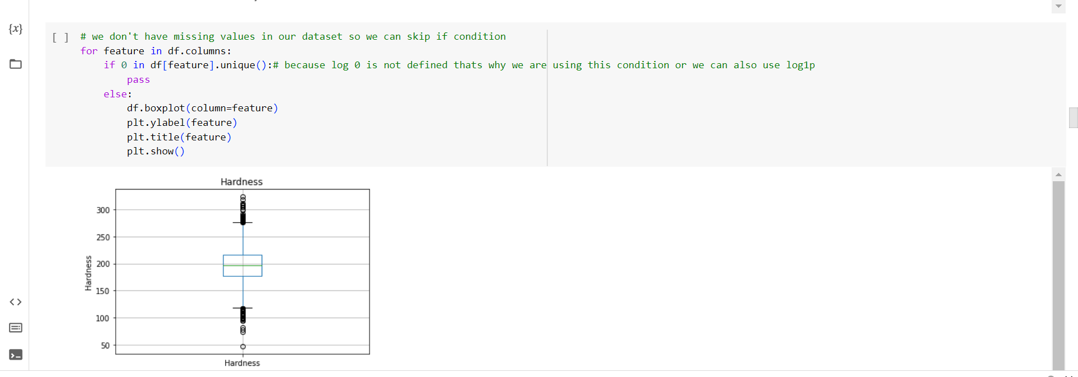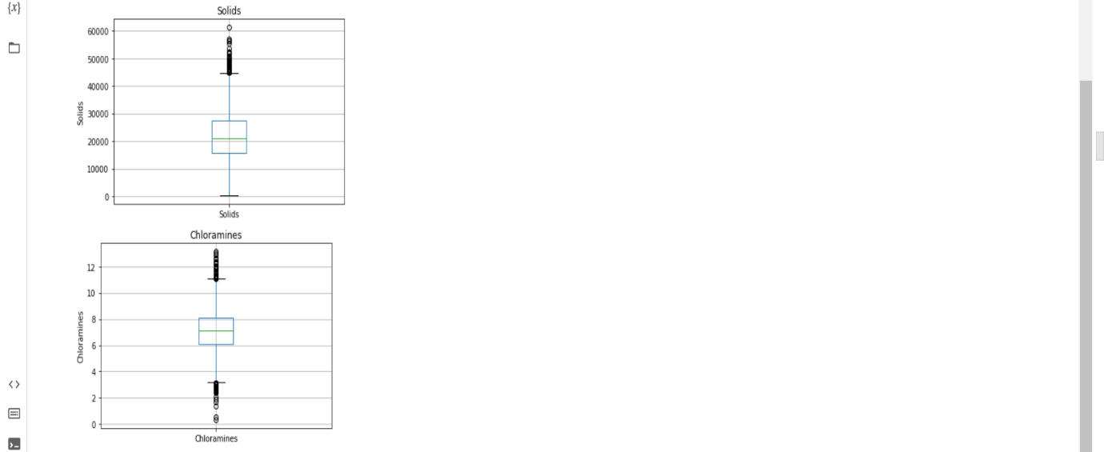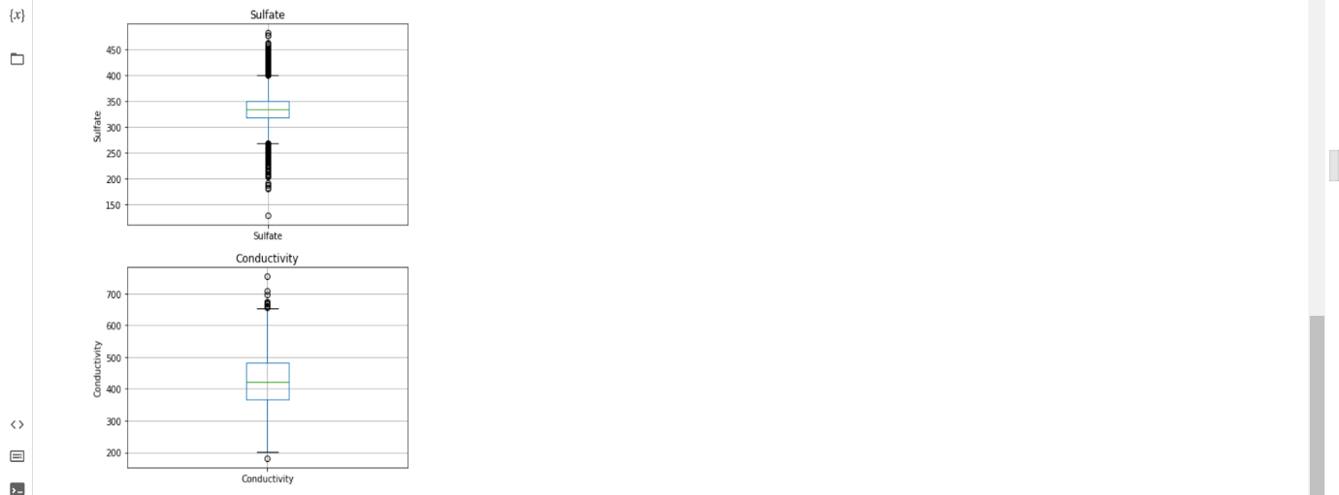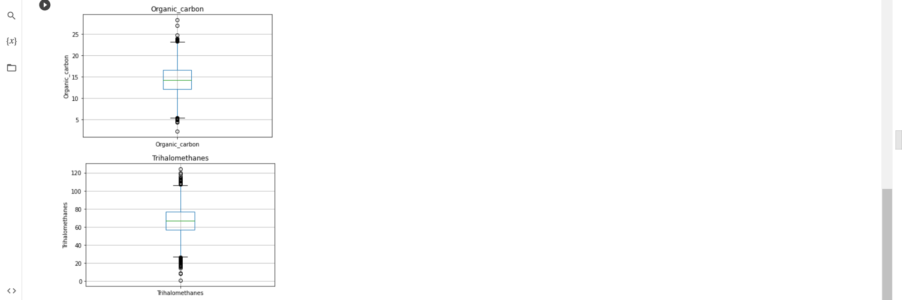

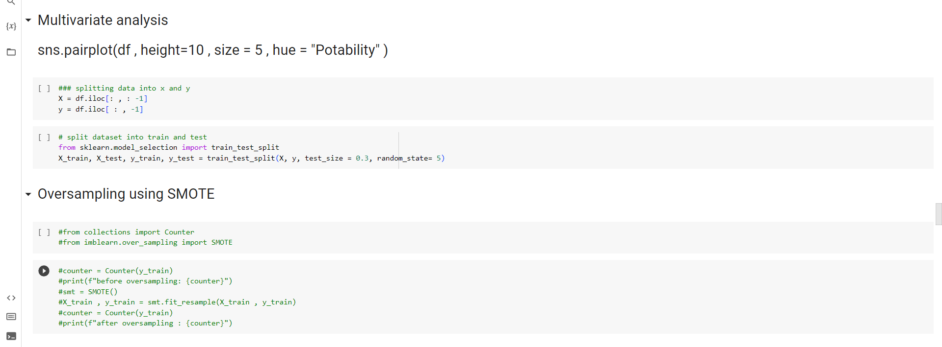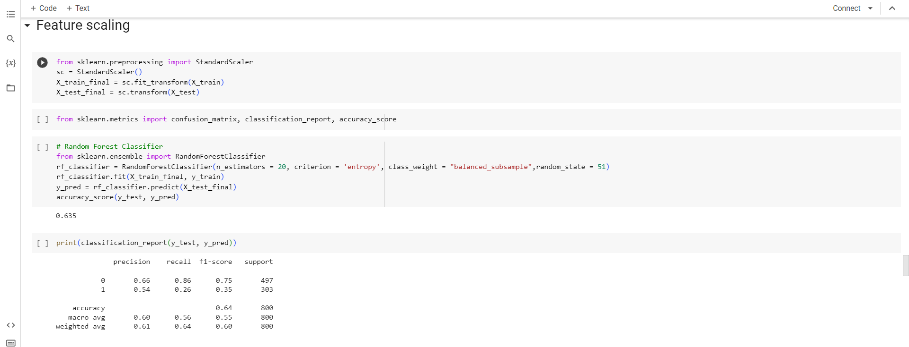

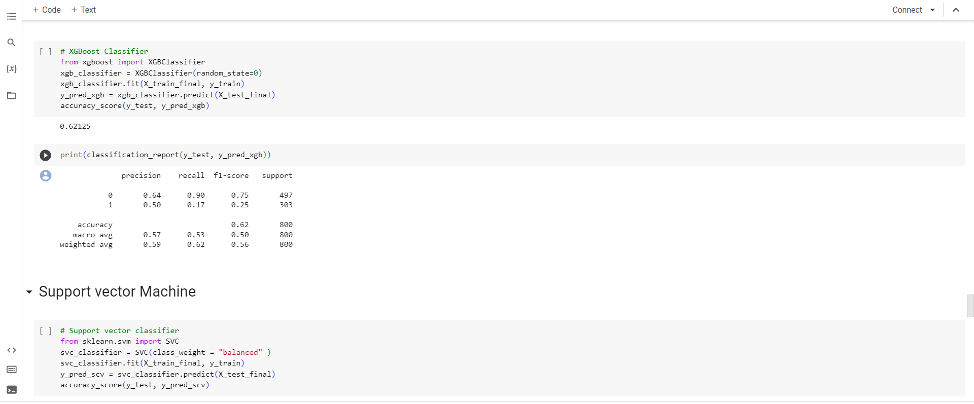

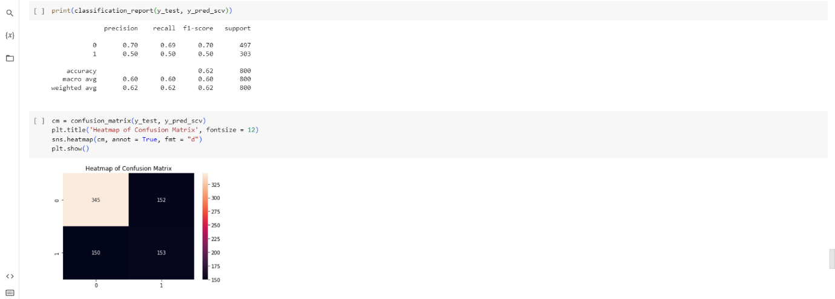

**CONCLUSION**

**In conclusion, the water quality analysis project has provided valuable insights into the condition of our water sources. Through extensive testing and data collection, we have identified key parameters such as pH levels, turbidity, dissolved oxygen, and pollutant concentrations. These findings can serve as a basis for informed decision-making in efforts to protect and improve water quality. It is imperative that we continue to monitor and address the identified issues to ensure the availability of clean and safe water for both current and future generations.**