**WOMEN DATA SCIENCE HACKATHON BY BAIN & COMPANY**

**Code and Approach**

**Index :**

* Import all essential libraries and dataset
* Feature Engineering
* Exploratory data analysis
* Basic inferences from EDA
* Model experimentation
* Final model selection
* Insights

1. **Import all essential libraries and dataset**

**Code :**

%matplotlib inline

from sklearn.preprocessing import MinMaxScaler

from sklearn.model_selection import train_test_split

from sklearn import metrics #Additional scklearn functions

from sklearn.model_selection import GridSearchCV

from sklearn.model_selection import cross_validate

from sklearn.model_selection import cross_val_score

from sklearn.model_selection import train_test_split

from sklearn.metrics import confusion_matrix

import numpy as np

import matplotlib.pyplot as plt

import pandas as pd

from sklearn.preprocessing import StandardScaler

from sklearn.metrics import accuracy_score

from sklearn import metrics

import matplotlib.pyplot as plt

import lightgbm as lgb

from bayes_opt import BayesianOptimization

from sklearn.metrics import r2_score

from sklearn.ensemble import RandomForestRegressor

train = pd.read_csv("train_bcg.csv")

test = pd.read_csv("test_bcg.csv")

1. **Feature Engineering**
   1. **One hot encoding for categorical features to extract importance all values for a variable**

**Code :**

train.loc[train['Course_Domain'] == 'Development', 'Development'] = 1

train.loc[train['Course_Domain'] == 'Software Marketing', 'Software_Marketing'] = 1

train.loc[train['Course_Domain'] == 'Finance & Accounting', 'Finance_Accounting'] = 1

train.loc[train['Course_Domain'] == 'Business', 'Business'] = 1

train.loc[train['Course_Type'] == 'Course', 'Course'] = 1

train.loc[train['Course_Type'] == 'Program', 'Program'] = 1

train.loc[train['Course_Type'] == 'Degree', 'Degree'] = 1

test.loc[test['Course_Domain'] == 'Development', 'Development'] = 1

test.loc[test['Course_Domain'] == 'Software Marketing', 'Software_Marketing'] = 1

test.loc[test['Course_Domain'] == 'Finance & Accounting', 'Finance_Accounting'] = 1

test.loc[test['Course_Domain'] == 'Business', 'Business'] = 1

test.loc[test['Course_Type'] == 'Course', 'Course'] = 1

test.loc[test['Course_Type'] == 'Program', 'Program'] = 1

test.loc[test['Course_Type'] == 'Degree', 'Degree'] = 1

* 1. **Missing value treatment**

**Code :**

train = train.fillna(0)

test = test.fillna(0)

* 1. **Feature User_tranffic is absent in test data to it does not make any use to use it in training process**

**Code :**

train=train.drop(['User_Traffic'],axis=1)

train=train.drop(['Course_Domain','Course_Type'],axis=1)

test=test.drop(['Course_Domain','Course_Type'],axis=1)

feature = [x for x in train.columns if x not in 'Sales']

y = train[['ID','Sales']]

X = train[feature]

X = X.set_index('ID')

test = test.set_index('ID')

y = y.set_index('ID')

* 1. **Outlier Removal**

**Code :**

upper_lim = train['Sales'].quantile(.98)

lower_lim = train['Sales'].quantile(.01)

train.loc[(train['Sales'] > upper_lim),'Sales'] = upper_lim

train.loc[(train['Sales'] < lower_lim),'Sales'] = lower_lim

feature = [x for x in train.columns if x not in 'Sales']

y = train[['Sales']]

X = train[feature]

1. **Exploratory data analysis:**
   1. **Correlation metrics**

**Code :**

import seaborn as sns

sns.set(rc={'figure.figsize':(11.7,8.27)})

train.corr()

sns.heatmap(train.corr(), annot=True)

plt.show()

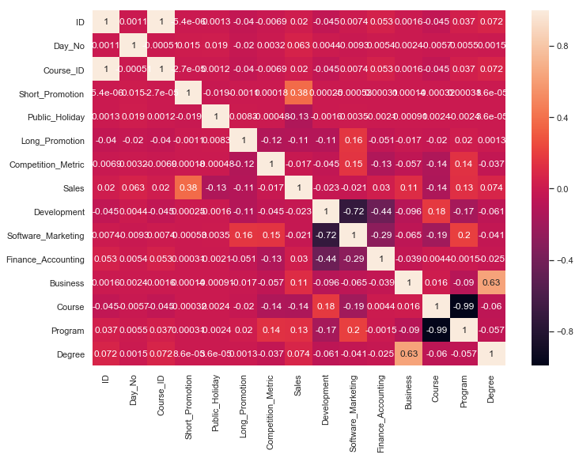

**Code :**

# fig, ax = plt.subplots()

# train['Day_No'].hist(color='#A9C5D3', edgecolor='black',

# grid=False)

# ax.set_title('Developer Age Histogram', fontsize=12)

# ax.set_xlabel('Day_No', fontsize=12)

# ax.set_ylabel('Frequency', fontsize=12)

# train.plot.scatter(x='Day_No',

# y='Sales',

# c='DarkBlue')

# train.plot.scatter(x='Course_ID',

# y='Sales',

# c='DarkBlue')

# train['Day_No'].max() #882

# train['Day_No'].min() #1

grouped_sales = train.groupby('Day_No',as_index=False).agg({'Sales': ['sum']})

grouped_sales

grouped_sales.plot.line(x='Day_No',

y='Sales',

c='DarkBlue',figsize=(20,5))

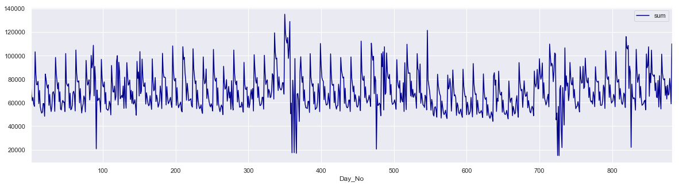

* 1. **Multicollinearity check:**

**Code :**

import numpy as np

import pandas as pd

import time

from statsmodels.stats.outliers_influence import variance_inflation_factor

from joblib import Parallel, delayed

# Defining the function that you will run later

def calculate_vif_(X, thresh=5.0):

variables = [X.columns[i] for i in range(X.shape[1])]

dropped=True

while dropped:

dropped=False

print(len(variables))

vif = Parallel(n_jobs=-1,verbose=5)(delayed(variance_inflation_factor)(X[variables].values, ix) for ix in range(len(variables)))

maxloc = vif.index(max(vif))

if max(vif) > thresh:

print(time.ctime() + ' dropping \'' + X[variables].columns[maxloc] + '\' at index: ' + str(maxloc))

variables.pop(maxloc)

dropped=True

print('Remaining variables:')

print([variables])

return X[[i for i in variables]]

feature_list = [x for x in train.columns ]

df = train[feature_list] # Selecting your data

df2 = calculate_vif_(train,5) # Actually running the function

**Dropped multicollinear features :**

X=X.drop(['Development','Program'],axis=1)

test=test.drop(['Development','Program'],axis=1)

1. **Base inferences from EDA**
   1. **The data looks stationary and does not be stationarized**
   2. **There is no seasonality in the data**
   3. **User_traffic is absent in test data hence omitted from analysis**
   4. **Sales is positively correlated with short promotions and negatively correlated with long promotion in extremes**
   5. **Development Course Domain and Program Course type cause multicollinearity hence omitted**
2. **Choice of model:**
   1. **Seasonal ARIMA**

**Code :**

from pmdarima import auto_arima

stepwise_model = auto_arima(train['Sales'],exogenous= X[['Course_ID', 'Short_Promotion', 'Public_Holiday','Long_Promotion', 'Competition_Metric', 'Development','Software_Marketing', 'Finance_Accounting', 'Business', 'Course','Program', 'Degree']]

,start_p=0, start_q=0,

max_p=5, max_q=5, m=1,

start_P=0, seasonal=False,

d=0, D=1, trace=True,

error_action='ignore',

suppress_warnings=True,

stepwise=True)

**Performance :** The algorithm took more than 2hrs+ to tune so I skipped this implementation.

* 1. **Random Forest :** 
     1. Tree based algorithms can handle multicollinearity I
     2. Its easier to tune Random Forest
     3. It’s useful to get feature importance

**Code :**

from sklearn.model_selection import GridSearchCV

# Create the parameter grid based on the results of random search

param_grid = {

'bootstrap': [True],

'max_depth': [80, 90, 100, 110],

'max_features': [2, 3,5],

'min_samples_leaf': [3, 4, 5],

'min_samples_split': [8, 10, 12],

'n_estimators': [100, 200, 300,1000] #will chck later with 1000 iterations

}

**e. Feature importance**

**Code :**

rf.feature_importances_

features = [x for x in train.columns if x not in ['ID','Sales']]

importances = rf.feature_importances_

indices = np.argsort(importances)

plt.title('Feature Importances')

plt.barh(range(len(indices)), importances[indices], color='b', align='center')

plt.yticks(range(len(indices)), [features[i] for i in indices])

plt.xlabel('Relative Importance')

plt.show()

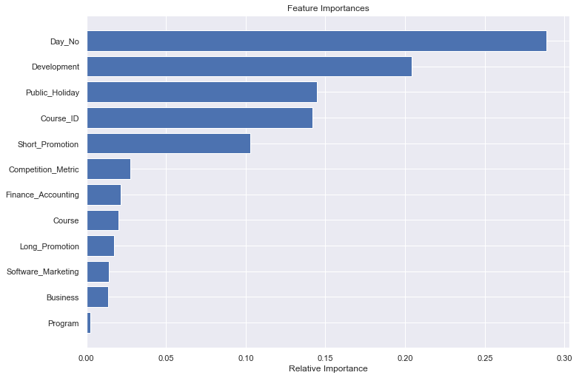

1. Day_No should play a role the model hence its omitted

**Code :**

rf = RandomForestRegressor()

# Instantiate the grid search model

grid_search = GridSearchCV(estimator = rf, param_grid = param_grid,

cv = 3, n_jobs = -1, verbose = 2)

grid_search.fit(X, y)

grid_search.best_params_

####based on best parameters build a base model

rf.fit(X,y)

* 1. **Light GBM**
     1. To leverage the accuracy of GBM based models and get the results in least possible time Light GBM was leveraged.
     2. It took few hours to tune the model and once the parameters were selected it took few minutes to train the model.
     3. Can handle categorical variables well without the need for one-hot encoding

**Code:**

cate_vars = ['Course_ID','Course_ID', 'Short_Promotion', 'Public_Holiday',

'Long_Promotion', 'Development', 'Software_Marketing', 'Finance_Accounting', 'Business', 'Course',

'Program', 'Degree']

X['Competition_Metric'] = X['Competition_Metric']*10

test['Competition_Metric'] = test['Competition_Metric']*10

X.drop(['Day_No'],axis=1)

test.drop(['Day_No'],axis=1)

lgb_train = lgb.Dataset(X, y ,categorical_feature = cate_vars)

lgb_eval = lgb.Dataset(X, y,reference=lgb_train)

params = {

'task': 'train',

'boosting_type': 'gbdt',

'objective': 'regression',

'metric': {'rmse'},

'learning_rate': [0.1,0.2,0.3,0.5],

'num_leaves': [16,32,64,1024],

'max_depth' : -1,

'reg_lambda':0.2,

'min_child_samples': [10,20,30,40]

'num_iteration': 1000, #optimize later

'verbose': 20,

'n_estimators': [100,200,300,500]

'njobs': -1

}

gbm = lgb.train(params,

lgb_train,

num_boost_round=1000,

valid_sets=lgb_eval,

early_stopping_rounds=10)

# Instantiate the grid search model

grid_search = GridSearchCV(estimator = gbm, param_grid = params,

cv = 3, n_jobs = -1, verbose = 2)

grid_search.fit(X, y)

grid_search.best_params_

* 1. **Model fitting**

y_pred = gbm.predict(test)

result = pd.DataFrame(y_pred,index = test.index,columns=['Sales'])

result.to_csv('submission_rf.csv',index=True)

1. **Final Selection of model** : Light GBM is chosen as the final model with lesser running time and better accuracy on the test data