Aeritx Website changes
- Remove Digital Card
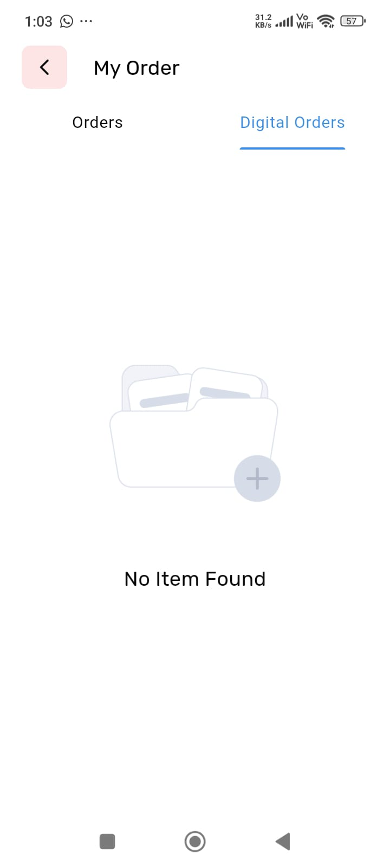
- Maine payment kiya nhi or oder create ho gaya or admin ko dikh raha hai lekin unpaid so ho raha hai main jab payment karu tab create hona hciye order
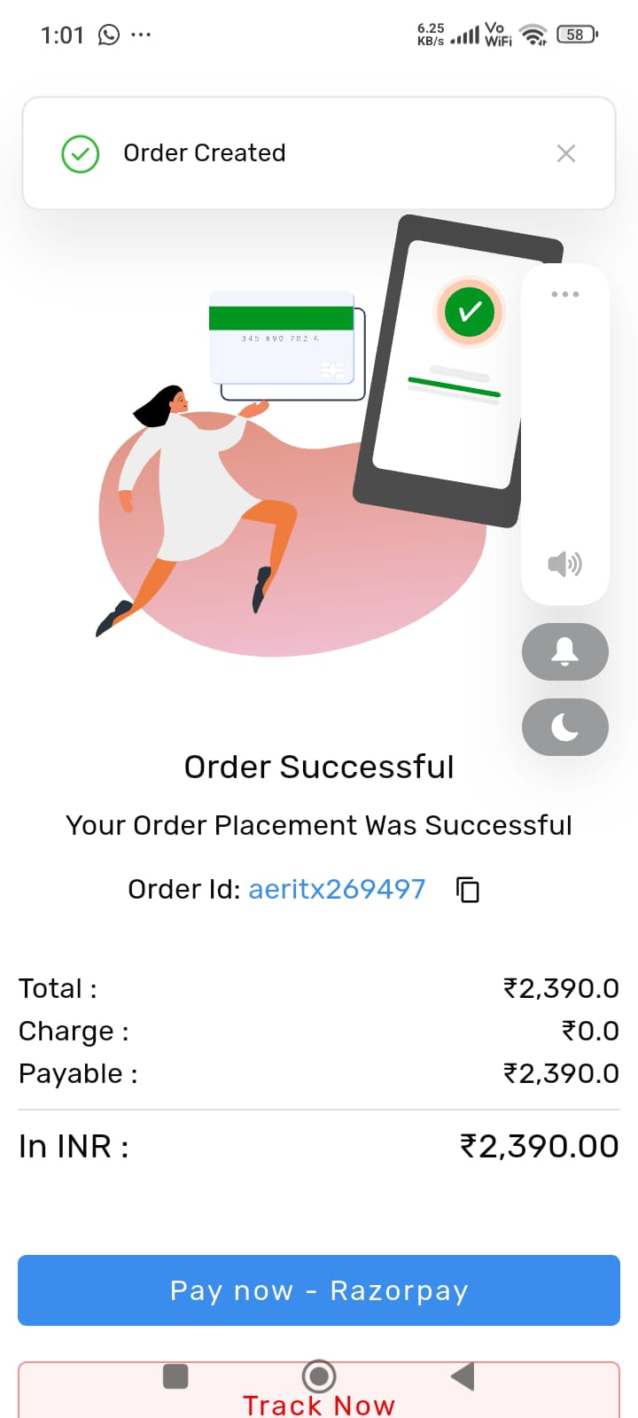
- Wishlist ya fir maine product cart main add kiya hai toh remove karne pe ye icon show ho raha hai templat icon hai please check
- 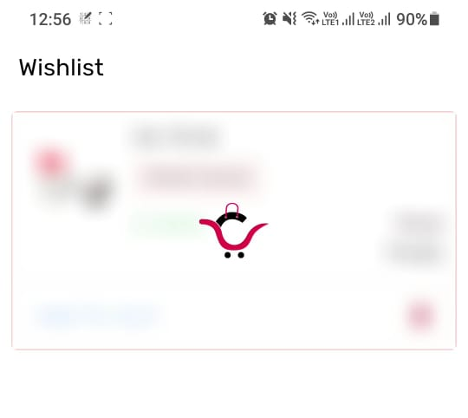
- Button responsive nhi hai or map button working nhi hai agar main direct street name bhar raha hu toh submit pe error show kar raha hai
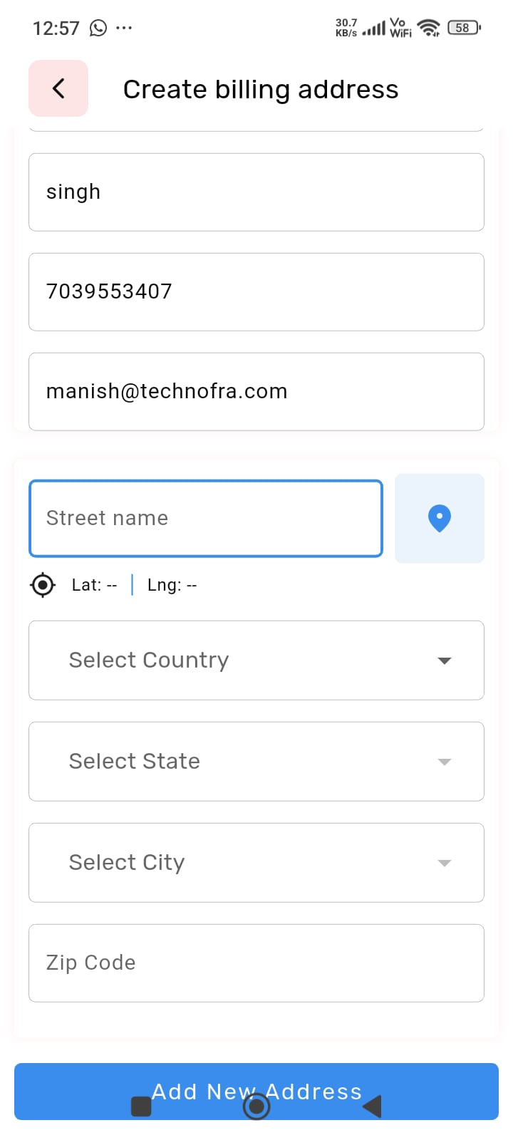
- Button proper responsive karo
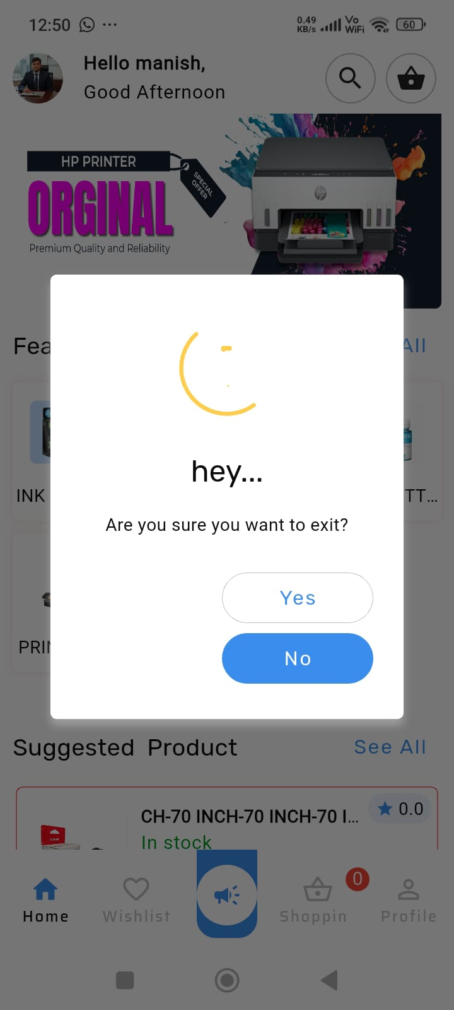
- All red colour ko blue karo them or seller chat button remove karo ya fir proper karo style
or my account section maine seller chat history show nhi ho raha hai agar seller button rakh rahe ho toh add to cart button same design problem
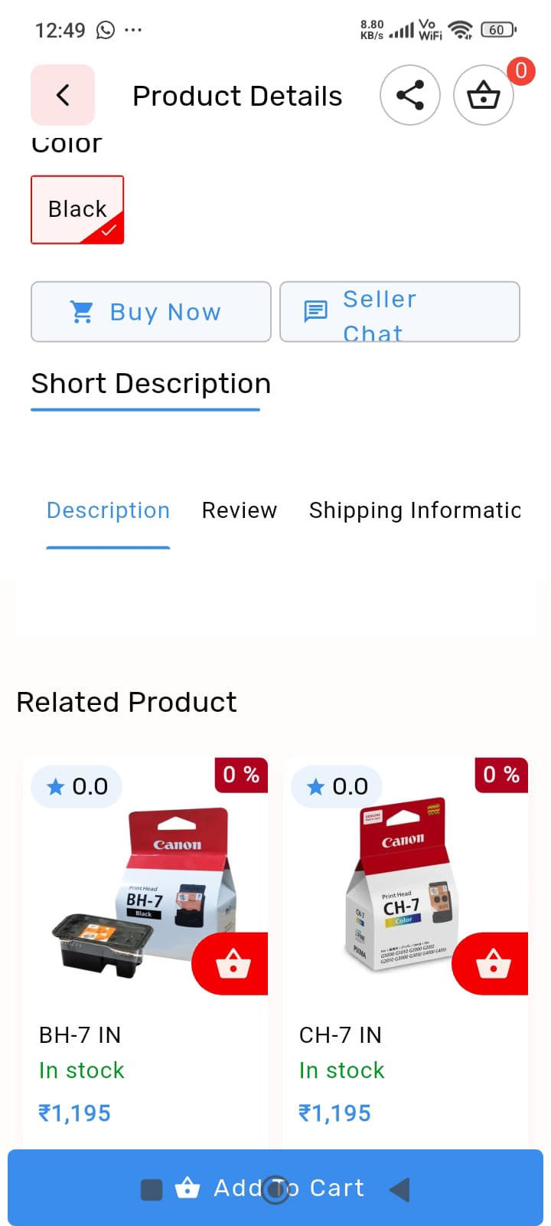
- Ye joh collection bana hai ismain product jitene show ho rahe hai who abhi inactive hai fir bhi show ho rahe hai or click pe erro show ho raha hai
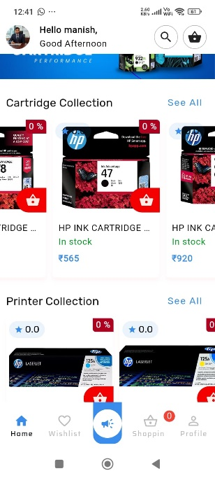
- Store ye section remove karo
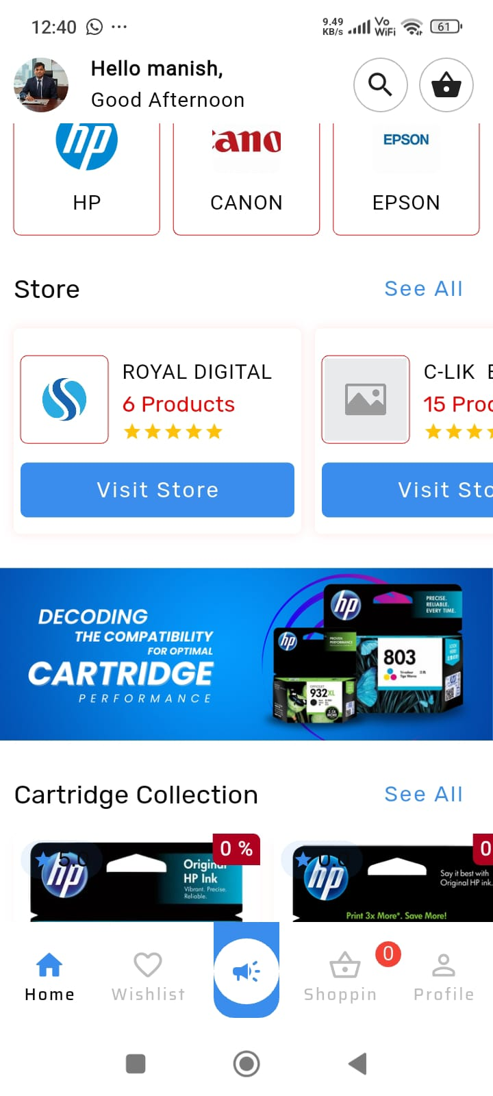
- Agar product new arrivals main nhi add hai toh who section show na ho jab main add karu product toh show ho

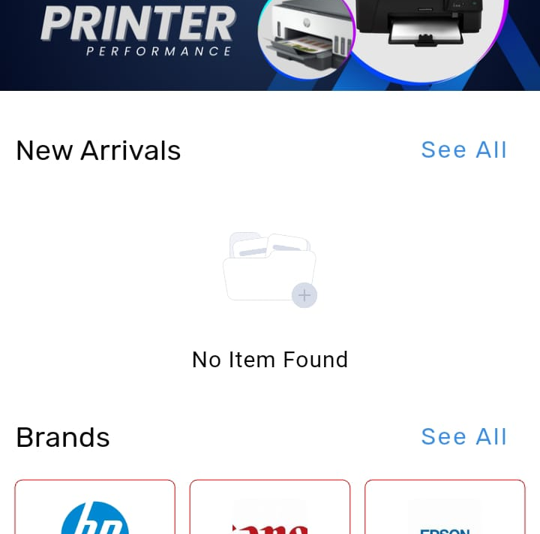
- Home page pe ye section remove karo
- 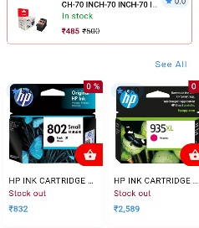
- - all colour red to blue
- 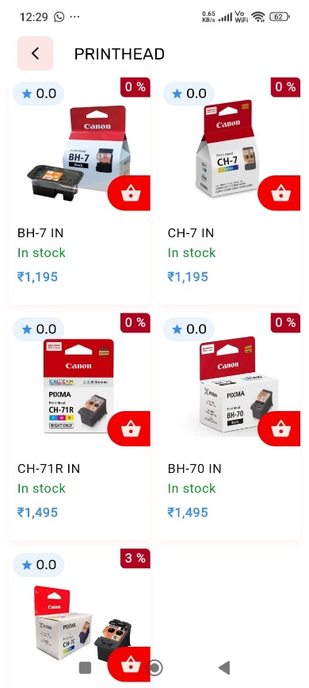
- Forget password pe otp nhi aa raha hai email pe
- 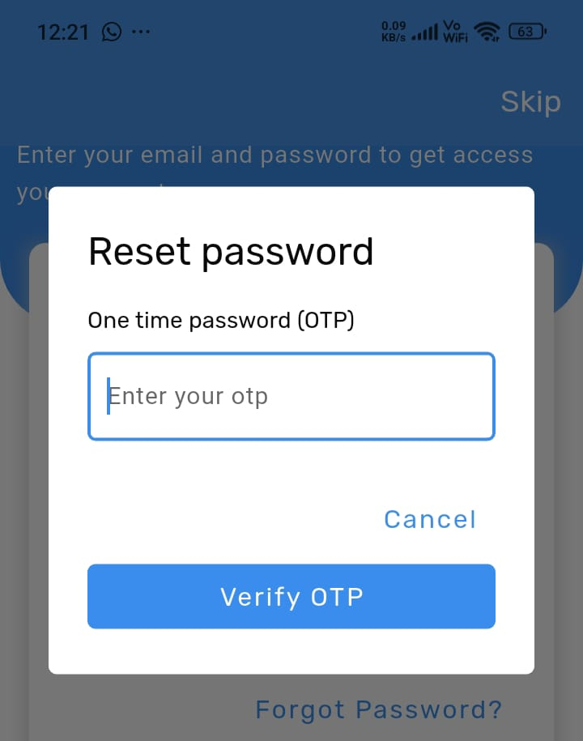
- App main jab main campaign product add kar raha hu toh ise view karne pe whatsuapp order show ho raha hai or ye working nhi hai isee proper karo ya remove kro button ko bye now wala button add karo


