1. The authenticated user ‘vinay’ who has ‘ADMIN’ access, can perform Save, view, update & delete operations.

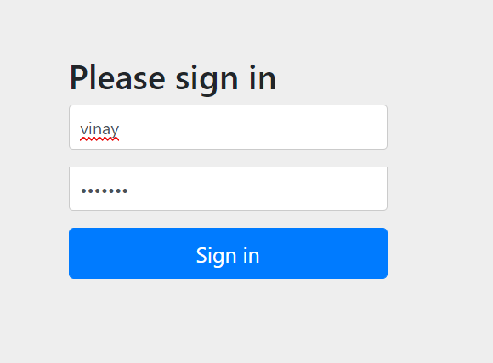

Saving a new user -’Shivam’

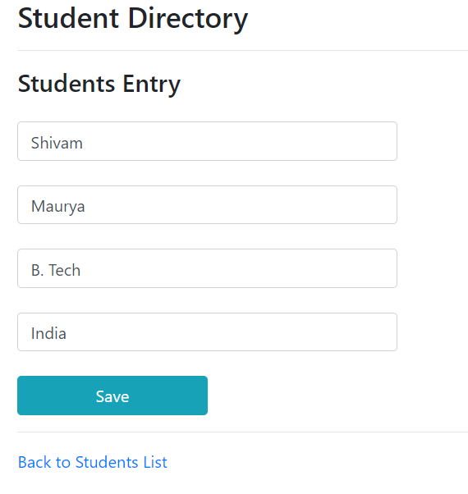

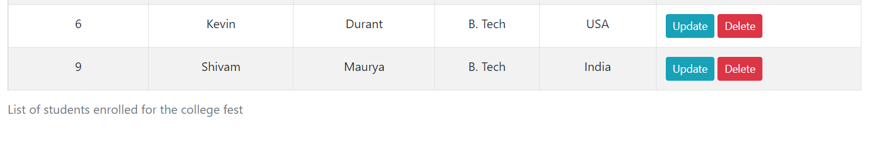

Update operation only to be performed by ADMIN->

Updating student Shivam’s detail here----

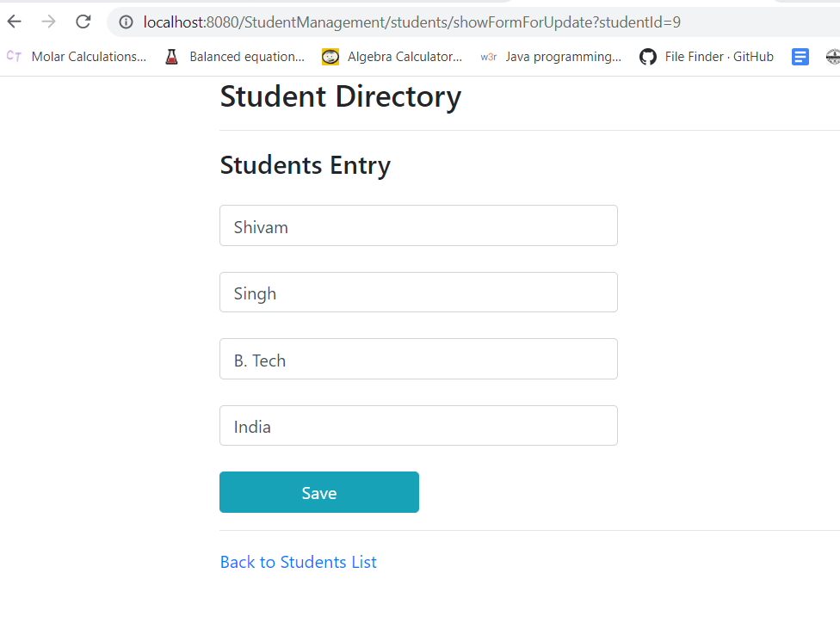

After updating the details->

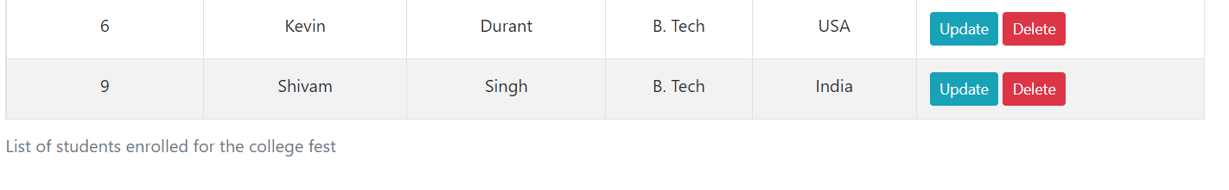

Deleting the user also requires ADMIN access. Deleting student ‘Shivam’->

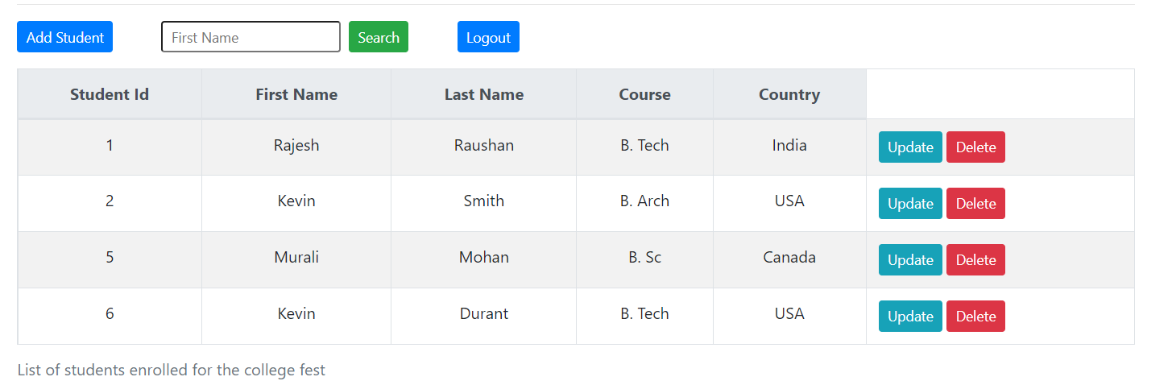

1. The user ‘kiran’ who has only ‘USER’ authorization can only save & view the list of students.

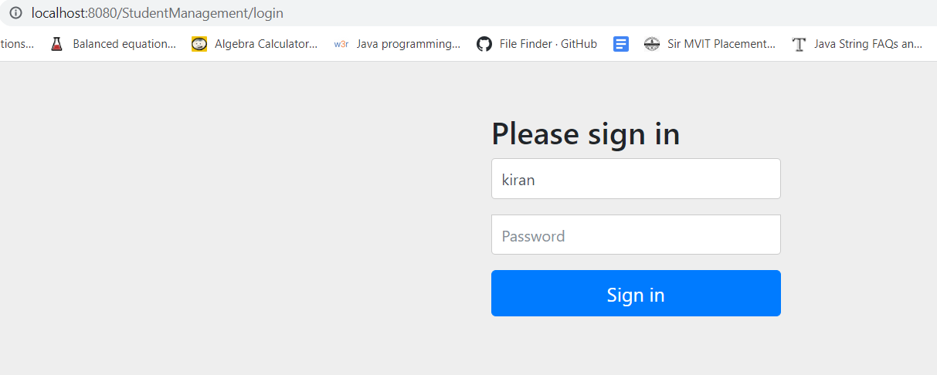

Saving a new student as a USER

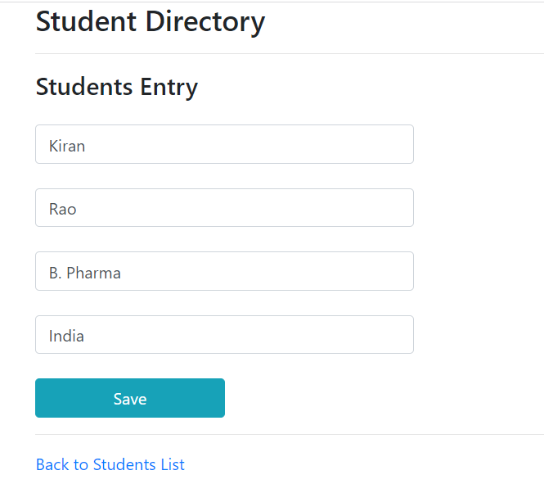

No access for delete or updating the students, for ‘USER’ authorization. ->

