1. The Customer landing page

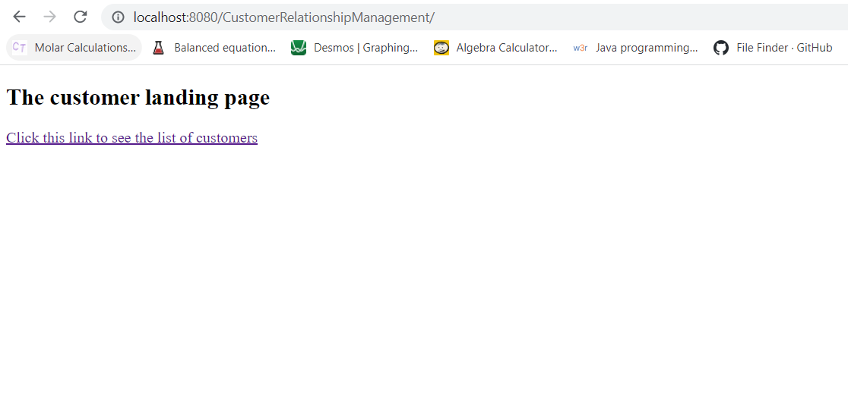

2. The Customer List page, containing the list of customers, Add Customer button & the Update/Delete button

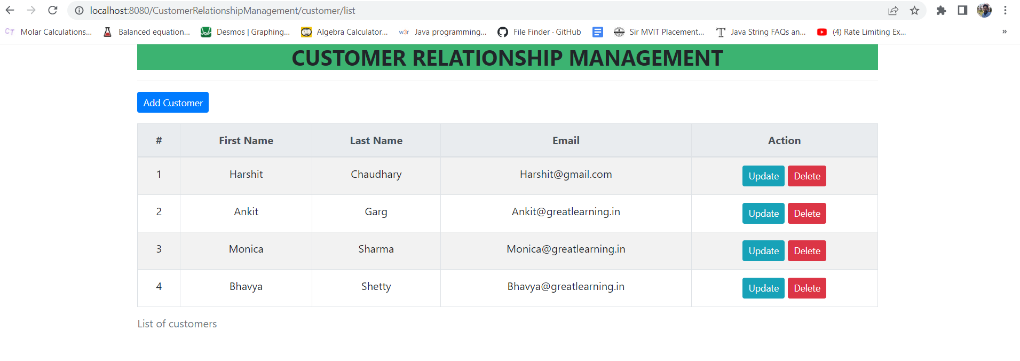

3. The list of customers as per the customer_database.

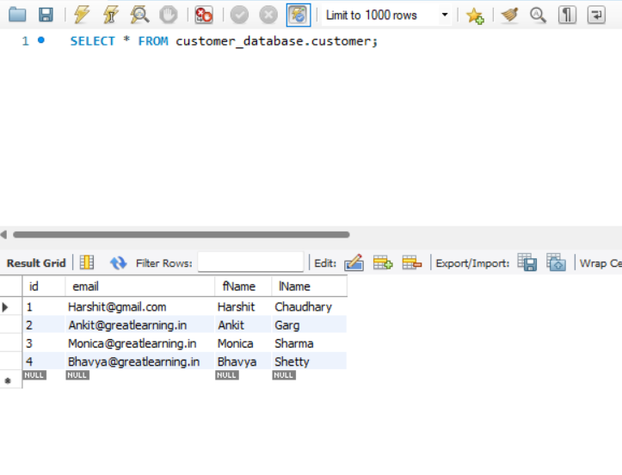

4. Upon clicking the Add Customer button user will be redirected to a new form page, wherein the user will enter details and save.

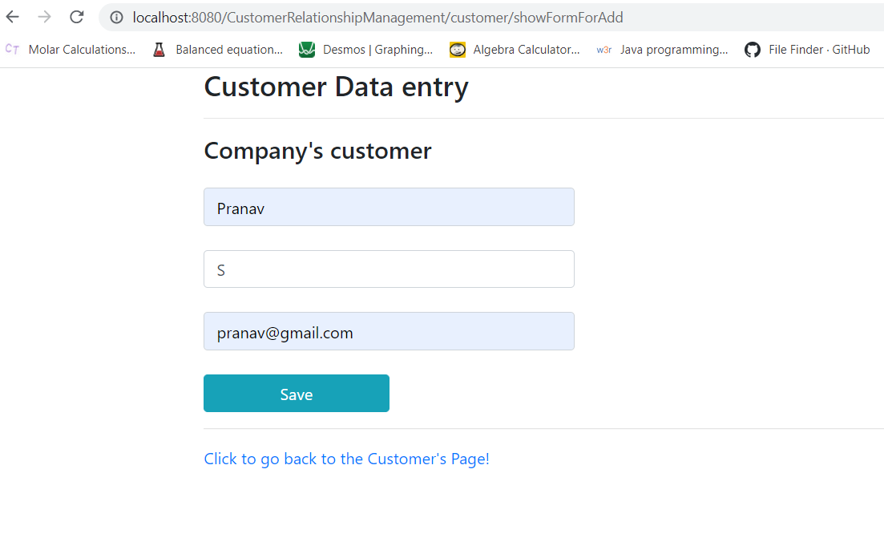

5. Updated list after adding a new customer ‘Pranav S’.

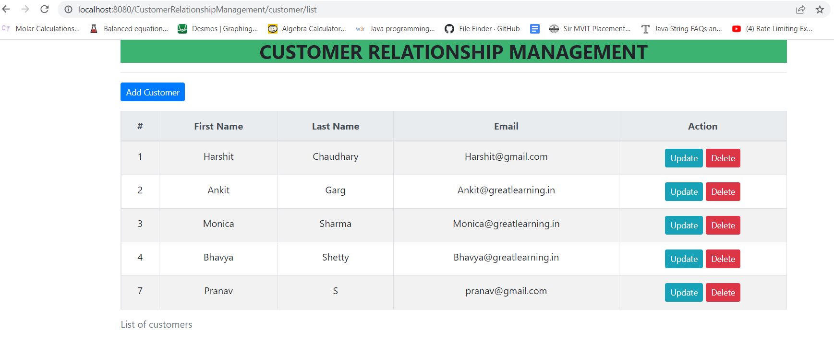

In the Database->

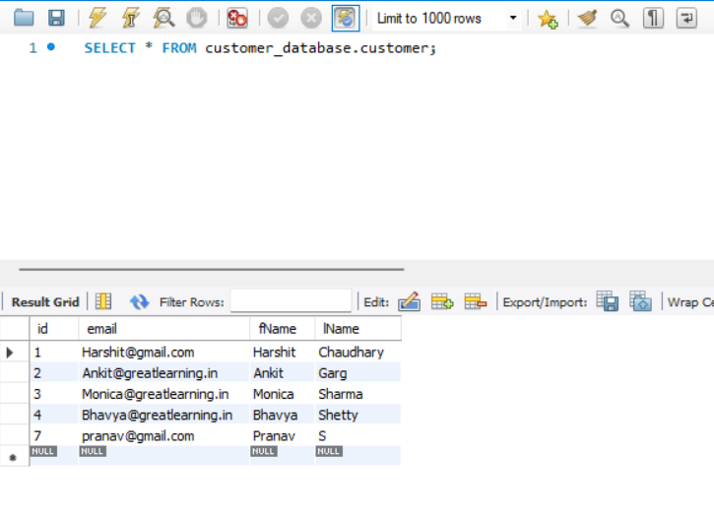

6. Upon clicking the update button the user is redirected to a new page which consists the form same as save page with pre populated data. After updating the details, upon clicking on save button, new data persists in the database.

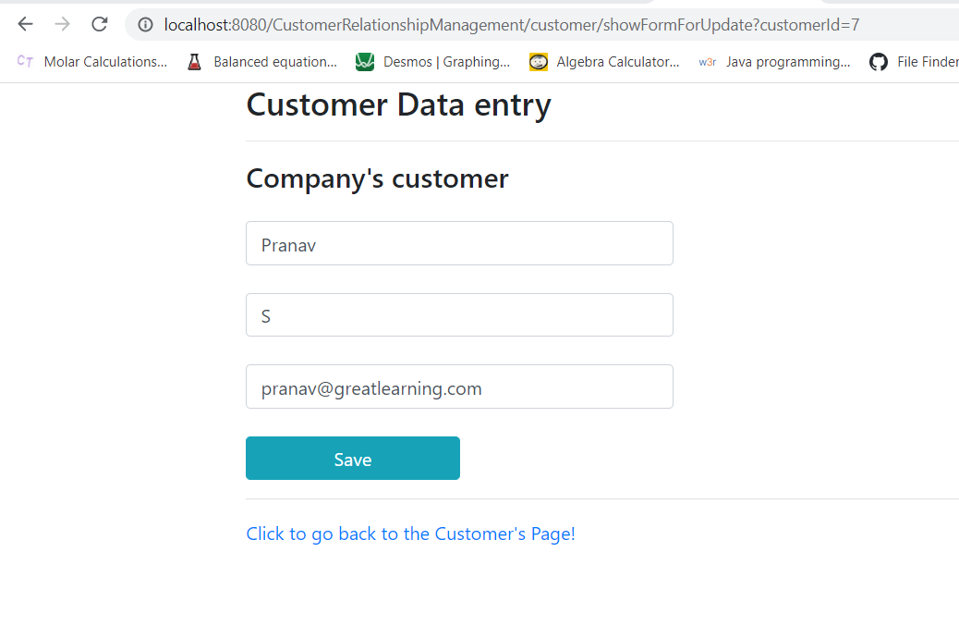

Updating the email address for customer Pranav S and saving it with address

‘greatlearning.com’.

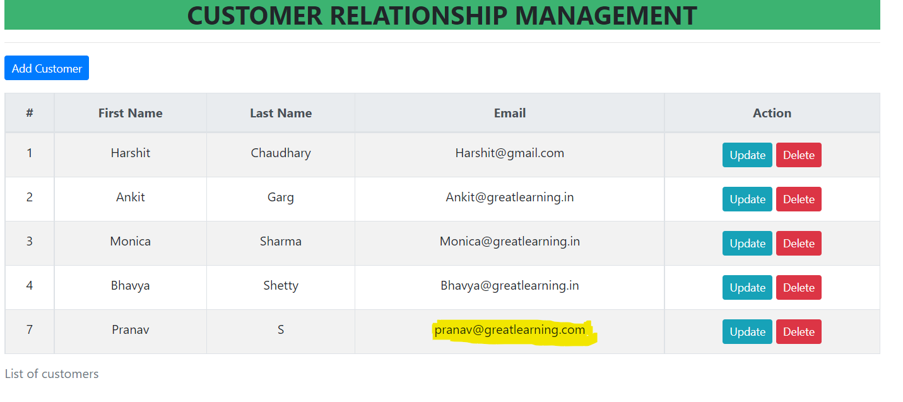

The updated data for Pranav S is also reflected in the database->

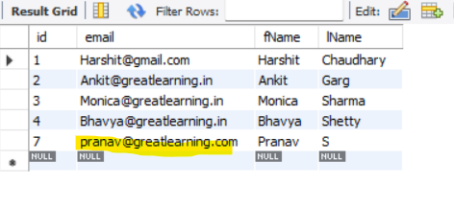

7. Upon clicking the delete button for Customer Pranav S, a pop up is generated.

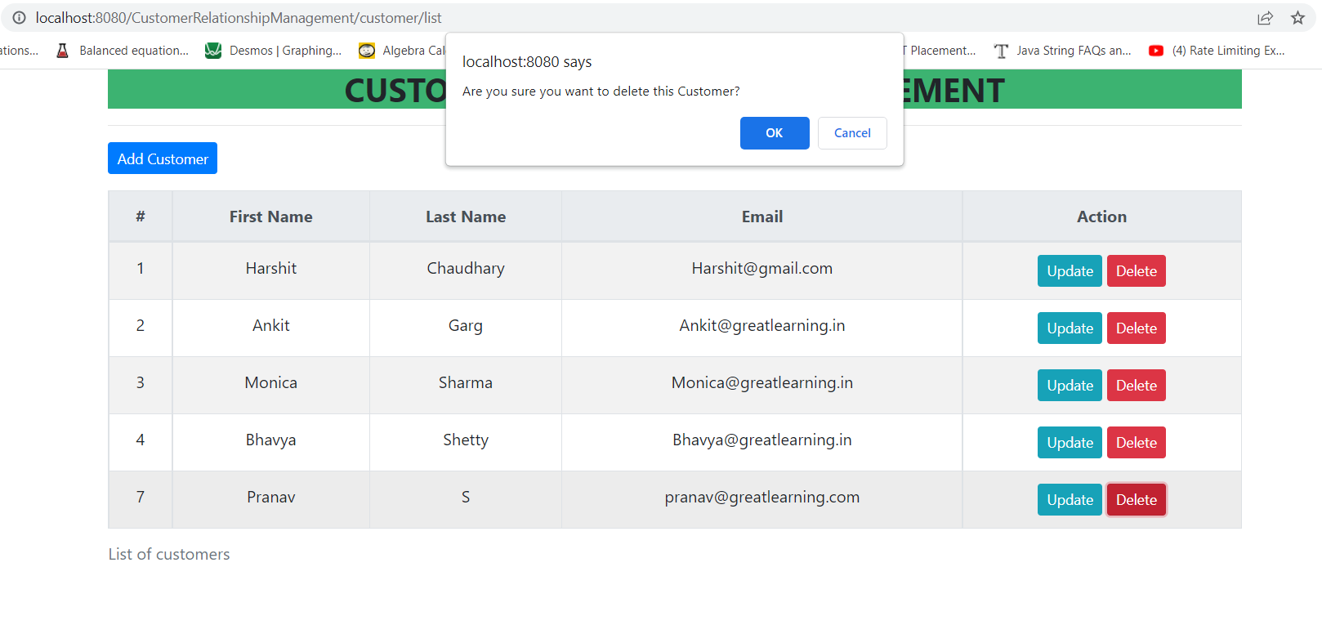

Upon clicking on the delete button , the customer entry gets deleted from the database.

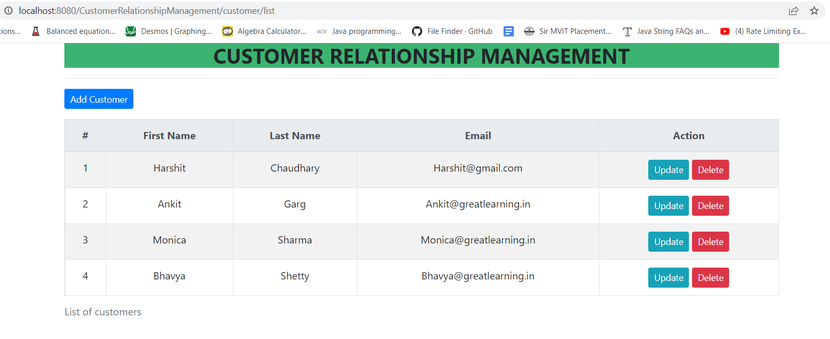

Updated list of employees upon deleting customer Pranav S.

